Sampling 1.

1000kHz

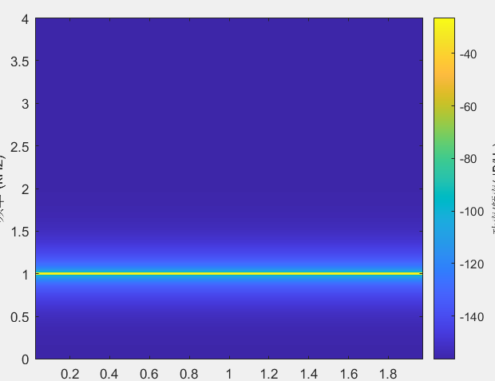

4000kHz

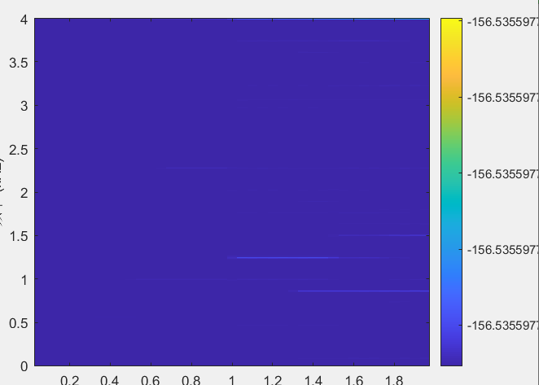

7000kHz

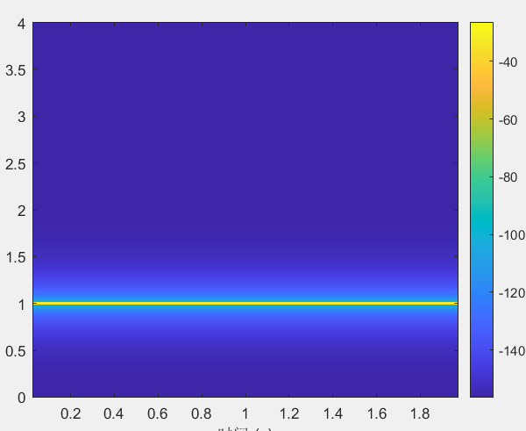

Sampling 2.

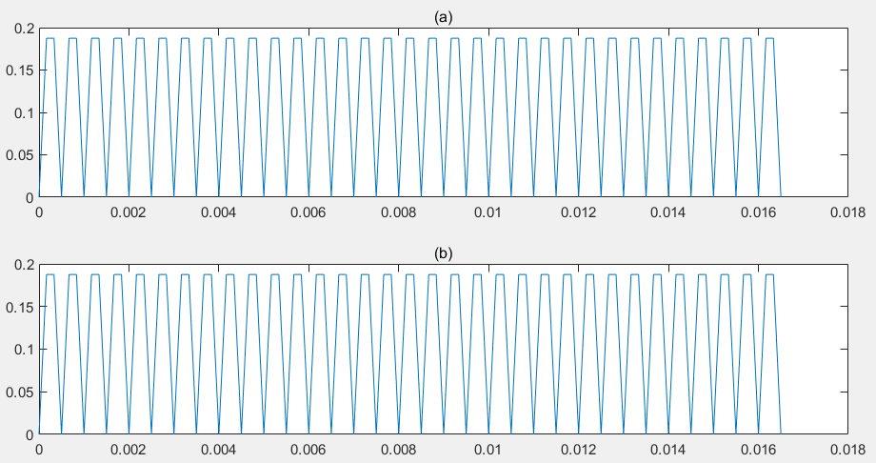

1. : X= (sin(2000\*pi\*t).^2).\*(cos(2000\*pi\*t).^2);

* X = 1/8 – 1/8\*cos(8000\*pi\*t);

F0x = 4000

1. : Y = 1/8 - 1/8\*cos(4000\*pi\*t);

F0y = 2000

Since Fs = 6000Hz, F0y+6000 = 8000 = 2F0x, therefore after 2F0x the sampling example should be identical.

Quantization2

a.

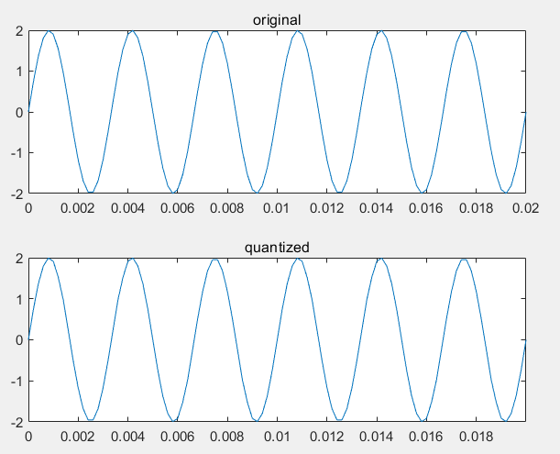

measured SNRs = 49.9257;

theoretical SNRs = 42.3982;

Bonus:

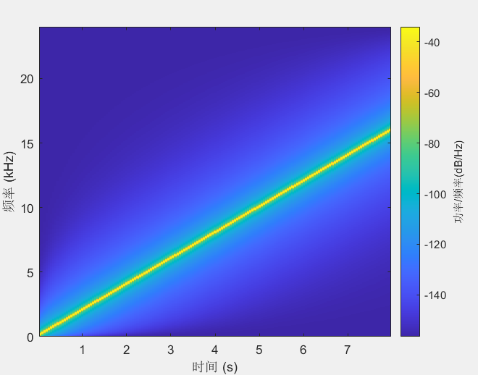

The sound comes from lower pitch to really high pitch, at the end it’s so high that it becomes hard to listen.

When the sampling frequency is 16khz, the tone went up at first and went down in the end. The different spampling frequencies sampled different results may be because of the 'Sampling theorem'. As long as the sampling frequency >= 2\*frequency of the original signal, the original signal can be generated, but 16000hz did not meet the requirement.