Correlation Experiments

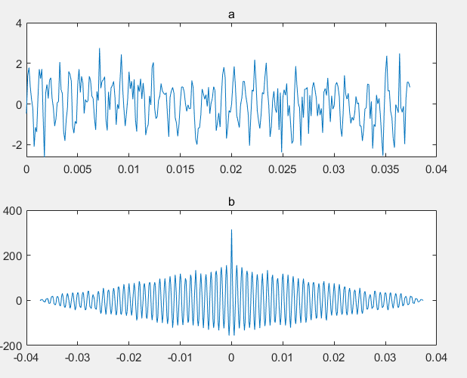

1. No periodicity, SNR was calculated to be -0.51dB

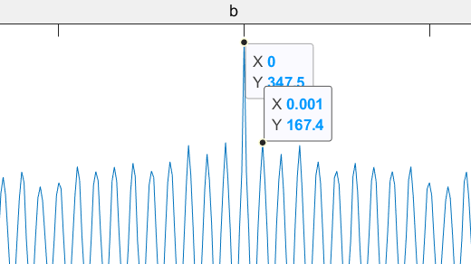

From the graph, the period is 0.001s, the frequency is 1000Hz

Correlation2.

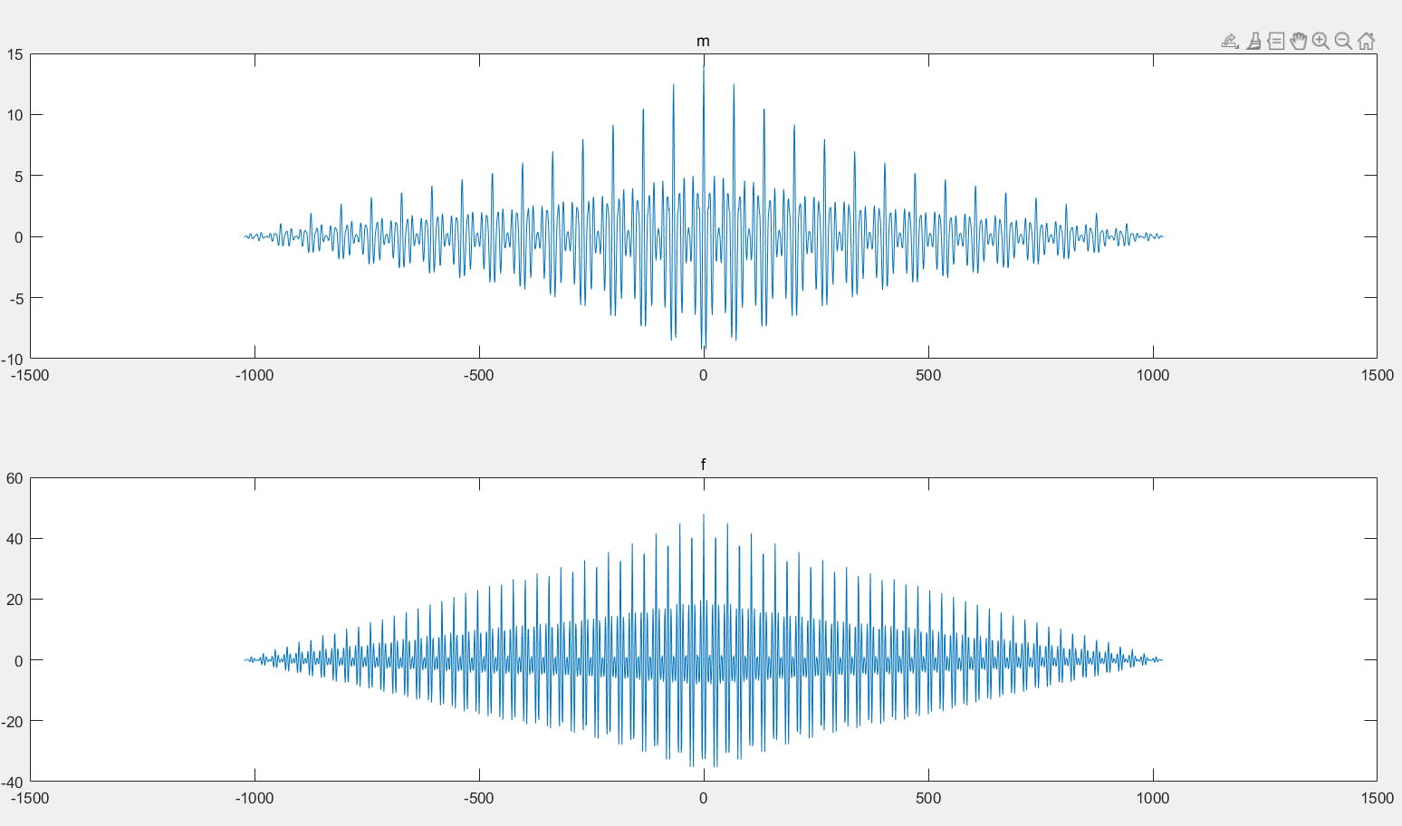

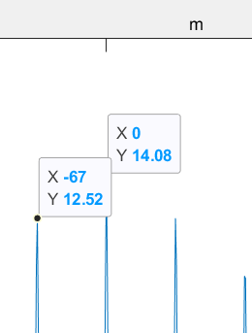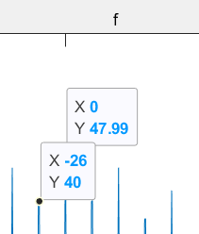

For female the lag is 26, sampling frequency is 8000hz, therefore the frequency should be 8000/26 around 307.7Hz, and for male the lab is 67, the frequency will be 119.4Hz

Spectrum

1.

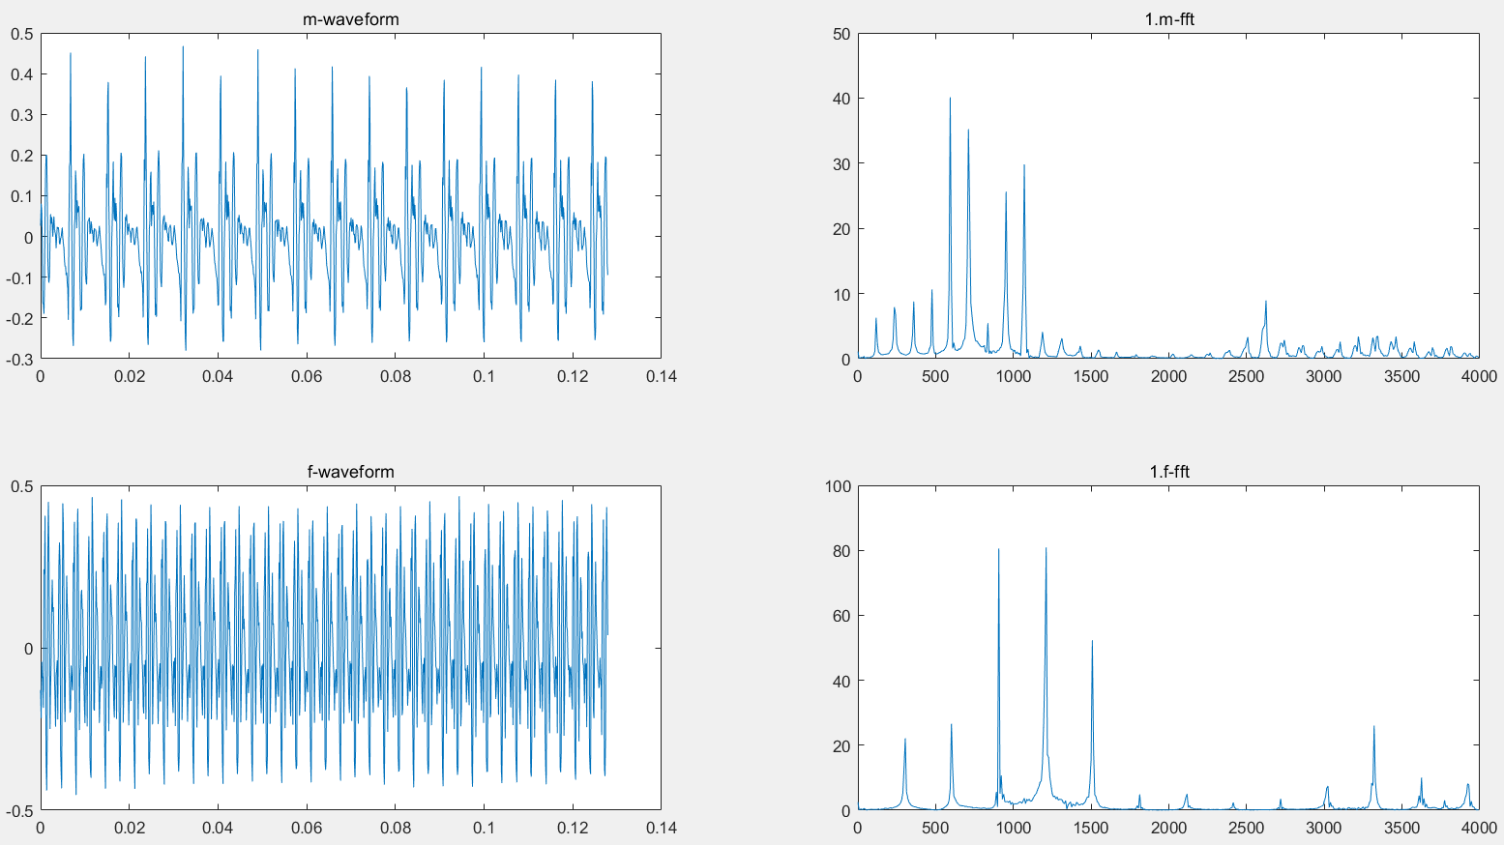

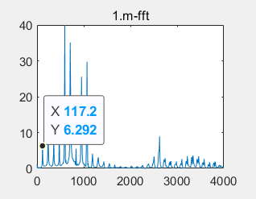 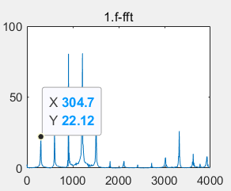

Fundamental Frequency for Female is 304.7Hz and for male is 117.2Hz.

2.

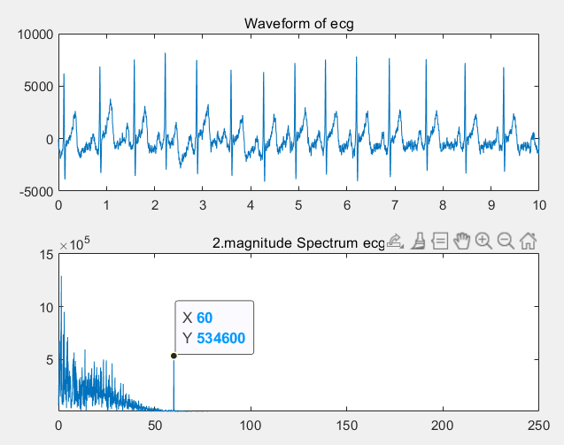

The approximate frequency range should be 0-60Hz. The artifact can be find at 60Hz, since there is a not normal bump.

3.

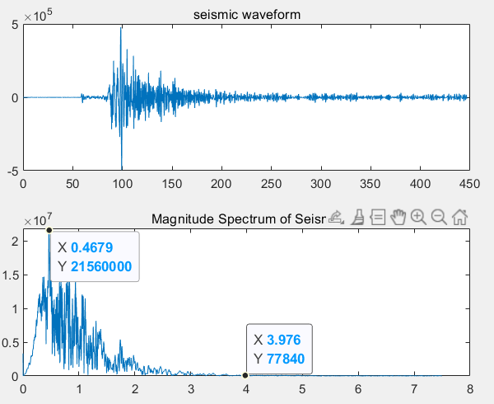

The Dominant frequency should be the highest peak which is 0.4679 I the graph, the frequency range is approximently 0-3.976Hz.

4.

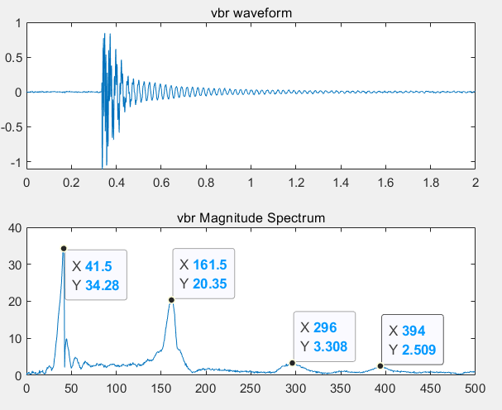

The dominate frequencies are 41.5Hz, 161.5Hz, 296Hz, 394Hz. (peaks)

Bonus.

a.

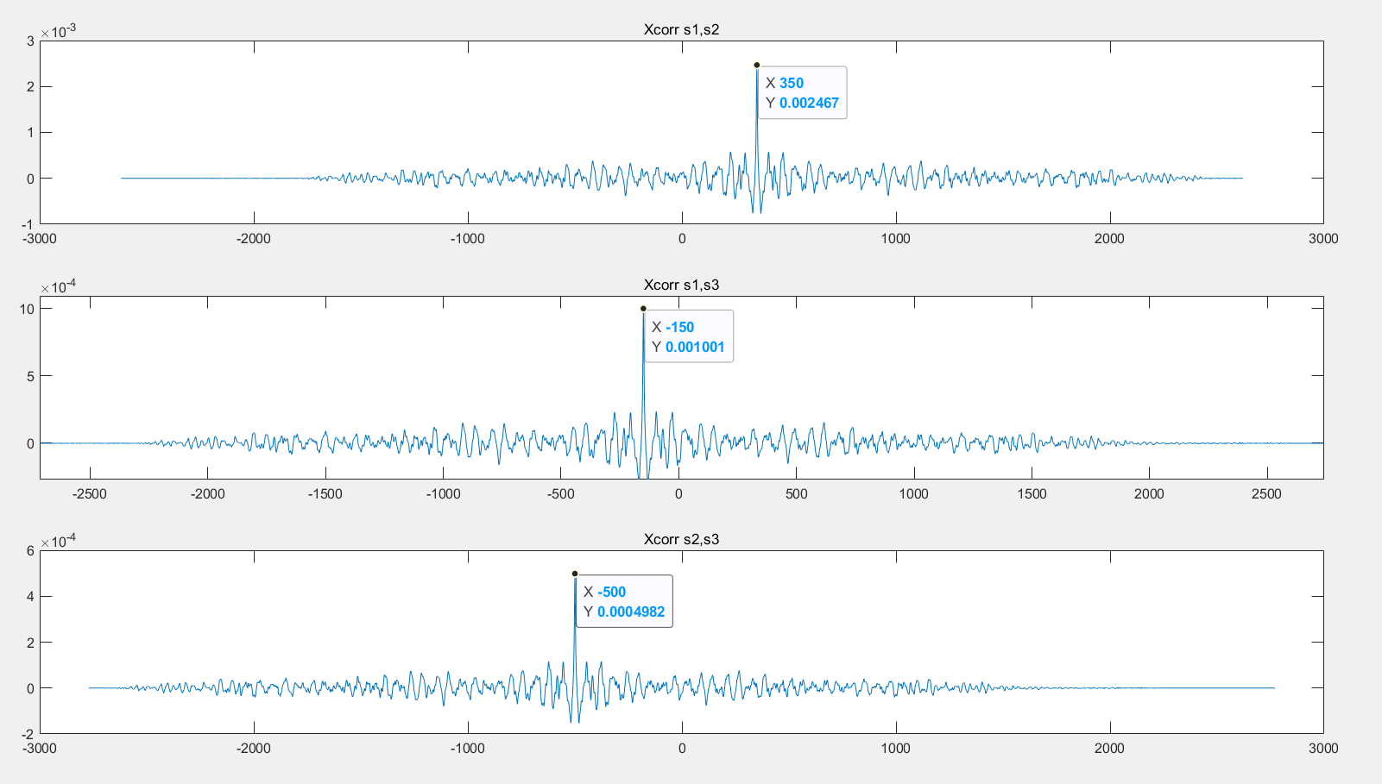

S2 leads S1 by 350 samples; S3 lags S1 by 150 samples.; S3 lags S2 by 500 samples.

b.

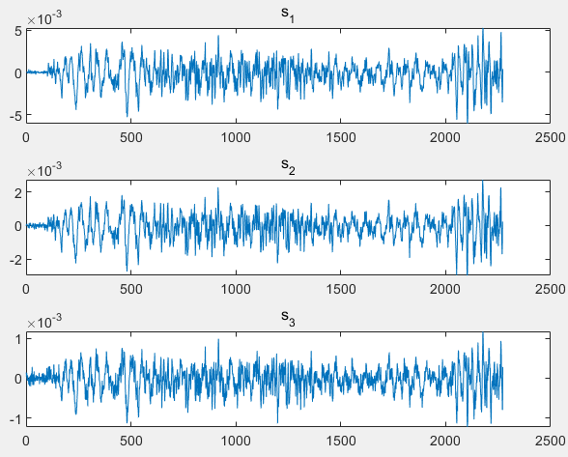

[a, lag1] = xcorr(s1,s2);

[b, lag2] = xcorr(s3, s1);

[c, lag3] = xcorr(s2, s3);

%from last question

%get the max value

[Ma,i1] = max(a);

[Mb,i2] = max(b);

[Mc,i3] = max(c);

%get lead or lags

ta = lag1(i1);

tb = lag2(i2);

tc = lag3(i3);

s1 = s1(ta:end);

s3 = s3(-tc:end);

ax(1) = subplot(3,1,1);

plot(s1)

title('s_1')

ax(2) = subplot(3,1,2);

plot(s2)

title('s_2')

ax(3) = subplot(3,1,3);

plot(s3)

title('s_3')