**ECE4429 Lab3 Answersheet**

**Xianglin Jin**

**251028972**

**Transfer function synthesis and stability**

*Z1 = [1.4*exp((1i*pi)/3); 1.4*exp(-(1i*pi)/3); 1.2*exp((1i*2*pi)/3); 1.2*exp(-(1i*2*pi)/3)];*

*P1 = [0.7*exp((1i*pi)/6); 0.7*exp(-(1i*pi)/6); 0; 0];*

*[num1, den1] = zp2tf(Z1,P1,1);*

*Tf1 = filt (num1, den1);*

*subplot(311);*

*impz(num1, den1);*

*title('Transfer Function 1');*

*P2 = [exp(-(1i*pi)/4);exp((1i*pi)/4)];*

*Z2 = [-1;1];*

*[num2, den2] = zp2tf(Z2, P2, 1);*

*Tf2 = filt (num2, den2);*

*subplot(312);*

*impz(num2, den2);*

*title('Transfer Function 2');*

*P3 = [1;1];*

*Z3 = [0;0];*

*[num3, den3] = zp2tf(Z3, P3, 1);*

*Tf3 = filt (num3, den3);*

*subplot(313);*

*impz(num3, den3);*

*title('Transfer Function 3');*

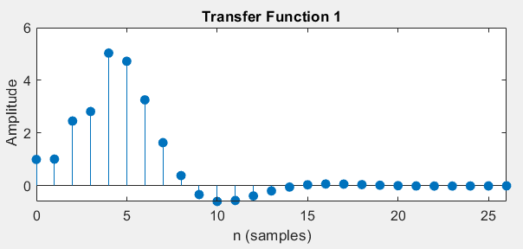

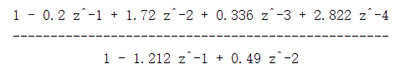

Transfer Function1 has a increase untill the 4th sample, and decreace to 0. Since all the poles and zeros are with in the unit circle, this is a steady response.

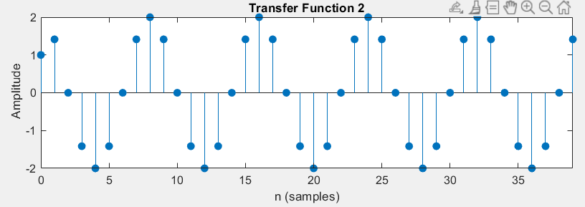

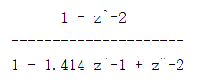

The transfer function2 has the impulse response as a wave with amplitude equals 2. Since all the poles and zeros are on the margin of unit circle, it is a marginally stable system.

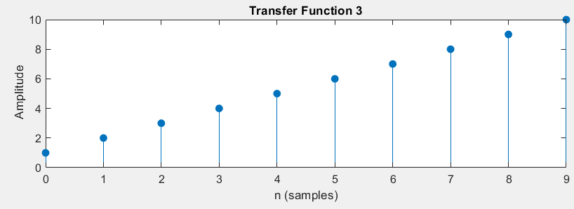

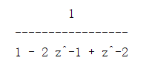

The impulse response of transfer function3 that is costantly increasing. It is unstable because repeated pole on the margin is unstable.

**Pole-zero, magnitude, and phase response plots**

*H = [1 0.1929 0.9861 -0.2393 0.4408 -0.1956 0.1139];*

*zplane(1, H);*

*figure*

*impz(1,H);*

*figure%magnitude and phase response*

*freqz(1,H); % Plots frequency response*

*title('The magnitude and phase response');*

**Q1.**

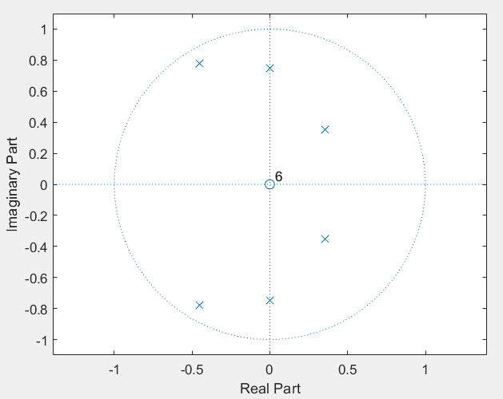

Base on the plot, this system is a bandpass filter.

From the plot, the poles are illustrate that the magnitude is at 0.25pi rad/sample, 0.5pi rad/sample, and 0.67pi rad/sample.

**Q2.**

This system is stable because all the poles and zeros are within the unit circle.

The impulse response decrease to 0 means this is stable.

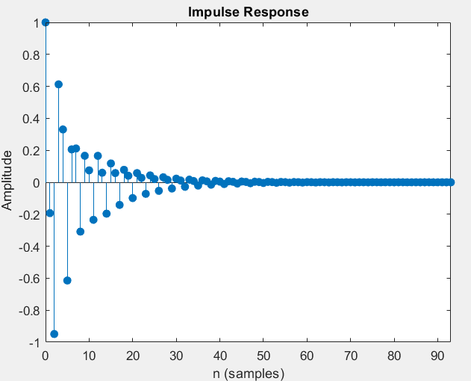

**Q3.**

The magnitude and phase response look ike what I expected. The magnitude response shows a bandpass filter, and the phase do react at 0.66pi rad/sample.

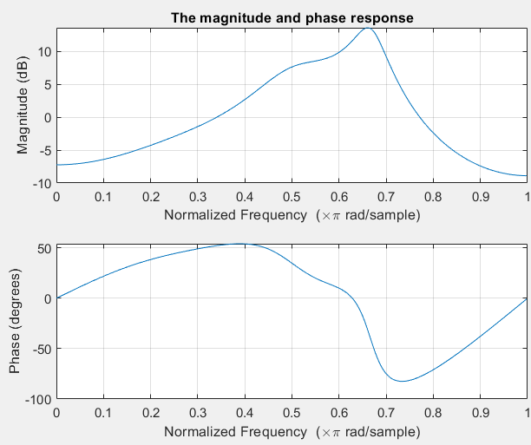

**Notch filter design & implementation**

* **Spectrum analysis**

*ecg = load('ecgbn.dat');*

*len = length(ecg);*

*fs = 600;*

*t = 1/fs*(0:len-1);*

*ecg_fft = fft(ecg);*

*frq = 0 : fs/len : fs/2-fs/len;*

*figure*

*plot(frq, abs(ecg_fft(1:len/2)));*

*title('ecg Magnitude Spectrum');*

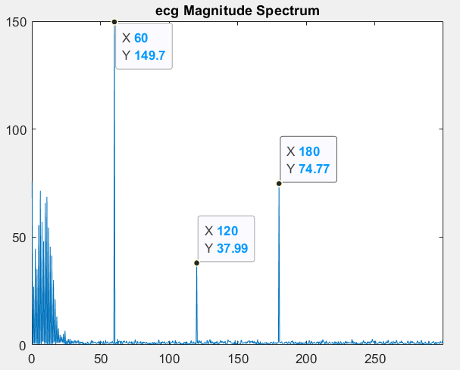

The unwanted frequencies are showed in the plot, with frequency ±60Hz, ±120Hz, ±180Hz.

* **Pole and Zero**

**Assume pole radii to be 0.95.**

*Z = [exp(-(1i*60*2*pi)/600);exp((1i*60*2*pi)/600);exp(-(1i*120*2*pi)/600);exp((1i*120*2*pi)/600);exp(-(1i*180*2*pi)/600);exp((1i*180*2*pi)/600)];*

*P = [0.95*exp(-(1i*60*2*pi)/600);0.95*exp((1i*60*2*pi)/600);0.95*exp(-(1i*120*2*pi)/600);0.95*exp((1i*120*2*pi)/600);0.95*exp(-(1i*180*2*pi)/600);0.95*exp((1i*180*2*pi)/600)];*

*[num, den] = zp2tf (Z,P,1);*

*Tf = filt (num, den);*

*figure*

*zplane(num, den);*

**Transfer Function:**

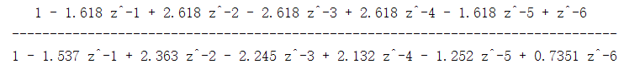

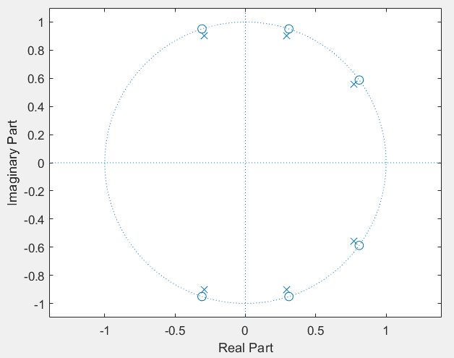

* **Magnitude, and Phase response**

*figure*

*freqz(num, den); % Plots frequency response*

*title('The magnitude and phase response');*

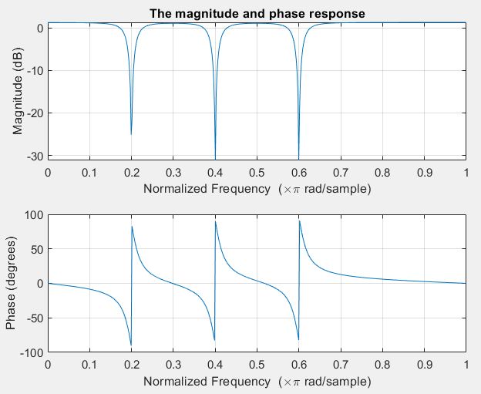

The plots have responds at 0.2pi/sample, 0.4pi/sample and 0.6pi/sample, which matches the frequency ±60Hz, ±120Hz, ±180Hz when sampling frequency is 600Hz. (60*2pi/600 = 0.2pi)

* **ECG filtering**

*ecg_filter = filtfilt(num, den, ecg);*

*figure*

*subplot(211);*

*plot(t, ecg);*

*title('ecg');*

*xlabel('time(seconds)')*

*ylabel('Amplitude')*

*subplot(212);*

*plot(t, ecg_filter);*

*title('ecg filtered');*

*xlabel('time(seconds)')*

*ylabel('Amplitude')*

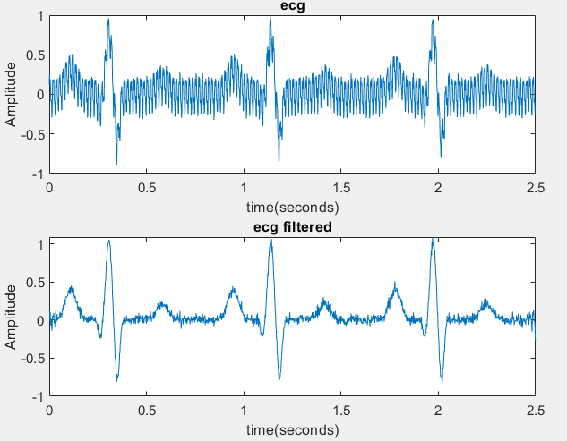

*figure*

*subplot(211);*

*plot(frq, abs(ecg_fft(1:len/2)));*

*title('ecg Magnitude Spectrum');*

*subplot(212);*

*ecg_fft_filter = fft(ecg_filter);*

*plot(frq, abs(ecg_fft_filter(1:len/2)));*

*title('ecg_filter Magnitude Spectrum');*

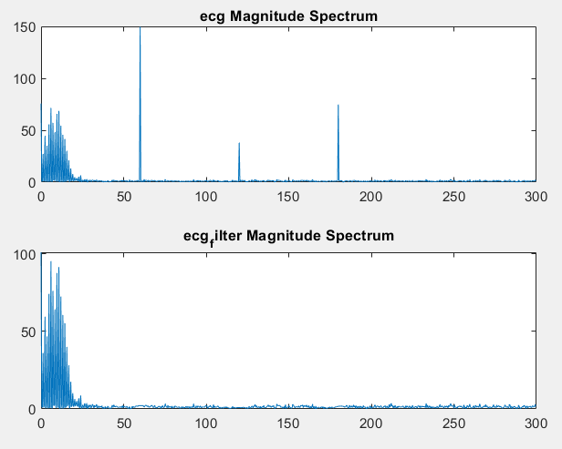

The plots show that the unwanted frequencies and noises are susseccfully removed by the filter.

**Transient response**

Transient response of the filter can be seen in the plot of the Filter ECG signal.

Transient response is the response of a system to a change from an equilibrium or a steady state.

