**ECE 4429a – Advanced Digital Signal Processing**

**Fall 2021**

**FIR Filter Design & Applications**

**Xianglin Jin**

**251028972**

**FIR filter design using the Window method.**

**BPF1:**

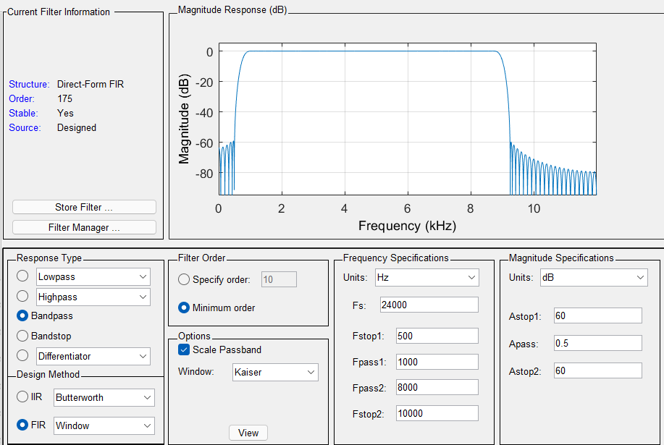

**BSF1:**

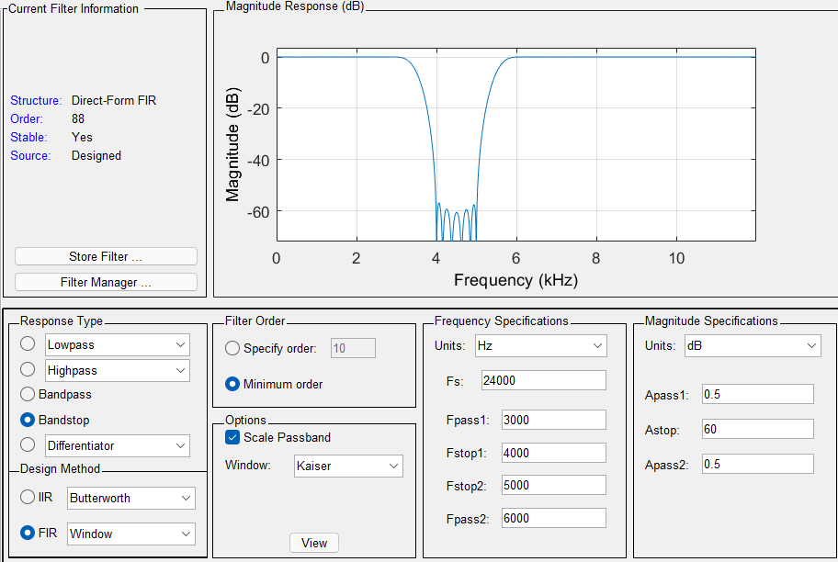

BPF2:

Apass = 1dB, Astop = 60dB

A = 60dB, A >= 50

a = 0.1102(A-8.7) = 5.65326

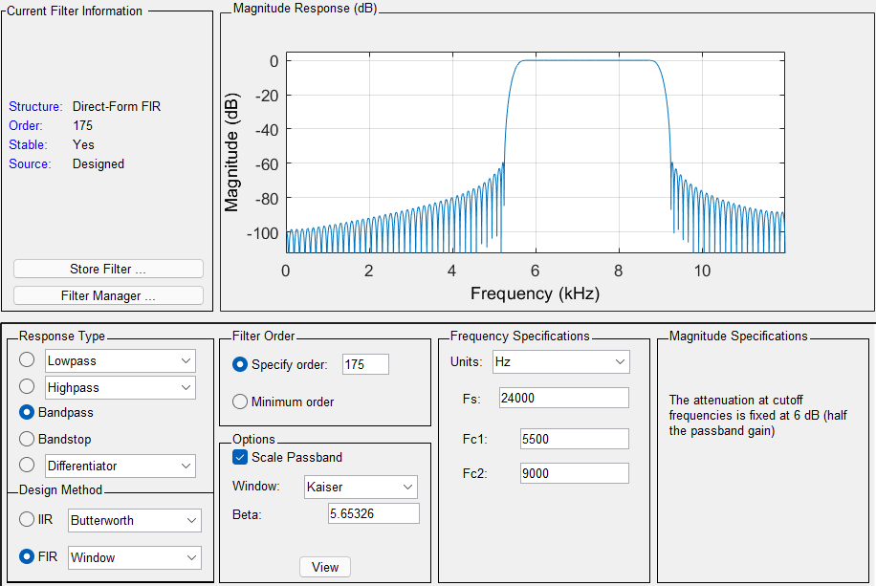

Cascade scheme:



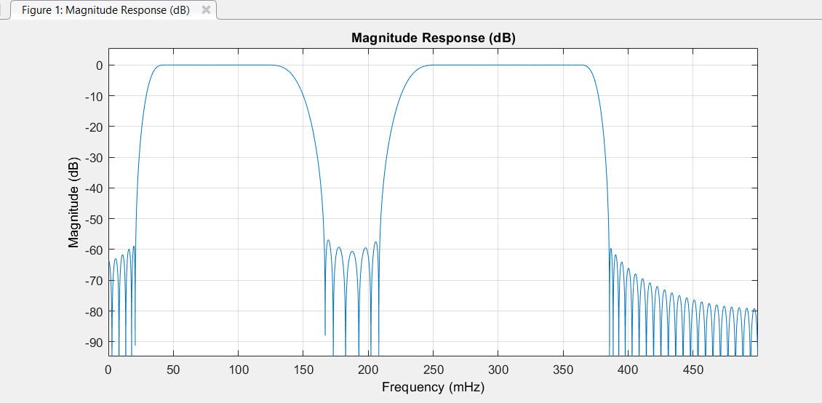

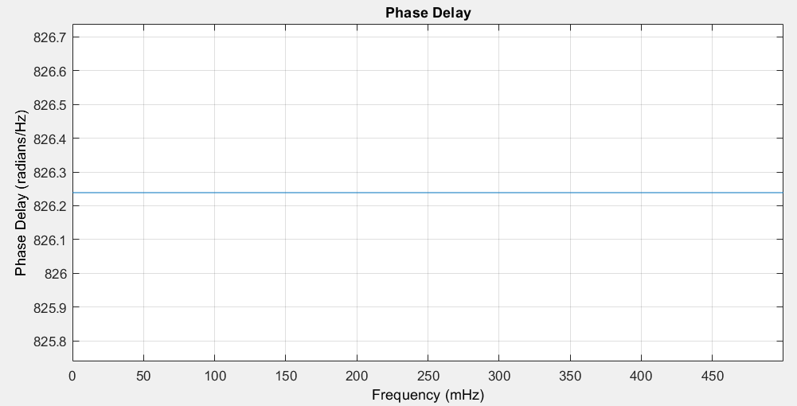

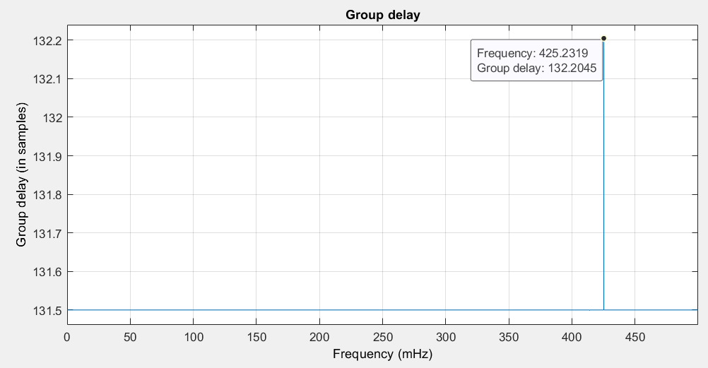

In the cascade scheme, group delay and phase delay have the same result of 131.5. The phase delay is constant, which means the phase response of the filter is a linear function of ω, and the filter is a linear phase system.

Parallel scheme:



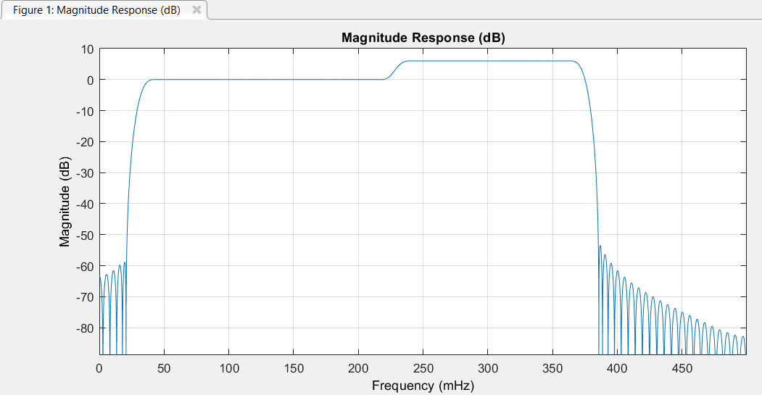

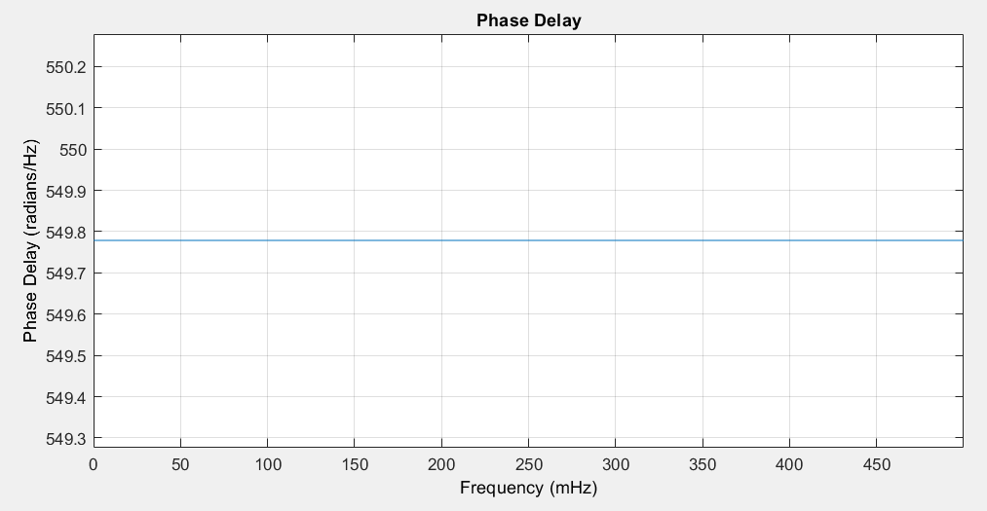

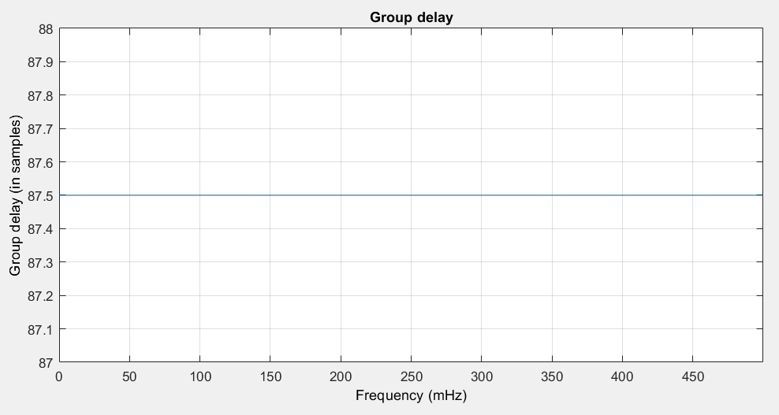

The parallel scheme also produces a linear response. In this scheme, phase and group delay are 87.5, which is lower than the phase and group delay in the cascade scheme. Both filters meet the design requirements and the second schemes apply with a sharper cutoff, which make the second filter more ideal. The second filtering scheme has a lower number of coefficients than the first one and the first scheme also has more delay. The parellal scheme is a better implementation.

**Digital differentiator experiment**

Plot the frequency response of the designed FIR filter

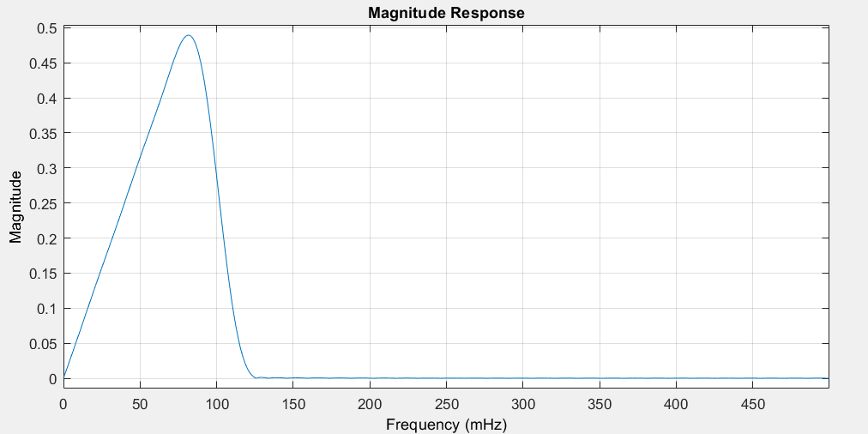

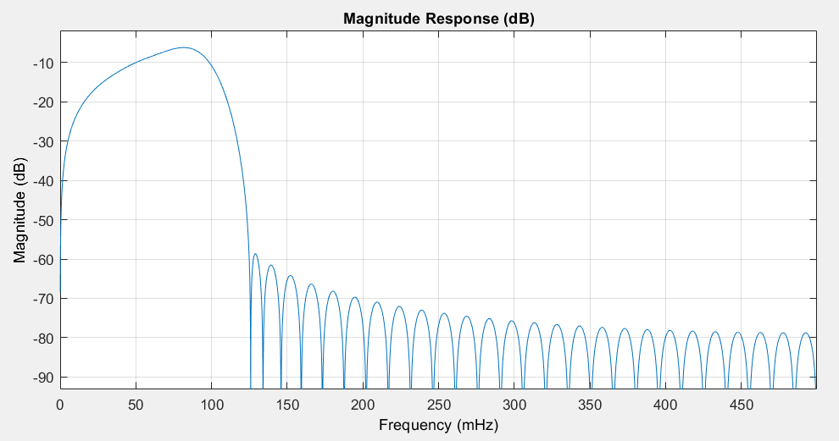

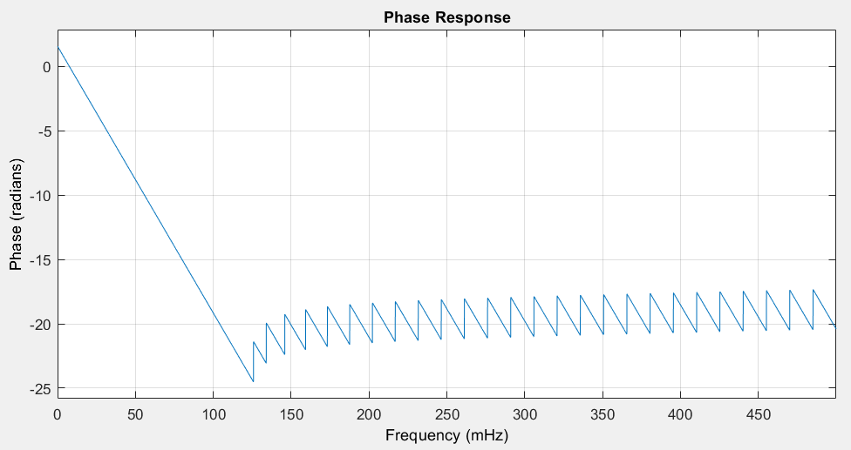

**Apply the designed FIR to the displacement to create velocity and acceleration waveforms**

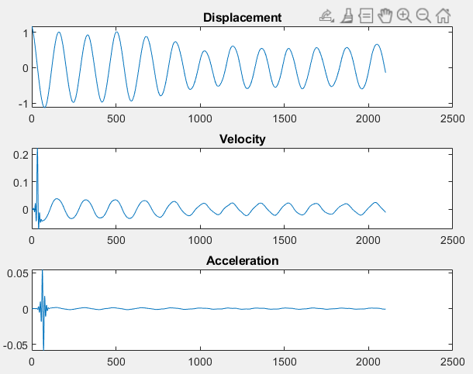

The transient response has a large spike in the velocity and acceleration plot. The velocity and displacement have the oscillation, but the acceleration is steady.

**full-band digital differentiator**

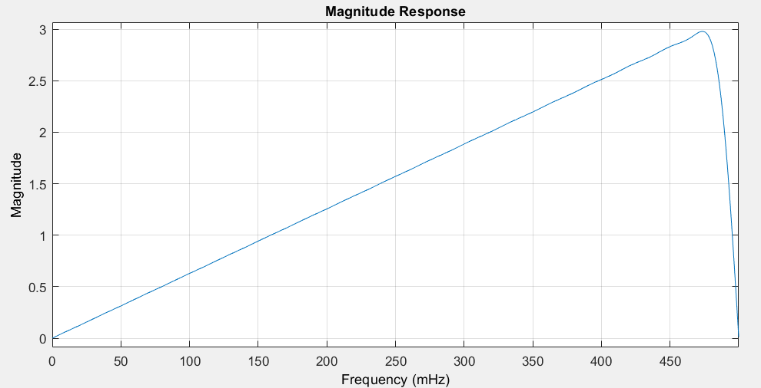

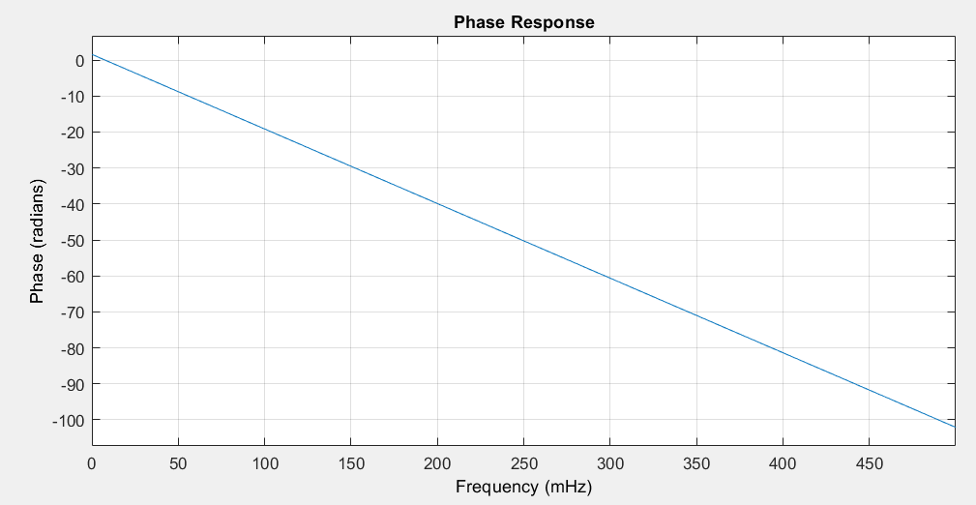

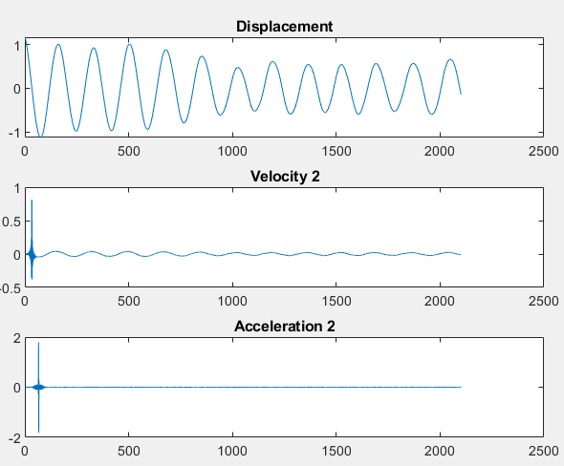

The full-band digital differentiator has a larger transient response than the previous plot.

**first order difference filter**

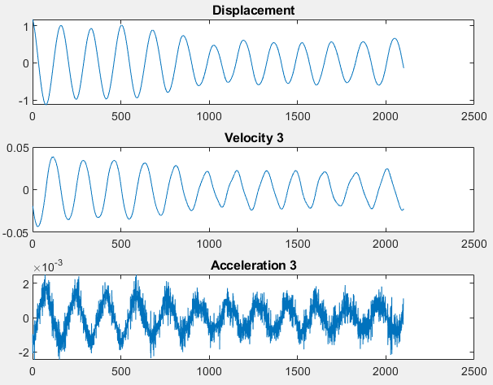

In the diff amplifies noise, the acceleration oscillates with many spikes, the velocity also has higher peaks than previous plots. The output clearly contains more noise. The transient response also disappeared.

**Arbitrary frequency response experiment**

**N = 11;**

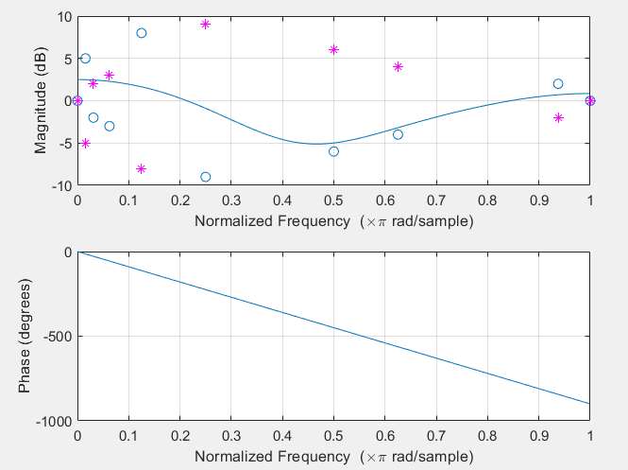

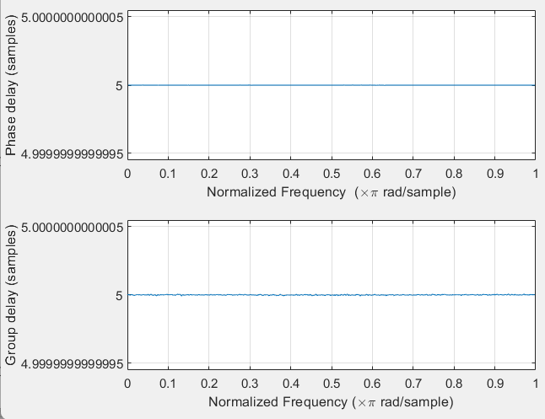

**N=31:**

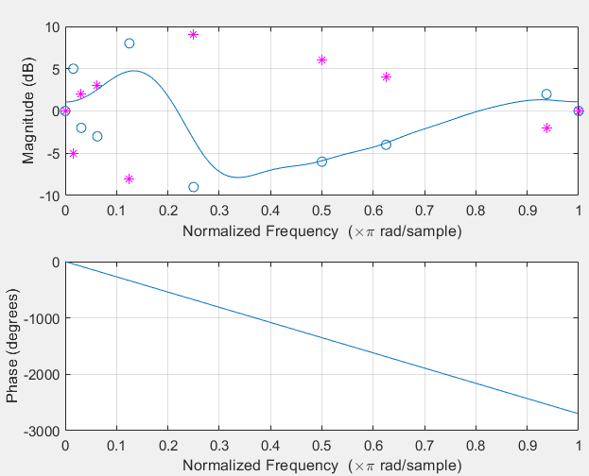

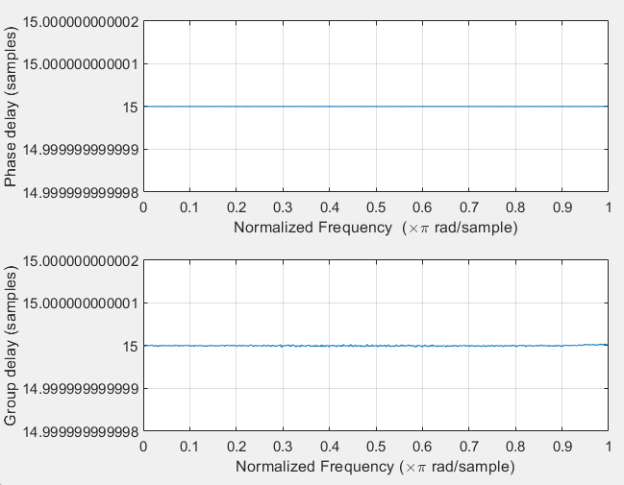

**N=101;**

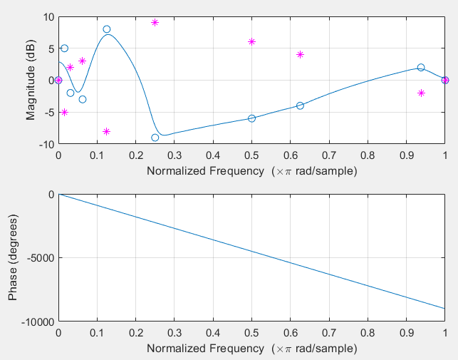

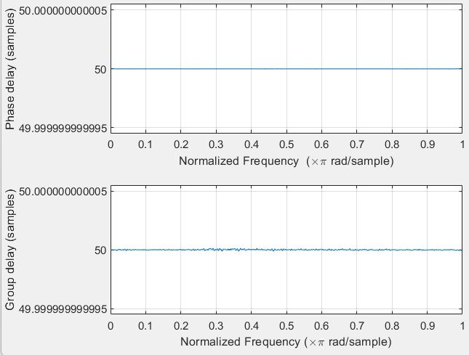

**N=1001;**

