1. 给定如下整数数组

**intArray WORD 600h, 500h, 400h, 300h, 200h**

分别用循环和非循环两种方法对该整数数组求和。

2. 给定如下字符串

**source BYTE 'Please copy this source string', 0**

写出一段汇编代码，实现对该字符串的拷贝。

3. 写出一个程序使用循环计算Fibonacci数列的前15个值。具体公式如下：  
计算公式为: Fib(1) = 1, Fib(2) = 1, Fib(*n*) = Fib(*n* – 1)  Fib(*n* – 2)。

4. **Greatest Common Divisor (GCD)**

The greatest common divisor (GCD) of two integers is the largest integer that will evenly divide  
both integers. The GCD algorithm involves integer division in a loop, described by the following  
pseudocode:

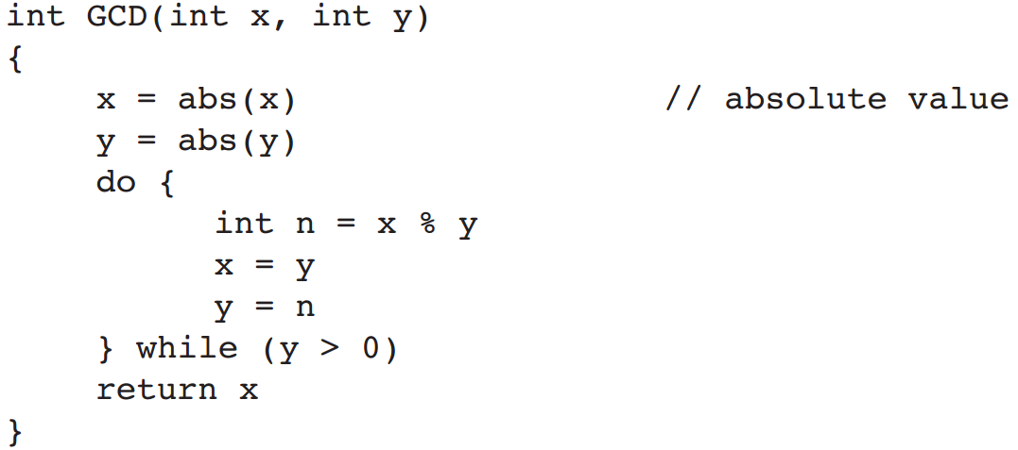

Implement this function in assembly language and write a test program that calls the function  
several times, passing it different values. Display all results on the screen.