1. **Draw Text Colors**

Write a program that displays the same string "Color output is easy!" in four different colors, using a loop. Call the **SetTextColor** procedure from the book’s link library. Any colors may be chosen, but you may find it easiest to change the foreground color.

2. **Show Procedure Parameters**

Write a procedure named **ShowParams** that displays the address and hexadecimal value of the 32-bit parameters on the runtime stack of the procedure that called it. The parameters are to be displayed in order from the lowest address to the highest. Input to the procedure will be a single integer that indicates the number of parameters to display. For example, suppose the following statement in main calls **MySample**, passing three arguments:

INVOKE MySample, 1234h, 5000h, 6543h

Next, inside **MySample**, you should be able to call ShowParams, passing the number of parameters you want to display:

MySample PROC first:DWORD, second:DWORD, third:DWORD  
paramCount = 3  
call ShowParams, paramCount

ShowParams should display output in the following format:

Stack parameters:  
---------------------------  
Address 0012FF80 = 00001234  
Address 0012FF84 = 00005000  
Address 0012FF88 = 00006543

3. **Str_concat Procedure**

写一个名为Str_concat的过程，把源字符串连接在目的字符串之后，目的字符串中必须有足够的空间容纳源字符串。传递的参数是指向源和目的的字符串的指针。下面是一个可能的调用示例：

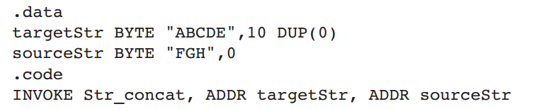

4. **Bubble Sort**

用汇编程序设计语言实现针对WORD数组的BubbleSort过程。要求在BubbleSort过程中存在一个变量，在内层循环中如果一对值进行了交换，则把该值置1，如果在某一遍处理后发现没有交换任何数值，则退出排序过程。

写一个程序测试该BubbleSort过程，至少包含两组不同的数据。

例如，一个可能的测试数据：myArray WORD 3, 1, 7, 5, 2, 9, 4, 3

5. **Student Records**

写一个程序完成下列功能：首先创建一个新的文本文件，然后提示用户输入学生的学号、姓名和生日，并把这些信息写入文件。用同样的方式输入多条记录后关闭文件。