Final Project

Owen Bolick

2024-10-13

## R Markdown

This is an R Markdown document. Markdown is a simple formatting syntax for authoring HTML, PDF, and MS Word documents. For more details on using R Markdown see <http://rmarkdown.rstudio.com>.

When you click the **Knit** button a document will be generated that includes both content as well as the output of any embedded R code chunks within the document. You can embed an R code chunk like this:

summary(cars)

## speed dist   
## Min. : 4.0 Min. : 2.00   
## 1st Qu.:12.0 1st Qu.: 26.00   
## Median :15.0 Median : 36.00   
## Mean :15.4 Mean : 42.98   
## 3rd Qu.:19.0 3rd Qu.: 56.00   
## Max. :25.0 Max. :120.00

## Including Plots

You can also embed plots, for example:

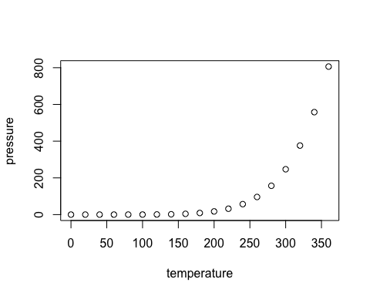

Note that the echo = FALSE parameter was added to the code chunk to prevent printing of the R code that generated the plot.

library(tidyverse)

## ── Attaching core tidyverse packages ──────────────────────── tidyverse 2.0.0 ──  
## ✔ dplyr 1.1.4 ✔ readr 2.1.5  
## ✔ forcats 1.0.0 ✔ stringr 1.5.1  
## ✔ ggplot2 3.5.0 ✔ tibble 3.2.1  
## ✔ lubridate 1.9.3 ✔ tidyr 1.3.1  
## ✔ purrr 1.0.2   
## ── Conflicts ────────────────────────────────────────── tidyverse_conflicts() ──  
## ✖ dplyr::filter() masks stats::filter()  
## ✖ dplyr::lag() masks stats::lag()  
## ℹ Use the conflicted package (<http://conflicted.r-lib.org/>) to force all conflicts to become errors

library(readr)  
library(dplyr)  
ames_student_1 <- read_csv("~/Downloads/ames_student-1.csv")

## Rows: 2053 Columns: 81  
## ── Column specification ────────────────────────────────────────────────────────  
## Delimiter: ","  
## chr (47): MS_SubClass, MS_Zoning, Street, Alley, Lot_Shape, Land_Contour, Ut...  
## dbl (34): Lot_Frontage, Lot_Area, Year_Built, Year_Remod_Add, Mas_Vnr_Area, ...  
##   
## ℹ Use `spec()` to retrieve the full column specification for this data.  
## ℹ Specify the column types or set `show_col_types = FALSE` to quiet this message.

summary(select(ames_student_1, where(is.numeric)))

## Lot_Frontage Lot_Area Year_Built Year_Remod_Add  
## Min. : 0.00 Min. : 1300 Min. :1875 Min. :1950   
## 1st Qu.: 43.00 1st Qu.: 7500 1st Qu.:1953 1st Qu.:1965   
## Median : 62.00 Median : 9548 Median :1972 Median :1993   
## Mean : 57.38 Mean : 10258 Mean :1971 Mean :1984   
## 3rd Qu.: 78.00 3rd Qu.: 11600 3rd Qu.:2000 3rd Qu.:2004   
## Max. :313.00 Max. :215245 Max. :2010 Max. :2010   
## Mas_Vnr_Area BsmtFin_SF_1 BsmtFin_SF_2 Bsmt_Unf_SF   
## Min. : 0.0 Min. :1.00 Min. : 0.00 Min. : 0.0   
## 1st Qu.: 0.0 1st Qu.:3.00 1st Qu.: 0.00 1st Qu.: 226.0   
## Median : 0.0 Median :3.00 Median : 0.00 Median : 460.0   
## Mean : 103.8 Mean :4.21 Mean : 52.57 Mean : 561.2   
## 3rd Qu.: 164.0 3rd Qu.:7.00 3rd Qu.: 0.00 3rd Qu.: 801.0   
## Max. :1600.0 Max. :7.00 Max. :1526.00 Max. :2336.0   
## Total_Bsmt_SF First_Flr_SF Second_Flr_SF Low_Qual_Fin_SF   
## Min. : 0 Min. : 432 Min. : 0.0 Min. : 0.000   
## 1st Qu.: 793 1st Qu.: 882 1st Qu.: 0.0 1st Qu.: 0.000   
## Median : 988 Median :1088 Median : 0.0 Median : 0.000   
## Mean :1055 Mean :1168 Mean : 326.1 Mean : 4.973   
## 3rd Qu.:1304 3rd Qu.:1402 3rd Qu.: 701.0 3rd Qu.: 0.000   
## Max. :5095 Max. :5095 Max. :1862.0 Max. :1064.000   
## Gr_Liv_Area Bsmt_Full_Bath Bsmt_Half_Bath Full_Bath   
## Min. : 480 Min. :0.0000 Min. :0.00000 Min. :0.000   
## 1st Qu.:1137 1st Qu.:0.0000 1st Qu.:0.00000 1st Qu.:1.000   
## Median :1447 Median :0.0000 Median :0.00000 Median :2.000   
## Mean :1499 Mean :0.4301 Mean :0.05796 Mean :1.564   
## 3rd Qu.:1737 3rd Qu.:1.0000 3rd Qu.:0.00000 3rd Qu.:2.000   
## Max. :5095 Max. :3.0000 Max. :2.00000 Max. :4.000   
## Half_Bath Bedroom_AbvGr Kitchen_AbvGr TotRms_AbvGrd   
## Min. :0.0000 Min. :0.000 Min. :1.000 Min. : 3.000   
## 1st Qu.:0.0000 1st Qu.:2.000 1st Qu.:1.000 1st Qu.: 5.000   
## Median :0.0000 Median :3.000 Median :1.000 Median : 6.000   
## Mean :0.3751 Mean :2.855 Mean :1.047 Mean : 6.442   
## 3rd Qu.:1.0000 3rd Qu.:3.000 3rd Qu.:1.000 3rd Qu.: 7.000   
## Max. :2.0000 Max. :6.000 Max. :3.000 Max. :15.000   
## Fireplaces Garage_Cars Garage_Area Wood_Deck_SF   
## Min. :0.000 Min. :0.000 Min. : 0 Min. : 0.00   
## 1st Qu.:0.000 1st Qu.:1.000 1st Qu.: 320 1st Qu.: 0.00   
## Median :1.000 Median :2.000 Median : 478 Median : 0.00   
## Mean :0.603 Mean :1.774 Mean : 472 Mean : 93.52   
## 3rd Qu.:1.000 3rd Qu.:2.000 3rd Qu.: 576 3rd Qu.: 168.00   
## Max. :4.000 Max. :5.000 Max. :1488 Max. :1424.00   
## Open_Porch_SF Enclosed_Porch Three_season_porch Screen_Porch   
## Min. : 0.00 Min. : 0.00 Min. : 0.000 Min. : 0.00   
## 1st Qu.: 0.00 1st Qu.: 0.00 1st Qu.: 0.000 1st Qu.: 0.00   
## Median : 27.00 Median : 0.00 Median : 0.000 Median : 0.00   
## Mean : 48.17 Mean : 23.02 Mean : 2.799 Mean : 16.68   
## 3rd Qu.: 72.00 3rd Qu.: 0.00 3rd Qu.: 0.000 3rd Qu.: 0.00   
## Max. :742.00 Max. :584.00 Max. :407.000 Max. :576.00   
## Pool_Area Misc_Val Mo_Sold Year_Sold   
## Min. : 0.000 Min. : 0.00 Min. : 1.000 Min. :2006   
## 1st Qu.: 0.000 1st Qu.: 0.00 1st Qu.: 4.000 1st Qu.:2007   
## Median : 0.000 Median : 0.00 Median : 6.000 Median :2008   
## Mean : 1.339 Mean : 60.12 Mean : 6.189 Mean :2008   
## 3rd Qu.: 0.000 3rd Qu.: 0.00 3rd Qu.: 8.000 3rd Qu.:2009   
## Max. :800.000 Max. :17000.00 Max. :12.000 Max. :2010   
## Longitude Latitude   
## Min. :-93.69 Min. :41.99   
## 1st Qu.:-93.66 1st Qu.:42.02   
## Median :-93.64 Median :42.03   
## Mean :-93.64 Mean :42.03   
## 3rd Qu.:-93.62 3rd Qu.:42.05   
## Max. :-93.58 Max. :42.06

ggplot(ames_student_1, aes(x = Above_Median, y = Lot_Area)) +  
 geom_boxplot() +  
 labs(title = "Lot Area Distribution by Above Median",   
 x = "Above Median Price",   
 y = "Lot Area")

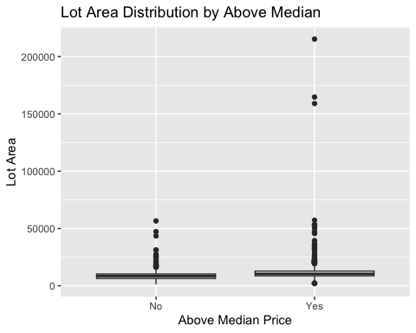

ggplot(ames_student_1, aes(x = Above_Median, y = Year_Built)) +  
 geom_boxplot() +  
 labs(title = "Year Built Distribution by Above Median",   
 x = "Above Median Price",   
 y = "Year Built")

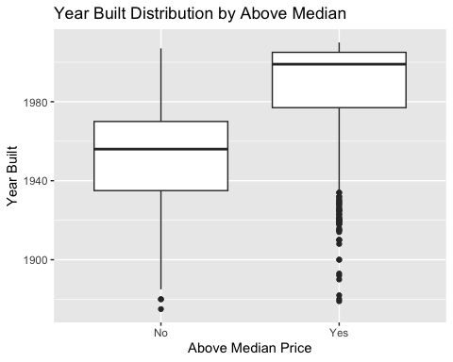

ggplot(ames_student_1, aes(x = Above_Median, y = Total_Bsmt_SF)) +  
 geom_boxplot() +  
 labs(title = "Total Basement SF by Above Median",   
 x = "Above Median Price",   
 y = "Total Basement SF")

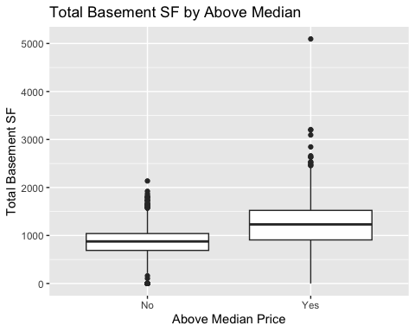

ggplot(ames_student_1, aes(x = Above_Median, y = First_Flr_SF)) +  
 geom_boxplot() +  
 labs(title = "First Floor SF by Above Median",   
 x = "Above Median Price",   
 y = "First Floor SF")

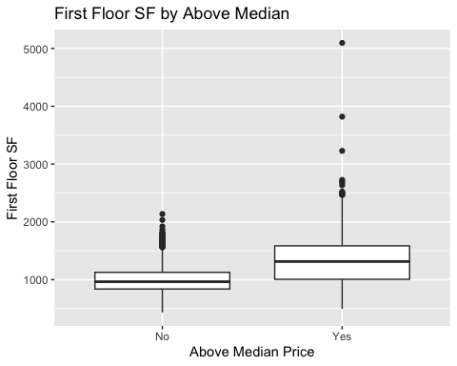

ames_student_1$Above_Median_Num <- ifelse(ames_student_1$Above_Median == "Yes", 1, 0)  
  
num_vars <- select(ames_student_1, where(is.numeric))  
cor_matrix <- cor(num_vars, use = "complete.obs")  
  
cor_matrix[,"Above_Median_Num"]

## Lot_Frontage Lot_Area Year_Built Year_Remod_Add   
## 0.091920232 0.189377364 0.582288565 0.529246315   
## Mas_Vnr_Area BsmtFin_SF_1 BsmtFin_SF_2 Bsmt_Unf_SF   
## 0.301026422 -0.095715517 0.001246641 0.183641060   
## Total_Bsmt_SF First_Flr_SF Second_Flr_SF Low_Qual_Fin_SF   
## 0.441421509 0.430708299 0.260966734 -0.061578721   
## Gr_Liv_Area Bsmt_Full_Bath Bsmt_Half_Bath Full_Bath   
## 0.565688190 0.141372151 -0.014161064 0.588631443   
## Half_Bath Bedroom_AbvGr Kitchen_AbvGr TotRms_AbvGrd   
## 0.297206579 0.111896015 -0.166102822 0.375236118   
## Fireplaces Garage_Cars Garage_Area Wood_Deck_SF   
## 0.440745636 0.560091912 0.494627712 0.293820057   
## Open_Porch_SF Enclosed_Porch Three_season_porch Screen_Porch   
## 0.271078175 -0.162041135 0.015245812 0.108880884   
## Pool_Area Misc_Val Mo_Sold Year_Sold   
## 0.014874614 0.017703377 0.015321303 -0.022151039   
## Longitude Latitude Above_Median_Num   
## -0.284912353 0.214819594 1.000000000

ggplot(ames_student_1, aes(x = MS_Zoning, fill = Above_Median)) +  
 geom_bar(position = "fill") +  
 labs(title = "Distribution of Above Median by Zoning",   
 x = "Zoning",   
 y = "Proportion")

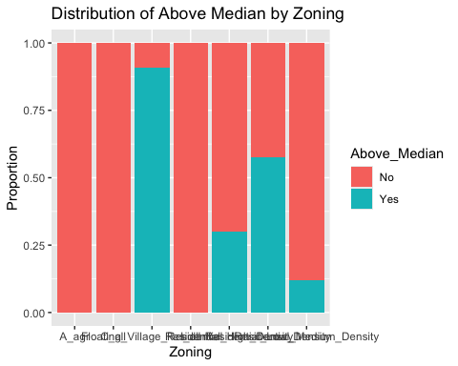

ggplot(ames_student_1, aes(x = Neighborhood, fill = Above_Median)) +  
 geom_bar(position = "fill") +  
 labs(title = "Distribution of Above Median by Neighborhood",   
 x = "Neighborhood",   
 y = "Proportion") +  
 theme(axis.text.x = element_text(angle = 90, hjust = 1))

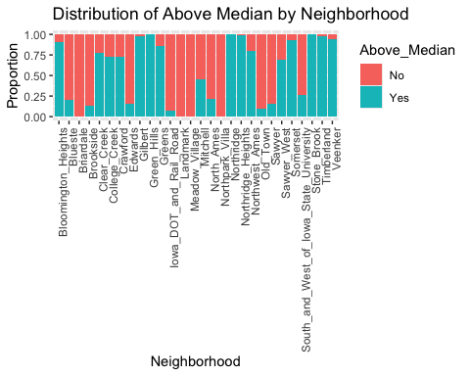

ames_student_1$House_Age <- ames_student_1$Year_Sold - ames_student_1$Year_Built  
  
ggplot(ames_student_1, aes(x = Above_Median, y = House_Age)) +  
 geom_boxplot() +  
 labs(title = "House Age by Above Median",   
 x = "Above Median",   
 y = "House Age")

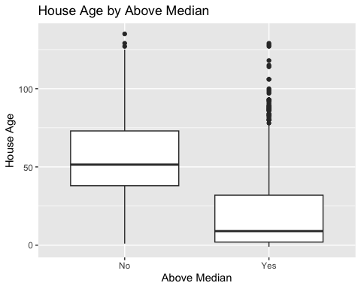

missing_data <- colSums(is.na(ames_student_1))  
missing_data[missing_data > 0]

## named numeric(0)

ggplot(ames_student_1, aes(x = Lot_Area, fill = Above_Median)) +  
 geom_histogram(bins = 30) +  
 facet_wrap(~Neighborhood) +  
 labs(title = "Lot Area Distribution by Neighborhood and Above Median",   
 x = "Lot Area",   
 y = "Count")

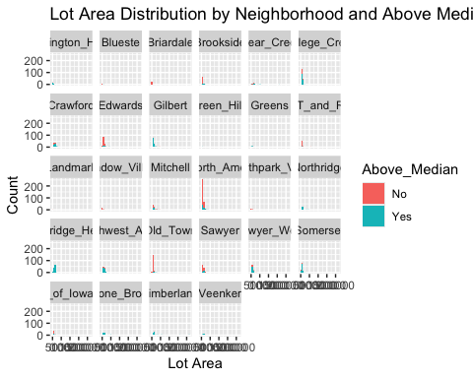

library(caret)

## Loading required package: lattice

##   
## Attaching package: 'caret'

## The following object is masked from 'package:purrr':  
##   
## lift

set.seed(123)  
  
train_index <- createDataPartition(ames_student_1$Above_Median, p = 0.8, list = FALSE)  
train_data <- ames_student_1[train_index, ]  
test_data <- ames_student_1[-train_index, ]  
  
dim(train_data)

## [1] 1643 83

dim(test_data)

## [1] 410 83

train_data$MS_Zoning <- as.factor(train_data$MS_Zoning)  
train_data$Neighborhood <- as.factor(train_data$Neighborhood)  
train_data$Above_Median <- as.factor(train_data$Above_Median)  
  
test_data$MS_Zoning <- as.factor(test_data$MS_Zoning)  
test_data$Neighborhood <- as.factor(test_data$Neighborhood)  
test_data$Above_Median <- as.factor(test_data$Above_Median)

library(tidymodels)

## ── Attaching packages ────────────────────────────────────── tidymodels 1.2.0 ──

## ✔ broom 1.0.5 ✔ rsample 1.2.1   
## ✔ dials 1.2.1 ✔ tune 1.2.1   
## ✔ infer 1.0.7 ✔ workflows 1.1.4   
## ✔ modeldata 1.4.0 ✔ workflowsets 1.1.0   
## ✔ parsnip 1.2.1 ✔ yardstick 1.3.1   
## ✔ recipes 1.0.10

## ── Conflicts ───────────────────────────────────────── tidymodels_conflicts() ──  
## ✖ scales::discard() masks purrr::discard()  
## ✖ dplyr::filter() masks stats::filter()  
## ✖ recipes::fixed() masks stringr::fixed()  
## ✖ dplyr::lag() masks stats::lag()  
## ✖ caret::lift() masks purrr::lift()  
## ✖ yardstick::precision() masks caret::precision()  
## ✖ yardstick::recall() masks caret::recall()  
## ✖ yardstick::sensitivity() masks caret::sensitivity()  
## ✖ yardstick::spec() masks readr::spec()  
## ✖ yardstick::specificity() masks caret::specificity()  
## ✖ recipes::step() masks stats::step()  
## • Search for functions across packages at https://www.tidymodels.org/find/

logit_model <- logistic_reg() %>%  
 set_engine("glm") %>%  
 fit(Above_Median ~ Lot_Area + Year_Built + Total_Bsmt_SF + First_Flr_SF + MS_Zoning + Neighborhood,   
 data = train_data)  
  
logit_model

## parsnip model object  
##   
##   
## Call: stats::glm(formula = Above_Median ~ Lot_Area + Year_Built + Total_Bsmt_SF +   
## First_Flr_SF + MS_Zoning + Neighborhood, family = stats::binomial,   
## data = data)  
##   
## Coefficients:  
## (Intercept)   
## -9.534e+01   
## Lot_Area   
## 1.002e-04   
## Year_Built   
## 3.732e-02   
## Total_Bsmt_SF   
## 5.777e-04   
## First_Flr_SF   
## 2.079e-03   
## MS_ZoningC_all   
## 3.126e+00   
## MS_ZoningFloating_Village_Residential   
## 5.228e+00   
## MS_ZoningI_all   
## -1.229e+00   
## MS_ZoningResidential_High_Density   
## 1.893e+01   
## MS_ZoningResidential_Low_Density   
## 1.955e+01   
## MS_ZoningResidential_Medium_Density   
## 1.859e+01   
## NeighborhoodBlueste   
## -1.731e+01   
## NeighborhoodBriardale   
## -1.718e+01   
## NeighborhoodBrookside   
## -8.291e-01   
## NeighborhoodClear_Creek   
## -1.104e+00   
## NeighborhoodCollege_Creek   
## -1.446e+00   
## NeighborhoodCrawford   
## 6.712e-01   
## NeighborhoodEdwards   
## -3.072e+00   
## NeighborhoodGilbert   
## 1.201e+00   
## NeighborhoodGreen_Hills   
## 1.768e+01   
## NeighborhoodGreens   
## 3.471e-01   
## NeighborhoodIowa_DOT_and_Rail_Road   
## -1.371e+00   
## NeighborhoodLandmark   
## -1.858e+01   
## NeighborhoodMeadow_Village   
## -1.728e+01   
## NeighborhoodMitchell   
## -2.502e+00   
## NeighborhoodNorth_Ames   
## -2.993e+00   
## NeighborhoodNorthpark_Villa   
## -1.932e+01   
## NeighborhoodNorthridge   
## 1.497e+01   
## NeighborhoodNorthridge_Heights   
## 6.781e-01   
## NeighborhoodNorthwest_Ames   
## -1.026e+00   
## NeighborhoodOld_Town   
## -1.145e+00   
## NeighborhoodSawyer   
## -3.123e+00   
## NeighborhoodSawyer_West   
## -1.400e+00   
## NeighborhoodSomerset   
## 1.458e+01   
## NeighborhoodSouth_and_West_of_Iowa_State_University   
## -7.778e-01   
## NeighborhoodStone_Brook   
## 1.499e+01   
## NeighborhoodTimberland   
## 6.148e-01   
## NeighborhoodVeenker   
## -8.511e-01   
##   
## Degrees of Freedom: 1642 Total (i.e. Null); 1605 Residual  
## Null Deviance: 2277   
## Residual Deviance: 1028 AIC: 1104

logit_preds <- predict(logit_model, new_data = test_data, type = "prob")  
  
logit_class <- ifelse(logit_preds$.pred_Yes > 0.5, "Yes", "No")  
  
confusionMatrix(as.factor(logit_class), test_data$Above_Median)

## Confusion Matrix and Statistics  
##   
## Reference  
## Prediction No Yes  
## No 182 32  
## Yes 20 176  
##   
## Accuracy : 0.8732   
## 95% CI : (0.837, 0.9038)  
## No Information Rate : 0.5073   
## P-Value [Acc > NIR] : <2e-16   
##   
## Kappa : 0.7465   
##   
## Mcnemar's Test P-Value : 0.1272   
##   
## Sensitivity : 0.9010   
## Specificity : 0.8462   
## Pos Pred Value : 0.8505   
## Neg Pred Value : 0.8980   
## Prevalence : 0.4927   
## Detection Rate : 0.4439   
## Detection Prevalence : 0.5220   
## Balanced Accuracy : 0.8736   
##   
## 'Positive' Class : No   
##

test_data$MS_Zoning <- factor(test_data$MS_Zoning, levels = levels(train_data$MS_Zoning))  
test_data$Neighborhood <- factor(test_data$Neighborhood, levels = levels(train_data$Neighborhood))  
  
test_data$Above_Median <- factor(test_data$Above_Median, levels = levels(train_data$Above_Median))

library(randomForest)

## randomForest 4.7-1.2

## Type rfNews() to see new features/changes/bug fixes.

##   
## Attaching package: 'randomForest'

## The following object is masked from 'package:dplyr':  
##   
## combine

## The following object is masked from 'package:ggplot2':  
##   
## margin

rf_model <- randomForest(Above_Median ~ Lot_Area + Year_Built + Total_Bsmt_SF + First_Flr_SF + MS_Zoning + Neighborhood,   
 data = train_data,   
 importance = TRUE)  
  
print(rf_model)

##   
## Call:  
## randomForest(formula = Above_Median ~ Lot_Area + Year_Built + Total_Bsmt_SF + First_Flr_SF + MS_Zoning + Neighborhood, data = train_data, importance = TRUE)   
## Type of random forest: classification  
## Number of trees: 500  
## No. of variables tried at each split: 2  
##   
## OOB estimate of error rate: 11.93%  
## Confusion matrix:  
## No Yes class.error  
## No 713 95 0.1175743  
## Yes 101 734 0.1209581

varImpPlot(rf_model)

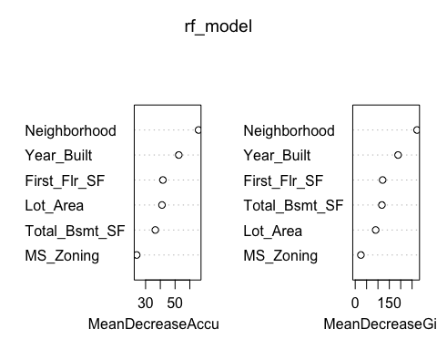

rf_preds <- predict(rf_model, newdata = test_data)  
  
confusionMatrix(rf_preds, test_data$Above_Median)

## Confusion Matrix and Statistics  
##   
## Reference  
## Prediction No Yes  
## No 183 25  
## Yes 19 183  
##   
## Accuracy : 0.8927   
## 95% CI : (0.8586, 0.9209)  
## No Information Rate : 0.5073   
## P-Value [Acc > NIR] : <2e-16   
##   
## Kappa : 0.7854   
##   
## Mcnemar's Test P-Value : 0.451   
##   
## Sensitivity : 0.9059   
## Specificity : 0.8798   
## Pos Pred Value : 0.8798   
## Neg Pred Value : 0.9059   
## Prevalence : 0.4927   
## Detection Rate : 0.4463   
## Detection Prevalence : 0.5073   
## Balanced Accuracy : 0.8929   
##   
## 'Positive' Class : No   
##

library(rpart)

##   
## Attaching package: 'rpart'

## The following object is masked from 'package:dials':  
##   
## prune

tree_model <- rpart(Above_Median ~ Lot_Area + Year_Built + Total_Bsmt_SF + First_Flr_SF + MS_Zoning + Neighborhood,   
 data = train_data,   
 method = "class")  
  
plot(tree_model)  
text(tree_model, pretty = 1)

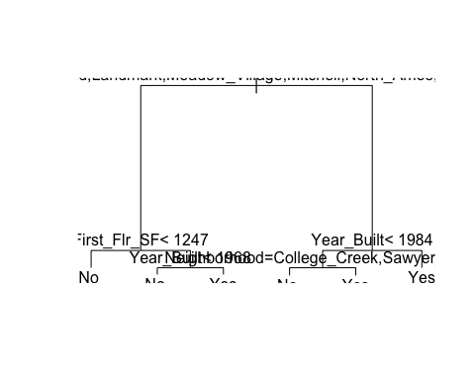

tree_preds <- predict(tree_model, newdata = test_data, type = "class")  
  
library(caret)  
confusionMatrix(tree_preds, test_data$Above_Median)

## Confusion Matrix and Statistics  
##   
## Reference  
## Prediction No Yes  
## No 179 32  
## Yes 23 176  
##   
## Accuracy : 0.8659   
## 95% CI : (0.829, 0.8973)  
## No Information Rate : 0.5073   
## P-Value [Acc > NIR] : <2e-16   
##   
## Kappa : 0.7318   
##   
## Mcnemar's Test P-Value : 0.2807   
##   
## Sensitivity : 0.8861   
## Specificity : 0.8462   
## Pos Pred Value : 0.8483   
## Neg Pred Value : 0.8844   
## Prevalence : 0.4927   
## Detection Rate : 0.4366   
## Detection Prevalence : 0.5146   
## Balanced Accuracy : 0.8661   
##   
## 'Positive' Class : No   
##

tree_accuracy <- mean(tree_preds == test_data$Above_Median)  
print(paste("Decision Tree Accuracy: ", tree_accuracy))

## [1] "Decision Tree Accuracy: 0.865853658536585"

rf_accuracy <- mean(rf_preds == test_data$Above_Median)  
  
logit_accuracy <- mean(logit_class == test_data$Above_Median)  
  
tree_accuracy <- mean(tree_preds == test_data$Above_Median)  
  
print(tibble(  
 Model = c("Random Forest", "Logistic Regression", "Decision Tree"),  
 Accuracy = c(rf_accuracy, logit_accuracy, tree_accuracy)  
))

## # A tibble: 3 × 2  
## Model Accuracy  
## <chr> <dbl>  
## 1 Random Forest 0.893  
## 2 Logistic Regression 0.873  
## 3 Decision Tree 0.866

results <- tibble(  
 Model = c("Random Forest", "Logistic Regression", "Decision Tree"),  
 Accuracy = c(0.9024390, 0.8731707, 0.8658537)  
)  
  
print(results)

## # A tibble: 3 × 2  
## Model Accuracy  
## <chr> <dbl>  
## 1 Random Forest 0.902  
## 2 Logistic Regression 0.873  
## 3 Decision Tree 0.866

varImpPlot(rf_model)



# Logistic Regression Training Accuracy  
logit_train_preds <- predict(logit_model, new_data = train_data, type = "prob")  
logit_train_class <- ifelse(logit_train_preds$.pred_Yes > 0.5, "Yes", "No")  
logit_train_accuracy <- mean(logit_train_class == train_data$Above_Median)  
print(paste("Logistic Regression Training Accuracy: ", logit_train_accuracy))

## [1] "Logistic Regression Training Accuracy: 0.873402312842362"

# Random Forest Training Accuracy  
rf_train_preds <- predict(rf_model, newdata = train_data)  
rf_train_accuracy <- mean(rf_train_preds == train_data$Above_Median)  
print(paste("Random Forest Training Accuracy: ", rf_train_accuracy))

## [1] "Random Forest Training Accuracy: 0.999391357273281"

# Decision Tree Training Accuracy  
tree_train_preds <- predict(tree_model, newdata = train_data, type = "class")  
tree_train_accuracy <- mean(tree_train_preds == train_data$Above_Median)  
print(paste("Decision Tree Training Accuracy: ", tree_train_accuracy))

## [1] "Decision Tree Training Accuracy: 0.87522824102252"

# Original Random Forest Model  
rf_model <- randomForest(Above_Median ~ Lot_Area + Year_Built + Total_Bsmt_SF + First_Flr_SF + MS_Zoning + Neighborhood,   
 data = train_data,   
 importance = TRUE)  
  
# Original training accuracy  
rf_train_preds <- predict(rf_model, newdata = train_data)  
rf_train_accuracy <- mean(rf_train_preds == train_data$Above_Median)  
print(paste("Original Random Forest Training Accuracy: ", rf_train_accuracy))

## [1] "Original Random Forest Training Accuracy: 1"

# Original test accuracy  
rf_test_preds <- predict(rf_model, newdata = test_data)  
rf_test_accuracy <- mean(rf_test_preds == test_data$Above_Median)  
print(paste("Original Random Forest Test Accuracy: ", rf_test_accuracy))

## [1] "Original Random Forest Test Accuracy: 0.897560975609756"

# Tuned Random Forest Model - Limiting Tree Depth  
rf_model_tuned <- randomForest(Above_Median ~ Lot_Area + Year_Built + Total_Bsmt_SF + First_Flr_SF + MS_Zoning + Neighborhood,   
 data = train_data,   
 importance = TRUE,   
 ntree = 500, # Number of trees  
 maxnodes = 30) # Limit tree depth  
  
# Tuned training accuracy  
rf_train_preds_tuned <- predict(rf_model_tuned, newdata = train_data)  
rf_train_accuracy_tuned <- mean(rf_train_preds_tuned == train_data$Above_Median)  
print(paste("Tuned Random Forest Training Accuracy: ", rf_train_accuracy_tuned))

## [1] "Tuned Random Forest Training Accuracy: 0.907486305538649"

# Tuned test accuracy  
rf_test_preds_tuned <- predict(rf_model_tuned, newdata = test_data)  
rf_test_accuracy_tuned <- mean(rf_test_preds_tuned == test_data$Above_Median)  
print(paste("Tuned Random Forest Test Accuracy: ", rf_test_accuracy_tuned))

## [1] "Tuned Random Forest Test Accuracy: 0.88780487804878"