<https://www.youtube.com/watch?v=jJYv-nfkMXk> – three tier architecture

<https://www.youtube.com/watch?v=KlHvRKSH4pk> – n-tier architecture

<https://www.youtube.com/watch?v=ccOzcjHQVos> – architecture patters

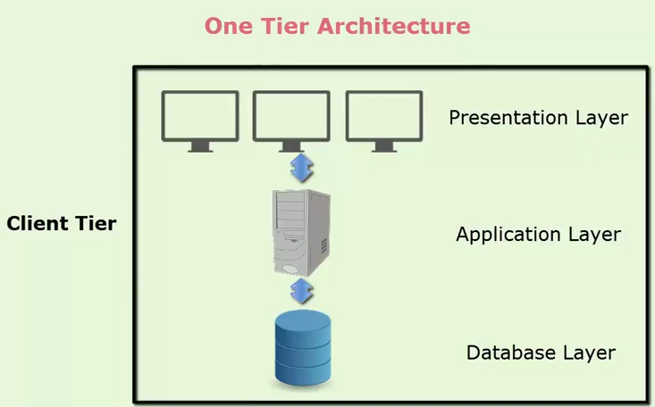

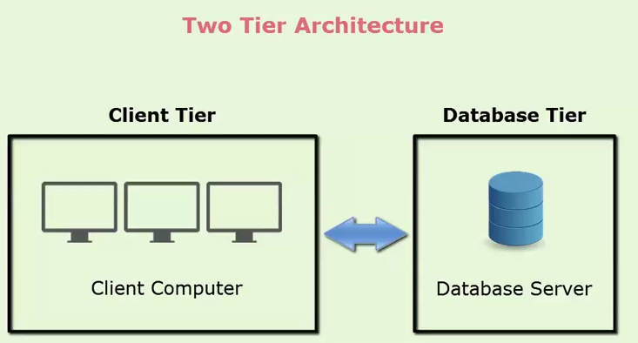

Web-based

