Implementing an OpenShift (OCP) Source to Image (S2I) Pipeline

April 10, 2020

Contents

Git Repository 4

Repository URL 4

PHP Source Code 4

Console Output 5

Create a Project 5

Create a New OCP Application 5

Check OCP Status 6

Check OCP Status with Suggest Switch 7

Check OCP Pods 8

Check OCP Pods Again 8

Check OCP Pods Once More 9

Get Service Name 9

Expose Service 9

Get the Route to the Application Pod 9

Use Curl to Access the Application 10

User Browser to Access Application 10

Start Another Build 11

Check Pods 11

Check Status 11

Check Status Again 12

Check Status Once More 13

Check Pods 14

Get the Service Name 14

Get Routes 14

Use Curl to Access Application 14

Start Another Build 15

Check Pods 15

Check Pods Again 16

Check Pods Once More 16

Check Pods Again 16

Check Pods Again 17

Use Curl to Access Application 17

Use Browser to Access Application 18

OCP Artifacts that are Created 18

Deployment Config 18

Config Maps 20

Replication Controllers 20

Services 21

Routes 22

Build Configs 22

Builds 23

Image Streams 23

Git Commands 24

# Git Repository

You should create a public Git repository and push your source code there.

## Repository URL

https://github.com/owencline/php-helloworld

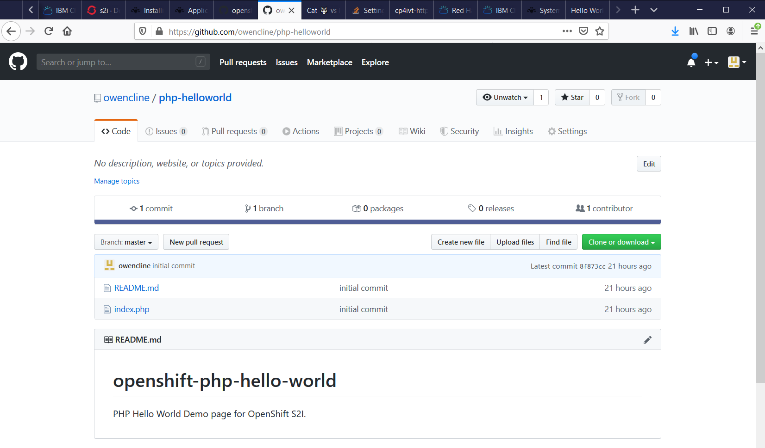

## PHP Source Code



# Console Output

You should go to a console and log into your OCP cluster.

## Create a Project

root@jumpserver01:~/dockerfile-create# oc project s2i

Now using project "s2i" on server "https://api.orc7.owencline.com:6443".

## Create a New OCP Application

root@jumpserver01:~/dockerfile-create# oc new-app --name php-helloworld https://github.com/owencline/php-helloworld.git

--> Found image 7216d5f (6 weeks old) in image stream "openshift/php" under tag "7.2" for "php"

Apache 2.4 with PHP 7.2

-----------------------

PHP 7.2 available as container is a base platform for building and running various PHP 7.2 applications and frameworks. PHP is an HTML-embedded scripting language. PHP attempts to make it easy for developers to write dynamically generated web pages. PHP also offers built-in database integration for several commercial and non-commercial database management systems, so writing a database-enabled webpage with PHP is fairly simple. The most common use of PHP coding is probably as a replacement for CGI scripts.

Tags: builder, php, php72, rh-php72

* The source repository appears to match: php

* A source build using source code from https://github.com/owencline/php-helloworld.git will be created

* The resulting image will be pushed to image stream tag "php-helloworld:latest"

* Use 'oc start-build' to trigger a new build

* This image will be deployed in deployment config "php-helloworld"

* Ports 8080/tcp, 8443/tcp will be load balanced by service "php-helloworld"

* Other containers can access this service through the hostname "php-helloworld"

--> Creating resources ...

imagestream.image.openshift.io "php-helloworld" created

buildconfig.build.openshift.io "php-helloworld" created

deploymentconfig.apps.openshift.io "php-helloworld" created

service "php-helloworld" created

--> Success

Build scheduled, use 'oc logs -f bc/php-helloworld' to track its progress.

Application is not exposed. You can expose services to the outside world by executing one or more of the commands below:

'oc expose svc/php-helloworld'

Run 'oc status' to view your app.

## Check OCP Status

root@jumpserver01:~/dockerfile-create# oc status

In project s2i on server https://api.orc7.owencline.com:6443

svc/php-helloworld - 172.30.74.79 ports 8080, 8443

dc/php-helloworld deploys istag/php-helloworld:latest <-

bc/php-helloworld source builds https://github.com/owencline/php-helloworld.git on openshift/php:7.2

build #1 pending for 6 seconds

deployment #1 waiting on image or update

2 infos identified, use 'oc status --suggest' to see details.

root@jumpserver01:~/dockerfile-create# oc status

In project s2i on server https://api.orc7.owencline.com:6443

svc/php-helloworld - 172.30.74.79 ports 8080, 8443

dc/php-helloworld deploys istag/php-helloworld:latest <-

bc/php-helloworld source builds https://github.com/owencline/php-helloworld.git on openshift/php:7.2

build #1 running for 14 seconds

deployment #1 waiting on image or update

2 infos identified, use 'oc status --suggest' to see details.

## Check OCP Status with Suggest Switch

root@jumpserver01:~/dockerfile-create# oc status --suggest

In project s2i on server https://api.orc7.owencline.com:6443

svc/php-helloworld - 172.30.74.79 ports 8080, 8443

dc/php-helloworld deploys istag/php-helloworld:latest <-

bc/php-helloworld source builds https://github.com/owencline/php-helloworld.git on openshift/php:7.2

build #1 running for 27 seconds - 8f873cc: initial commit (owencline <orcline@yahoo.com>)

deployment #1 waiting on image or update

Info:

* dc/php-helloworld has no readiness probe to verify pods are ready to accept traffic or ensure deployment is successful.

try: oc set probe dc/php-helloworld --readiness ...

* dc/php-helloworld has no liveness probe to verify pods are still running.

try: oc set probe dc/php-helloworld --liveness ...

View details with 'oc describe <resource>/<name>' or list everything with 'oc get all'.

## Check OCP Pods

The reason that we are checking the pods repeatedly is to verify that the application is being built successfully. The build is triggered automatically when the project was created above (see oc new-app).

root@jumpserver01:~/dockerfile-create# oc get pods

NAME READY STATUS RESTARTS AGE

php-helloworld-1-build 1/1 Running 0 50s

## Check OCP Pods Again

root@jumpserver01:~/dockerfile-create# oc get pods -w

NAME READY STATUS RESTARTS AGE

php-helloworld-1-247jq 0/1 ContainerCreating 0 7s

php-helloworld-1-build 0/1 Completed 0 87s

php-helloworld-1-deploy 1/1 Running 0 15s

NAME READY STATUS RESTARTS AGE

php-helloworld-1-247jq 0/1 ContainerCreating 0 8s

php-helloworld-1-247jq 1/1 Running 0 19s

php-helloworld-1-deploy 0/1 Completed 0 28s

php-helloworld-1-deploy 0/1 Completed 0 28s

## Check OCP Pods Once More

root@jumpserver01:~/dockerfile-create# oc get pods

NAME READY STATUS RESTARTS AGE

php-helloworld-1-247jq 1/1 Running 0 58s

php-helloworld-1-build 0/1 Completed 0 2m18s

php-helloworld-1-deploy 0/1 Completed 0 66s

## Get Service Name

From the list of pods above, we can see that the application is built and running (see php-helloworld-1-247jq). OCP should have created a service to act as a façade and load balancer to the pod running the application.

root@jumpserver01:~/dockerfile-create# oc get svc

NAME TYPE CLUSTER-IP EXTERNAL-IP PORT(S) AGE

php-helloworld ClusterIP 172.30.74.79 <none> 8080/TCP,8443/TCP 2m44s

## Expose Service

If you want to access the application from the internet, you have to expose its service. When you expose the service, a route is created.

root@jumpserver01:~/dockerfile-create# oc expose svc/php-helloworld

route.route.openshift.io/php-helloworld exposed

## Get the Route to the Application Pod

The host/port is the URL to access your application.

root@jumpserver01:~/dockerfile-create# oc get routes

NAME HOST/PORT PATH SERVICES PORT TERMINATION WILDCARD

php-helloworld php-helloworld-s2i.apps.orc7.owencline.com php-helloworld 8080-tcp None

## Use Curl to Access the Application

root@jumpserver01:~/dockerfile-create# curl php-helloworld-s2i.apps.orc7.owencline.com

<html>

<head>

<title>Hello World!</title>

</head>

<body>

Hello World!<h3>My hostname is php-helloworld-1-247jq<br /><br />

PHP_HELLOWORLD_SERVICE listening on port 8443/TCP available at 8443<br />PHP_HELLOWORLD_SERVICE listening on port 8080/TCP available at 8080<br />PHP_HELLOWORLD listening on port 8443/TCP available at tcp://172.30.74.79:8443<br />PHP_HELLOWORLD listening on port 8080/TCP available at tcp://172.30.74.79:8080<br />KUBERNETES listening on port 443/TCP available at tcp://172.30.0.1:443<br />

</body>

</html>

## User Browser to Access Application

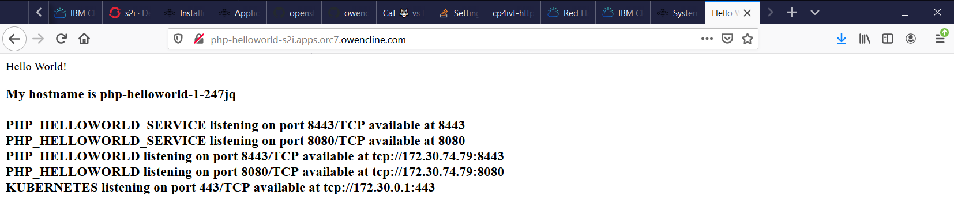

## Start Another Build

You can initiate new builds. For example, you can edit your source code and then, using Git, add, commit and push the changes from your local Git repository to the public Git repository. If you do make changes, you need to initiate another build.

root@jumpserver01:~/dockerfile-create# oc start-build php-helloworld

build.build.openshift.io/php-helloworld-2 started

## Check Pods

root@jumpserver01:~/dockerfile-create# oc get pods

NAME READY STATUS RESTARTS AGE

php-helloworld-1-247jq 1/1 Running 0 7m41s

php-helloworld-1-build 0/1 Completed 0 9m1s

php-helloworld-1-deploy 0/1 Completed 0 7m49s

php-helloworld-2-build 0/1 Init:0/2 0 7s

## Check Status

root@jumpserver01:~/dockerfile-create# oc status --suggest

In project s2i on server https://api.orc7.owencline.com:6443

http://php-helloworld-s2i.apps.orc7.owencline.com to pod port 8080-tcp (svc/php-helloworld)

dc/php-helloworld deploys istag/php-helloworld:latest <-

bc/php-helloworld source builds https://github.com/owencline/php-helloworld.git on openshift/php:7.2

deployment #2 deployed 19 hours ago - 1 pod

deployment #1 deployed 19 hours ago

Info:

* pod/php-helloworld-1-deploy has no liveness probe to verify pods are still running.

try: oc set probe pod/php-helloworld-1-deploy --liveness ...

* pod/php-helloworld-2-deploy has no liveness probe to verify pods are still running.

try: oc set probe pod/php-helloworld-2-deploy --liveness ...

* dc/php-helloworld has no readiness probe to verify pods are ready to accept traffic or ensure deployment is successful.

try: oc set probe dc/php-helloworld --readiness ...

* dc/php-helloworld has no liveness probe to verify pods are still running.

try: oc set probe dc/php-helloworld --liveness ...

View details with 'oc describe <resource>/<name>' or list everything with 'oc get all'.

## Check Status Again

root@jumpserver01:~/dockerfile-create# oc status

In project s2i on server https://api.orc7.owencline.com:6443

http://php-helloworld-s2i.apps.orc7.owencline.com to pod port 8080-tcp (svc/php-helloworld)

dc/php-helloworld deploys istag/php-helloworld:latest <-

bc/php-helloworld source builds https://github.com/owencline/php-helloworld.git on openshift/php:7.2

deployment #2 deployed 19 hours ago - 1 pod

deployment #1 deployed 19 hours ago

4 infos identified, use 'oc status --suggest' to see details.

## Check Status Once More

root@jumpserver01:~/dockerfile-create# oc status --suggest

In project s2i on server https://api.orc7.owencline.com:6443

http://php-helloworld-s2i.apps.orc7.owencline.com to pod port 8080-tcp (svc/php-helloworld)

dc/php-helloworld deploys istag/php-helloworld:latest <-

bc/php-helloworld source builds https://github.com/owencline/php-helloworld.git on openshift/php:7.2

deployment #2 deployed 19 hours ago - 1 pod

deployment #1 deployed 19 hours ago

Info:

* pod/php-helloworld-1-deploy has no liveness probe to verify pods are still running.

try: oc set probe pod/php-helloworld-1-deploy --liveness ...

* pod/php-helloworld-2-deploy has no liveness probe to verify pods are still running.

try: oc set probe pod/php-helloworld-2-deploy --liveness ...

* dc/php-helloworld has no readiness probe to verify pods are ready to accept traffic or ensure deployment is successful.

try: oc set probe dc/php-helloworld --readiness ...

* dc/php-helloworld has no liveness probe to verify pods are still running.

try: oc set probe dc/php-helloworld --liveness ...

View details with 'oc describe <resource>/<name>' or list everything with 'oc get all'.

## Check Pods

root@jumpserver01:~/dockerfile-create# oc get pods

NAME READY STATUS RESTARTS AGE

php-helloworld-1-build 0/1 Completed 0 18h

php-helloworld-1-deploy 0/1 Completed 0 18h

php-helloworld-2-7nktj 1/1 Running 0 18h

php-helloworld-2-build 0/1 Completed 0 18h

php-helloworld-2-deploy 0/1 Completed 0 18h

## Get the Service Name

root@jumpserver01:~/dockerfile-create# oc get svc

NAME TYPE CLUSTER-IP EXTERNAL-IP PORT(S) AGE

php-helloworld ClusterIP 172.30.74.79 <none> 8080/TCP,8443/TCP 19h

root@jumpserver01:~/dockerfile-create# oc expose svc/php-helloworld

Error from server (AlreadyExists): routes.route.openshift.io "php-helloworld" already exists

## Get Routes

root@jumpserver01:~/dockerfile-create# oc get routes

NAME HOST/PORT PATH SERVICES PORT TERMINATION WILDCARD

php-helloworld php-helloworld-s2i.apps.orc7.owencline.com php-helloworld 8080-tcp None

## Use Curl to Access Application

root@jumpserver01:~/dockerfile-create# curl php-helloworld-s2i.apps.orc7.owencline.com

<html>

<head>

<title>Hello World! This is Owen's PHP app.</title>

</head>

<body>

Hello World!<h3>My hostname is php-helloworld-2-7nktj<br /><br />

PHP_HELLOWORLD_SERVICE listening on port 8443/TCP available at 8443<br />PHP_HELLOWORLD_SERVICE listening on port 8080/TCP available at 8080<br />PHP_HELLOWORLD listening on port 8443/TCP available at tcp://172.30.74.79:8443<br />PHP_HELLOWORLD listening on port 8080/TCP available at tcp://172.30.74.79:8080<br />KUBERNETES listening on port 443/TCP available at tcp://172.30.0.1:443<br />

</body>

</html>

## Start Another Build

root@jumpserver01:~/dockerfile-create# oc start-build php-helloworld

build.build.openshift.io/php-helloworld-3 started

## Check Pods

root@jumpserver01:~/dockerfile-create# oc get pods

NAME READY STATUS RESTARTS AGE

php-helloworld-1-build 0/1 Completed 0 19h

php-helloworld-1-deploy 0/1 Completed 0 19h

php-helloworld-2-7nktj 1/1 Running 0 18h

php-helloworld-2-build 0/1 Completed 0 18h

php-helloworld-2-deploy 0/1 Completed 0 18h

php-helloworld-3-build 1/1 Running 0 17s

## Check Pods Again

root@jumpserver01:~/dockerfile-create# oc get pods

NAME READY STATUS RESTARTS AGE

php-helloworld-1-build 0/1 Completed 0 19h

php-helloworld-1-deploy 0/1 Completed 0 19h

php-helloworld-2-7nktj 1/1 Running 0 18h

php-helloworld-2-build 0/1 Completed 0 18h

php-helloworld-2-deploy 0/1 Completed 0 18h

php-helloworld-3-build 1/1 Running 0 34s

## Check Pods Once More

root@jumpserver01:~/dockerfile-create# oc get pods

NAME READY STATUS RESTARTS AGE

php-helloworld-1-build 0/1 Completed 0 19h

php-helloworld-1-deploy 0/1 Completed 0 19h

php-helloworld-2-7nktj 1/1 Running 0 18h

php-helloworld-2-build 0/1 Completed 0 18h

php-helloworld-2-deploy 0/1 Completed 0 18h

php-helloworld-3-build 1/1 Running 0 43s

## Check Pods Again

root@jumpserver01:~/dockerfile-create# oc get pods

NAME READY STATUS RESTARTS AGE

php-helloworld-1-build 0/1 Completed 0 19h

php-helloworld-1-deploy 0/1 Completed 0 19h

php-helloworld-2-7nktj 1/1 Running 0 18h

php-helloworld-2-build 0/1 Completed 0 18h

php-helloworld-2-deploy 0/1 Completed 0 18h

php-helloworld-3-build 1/1 Running 0 46s

## Check Pods Again

root@jumpserver01:~/dockerfile-create# oc get pods

NAME READY STATUS RESTARTS AGE

php-helloworld-1-build 0/1 Completed 0 19h

php-helloworld-1-deploy 0/1 Completed 0 19h

php-helloworld-2-build 0/1 Completed 0 19h

php-helloworld-2-deploy 0/1 Completed 0 19h

php-helloworld-3-build 0/1 Completed 0 5m43s

php-helloworld-3-deploy 0/1 Completed 0 4m54s

php-helloworld-3-dns56 1/1 Running 0 4m46s

## Use Curl to Access Application

root@jumpserver01:~/dockerfile-create# curl php-helloworld-s2i.apps.orc7.owencline.com

<html>

<head>

<title>Hello World! This is Owen's PHP app.</title>

</head>

<body>

Hello World!<h3>My hostname is php-helloworld-3-dns56<br /><br />

PHP_HELLOWORLD_SERVICE listening on port 8443/TCP available at 8443<br />PHP_HELLOWORLD_SERVICE listening on port 8080/TCP available at 8080<br />PHP_HELLOWORLD listening on port 8443/TCP available at tcp://172.30.74.79:8443<br />PHP_HELLOWORLD listening on port 8080/TCP available at tcp://172.30.74.79:8080<br />KUBERNETES listening on port 443/TCP available at tcp://172.30.0.1:443<br />

</body>

</html>

## Use Browser to Access Application

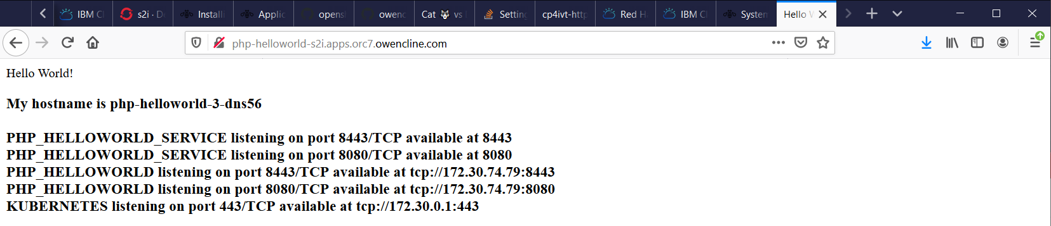

# OCP Artifacts that are Created

## Deployment Config

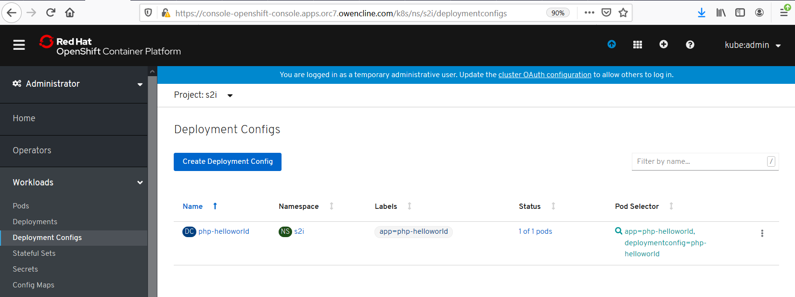



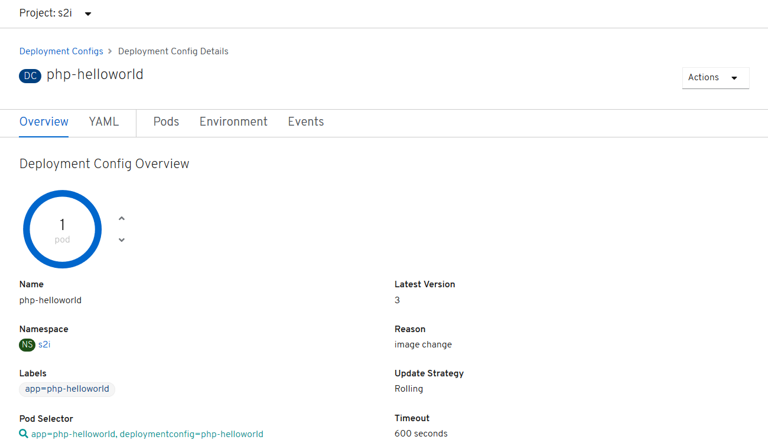

## Config Maps

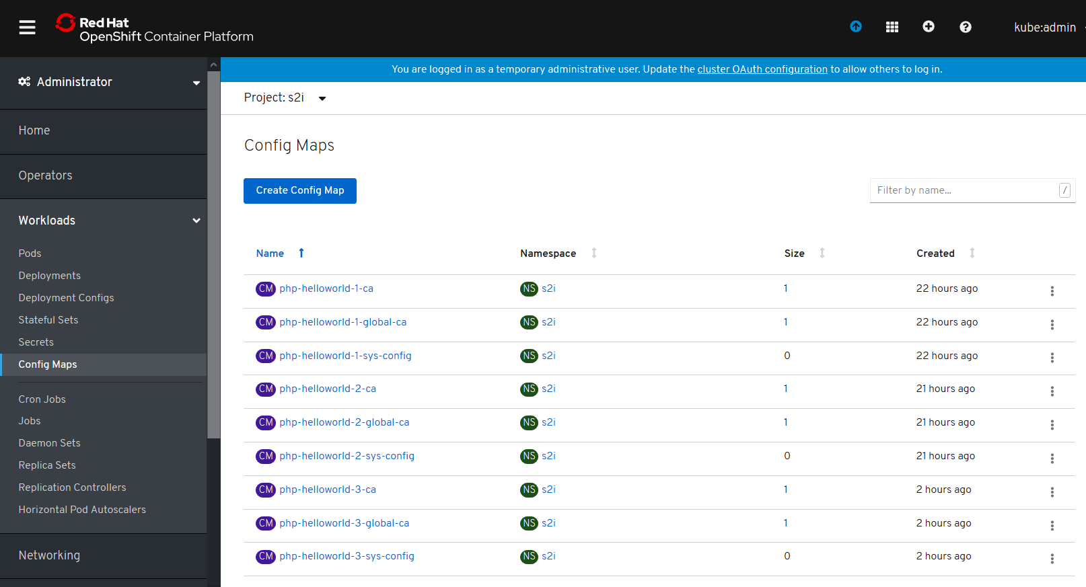

Config Map YAML Files for the third build of php-helloworld:







## Replication Controllers

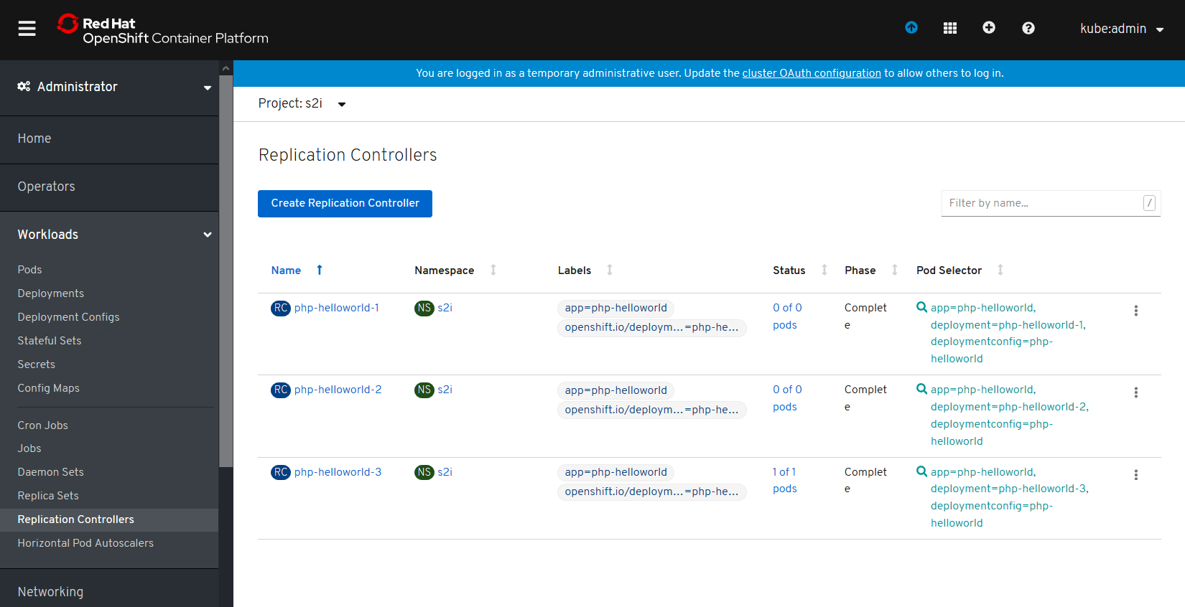



## Services

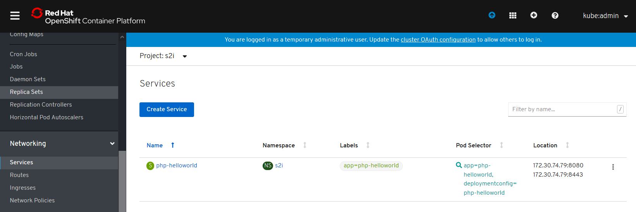



## Routes

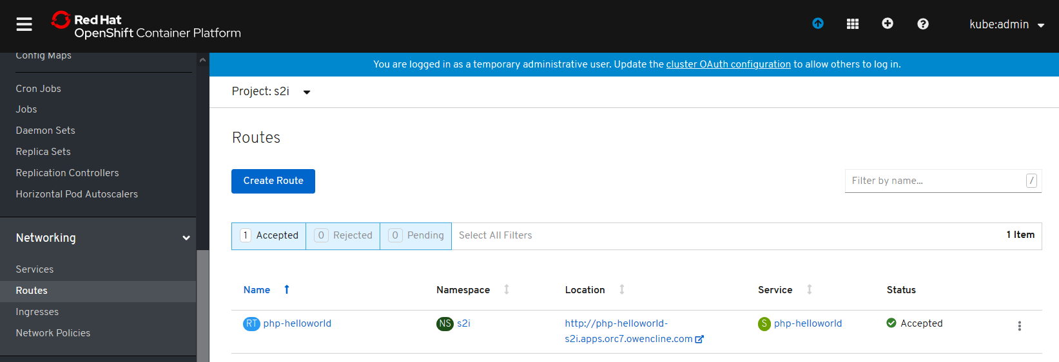



## Build Configs

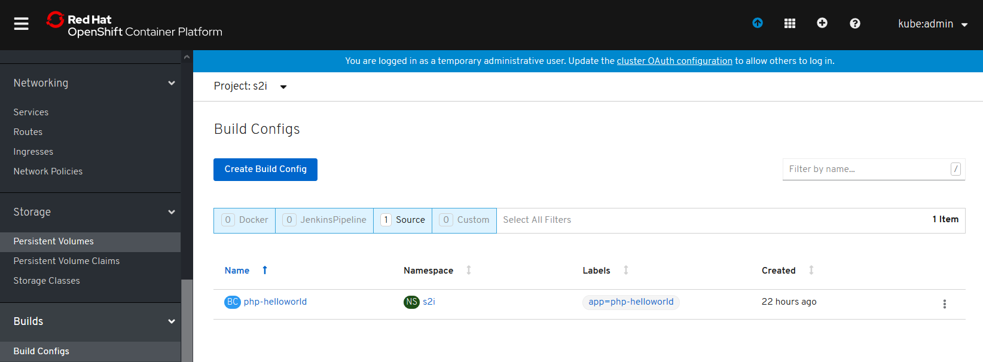



## Builds

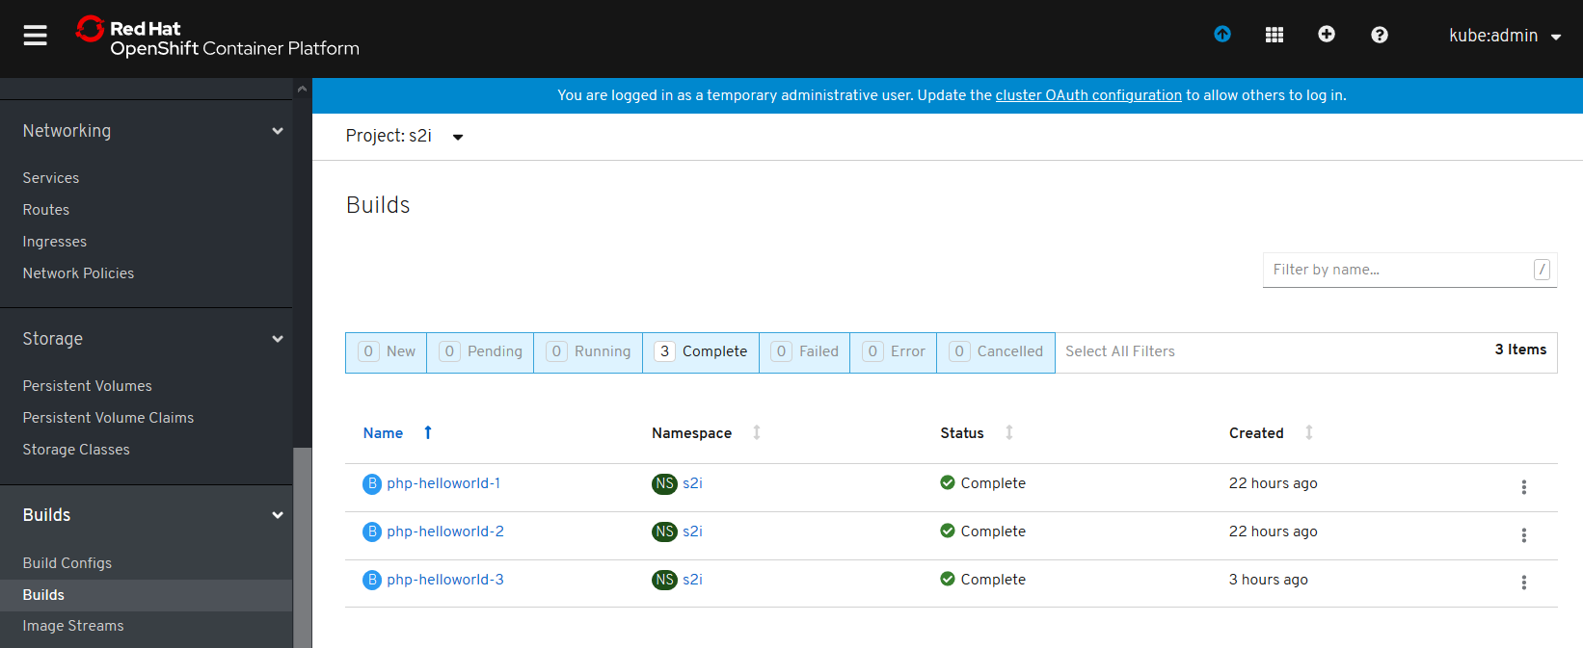



## Image Streams

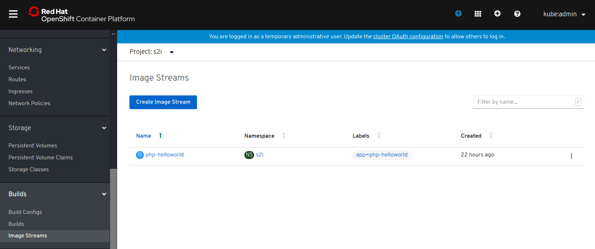



# Git Commands

This source code was unzipped into a Windows 10 directory ( C:\Users\OwenCline\Documents\GitHub\php-helloworld ).



All of these commands were entered in a Power Shell command line window on a Windows 10 node.

AzureAD+OwenCline@LAPTOP-J6S7UK2B MINGW64 ~/Documents/GitHub/php-helloworld

$ pwd

/c/Users/OwenCline/Documents/GitHub/php-helloworld

AzureAD+OwenCline@LAPTOP-J6S7UK2B MINGW64 ~/Documents/GitHub/php-helloworld

$ ls

index.php README.md

AzureAD+OwenCline@LAPTOP-J6S7UK2B MINGW64 ~/Documents/GitHub/php-helloworld

$ git init

Initialized empty Git repository in C:/Users/OwenCline/Documents/GitHub/php-helloworld/.git/

AzureAD+OwenCline@LAPTOP-J6S7UK2B MINGW64 ~/Documents/GitHub/php-helloworld (master)

$ git commit -am "initial version"

On branch master

Initial commit

Untracked files:

README.md

index.php

nothing added to commit but untracked files present

AzureAD+OwenCline@LAPTOP-J6S7UK2B MINGW64 ~/Documents/GitHub/php-helloworld (master)

$ git add *

warning: LF will be replaced by CRLF in README.md.

The file will have its original line endings in your working directory

warning: LF will be replaced by CRLF in index.php.

The file will have its original line endings in your working directory

AzureAD+OwenCline@LAPTOP-J6S7UK2B MINGW64 ~/Documents/GitHub/php-helloworld (master)

$ git status

On branch master

No commits yet

Changes to be committed:

(use "git rm --cached <file>..." to unstage)

new file: README.md

new file: index.php

AzureAD+OwenCline@LAPTOP-J6S7UK2B MINGW64 ~/Documents/GitHub/php-helloworld (master)

$ git commit -m "initial commit"

[master (root-commit) 8f873cc] initial commit

2 files changed, 36 insertions(+)

create mode 100644 README.md

create mode 100644 index.php

AzureAD+OwenCline@LAPTOP-J6S7UK2B MINGW64 ~/Documents/GitHub/php-helloworld (master)

$ git status

On branch master

nothing to commit, working tree clean

AzureAD+OwenCline@LAPTOP-J6S7UK2B MINGW64 ~/Documents/GitHub/php-helloworld (master)

$ git push

fatal: No configured push destination.

Either specify the URL from the command-line or configure a remote repository using

git remote add <name> <url>

and then push using the remote name

git push <name>

AzureAD+OwenCline@LAPTOP-J6S7UK2B MINGW64 ~/Documents/GitHub/php-helloworld (master)

$ pwd

/c/Users/OwenCline/Documents/GitHub/php-helloworld

AzureAD+OwenCline@LAPTOP-J6S7UK2B MINGW64 ~/Documents/GitHub/php-helloworld (master)

$ git remote add origin https://github.com/owencline/php-helloworld.git

AzureAD+OwenCline@LAPTOP-J6S7UK2B MINGW64 ~/Documents/GitHub/php-helloworld (master)

$ git push -u origin master

Enumerating objects: 4, done.

Counting objects: 100% (4/4), done.

Delta compression using up to 12 threads

Compressing objects: 100% (4/4), done.

Writing objects: 100% (4/4), 675 bytes | 675.00 KiB/s, done.

Total 4 (delta 0), reused 0 (delta 0)

To https://github.com/owencline/php-helloworld.git

* [new branch] master -> master

Branch 'master' set up to track remote branch 'master' from 'origin'.

AzureAD+OwenCline@LAPTOP-J6S7UK2B MINGW64 ~/Documents/GitHub/php-helloworld (master)

$ ^C

AzureAD+OwenCline@LAPTOP-J6S7UK2B MINGW64 ~/Documents/GitHub/php-helloworld (master)

$ ^C

AzureAD+OwenCline@LAPTOP-J6S7UK2B MINGW64 ~/Documents/GitHub/php-helloworld (master)

$ ls

index.php README.md

AzureAD+OwenCline@LAPTOP-J6S7UK2B MINGW64 ~/Documents/GitHub/php-helloworld (master)

$ git status

On branch master

Your branch is up to date with 'origin/master'.

Changes not staged for commit:

(use "git add <file>..." to update what will be committed)

(use "git restore <file>..." to discard changes in working directory)

modified: index.php

no changes added to commit (use "git add" and/or "git commit -a")

AzureAD+OwenCline@LAPTOP-J6S7UK2B MINGW64 ~/Documents/GitHub/php-helloworld (master)

$ got commit -am "changed line"

bash: got: command not found

AzureAD+OwenCline@LAPTOP-J6S7UK2B MINGW64 ~/Documents/GitHub/php-helloworld (master)

$ git commit -am "changed line"

warning: LF will be replaced by CRLF in index.php.

The file will have its original line endings in your working directory

[master f15f40d] changed line

1 file changed, 1 insertion(+), 1 deletion(-)

AzureAD+OwenCline@LAPTOP-J6S7UK2B MINGW64 ~/Documents/GitHub/php-helloworld (master)

$ git status

On branch master

Your branch is ahead of 'origin/master' by 1 commit.

(use "git push" to publish your local commits)

nothing to commit, working tree clean

AzureAD+OwenCline@LAPTOP-J6S7UK2B MINGW64 ~/Documents/GitHub/php-helloworld (master)

$ git push

Enumerating objects: 5, done.

Counting objects: 100% (5/5), done.

Delta compression using up to 12 threads

Compressing objects: 100% (3/3), done.

Writing objects: 100% (3/3), 325 bytes | 325.00 KiB/s, done.

Total 3 (delta 1), reused 0 (delta 0)

remote: Resolving deltas: 100% (1/1), completed with 1 local object.

To https://github.com/owencline/php-helloworld.git

8f873cc..f15f40d master -> master

AzureAD+OwenCline@LAPTOP-J6S7UK2B MINGW64 ~/Documents/GitHub/php-helloworld (master)

$

AzureAD+OwenCline@LAPTOP-J6S7UK2B MINGW64 ~/Documents/GitHub/php-helloworld (master)

$ ls

index.php README.md

AzureAD+OwenCline@LAPTOP-J6S7UK2B MINGW64 ~/Documents/GitHub/php-helloworld (master)

$ ls

'Implementing an OpenShift (OCP) Source to Image (S2I) Pipeline.docx' index.php README.md

AzureAD+OwenCline@LAPTOP-J6S7UK2B MINGW64 ~/Documents/GitHub/php-helloworld (master)

$ ls

Implementing_an_OpenShift_Source_to_Image_Pipeline.docx index.php README.md

AzureAD+OwenCline@LAPTOP-J6S7UK2B MINGW64 ~/Documents/GitHub/php-helloworld (master)

$ git status

On branch master

Your branch is up to date with 'origin/master'.

Untracked files:

(use "git add <file>..." to include in what will be committed)

Implementing_an_OpenShift_Source_to_Image_Pipeline.docx

nothing added to commit but untracked files present (use "git add" to track)

AzureAD+OwenCline@LAPTOP-J6S7UK2B MINGW64 ~/Documents/GitHub/php-helloworld (master)

$ git commit -am "add documentation"

On branch master

Your branch is up to date with 'origin/master'.

Untracked files:

Implementing_an_OpenShift_Source_to_Image_Pipeline.docx

nothing added to commit but untracked files present

AzureAD+OwenCline@LAPTOP-J6S7UK2B MINGW64 ~/Documents/GitHub/php-helloworld (master)

$ git commit * -am "add documentation"

fatal: paths 'Implementing_an_OpenShift_Source_to_Image_Pipeline.docx ...' with -a does not make sense

AzureAD+OwenCline@LAPTOP-J6S7UK2B MINGW64 ~/Documents/GitHub/php-helloworld (master)

$ git add Implementing_an_OpenShift_Source_to_Image_Pipeline.docx

AzureAD+OwenCline@LAPTOP-J6S7UK2B MINGW64 ~/Documents/GitHub/php-helloworld (master)

$ git commit -m "add document"

[master 0fe35c0] add document

1 file changed, 0 insertions(+), 0 deletions(-)

create mode 100644 Implementing_an_OpenShift_Source_to_Image_Pipeline.docx

AzureAD+OwenCline@LAPTOP-J6S7UK2B MINGW64 ~/Documents/GitHub/php-helloworld (master)

$ git status

On branch master

Your branch is ahead of 'origin/master' by 1 commit.

(use "git push" to publish your local commits)

nothing to commit, working tree clean

AzureAD+OwenCline@LAPTOP-J6S7UK2B MINGW64 ~/Documents/GitHub/php-helloworld (master)

$ git push

Enumerating objects: 4, done.

Counting objects: 100% (4/4), done.

Delta compression using up to 12 threads

Compressing objects: 100% (3/3), done.

Writing objects: 100% (3/3), 1.12 MiB | 1000.00 KiB/s, done.

Total 3 (delta 0), reused 0 (delta 0)

To https://github.com/owencline/php-helloworld.git

f15f40d..0fe35c0 master -> master

AzureAD+OwenCline@LAPTOP-J6S7UK2B MINGW64 ~/Documents/GitHub/php-helloworld (master)

$