Owen Compher

Kris Rafferty

ENC 2135

October 28, 2022

Automation and Income Inequality: Artifacts

*The Triple Revolution* (<https://www.marxists.org/history/etol/newspape/isr/vol25/no03/adhoc.html>)was a document published in the summer of 1964 and is an early, influential examination of automation and its effect on the economy and society. The document was an open letter to the president, meant to raise awareness of the “cybernation revolution” and to call for discourse and specific policies addressing the issue. It was widely published and very controversial, as well as highly effective for a couple reasons.

The document was signed by the Ad Hoc Committee, which was made up of 35 economists, professors, and social activists. The group of signatories, which included multiple Nobel Prize winners, gave the document a strong ethos.

As an open letter, the document needed to reach a wide audience, especially activists. It did this by listing the cybernation revolution, which was the main topic, alongside the “weaponry revolution” (the proliferation of nuclear weapons and the doctrine of mutually assured destruction) and the civil rights movement. One could argue that this strategy was successful: in his final sermon in 1968, Martin Luther King Jr referenced the “triple revolution” and drew further attention to the cause.

[The Rise of the Machines – Why Automation is Different this Time](https://youtu.be/WSKi8HfcxEk)

[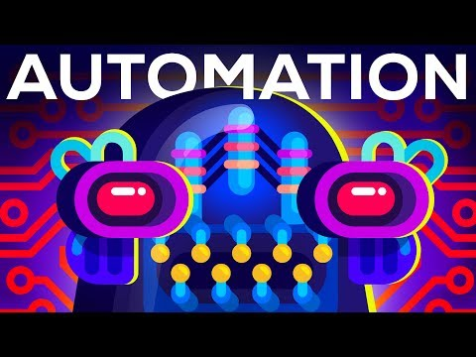](https://youtu.be/WSKi8HfcxEk)

*The Rise of the Machines – Why Automation is Different this Time* is a YouTube video posted by the education channel *Kurzgesagt* in June 2017. *Kurzgesagt* makes animated videos focusing on science, philosophy, and other topics. The true purpose of *Kurzgesagt’s* videos - including this one - can be debated (whether they want solely to inform, or also make money by monetizing their videos); their audience is anyone who is interested in the topic. Many elements of the video are designed to expand this audience, by making the viewing experience more pleasant or accessible to more people. Each video is narrated by Steve Taylor, who has a calm, soothing voice. The colorful, simple graphics can appeal to anyone, and generate interest and better engagement among a YouTube audience with short attention spans.