CH1
Permutations (123 ≠ 132), Combinations (123 = 132)
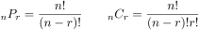
A or B occurs is:
→ If A and B are mutually exclusive (no overlap) than
A or B or C:
2 Events A and B are independent if:
Probability of B given that A has occurred: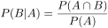
Law of Total Probability

