Assignment 1 – 300359036 – Owen Daigle

Question 1

Activity Diagram
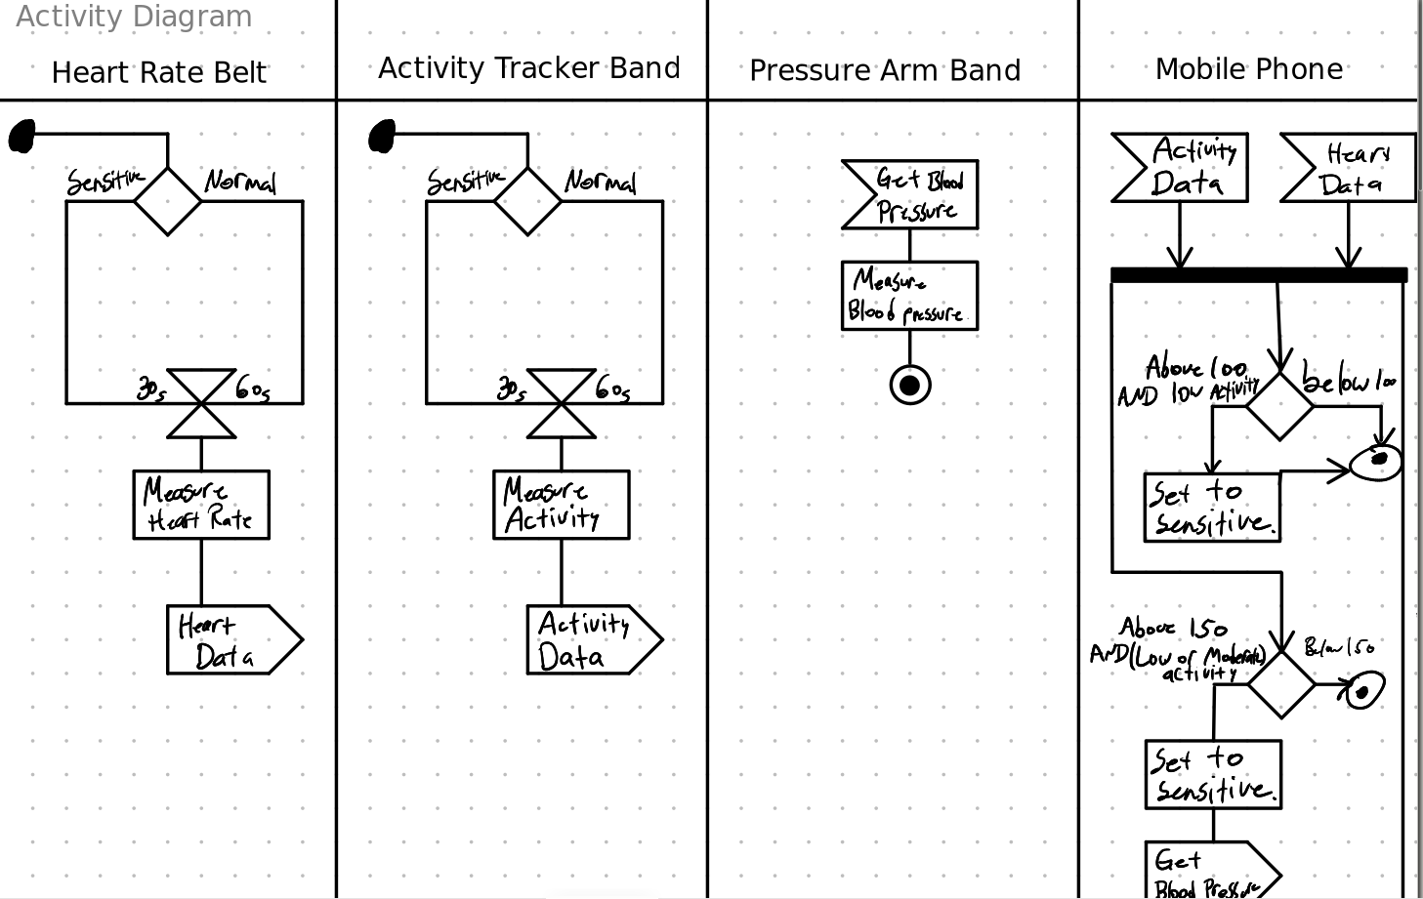
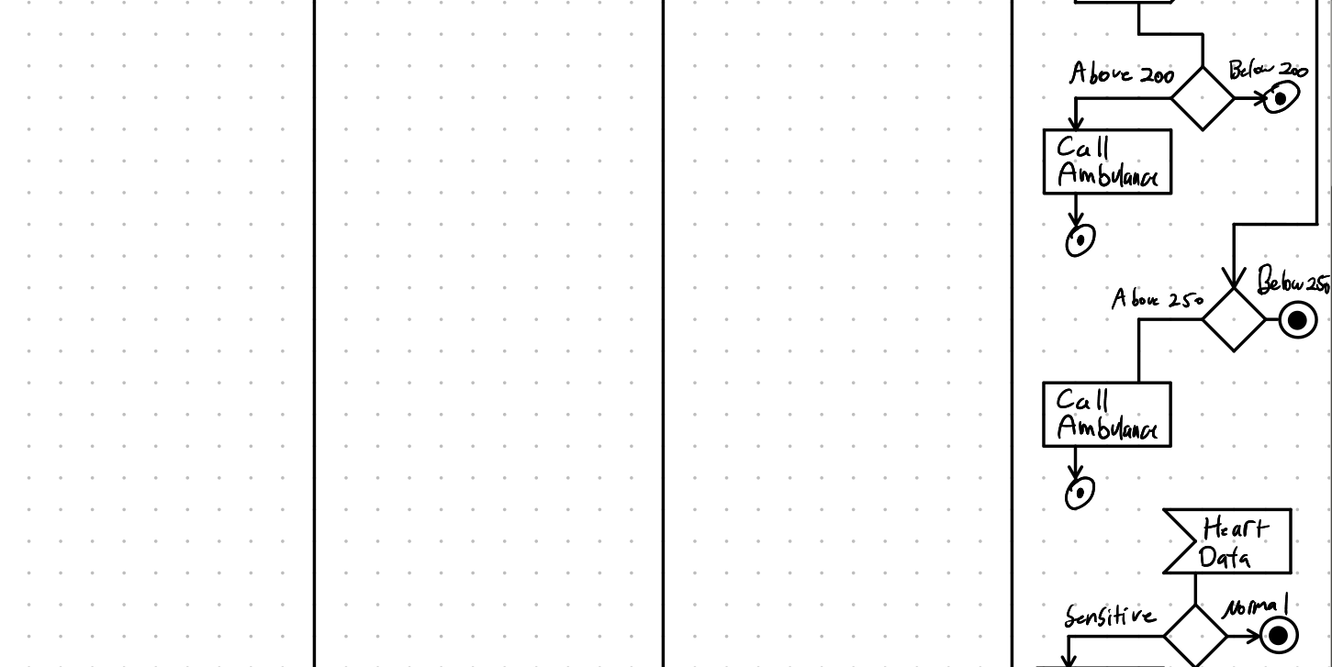
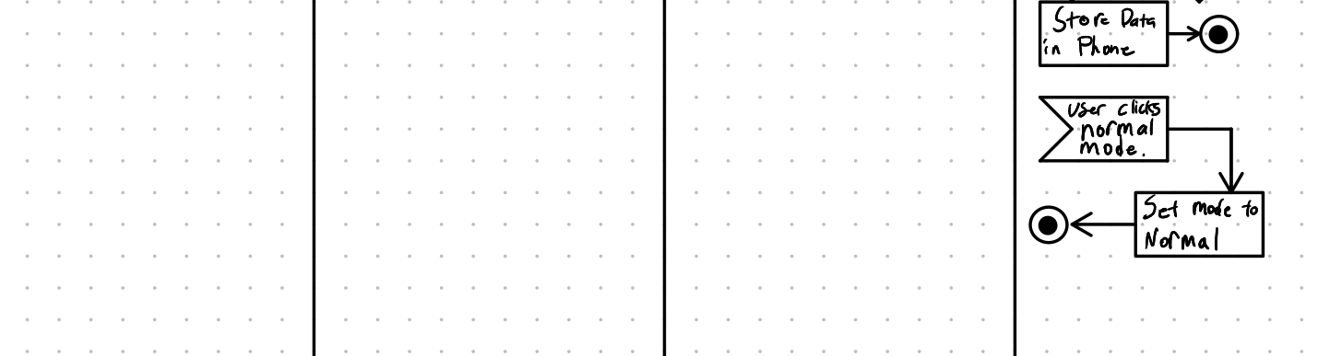

State Machine
This is for the heart rate sensor.
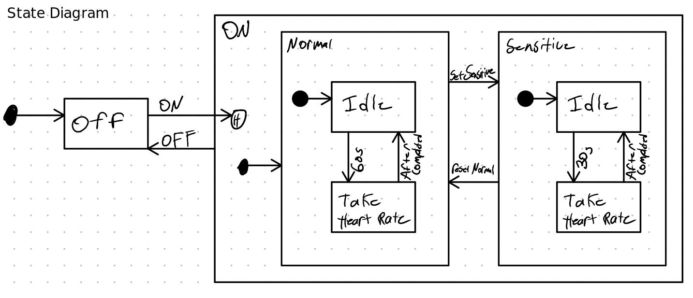

Question 2
Are these petri nets alive and or bounded?
Recall that alive means the petri net will always be able to do something (it will not die in a specific state)
Bounded means the petri net will not end up with an infinite number of tokens in any place.

1 NOT ALIVE, BOUNDED
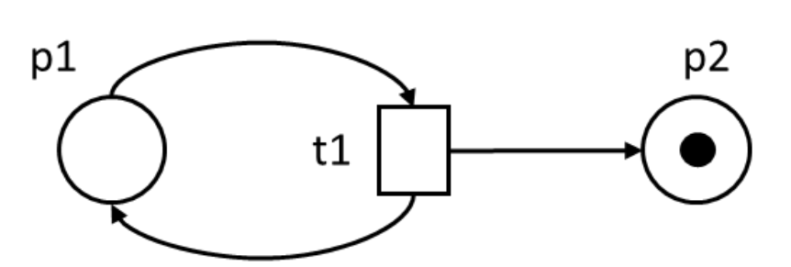
This one is not alive, and bounded.
In this start state, there is no way to perform any transitions. So it starts off being deadlocked.
Since it cannot do anything, even from the start, the number of tokens cannot increase at all since there are no transitions.

2 ALIVE, UNBOUNDED
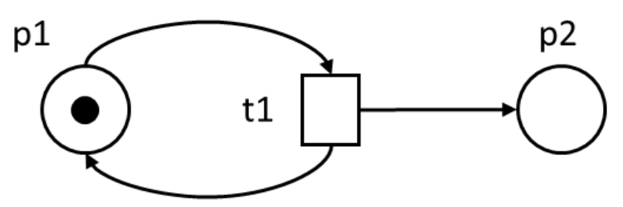
This petri net is unbounded and alive.
It is alive since if t1 is taken, it generates 2 new tokens, one in p2 (with no limit on number of tokens) and one in p1. The p1 can take t1 again.
It is unbounded since each time t1 is taken, a token is generated in p1 as well as p2. The p1 can be used up, but the p2 one can never be used. So if we do t1 n times, we will have n tokens in p2.

3 ALIVE, BOUNDED
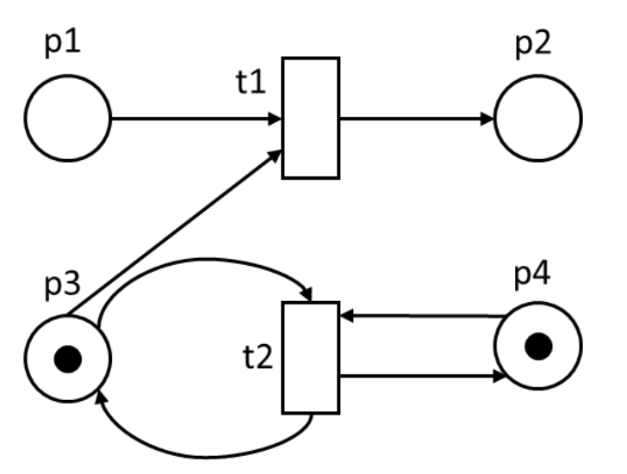
There is no way for any tokens to get into p2 or p1 so we can ignore those as well as t2 (since t2 is unreachable).
T2 takes 2 tokens to activate, so each time t2 is taken, it consumes a token in p4 and p3, and then generates a token in p4 and p3. So each iteration of t2 2 tokens are consumed and 2 tokens are produced which allows t2 to trigger again.
It is bounded, and alive.

4 NOT ALIVE, BOUNDED
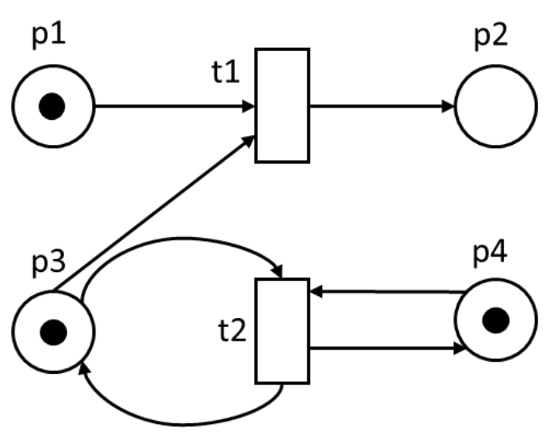
Same as the last one, this one is also bounded. Each transition generates the same number or less tokens than it requires.
This one is however not alive. This is because if we trigger t1, then there is a token in p2, and p4. Now t1 cannot trigger since no tokens in p1 or p3, and t2 cannot trigger since no tokens in p3.

5 ALIVE, BOUNDED
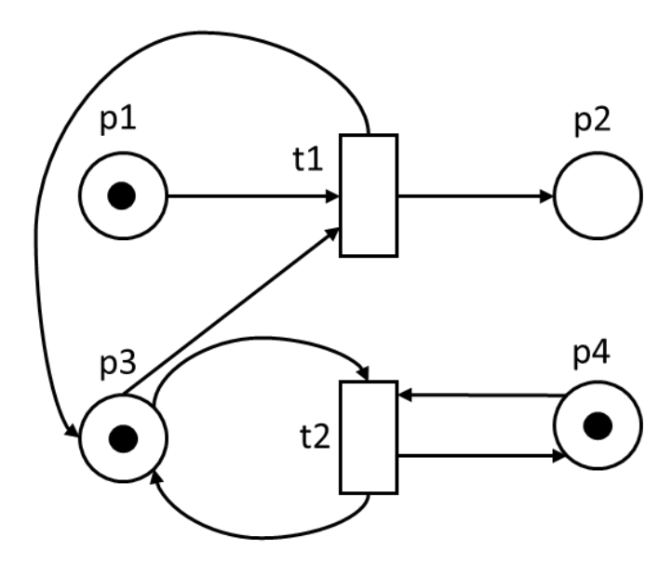
We see that t1 can only ever trigger once.
Again, each transition takes in 2 tokens and generates 2 as well, so it is bounded.
This is also alive since if we do t1, a token appears in p3, and p2. Then t1 can never go again since no token in p1. t2 can go though, and it will use tokens in p4 and p3, and then generate in p3 and p4. It can do this forever.
So it is bounded and alive.

6 ALIVE, BOUNDED
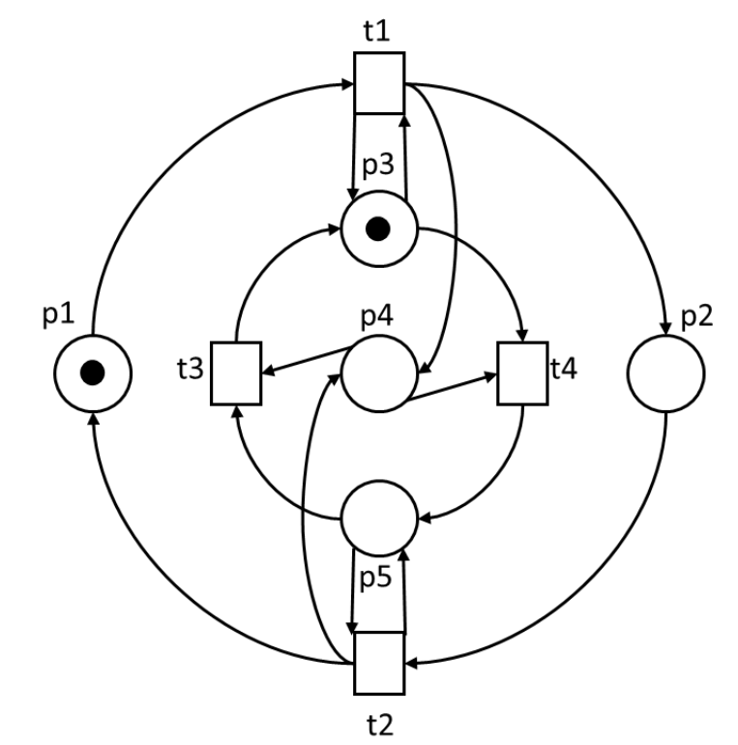
This one is bounded and alive. There is actually only one path that we can follow and we will end up back at the current state.
Start by t1, we cannot do any other transitions. We get tokens in p3, p2, p4.
Then we do t4 since t3 is missing p5, t1 missing p1, and t2 missing p5. We get tokens in p5 and p2 as well.
Next, we can only do t2 which gives tokens in p1, p5, and p4. Again this was the only option.
Finally, with tokens in p1, p4, p5, the only open transition is t3 giving tokens in p1 and p3, right back where we started.
Throughout this whole process, we started with 2 tokens, and ended with 2 tokens. We also only ever had one option to take, and it did not result in any deadlocks.
So it is alive and bounded.

7 NOT ALIVE, BOUNDED
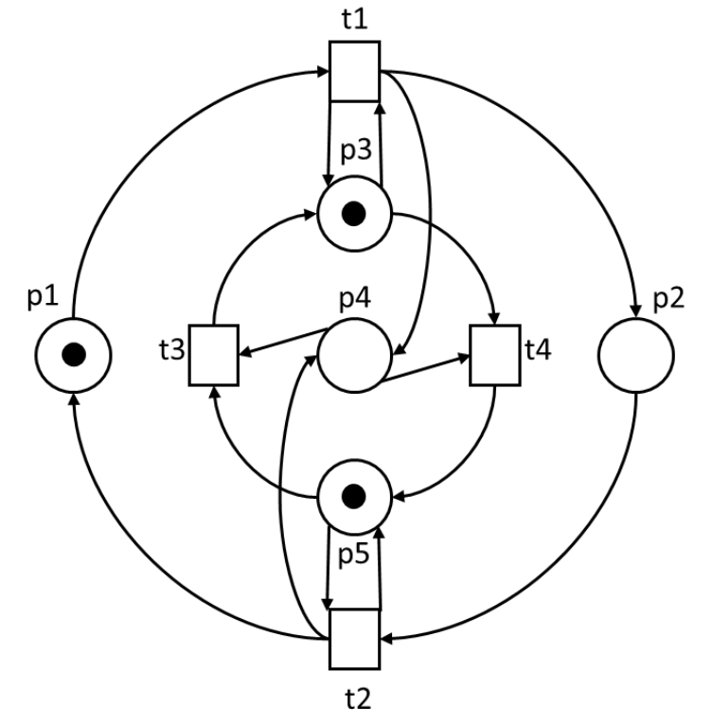
This one is unbounded since if we do t1, we end up with a token in p3, p4, p2, and p5. Then we take t2, and go back to the original state except we have two tokens in p4.
We can then repeat t1, then t2 to get 4 tokens in p4. We can repeat t1 then t2 n times to get 2n tokens in p4.
This one is also not alive since if we do t1, followed by t3, we end up with a token in p2, and 2 tokens in p3. Then we cannot do t1 since p1 has no tokens. t2 cannot happen since we are missing p5. t3 cannot happen since we are missing p4 and p5, and t4 cannot happen since we are missing p4. The system is then deadlocked, so it cannot be alive.

