JD Dog Care
User Guide

Table of Contents
Introduction 2
Hardware and Software Requirements 2
Minimum Hardware Requirements 2
Recommended Hardware Requirements 2
Software Requirements 2
Instructions 3
Database Connection 3
Navigation 4
Menu Strip – Different Services 4
Buttons – Main Menu 5
Buttons – Training Menu 6
Creating a New Booking 7
Accessing the Bookings Form 7
Creating a New Booking 8
Viewing Bookings 9
Accessing the View/Edit/Delete Bookings Form 9
Editing A Booking 11
Accessing the View/Edit/Delete Bookings Form 11
Editing a Booking 12
Deleting A Booking 13
Accessing the View/Edit/Delete Bookings Form 13
Deleting/Archiving a Booking 14
Adding a New Dog 15
Accessing the Add/Edit/Delete Form 15
Adding a New Dog 17
Editing a Dog 18
Accessing the Add/Edit/Delete Form 18
Editing a Dog 20
Archiving a Dog 21
Generating Printable Reports 22
Viewing and Printing the Report 23

Introduction
This system has been developed for JD Dog Care staff to have an easy and reliable system for creating and logging bookings, this user guide will cover each aspect of the Training subsystem specifically. Screenshots accompanied by instructions are included for each of the different menus the user will encounter while using the system. Some features that are covered in this guide are Adding, Editing and Deleting bookings along with using the report facility.

Hardware and Software Requirements

Minimum Hardware Requirements
Processor: 1.5GHz Intel Core i3
Memory: 2GB RAM
Storage: 100GB Available Space
Graphics: Direct X9 with WDDM 1.0 Driver

Recommended Hardware Requirements
Processor: 2GHz Intel Dual Core i5
Memory: 4GB RAM
Storage: 500GB Available Space
Graphics: Direct X9 with WDDM 1.0 Driver

Software Requirements
Operating System: Windows 10
IDE: Visual Studio 2015 or newer
SQL Sever 2016

Instructions

Database Connection
Before the system is used, the database must be connected. To ensure that the database is connected open Visual Studio and navigate to the “Server Explorer” on the left side of the screen. Here you should be able to see the following:
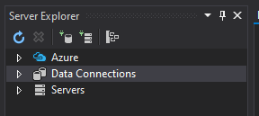
Click the arrow beside “Data Connections” and you will see the file “Database.mdf” appear underneath. If there is a Green symbol next to the file you do not need to do anything, but if there is a red ‘x’ beside it you need to right click on ‘Database.mdf’ and then click refresh.
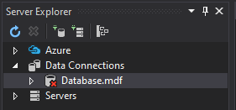
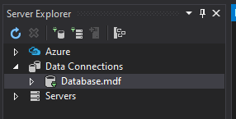
Green symbol shown beside Database.mdf
Red ‘X’ shown beside Database.mdf

Navigation

Menu Strip – Different Services
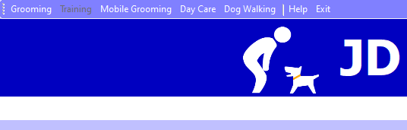
Clicking on any of the services will result in a Message Box saying, “This subsystem has not yet been implemented.” as this subsystem only focuses on the Training service. The Training section is disabled as at this stage the Training subsystem is already open.

Buttons – Main Menu
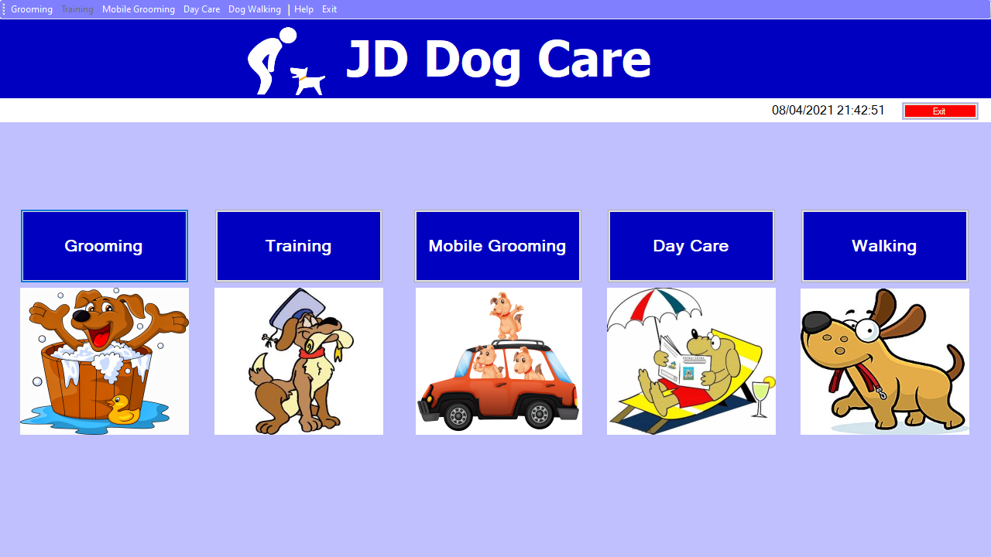
Clicking the Grooming, Mobile Grooming, Day Care and Walking buttons will all result in a message box appearing which says “This subsystem has not yet been implemented.” As this subsystem only focuses on the training service. Clicking the Training button will bring you to the training menu. The pictures underneath the buttons can also be clicked instead of the buttons.

Buttons – Training Menu
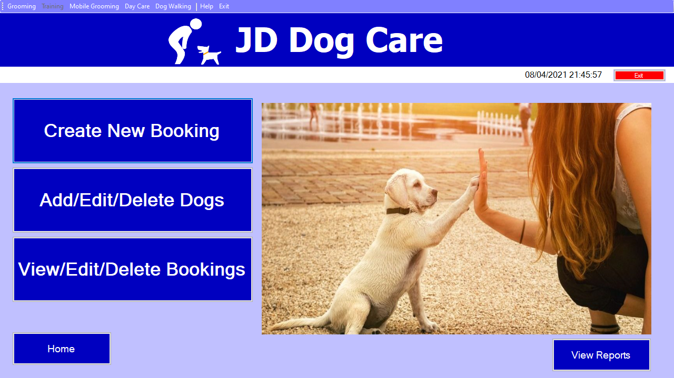

“Create New Booking” Button – This will bring you to the Create Booking form where a booking can be created and stored in the database.
“Add/Edit/Delete Dogs” Button – This will bring you to the form where you can Add, Edit or Delete dogs that are currently stored in the database.
“View/Edit/Delete Bookings” Button – This will bring you to the form which will display all of the currently active bookings where they can be viewed edited and deleted.
“Home” Button – This button will bring you back to the Main Menu where the different subsystems can be accessed.
“View Reports” Button – This will open the report form which will show monthly statistics based on bookings of classes starting in a given month.

Creating a New Booking

Accessing the Bookings Form
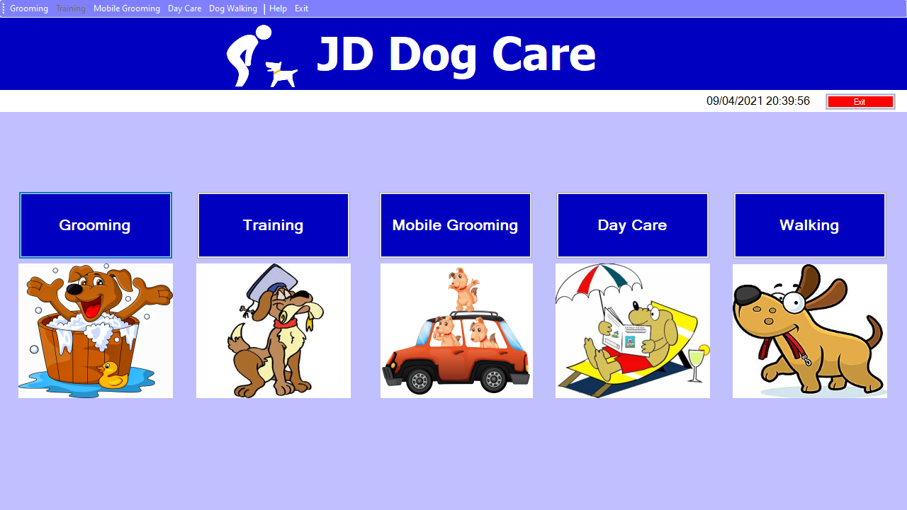
First Click the “Training” Button to be brought to the Training Menu.

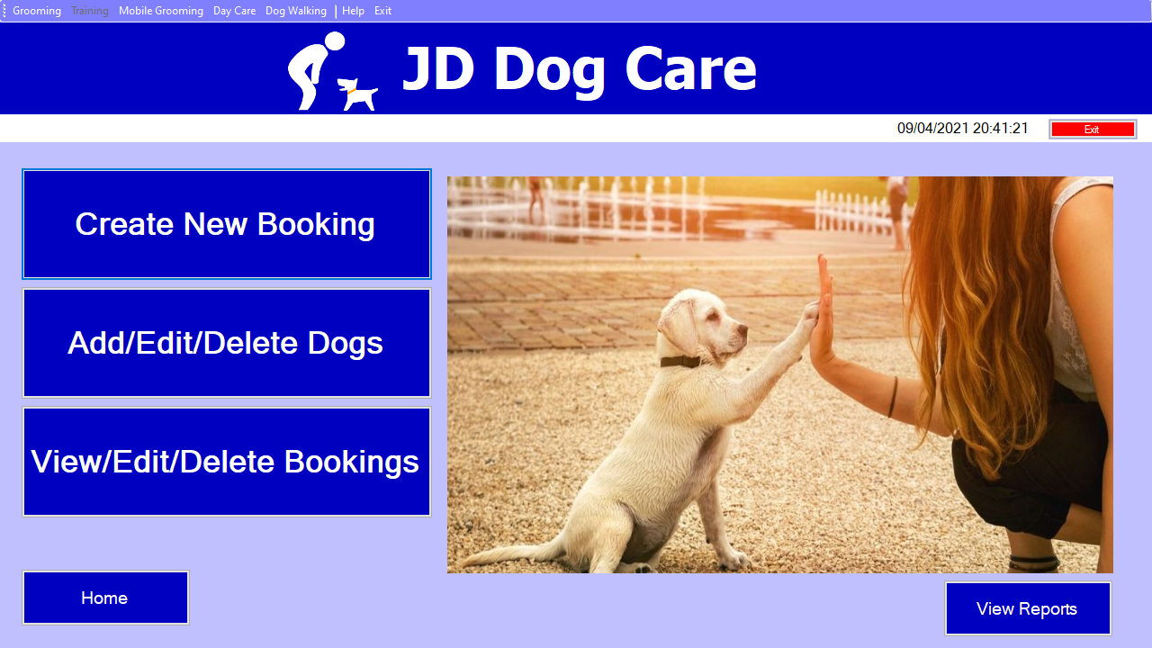
Next Click on the “Create New Booking” to be brought to the Create New Booking form.

Creating a New Booking
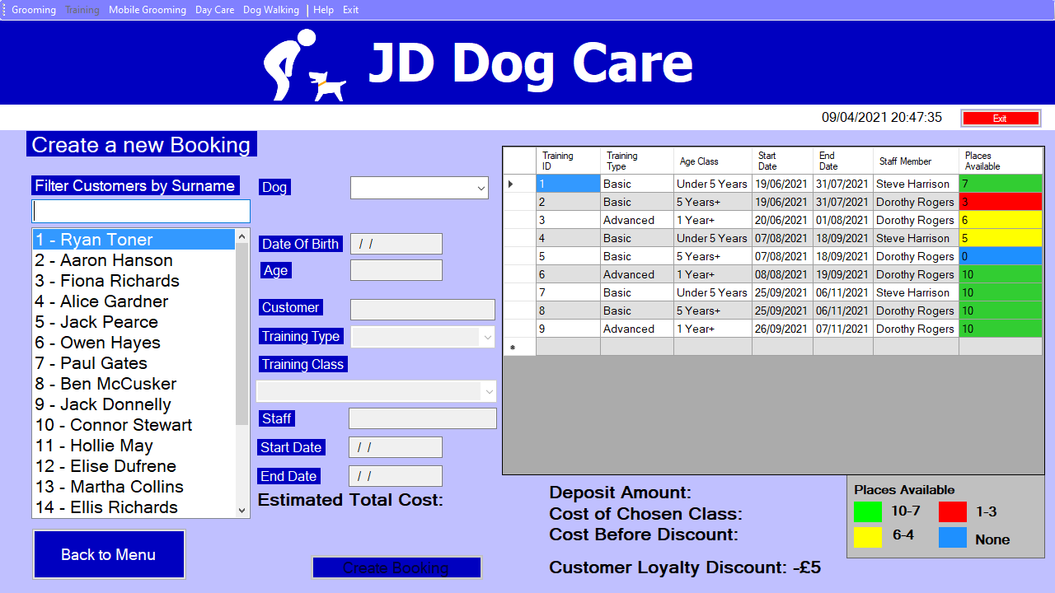
5
4
3
2
1
Here is how the form should be filled out
- First select the customer associated with the booking on the left hand side, you can search through the last names of customers to find the one you’re looking for.
- Next click the drop-down list at the top of the screen labelled “dog” and choose the dog you want to make a booking for.
- After selecting the dog, select the type of class you want to book the dog in for. If the dog is eligible for advanced classes there will be an option for advanced here, if not only basic will be available.
- Once the type of class has been selected select the actual class you want to book the dog in for, in this box you will see different dates available for the specific type of training class.
- Once all the information has been entered, the text on the “Create Booking” button will turn white meaning you can save the information about this booking to the system.
Clicking the “Back to Menu” button will take you back to the Training Menu form.

Viewing Bookings

Accessing the View/Edit/Delete Bookings Form
From the main menu click on the “Training” button to be brought to the training menu form

Next click on the “View/Edit/Delete Bookings” button.

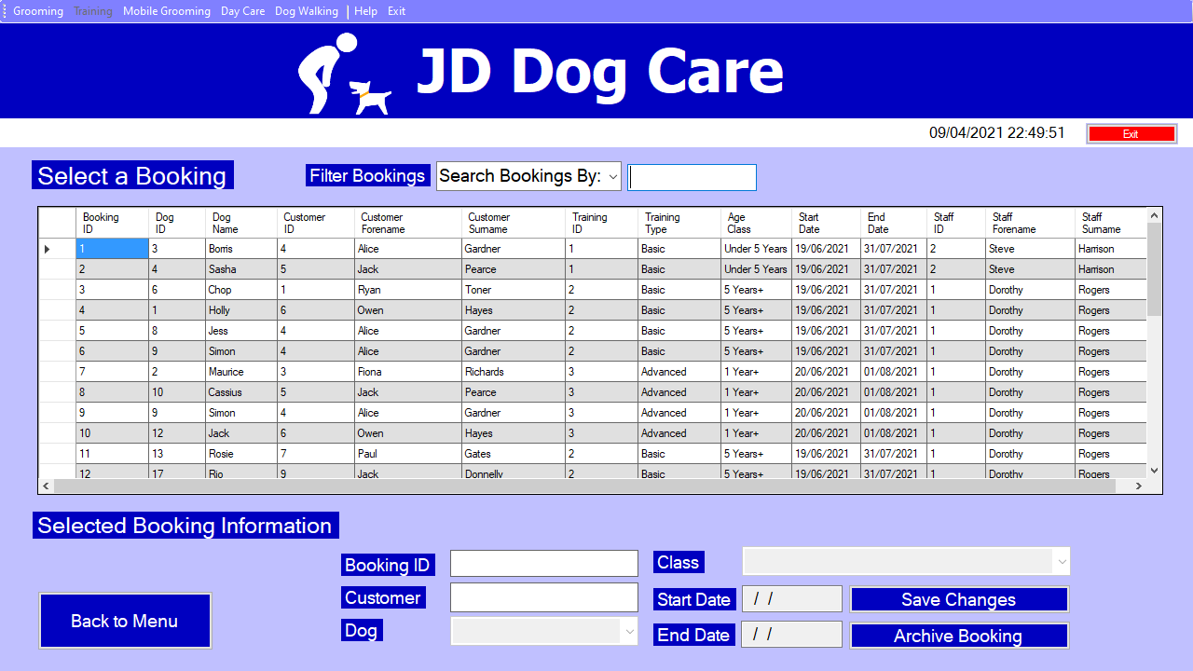
From here all of the currently active (not archived) bookings can be viewed.
The bookings can be filtered using the text box and drop-down list at the top, you can filter the bookings by
- Booking ID
- Customer Surname
- Dog Name
- Training Type
- Training Age Class
- Training Start Date

Editing A Booking

Accessing the View/Edit/Delete Bookings Form
From the main menu click on the “Training” button to be brought to the training menu form

Next click on the “View/Edit/Delete Bookings” button.

Editing a Booking
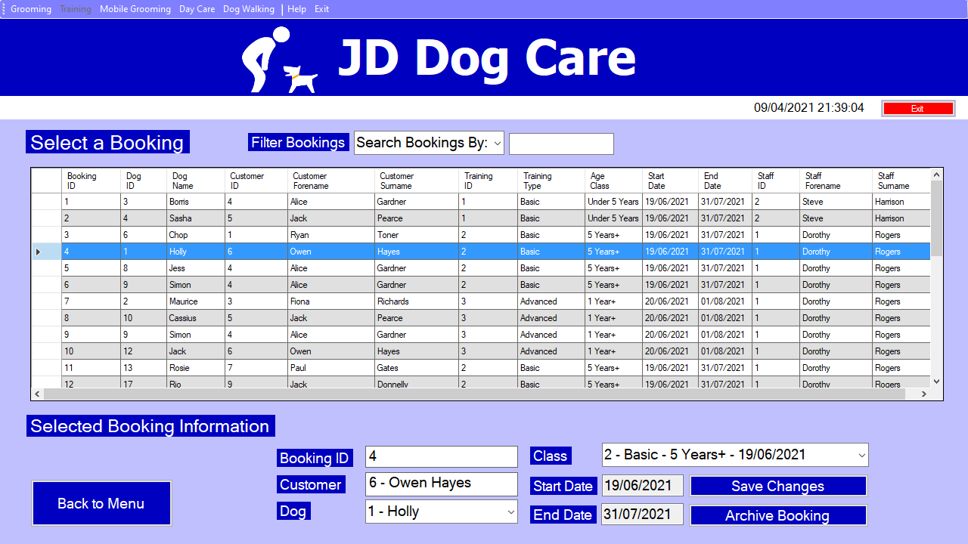
1A
4
3
2
1
Here you will see all currently active bookings
1 - Selecting the Booking you want to edit:
Click on any part of the booking you want to edit and the information will populate into the boxes below.
1A - Bookings can be filtered using the drop-down list and text box.
2 - To Edit the Dog associated with the booking:
Click on the drop-down list labelled “Dog” and select the new dog.
3 - To Edit the Class associated with the booking:
Click on the drop-down list labelled “Class” and select the class you wish to change to.
4 – Saving Changes:
After making the changes you want, click the “Save Changes” button.

Deleting A Booking

Accessing the View/Edit/Delete Bookings Form
From the main menu click on the “Training” button to be brought to the training menu form

Next click on the “View/Edit/Delete Bookings” button.

Deleting/Archiving a Booking
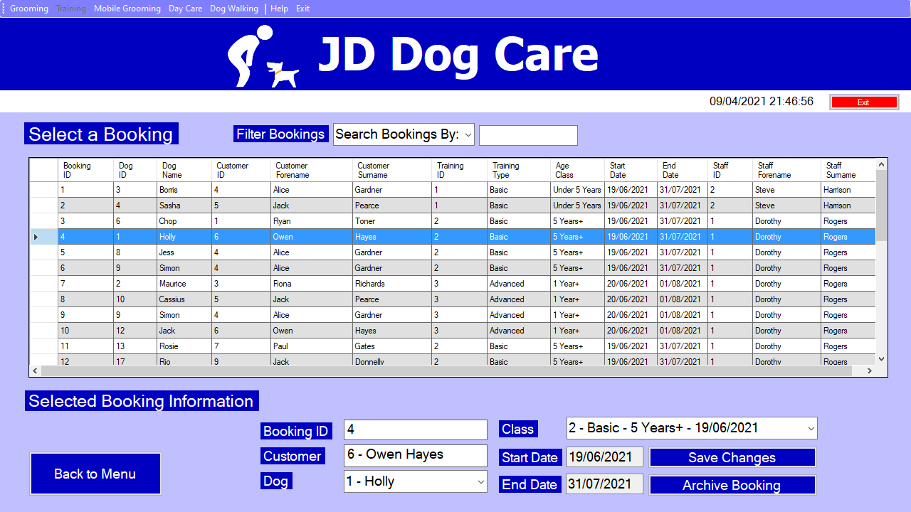
1A
2
1
Here you will see all of the currently active bookings
1 – Selecting the Booking you want to delete:
Click on any part of the booking you want to delete and the information will populate into the boxes below.
1A - Bookings can be filtered using the drop-down list and text box.
2 – Deleting the Booking:
Click on the “Archive Booking” button, if the booking is set to happen in the future it will be delete whereas if the booking has already happened then it will be archived meaning it is still stored in the system but cannot be edited.

Adding a New Dog

Accessing the Add/Edit/Delete Form
From the main menu click on the “Training” button to be brought to the training menu form

Next click on the “Add/Edit/Delete Dogs” button.

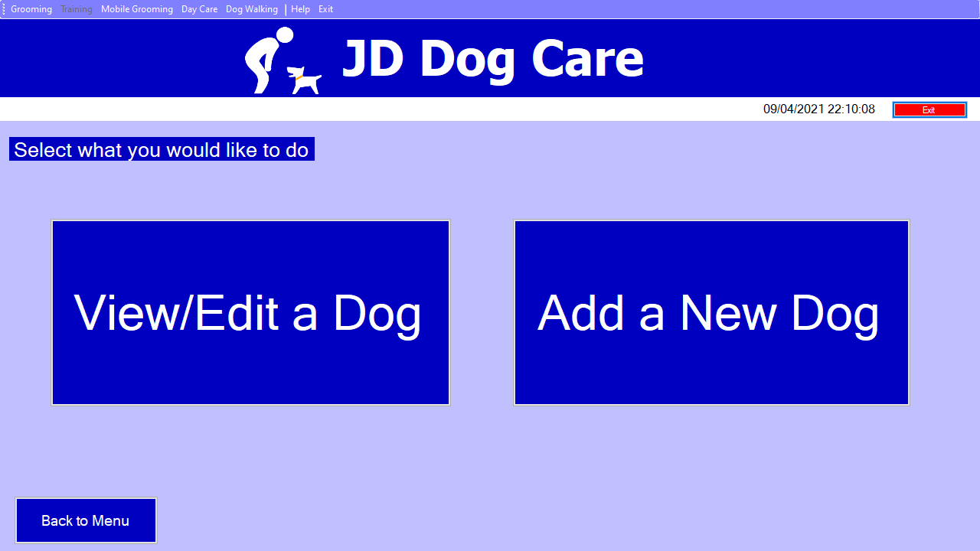

As we are adding a new Dog, click on the “Add a New Dog” button.

Adding a New Dog
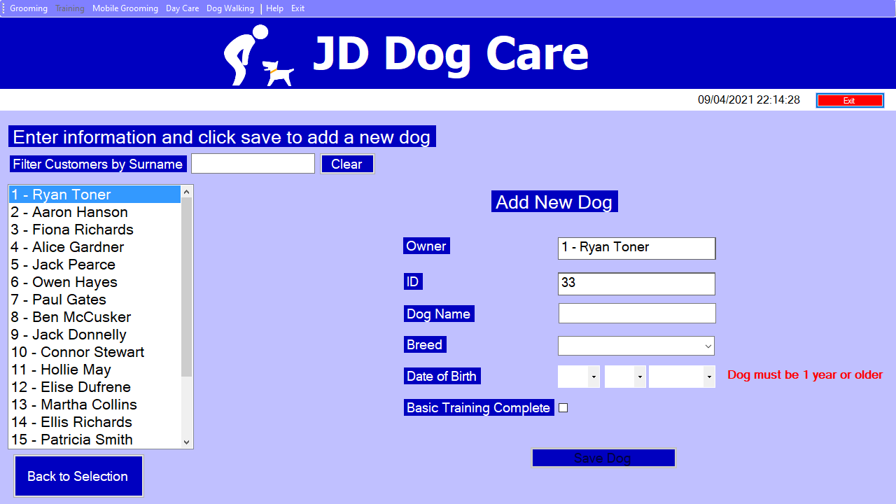
3
2D
2C
2B
2A
1
From here we can now add a new Dog by doing the following:
1 – Selecting the Customer that the new Dog belongs to:
Select the customer from the list on the left, this list can be searched through using the last name of the customer.
2 – Entering information about the Dog:
Enter information about the dog into the Text boxes, these being the Dog’s name (2A), the Dog’s breed (2B), the Dog’s date of birth (2C) and also tick the box if the dog has previously completed basic training (2D)
Note: The dog must be over 1 year old or else it cannot be added to the system.
3 – Saving the new Dog:
Click on the “Save Dog” button to save the dog to the system.

Editing a Dog

Accessing the Add/Edit/Delete Form
From the main menu click on the “Training” button to be brought to the training menu form

Next click on the “Add/Edit/Delete Dogs” button.

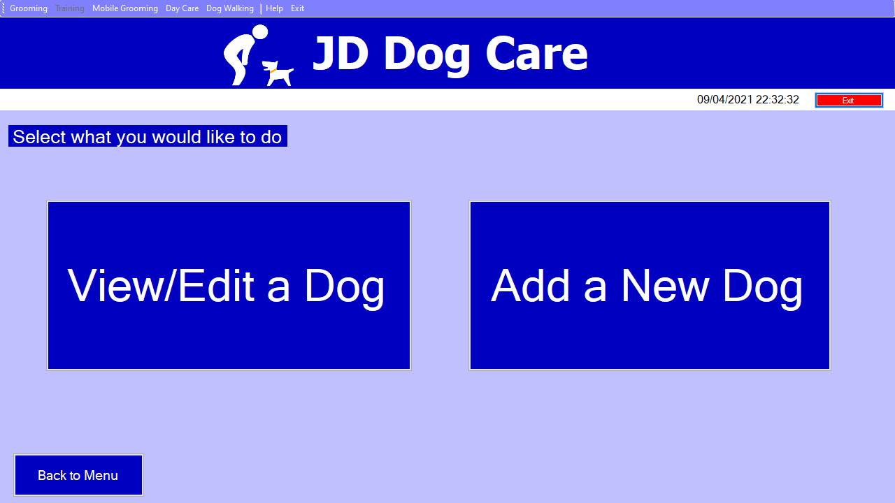

As we are editing a dog, click the “View/Edit Dog” button.

Editing a Dog
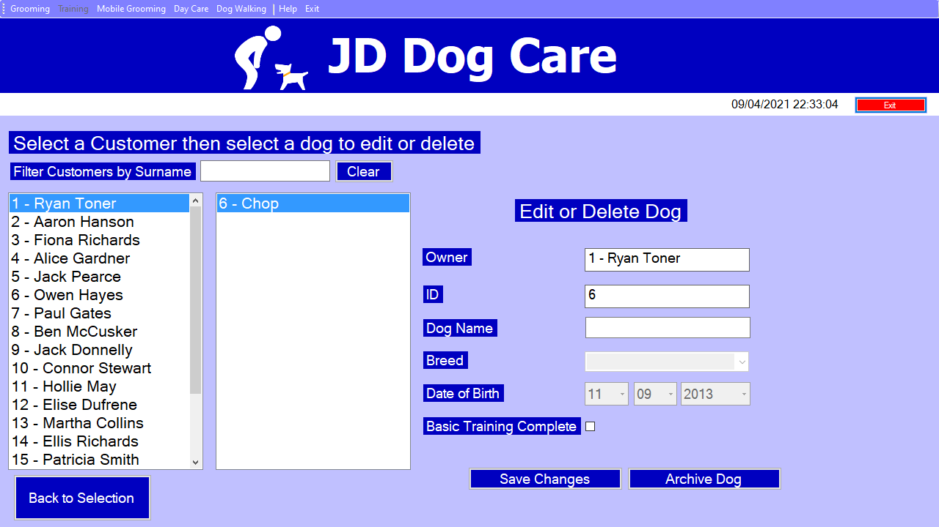
4
3
2
1
Here you can edit a dog by following these steps:
1 – Select the Customer that the dog belongs to:
Select the customer that the dog you want to edit belongs to using the list on the left, these customers can be filtered using the customers last name.
2 – Selecting the Dog you wish to edit:
Select the dog you want to edit using the list to the right of the customers list.
3 – Editing the Dog
Change the information in the appropriate boxes to the new values.
Note: The Date of birth and breed of the dog are not able to be changed.
4 – Saving Changes
Click the “Save Changes” button to update this dog in the system with the new information.

Archiving a Dog
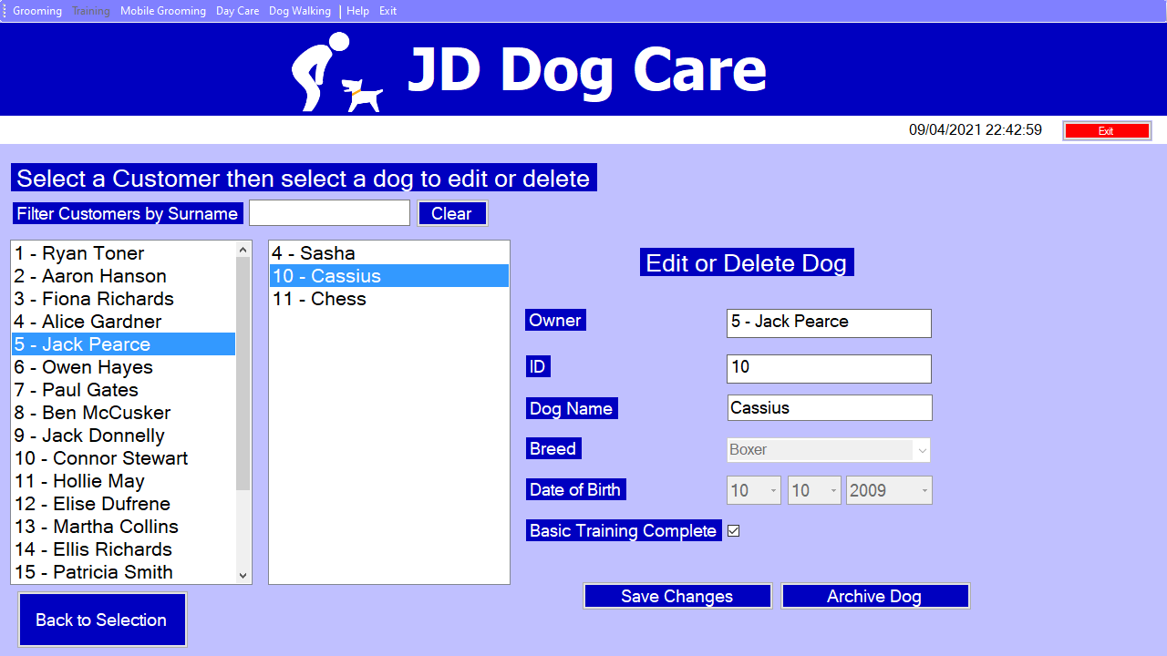
3
2
1
1 – Select the Customer that the dog belongs to:
Select the customer that the dog you want to archive belongs to using the list on the left, these customers can be filtered using the customers last name.
2 – Selecting the Dog you wish to archive:
Select the dog you want to archive using the list to the right of the customers list.
3 – Archiving the Dog
Click the “Archive Dog” button to archive the dog, this means that the dog can no longer be edited or have bookings made but is still stored in the system.

Generating Printable Reports
Accessing the Report Form
From the main menu click on the “Training” button to be brought to the training menu form

Now click on the “View Reports” button.

Viewing and Printing the Report
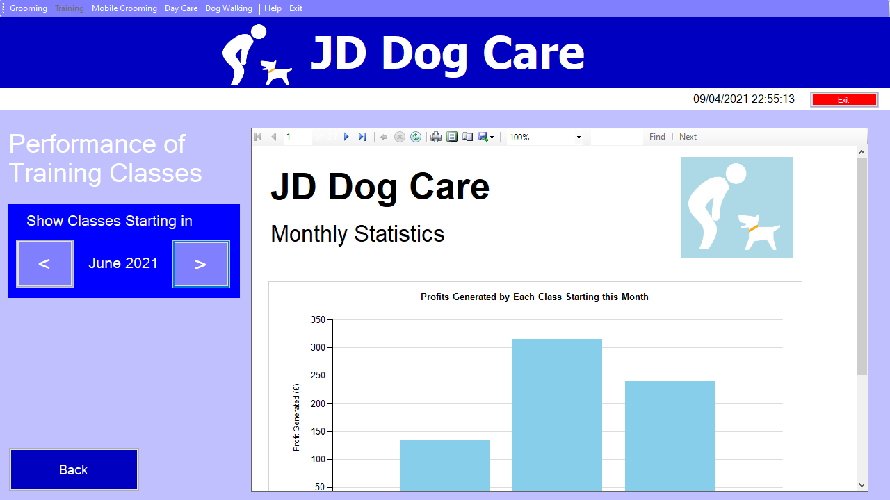
2
1
1
The report form will now open, the current month and year will be selected by default. The report will show data on the classes starting in the selected month.
Note: You will need to scroll down the report to see all of the information as shown below)
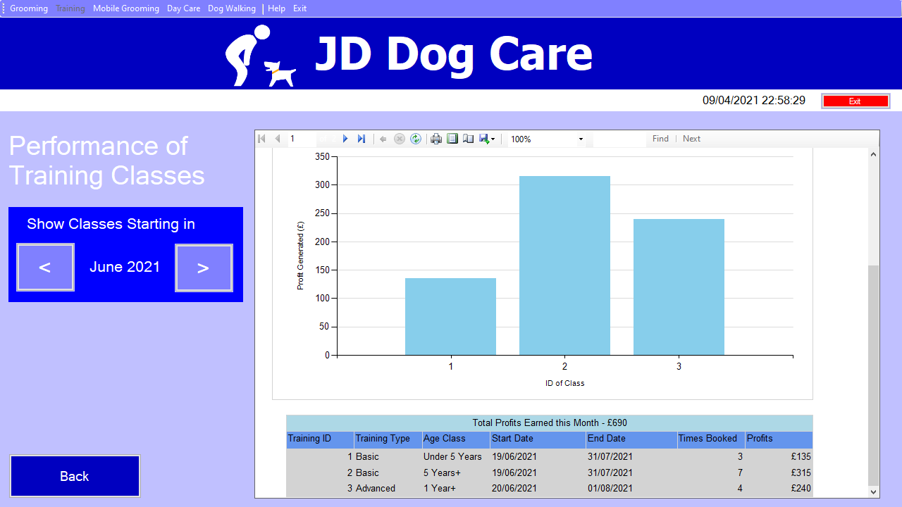
1 – Changing the Month the report is based on
Click on either the arrow pointing left or the arrow pointing right to go forward or back one month.
2 – Printing the report
Click on the printer icon located at the top of the report, this will open a menu where the correct printer can be selected and the document can be printed.

