Assignment 2 – Agile Software Practice

Name: Yuefeng Ju

Student ID: 20086477

## Client UI

* news page: guest can browser news about 'apple' in the nearest week, the titles can be clicked and linked to the external website.

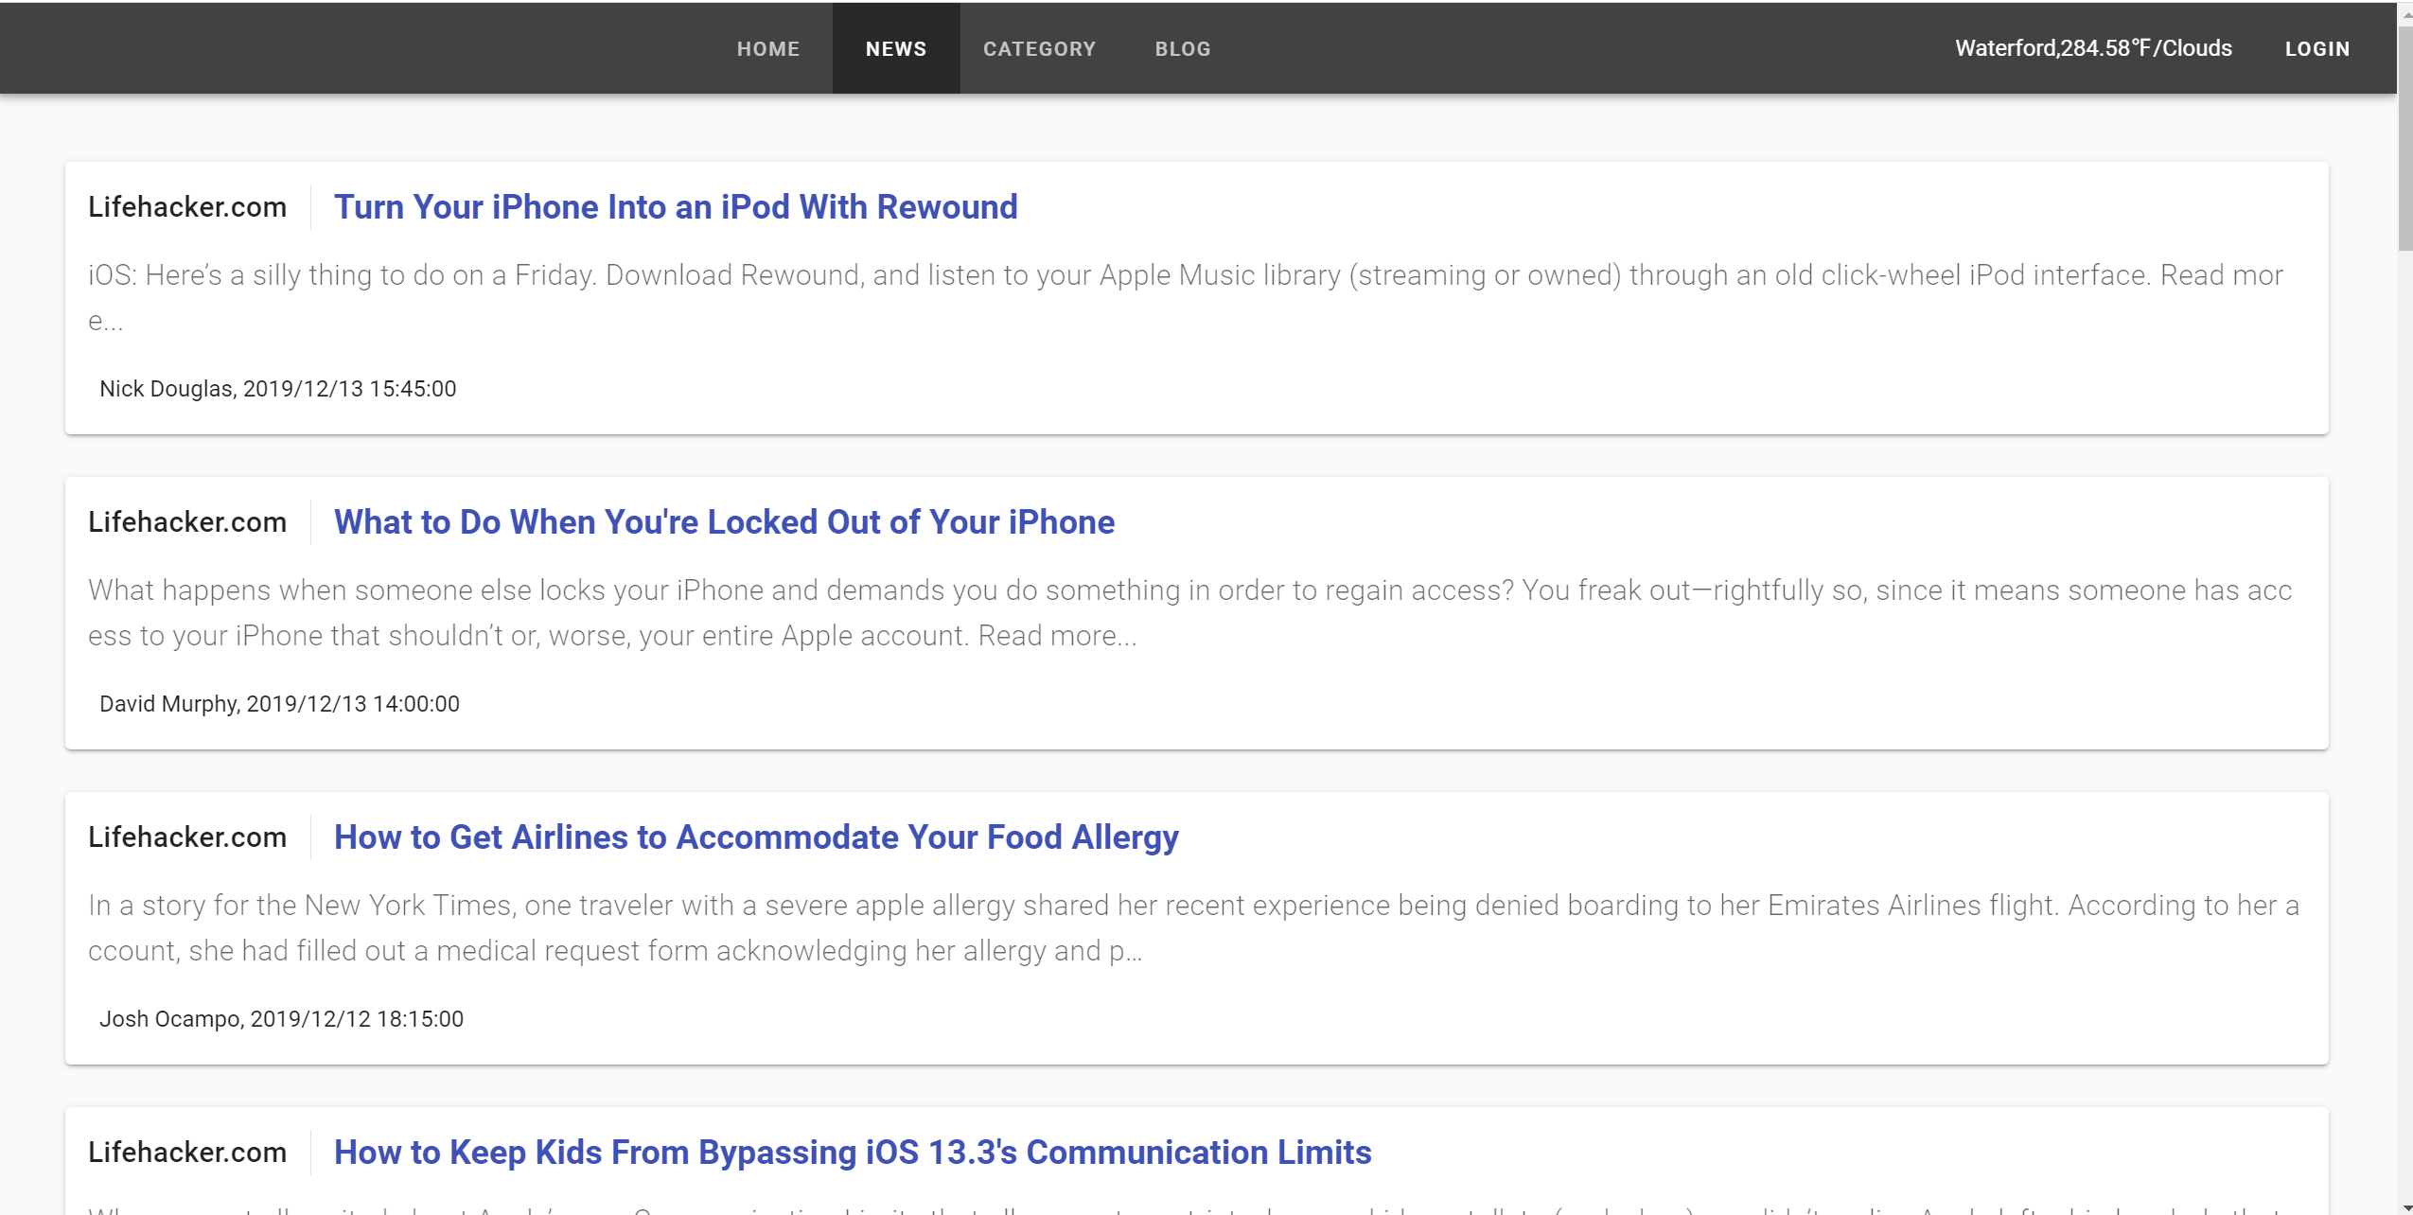

* home page:

+ published blogs are displayed in this page's list.

+ guest can click each title to go blog's details page to read more.

* details page: if logged in, user(administrator) can add review, if not logged in, guest can only browser the details.

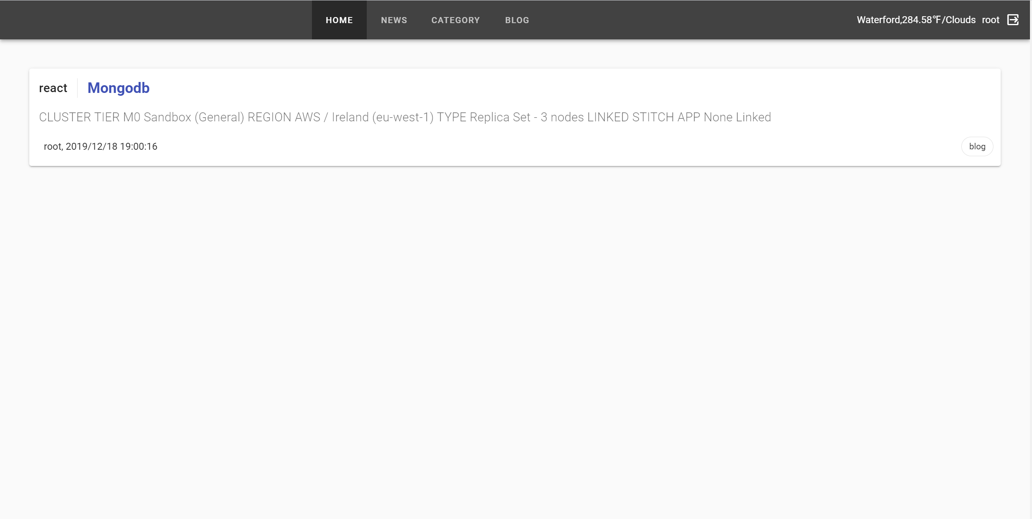

* category page

+ the added categories are listed as label.

+ logged-in user can add new category and remove category, but guests cann't.

+ the sorted blogs by categories and their counts are showed in a table.

+ guest can click the category's link to the blog's list page, namely home page, this page only show the blogs of the clicked category.

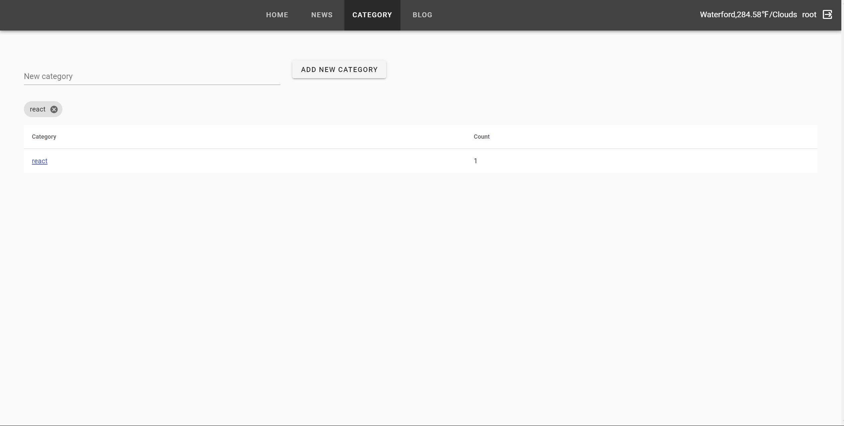

* blog page

+ there is a table to show the blogs' title, category, tags...

+ logged-in user can delete the blogs.

+ user can click each title's link to see the details.

+ click the post blog button, this page would go to the form page.

* form page: user can post a new blog. there are title, content, category, tags fields.

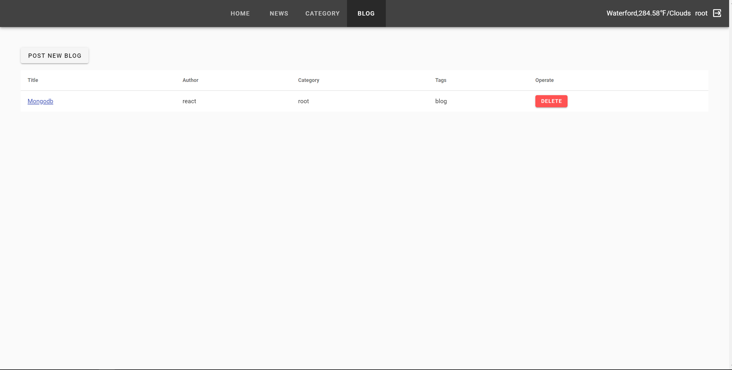

* login page

+ after clicking the login button, user can see this page.

+ name and password are required to login.

+ after logged in, the browsered page before would be showed.

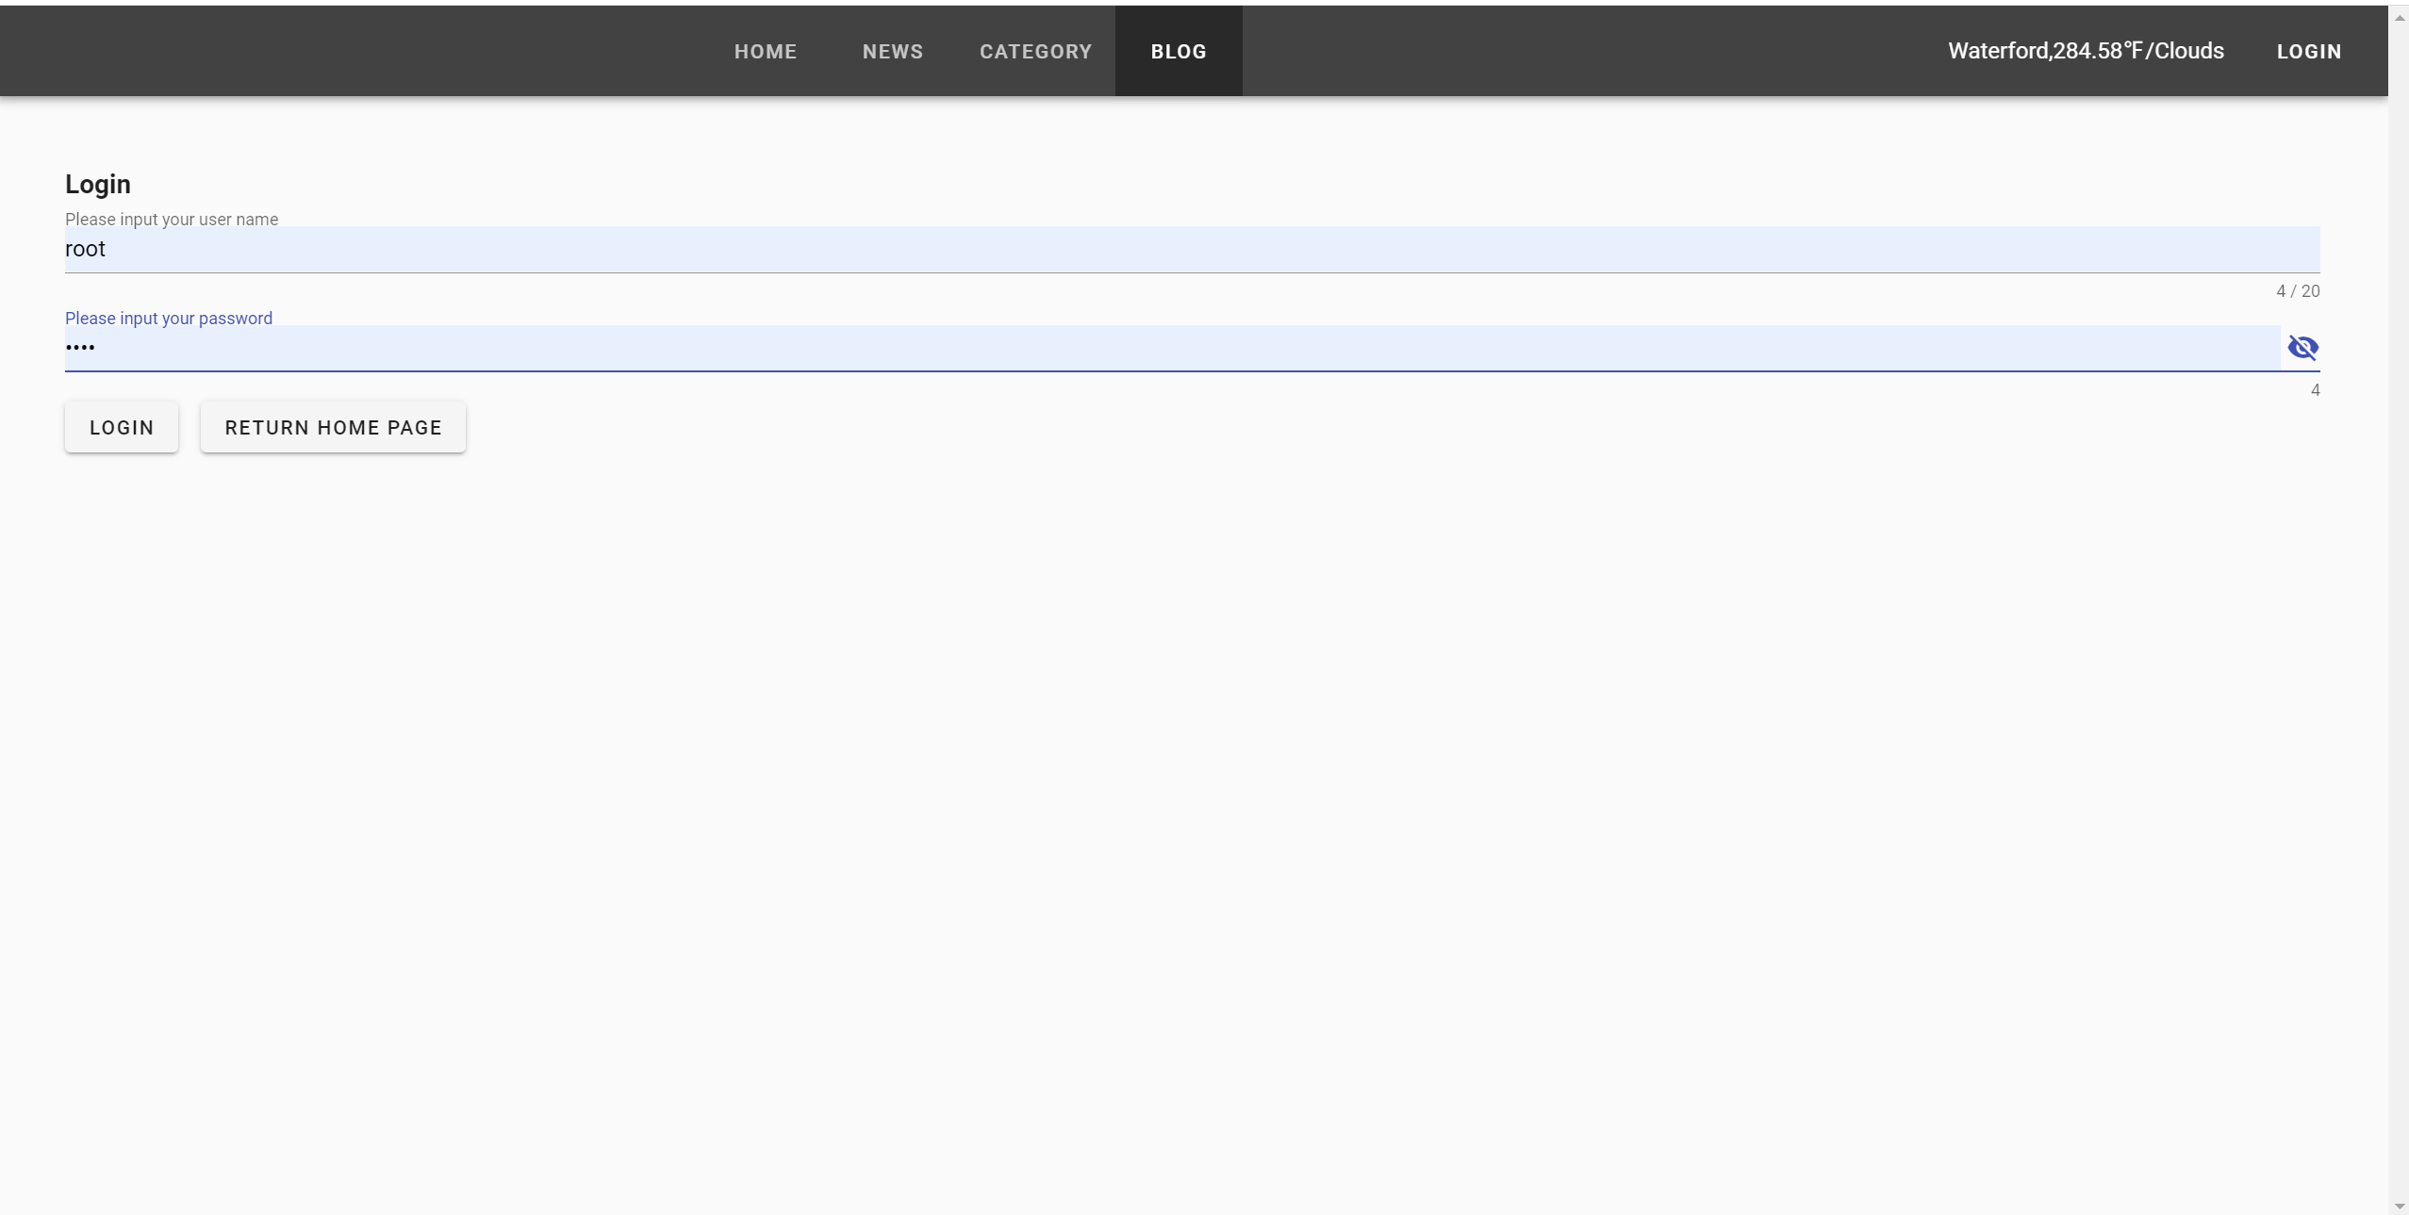

* navigation bar

+ there are HOME/NEWS/CATEGORY/BLOG four tabs to link each page.

+ there is a text area to show the current weather of Waterford.

+ there is a button of LOGIN to login or the logged-in user's name and LOGOUT button to loggout.



## Web API CI

<https://owenego.gitlab.io/node/>coverage/Icov-report

