Activate Cloud Shell

Cloud Shell is a virtual machine that is loaded with development tools. It offers a persistent 5GB home directory and runs on the Google Cloud. Cloud Shell provides command-line access to your Google Cloud resources.

In the Cloud Console, in the top right toolbar, click the **Activate Cloud Shell** button.

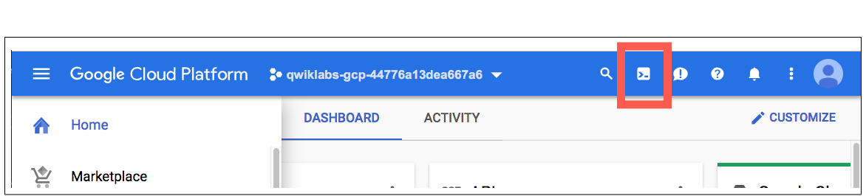

Click **Continue**.

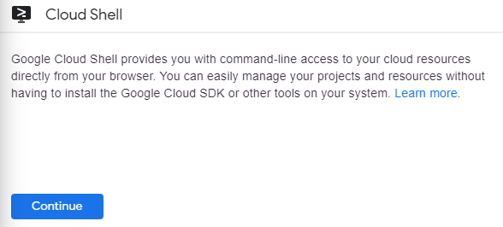

It takes a few moments to provision and connect to the environment. When you are connected, you are already authenticated, and the project is set to your *PROJECT_ID*. For example:



You can list the active account name with this command:

gcloud auth list

(Output)

Credentialed accounts:

- <myaccount>@<mydomain>.com (active)

(Example output)

Credentialed accounts:

- [stubent123@google.com](mailto:stubent123@google.com)

You can list the project ID with this command:

gcloud config list project

(Output)

[core]

project = <project_ID>

(Example output)

[core]

project = labs-gcp-4213k232k3232exd

**Create a new instance from the Cloud Console**

In this section, you'll learn how to create new pre-defined machine types with Compute Engine from the Cloud Console.

In the Cloud Console, on the Navigation menu (Navigation menu), click Compute Engine > VM Instances.

This may take a minute to initialize for the first time.

To create a new instance, click CREATE INSTANCE.

There are many parameters you can configure when creating a new instance. Use the following for this lab:

|  |  |  |
| --- | --- | --- |
| **Field** | **Value** | **Additional Information** |
| **Name** | **vm** | Name for the VM instance |
| **Region** | **asia-east2 (Hong Kong)** | For more information about regions, see [Regions and Zones](https://cloud.google.com/compute/docs/zones). |
| **Zone** | **asia-east2-a** | **Note:** Remember the zone that you selected: you'll need it later. For more information about zones, see [Regions and Zones](https://cloud.google.com/compute/docs/zones). |
| **Series** | **N1** | Name of the series |
| **Machine Type** | **f1-mirco** | N1: f1-micro and g1-small shared-core machine types have up to 1 vCPU available for short periods of bursting. |
| **Boot Disk** | **New 10 GB standard persistent disk** **OS Image: Debian GNU/Linux 10 (buster)** | Several images are available, including Debian, Ubuntu, CoreOS, and premium images such as Red Hat Enterprise Linux and Windows Server. For more information, see Operating System documentation. |
| **Firewall** | **Allow HTTP traffic** | Select this option in order to access a web server that you'll install later. **Note:** This will automatically create a firewall rule to allow HTTP traffic on port 80. |
| **Deletion Protection** | **Enable deletion Protection** | Protect specific VM instances from deletion |