**Creating an instance template**

Next, create a template for the instances that are created in the instance group that will use autoscaling. As part of the template, you specify the location (in Cloud Storage) of the startup script that should run when the instance starts.

1. In the Cloud Platform console, go to **Navigation menu** > **Compute Engine** > **Instance templates**.

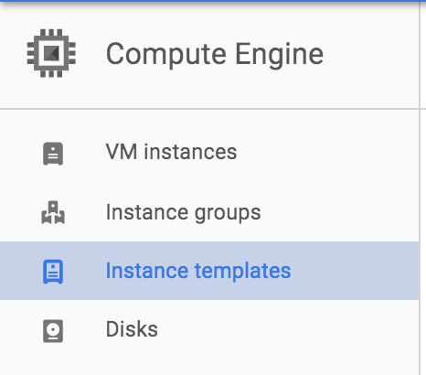

1. Click **Create Instance Template** at the top of the page.
2. Name the instance template autoscaling-instance01.

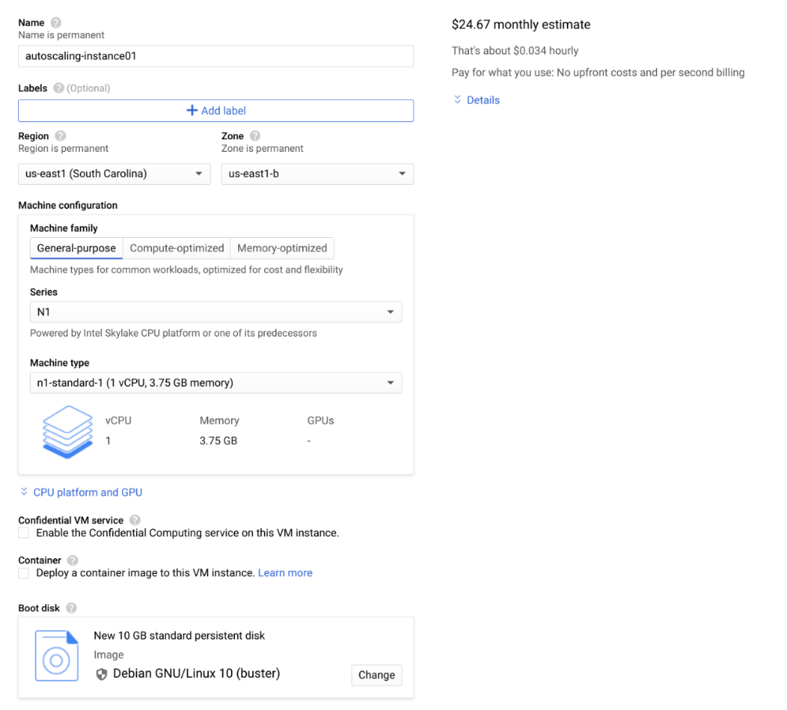

**Creating the instance group**

1. In the left pane, click **Instance groups**.

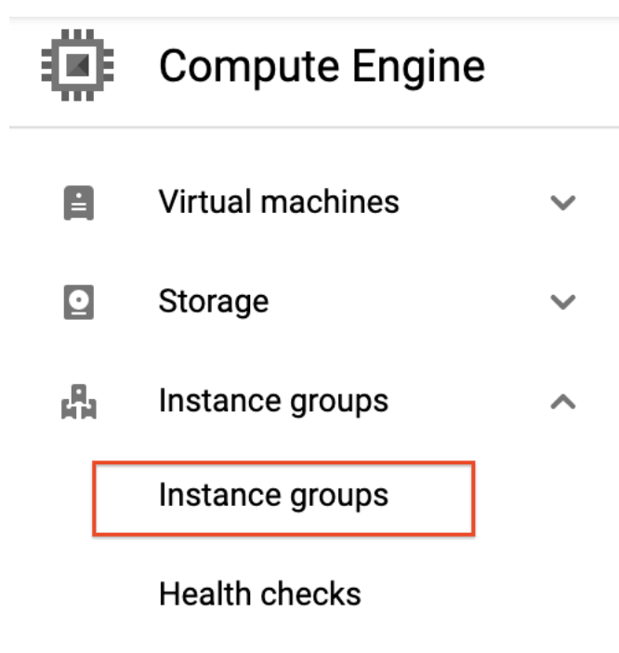

1. Click **Create instance group**.
2. **Name:** instance-group-1
3. Under **Instance template**, select the instance template you just created.
4. Set **Autoscaling mode** to **Don't autoscale**.

You'll edit the autoscaling setting after the instance group has been created. Leave the other settings at their default values.

1. Click **Create**.

**Test Completed Task**

Click **Check my progress** to verify your performed task. If you have successfully created an instance group, you will see an assessment score.

Create an instance group

Check my progress

**Verifying that the instance group has been created**

If you don't see the green icon, wait a short while and click the refresh icon. It might take the startup script several minutes to complete installation and begin reporting values. Click **Refresh** if it seems to be taking more than a few minutes.

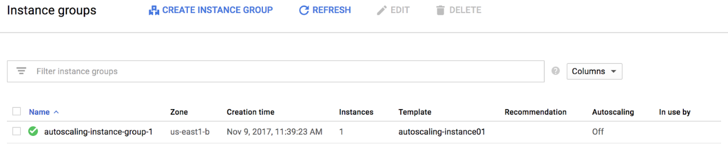

**Note:** If you see a red icon next to the other instance group that was pre-created by the lab, you can ignore this warning. The instance group reports a warning for up to ten minutes as it is initializing. This is expected behavior.

**Verifying that the Node.js script is running**

The custom metric custom.googleapis.com/appdemo_queue_depth_01 isn't created until the first instance in the group is created and that instance begins reporting custom metric values.

You can verify that the writeToCustomMetric.js script is running on the first instance in the instance group by checking whether the instance is logging custom metric values.

1. Still in the Compute Engine Instance groups window, click the name of the autoscaling-instance-group-1 to display the instances that are running in the group.
2. Click the instance name. Because autoscaling has not started additional instances, there is just a single instance running.

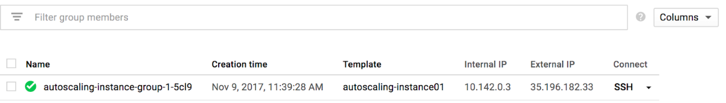

1. In the **Details** tab, click **Cloud Logging** to view the logs for the VM instance.

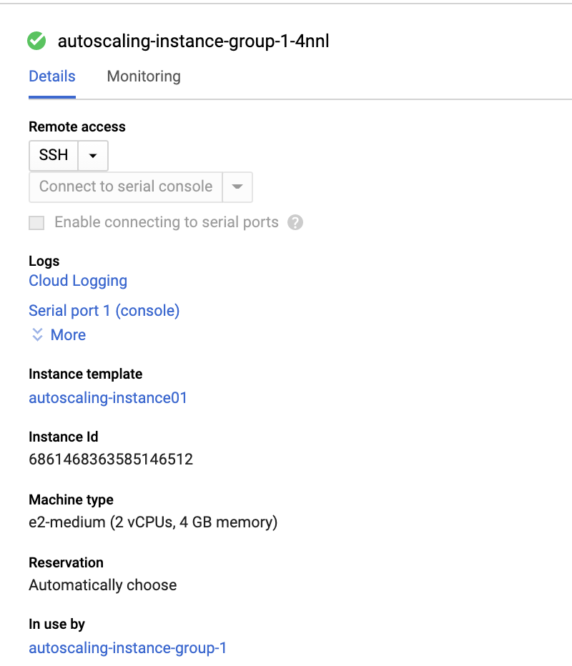

1. Wait a minute or 2 to let some data accumulate. You will see resource.type and resource.labels.instance_id in the **Query preview** box.



1. Now click drop-down arrow next to **Run Query** to open **Query builder** box.

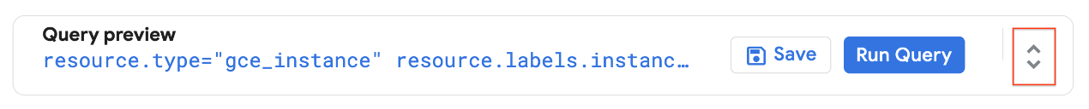

1. Add "nodeapp" as line three, so the code looks similar to this:

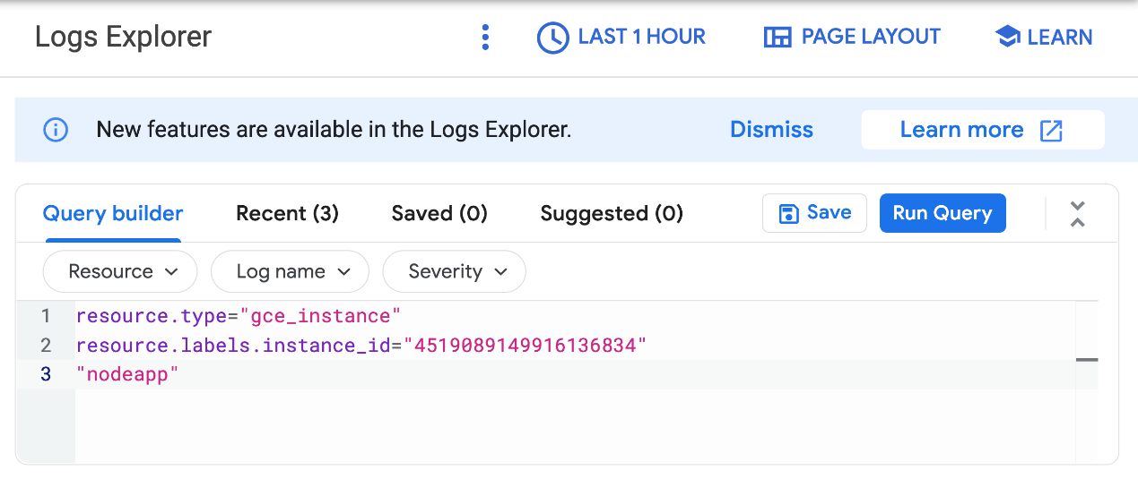

1. Click **Run Query**.

If the Node.js script is being executed on the Compute Engine instance, a request is sent to the API, and log entries that say Finished writing time series data appear in the logs. For example, in the preceding screenshot, entries like this appear at 10:31:05.000 and 10:30:53.000.

If you don't see this log entry, the Node.js script isn't reporting the custom metric values. Check that the metadata was entered correctly. If the metadata is incorrect, it might be easiest to restart the lab.

**Configure autoscaling for the instance group**

After you've verified that the custom metric is successfully reporting data from the first instance, the instance group can be configured to autoscale based on the value of the custom metric.

1. In the Cloud Console, go to **Compute Engine** > **Instance groups**.
2. Click the autoscaling-instance-group-1 group and then click **Configure autoscaling**.
3. Set **Autoscaling mode** to **Autoscale**.

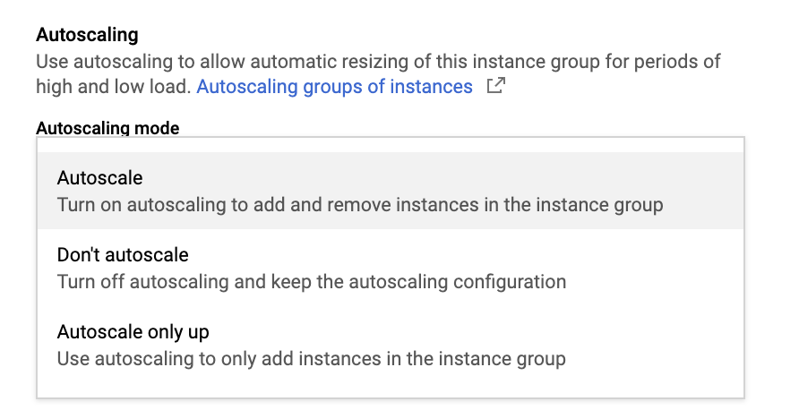

1. Under **Autoscaling Policy** click on **pencil icon** to edit metric. Set the following fields, leave all others at the default value.

* **Metric Type**: Stackdriver Monitoring metric
* **Metric export scope**: Time series per instance
* **Metric identifier**: custom.googleapis.com/appdemo_queue_depth_01
* **Utilization target**: 150

When custom monitoring metric values are higher or lower than the **Target** value, the autoscaler scales the managed instance group, increasing or decreasing the number of instances. The target value can be any [double](https://cloud.google.com/monitoring/api/ref_v3/rest/v3/projects.metricDescriptors#valuetype) value, but for this lab, the value 150 was chosen because it matches the values being reported by the custom monitoring metric.

* **Utilization target type**: Gauge

The **Gauge** setting specifies that the autoscaler should compute the average value of the data collected over the last few minutes and compare it to the target value. (By contrast, setting **Target mode** to **DELTA_PER_MINUTE** or **DELTA_PER_SECOND** autoscales based on the *observed* rate of change rather than an *average* value.)

* **Minimum number of instances**: 1
* **Maximum number of instances**: 1

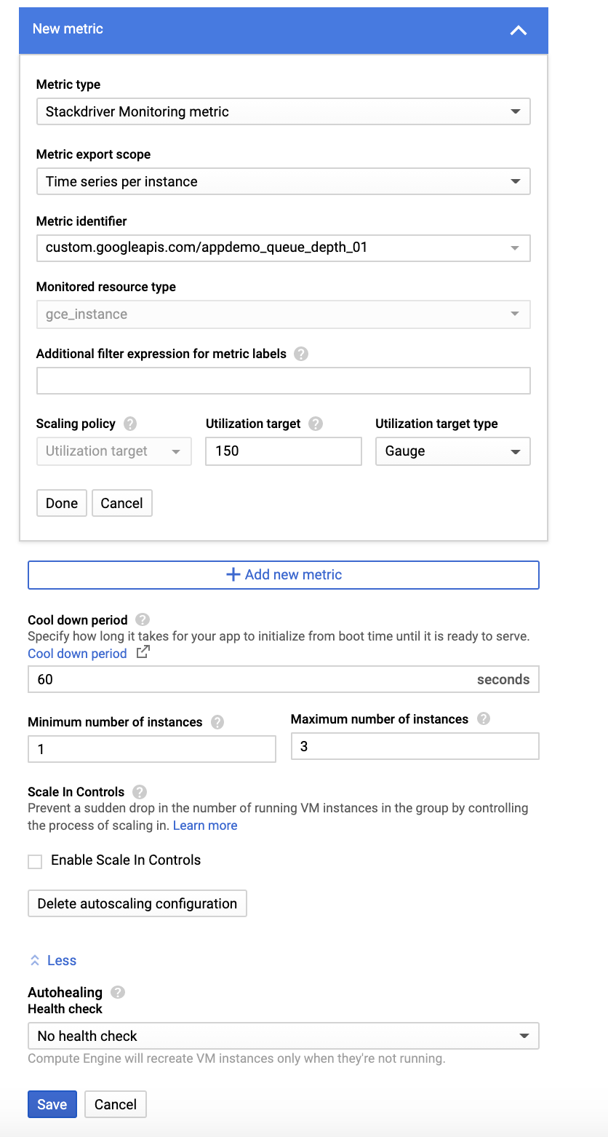

1. Click **Save**.

**Test Completed Task**

Click **Check my progress** to verify your performed task. If you have successfully configured autoscaling for the instance group, you will see an assessment score.