**Create a new instance templates from the Cloud Console**

**In this section, you'll learn how to create new pre-defined machine types with instance temples from the Cloud Console.**

**In the Cloud Console, on the Navigation menu (Navigation menu), click Compute Engine > instance temples**

**This may take a minute to initialize for the first time.**

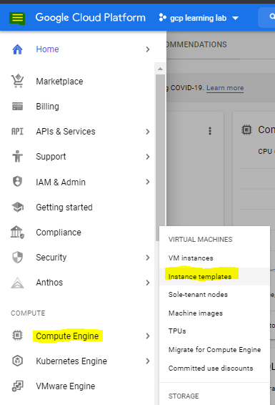

**To create a new instance, click CREATE instance temples**

**There are many parameters you can configure when creating a new instance temples . Use the following for this lab:**

|  |  |  |
| --- | --- | --- |
| **Field** | **Value** | **Additional Information** |
| **Name** | **vm** | Name for the VM instance |
| **Region** | **asia-east2 (Hong Kong)** | For more information about regions, see [Regions and Zones](https://cloud.google.com/compute/docs/zones). |
| **Zone** | **asia-east2-a** | **Note:** Remember the zone that you selected: you'll need it later. For more information about zones, see [Regions and Zones](https://cloud.google.com/compute/docs/zones). |
| **Series** | **N1** | Name of the series |
| **Machine Type** | **f1-mirco** | N1: f1-micro and g1-small shared-core machine types have up to 1 vCPU available for short periods of bursting. |
| **Boot Disk** | **New 10 GB standard persistent disk** **OS Image: Debian GNU/Linux 10 (buster)** | Several images are available, including Debian, Ubuntu, CoreOS, and premium images such as Red Hat Enterprise Linux and Windows Server. For more information, see Operating System documentation. |
| **Firewall** | **Allow HTTP traffic** | Select this option in order to access a web server that you'll install later. **Note:** This will automatically create a firewall rule to allow HTTP traffic on port 80. |
| **Startup script** | **sudo touch test.txt** | Startup scripts can be used to install software and updates, and to ensure that services are running within the virtual machine |

