**Setting up Pub/Sub**

You can use the Google Cloud Shell console to perform operations in Google Cloud Pub/Sub.

To use a Pub/Sub, you create a topic to hold data and a subscription to access data .published to the topic.

1. Click **Navigation menu** > **Pub/Sub** > **Topics**.

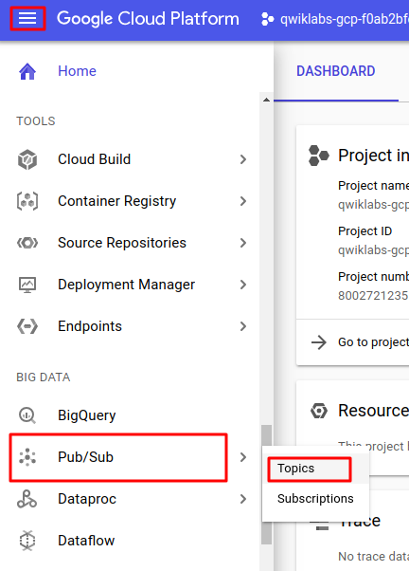

1. Click **Create a topic**.

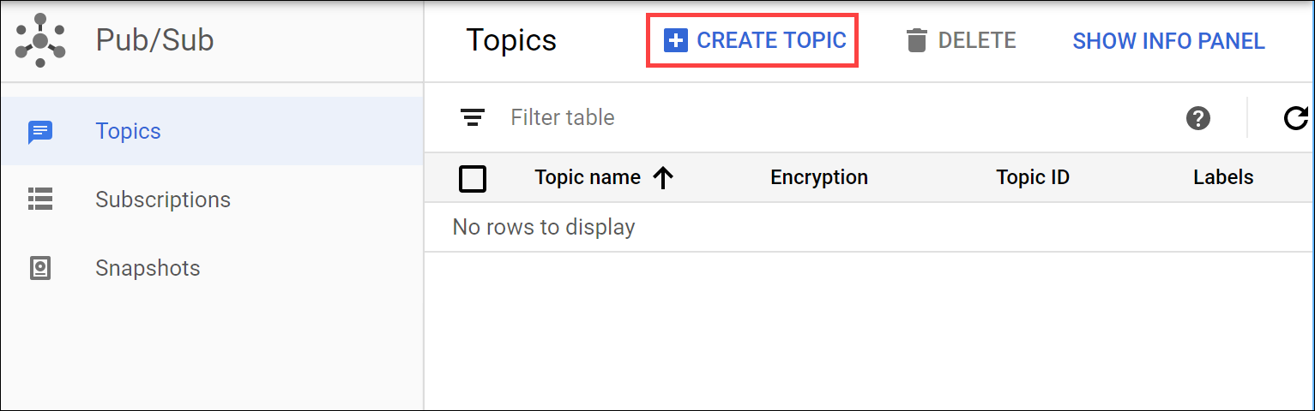

1. The topic must have a unique name. For this lab, name your topic MyTopic. In the **Create a topic** dialog:

* For **Topic ID**, type MyTopic.
* Leave **Encryption** at the default value.
* Click **CREATE TOPIC**.

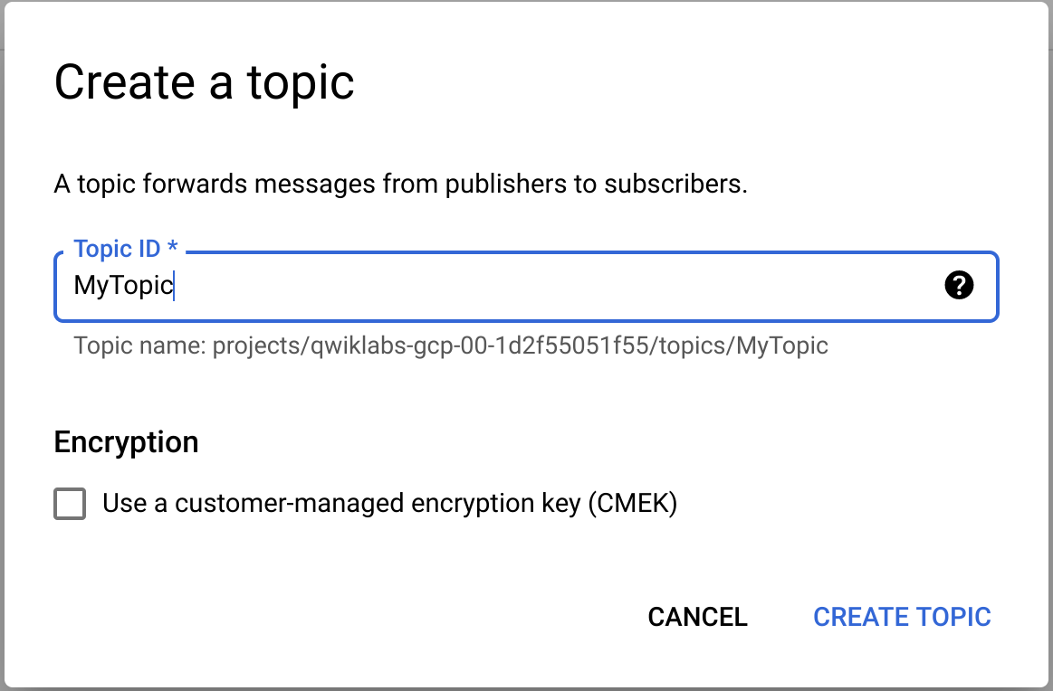

You've created a topic.

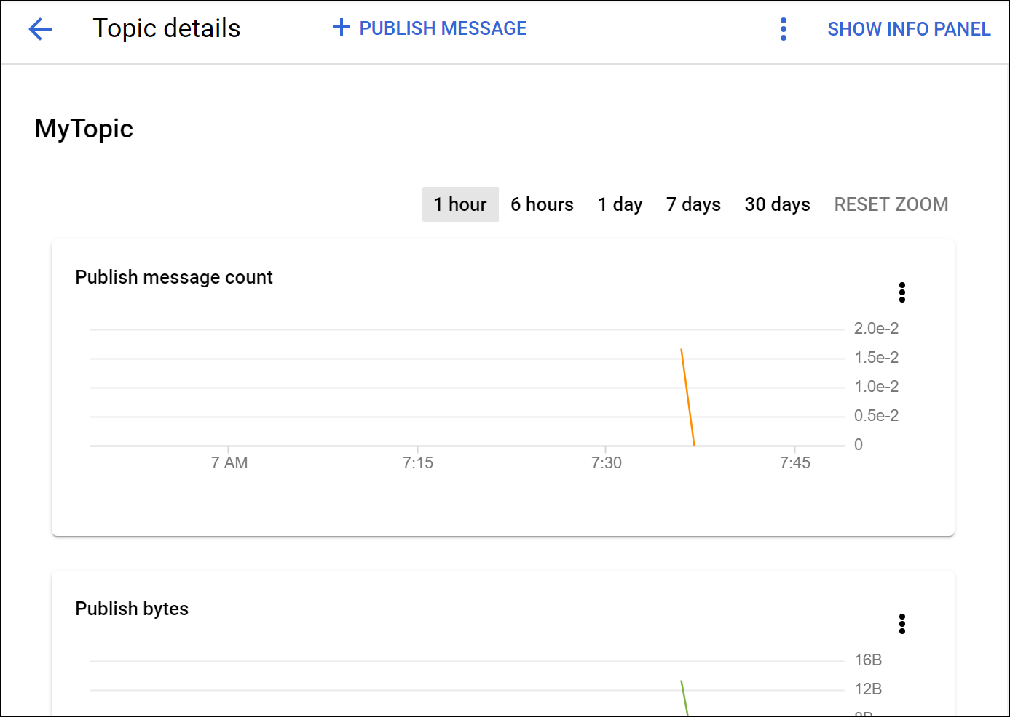

**Add a subscription**

Now you'll make a subscription to access the topic.

1. Click **Topics** in the left panel to return to the **Topics** dialog. For the topic you just made click the three dot icon > **Create subscription**.

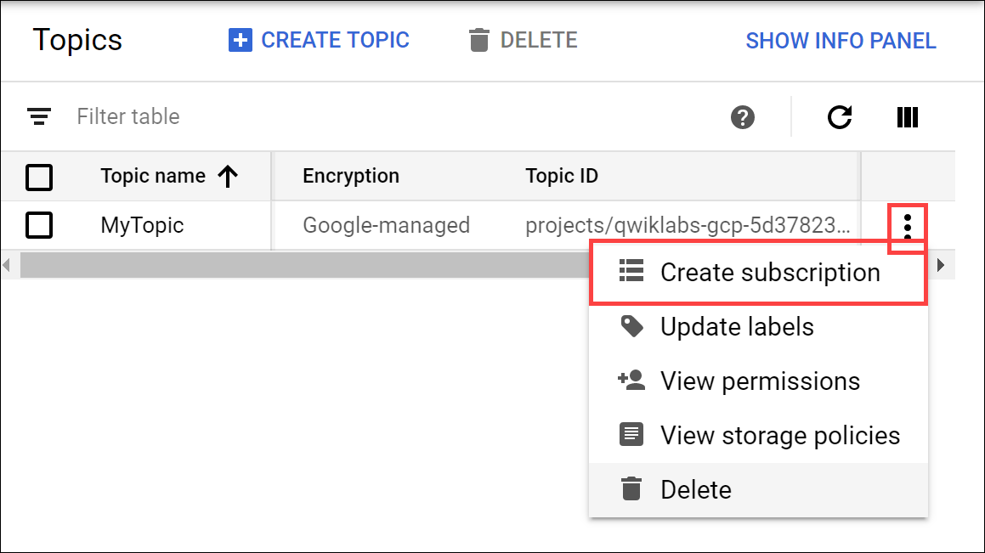

1. In the **Add subscription to topic** dialog:

* Type a name for the subscription, such as **MySub**
* Set the Delivery Type to **Pull**.
* Leave all other options at the default values.

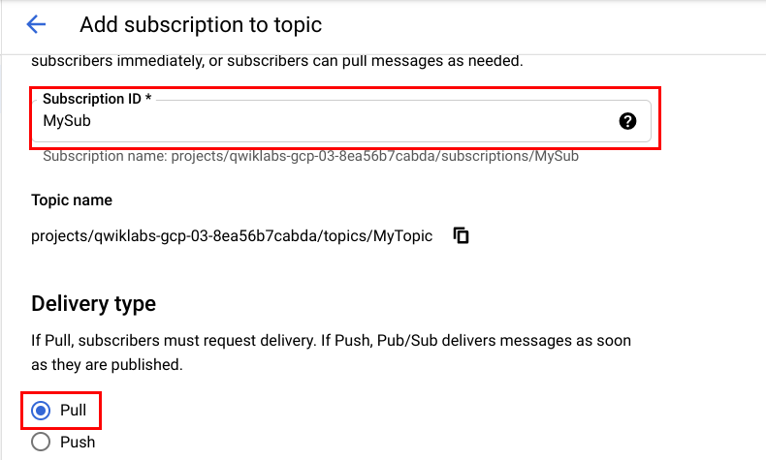

* Click **Create**.

Your subscription is listed in the Subscription list.

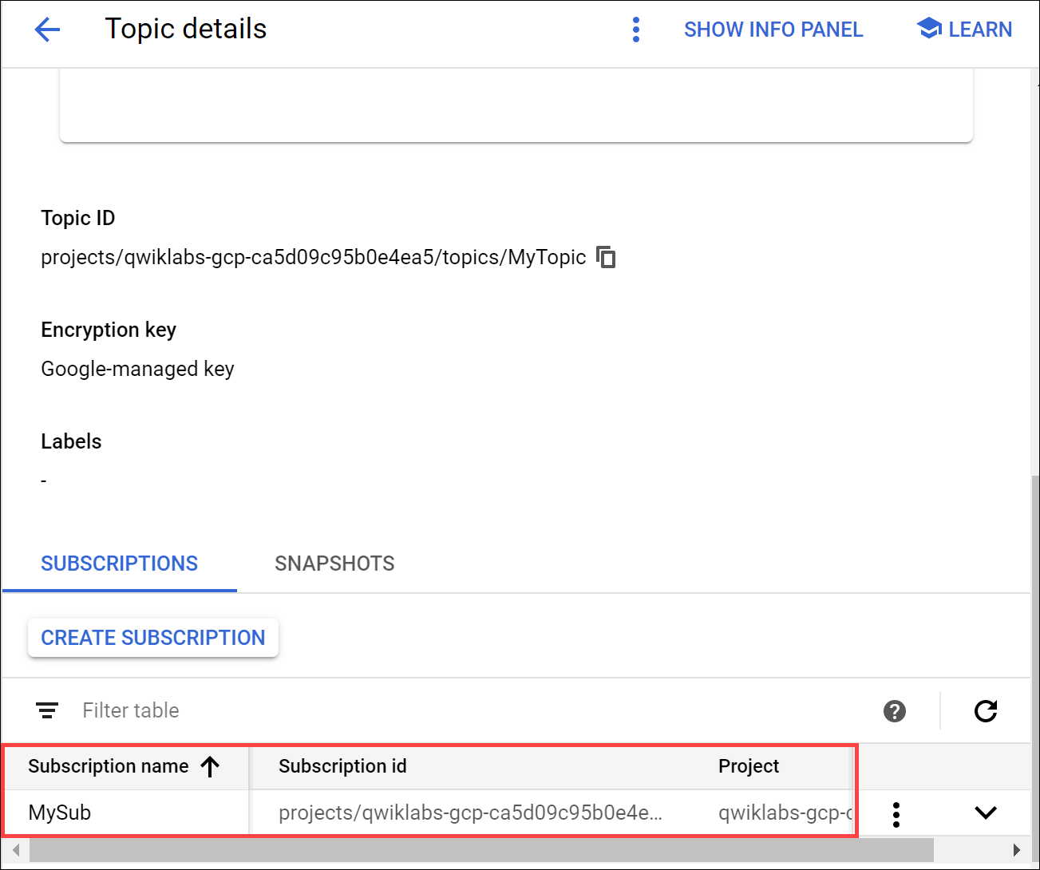

**Publish a message to the topic**

1. At the top of the **Topics details** dialog, click **PUBLISH MESSAGE**.
2. Enter Hello World in the **Message** field and click **Publish**.

