Streaming Manager API Workshop Prerequisites

Author: George Owen

This page left intentionally blank

Document History

Revision History

|  |  |
| --- | --- |
| Date of this revision: 16th March 2017 | Date of next revision On Request |

|  |  |  |  |
| --- | --- | --- | --- |
| Revision Number | Revision Date | Summary of Changes | Changes marked |
| V0.01 | Mar 16, 2017 | Initial Version | (N) |
| V0.2 | May 17, 2017 | Doug Updates | Y |
| V0.21 | June 12, 2017 | George Eclipse Installs | N |
|  |  |  |  |
|  |  |  |  |
|  |  |  |  |

Contents

1. Prerequisites and Setup 5

1.1 Bluemix 5

1.2 Streaming Manager 5

1.3 Cloud Foundry 5

1.4 Git 5

1.5 Eclipse Neon 6

1.6 Streaming Manager JS library 6

1.7 Eclipse tools for Bluemix 7

# Prerequisites and Setup

This workshop requires the local installation of additional software. Some of it is related to Bluemix and would not normally be required in a different environment.

## Bluemix

Sign-up for a Bluemix trial account at <https://console.ng.bluemix.net/> .

## Streaming Manager

Sign-up for a Streaming Manager trial account at <https://www.ustream.tv/platform/plans?itm_source=home_header&itm_medium=onsite&itm_content=sign_up&itm_campaign=header>.

After your account is provisioned send email to one of the workshop contacts with the id of your account. Additional options must be set on the account to support the workshop.

To prepare for the workshop there should be at least two channels and one or two videos in each channel. This will provide useful content for the 1st four labs.

Log onto your Streaming Manager account. Select the **Channels** link in the navigation pane on the left, then click the **Create new channel** button on the upper left.

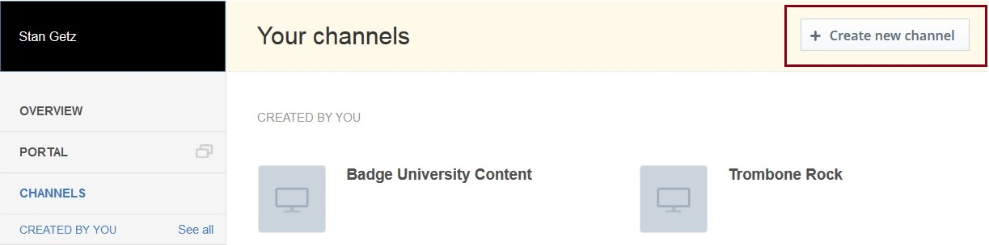

Enter a title for the channel and click **Create**.

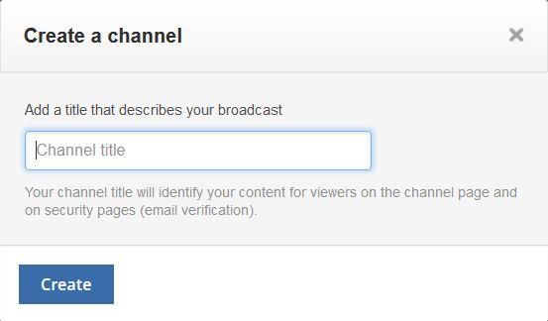

Click on the new channel title, either on the left under **Channels** or on the right. A new pane will open with an empty list of videos. Click the **Upload** button at the top right.

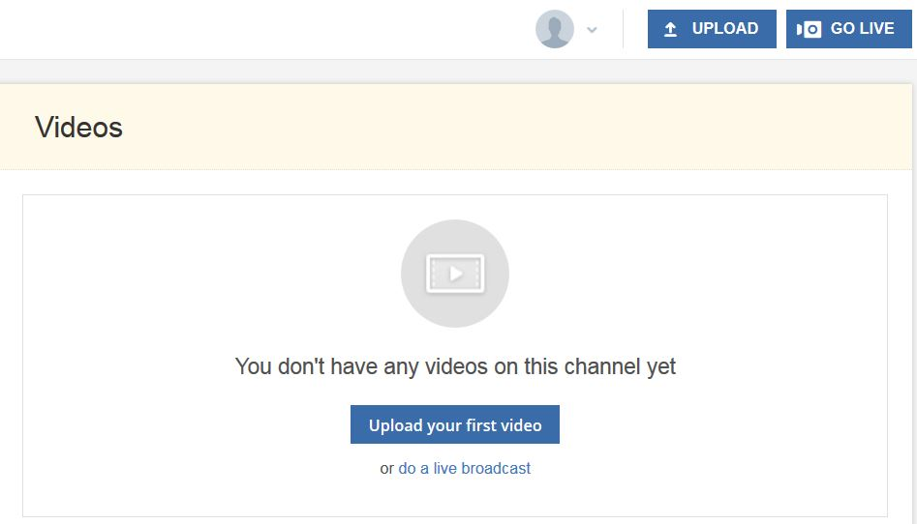

It may ask for the target channel, so select it from the dropdown.

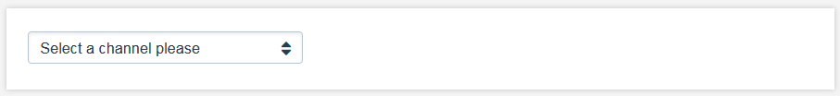

Now browse for a video to upload, or drag it into the upload window.

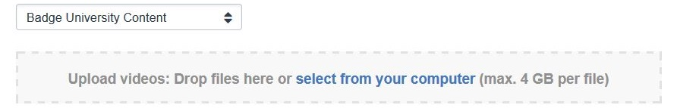

## Cloud Foundry

This tool is required for updating the application in Bluemix. Find the download files for various platforms at <https://github.com/cloudfoundry/cli#downloads> .

## Git

Used by Cloud Foundry, installers for various platforms found at <https://git-scm.com/downloads> .

## Eclipse Neon

Eclipse is optional and can be used regardless of the environment, but it does provide helpful IDE editors for PHP and Javascript. There are two options for finding the packages. The first is a public version, while the 2nd is an IBM version with some PHP options already configured. Requires Java 64-bit.

* <http://www.eclipse.org/downloads/download.php?file=/technology/epp/downloads/release/neon/M2/eclipse-java-neon-M2-win32-x86_64.zip>,
* <http://eclipse.org/go/DISTRO_IBM@INSTALLER-WIN64> (Eclipse Neon.3)

Given the choice, install the Java IDE:

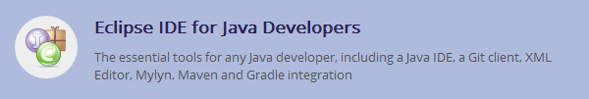

Then install additional Eclipse packages to support PHP and Javascript programming.

Start by going to the Eclipse Marketplace at **Help / Eclipse Marketplace**, or find the link on the Welcome page.

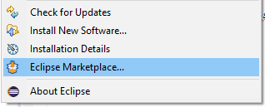 or 

On the **Search** tab enter “node.js”, set the **Markets** field to “Tools” and press Enter.



Scroll down until you find **“IBM Node.js Tools for Eclipse**” and then click the **Install** button. There are various packages for JavaScript support but this one is relatively lightweight and provides all the support needed. If the package isn’t on the returned list, which is likely, follow the link at the bottom of the list:

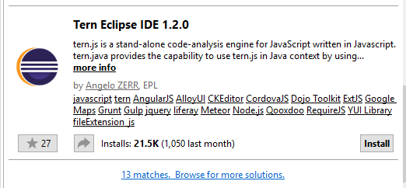

Once the package is found click the **Install** button.

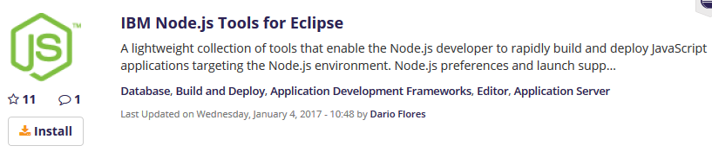

After that is installed go back to the **Search** tab and enter “php development”. Scroll to find the following package and install.

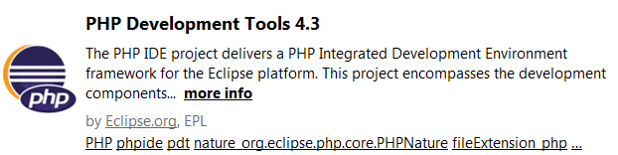

## Streaming Manager JS library

There is a JavaScript library required for interacting with the embedded video player. Currently it can be downloaded from this location <https://github.com/ustream/embedapi/tree/master/src>. Right-click the file link (ustream-embedapi.js) and then click “**Save Link as …**”.

This file will be imported into the Eclipse project during the lab setup.

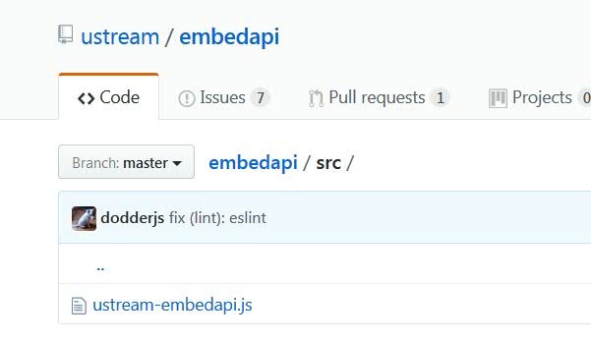

## Eclipse tools for Bluemix

Also optional, can be found here or installed inside Eclipse <http://marketplace.eclipse.org/content/ibm-eclipse-tools-bluemix>.

