Mean and SD estimates:

Temperature Mean: 12.20743

Temperature SD: 5.412521

Salinity Mean: 29.70221

Salinity SD: 5.421593

Means across all sites:

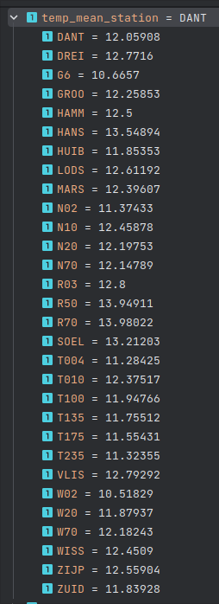 Temperature and salinity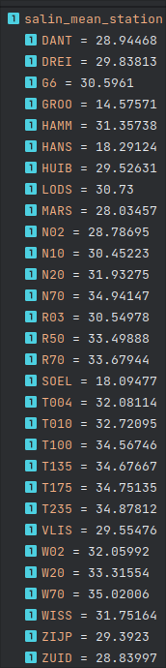:

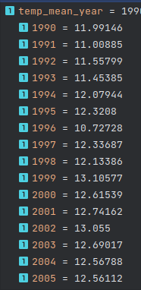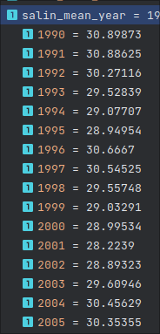And by year temp and salinity:

Aggregates: see agg1.csv for temperature data and agg2.csv for salinity data

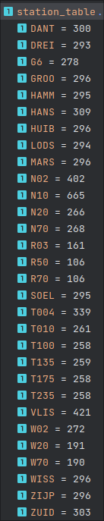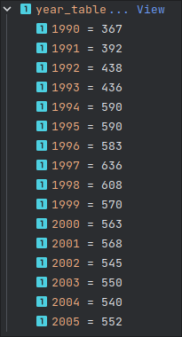

Table function, se tab1.csv for combined tables