jun9_a2ui_agui
CopilotKit AG-UI / A2UI Business Trip Planner 설명 문서
작성일: 2026-06-09 | 대상: week8/labs/a2ui_agui
문서 목적
이 문서는 demo 앱의 request flow, endpoint 경계, frontend/backend tool 위치, shared state 유지 방식, 그리고 실제 코드에서 각 책임이 구현된 위치를 빠르게 설명하기 위한 기술 reference다.

1. 요약
- 이 프로젝트는 Bun + Next.js frontend와 FastAPI + Pydantic AI backend를 CopilotKit AG-UI로 연결한 출장 계획 demo다.
- Main workspace는 React component가 AG-UI shared state를 읽어 render한다. Agent가 직접 DOM을 만들거나 route를 직접 바꾸지 않는다.
- A2UI는 CopilotSidebar chat 안에 declarative visual surface를 그리는 선택적 경로다. Main workspace 갱신은 stage-specific frontend tool과 agent.setState()가 담당한다.
- Shared state의 browser-side source of truth는 CopilotKit agent.state이며, 매 AG-UI run마다 backend의 TravelPlannerState로 검증되어 system prompt에 JSON으로 재주입된다.

2. A2UI / AG-UI 문서 확인 메모
A2UI는 agent가 JSON 기반 schema와 data update로 UI surface를 선언하고, client renderer가 안전한 native component catalog로 render하는 declarative Generative UI 방식이다. CopilotKit 문서 기준으로 A2UI surface는 create/update/data/render 계열 operation으로 구성되며, CopilotRuntime에서 a2ui를 활성화해야 tool result가 plain text가 아니라 rich surface로 처리된다.
Dynamic Schema 접근에서는 runtime이 render_a2ui tool을 agent request에 주입할 수 있고, agent는 이 tool을 호출해 chat-side UI artifact를 만든다. 이 프로젝트에서는 main workspace와 A2UI를 분리해, workspace는 shared state 기반 React stage view로 유지한다.
Chrome DevTools note
요청된 jun9_a2ui_agui Chrome tab은 현재 DevTools MCP에서 접근 가능한 Chrome profile에 노출되지 않았다. 실제 접근 가능한 Chrome window는 Incognito new tab 하나였고, DevToolsActivePort 연결도 실패했다. 따라서 A2UI 설명은 공식 CopilotKit/A2UI 문서와 로컬 reference/codebase 기준으로 교차 확인했다.

Reference | Use in this document
CopilotKit A2UI docs | A2UI concept, runtime a2ui enablement, render_a2ui boundary
A2UI Protocol v0.10 | surface/data model/update/action concepts
Pydantic AI AG-UI adapter docs | backend /api/ag-ui adapter path and state injection model
Local codebase | actual route, tools, state, and component contracts

Links: CopilotKit A2UI | Dynamic Schema A2UI | A2UI Protocol | Pydantic AI AG-UI

3. Flow diagrams
아래 diagram은 Downloads에서 가져온 Eraser export 이미지이며, 현재 프로젝트의 실제 runtime boundary를 기준으로 정리했다.
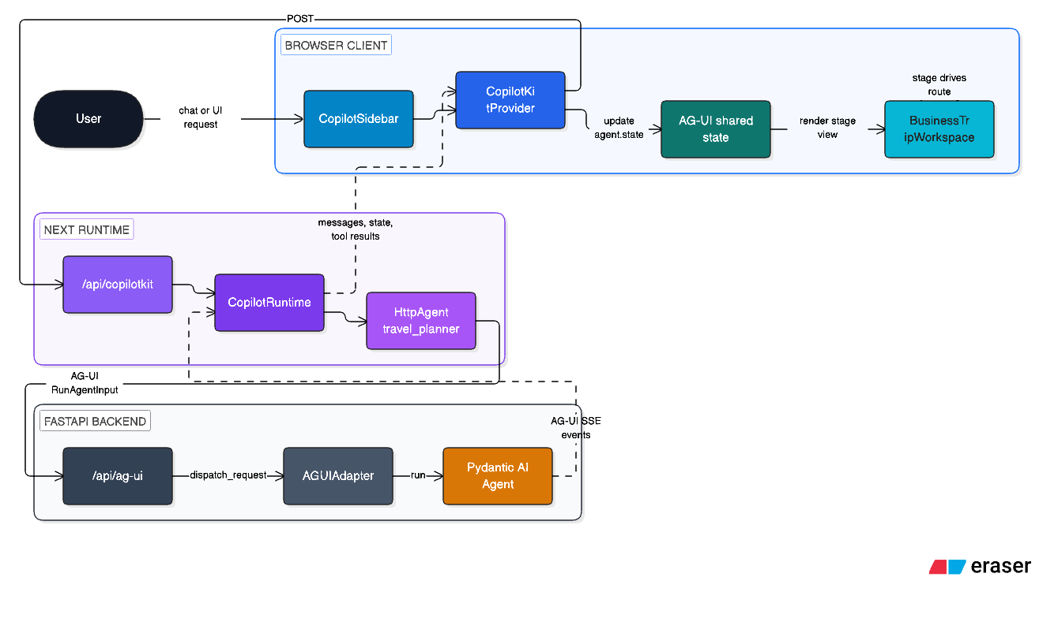
Figure 1. Runtime boundary: Browser, Next runtime, FastAPI backend, Pydantic AI agent.
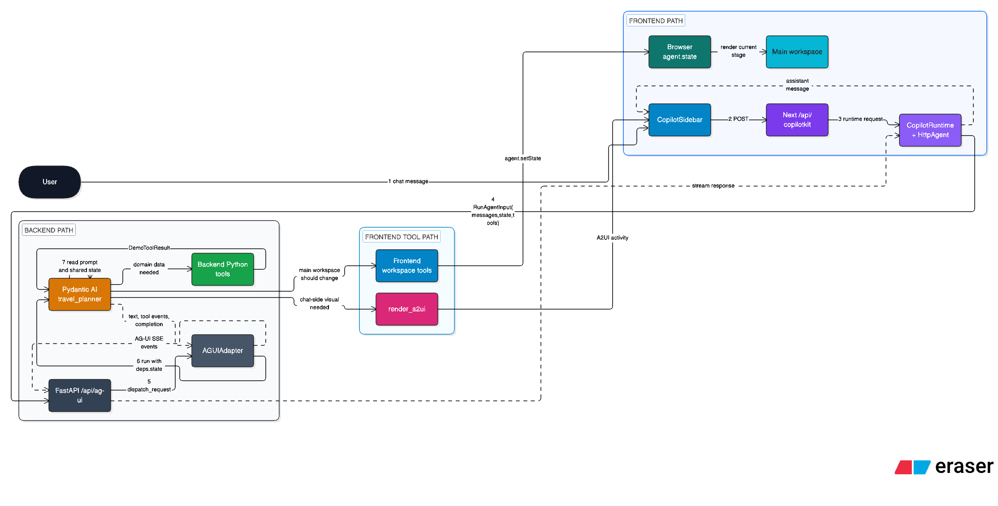
Figure 2. Full request flow: chat message부터 AG-UI SSE response까지.
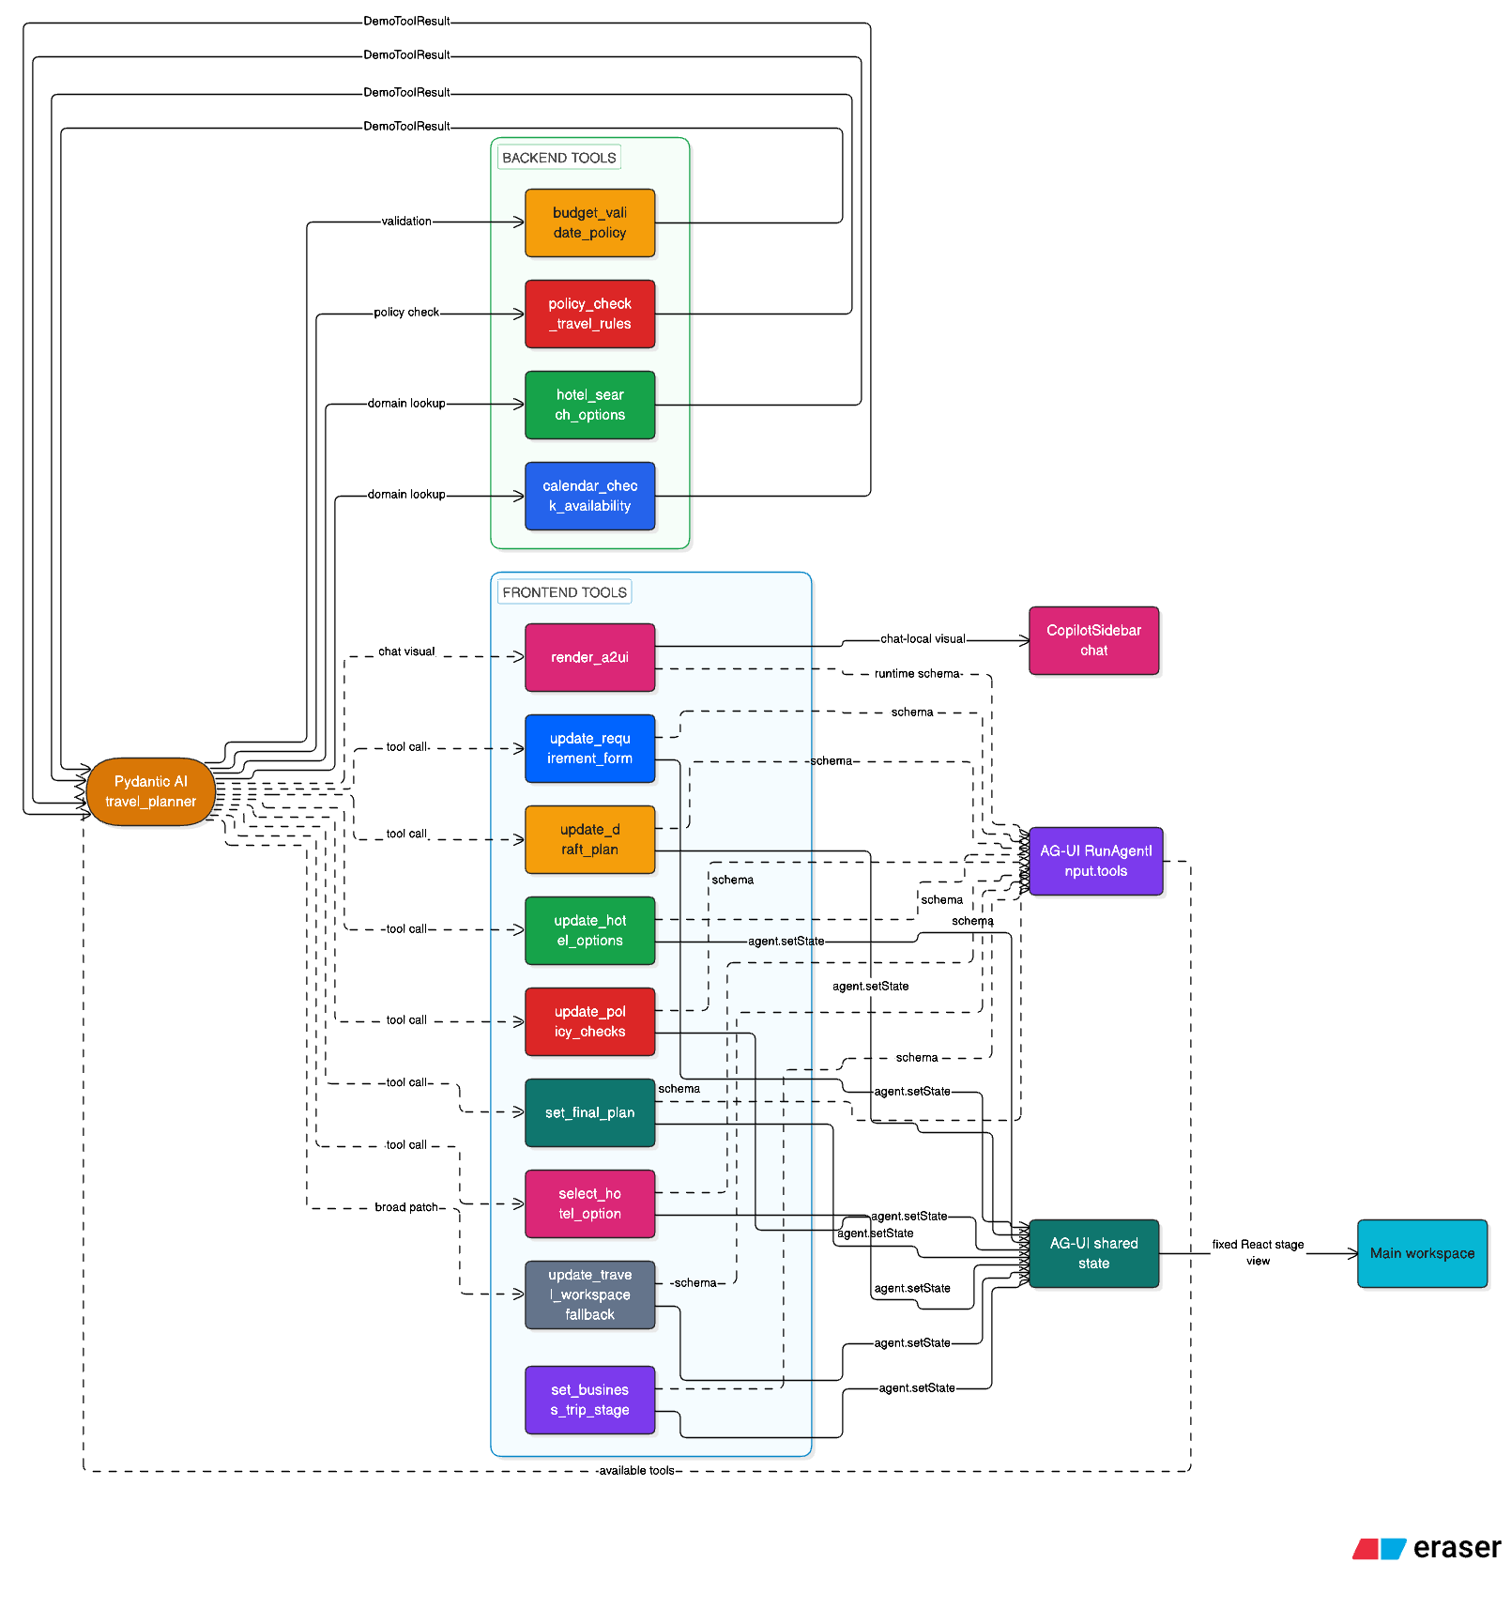
Figure 3. Backend Python tools, frontend workspace tools, render_a2ui의 위치.
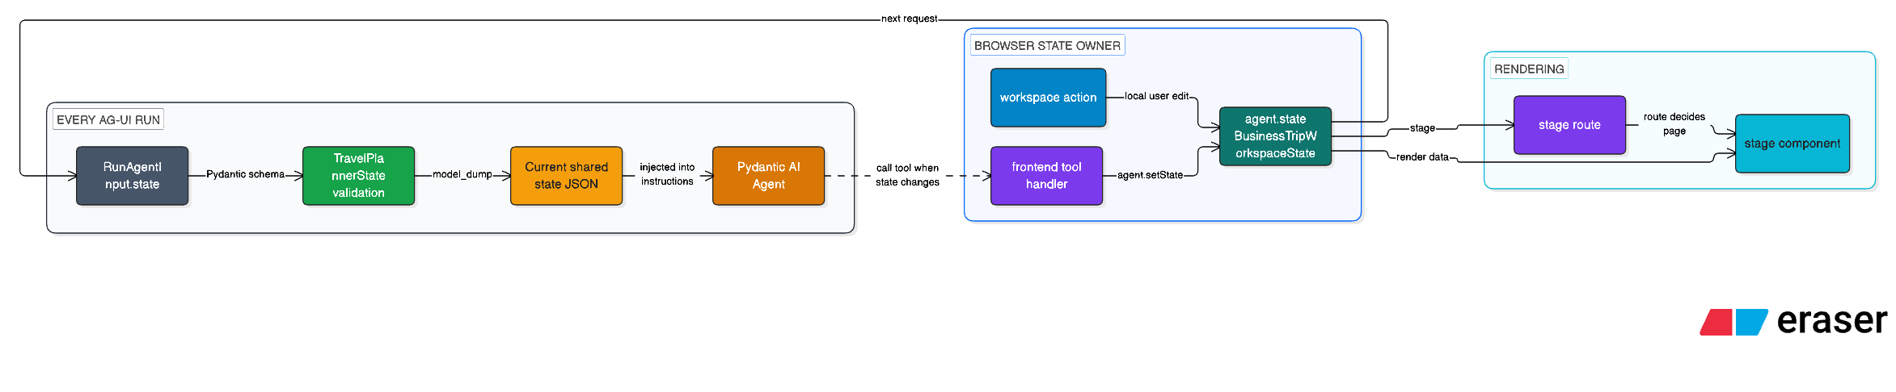
Figure 4. Shared state lifecycle: browser agent.state -> RunAgentInput.state -> backend prompt.
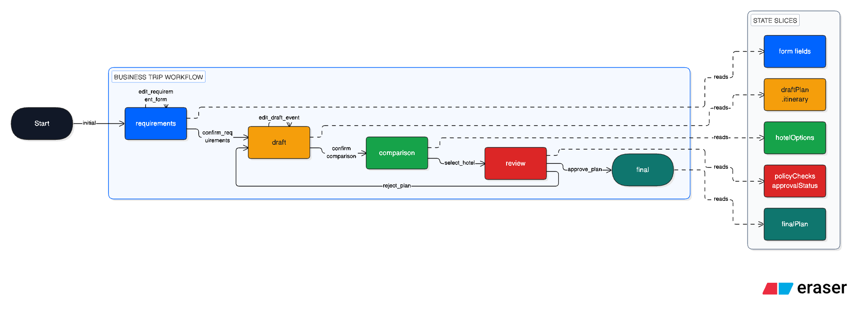
Figure 5. Stage transition and state slice mapping.
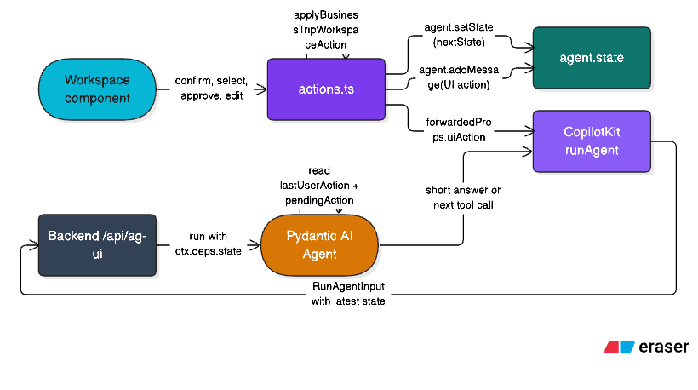
Figure 6. UI component action flow: workspace action -> state -> runAgent -> backend.

4. Architecture reading guide
Layer | Primary files | Responsibility
Next runtime | copilotkit_agui/src/app/api/copilotkit/route.ts | Create CopilotRuntime, register HttpAgent, expose single CopilotKit endpoint, enable A2UI runtime capability.
React provider/chat | copilot-business-trip-provider.tsx, copilot-business-trip-sidebar.tsx | Mount CopilotKitProvider and CopilotSidebar for the travel_planner agent.
Workspace shell | business-trip-workspace.tsx | Read agent.state, register frontend tools, route by stage, send UI actions back through runAgent.
Frontend tools | business-trip/tools.tsx | Expose stage-specific state patch tools to the agent through AG-UI request tools.
Frontend state schema | business-trip/state.ts | Define zod schema, merge/coerce helpers, and UI-facing state contract.
Backend endpoint | agent_shared_backend/src/api/endpoints.py | Expose /api/ag-ui as primary demo path and /api/chat as backend-only debug path.
Backend agent | travel_planner/agent.py | Construct Pydantic AI agent, attach tools, inject Current AG-UI shared state JSON into instructions.
Backend state schema | travel_planner/state.py | Mirror frontend state schema and satisfy Pydantic AI StateHandler shape.

5. Code snippets by role

5.1 Next.js CopilotKit runtime bridge
File: week8/labs/a2ui_agui/copilotkit_agui/src/app/api/copilotkit/route.ts
Role: Creates HttpAgent that forwards to FastAPI /api/ag-ui and enables runtime-level A2UI capability.
7 | const agentUrl = process.env.AGENT_AG_UI_URL ?? "http://localhost:8200/api/ag-ui";
8 | const travelPlannerAgent = new HttpAgent({
9 | agentId: "travel_planner",
10 | url: agentUrl,
11 | });
12 |
13 | const runtime = new CopilotRuntime({
14 | agents: {
15 | // CopilotKit 1.59.5 runtime package pins @ag-ui/client internally.
16 | // registry 최신 @ag-ui/client와 private field 타입만 갈라지므로 runtime agent 계약으로 좁혀서 넘긴다.
17 | travel_planner: travelPlannerAgent as never,
18 | },
19 | // A2UI renderer는 client provider가 직접 주입하지 않는다.
20 | // runtime이 이 값을 /info 경로로 알려야 CopilotKit v2 provider가 A2UI activity renderer를 자동으로 켠다.
21 | a2ui: {},
22 | });
23 |
24 | const handleCopilotKitRequest = createCopilotRuntimeHandler({
25 | runtime,
26 | basePath: "/api/copilotkit",
27 | mode: "single-route",
28 | });

5.2 Browser provider and A2UI theme boundary
File: week8/labs/a2ui_agui/copilotkit_agui/src/ui/components/copilot-business-trip-provider/copilot-business-trip-provider.tsx
Role: Mounts CopilotKitProvider against /api/copilotkit and sets the A2UI renderer theme.
11 | export function CopilotBusinessTripProvider({
12 | children,
13 | }: CopilotBusinessTripProviderProps) {
14 | return (
15 | <CopilotKitProvider
16 | runtimeUrl="/api/copilotkit"
17 | useSingleEndpoint
18 | a2ui={{
19 | theme: {
20 | colors: {
21 | primary: "#0064FF",
22 | },
23 | },
24 | }}
25 | >
26 | <TooltipProvider>{children}</TooltipProvider>
27 | </CopilotKitProvider>

5.3 CopilotSidebar agent binding
File: week8/labs/a2ui_agui/copilotkit_agui/src/ui/components/copilot-business-trip-sidebar/copilot-business-trip-sidebar.tsx
Role: Uses CopilotKit prebuilt sidebar and binds it to agentId=travel_planner.
5 | export function CopilotBusinessTripSidebar() {
6 | return (
7 | <CopilotSidebar
8 | agentId="travel_planner"
9 | defaultOpen
10 | position="right"
11 | width={500}
12 | labels={{
13 | chatInputPlaceholder: "출장 요청을 입력하세요",
14 | chatDisclaimerText: "중요한 정보는 직접 확인하세요.",
15 | chatToggleCloseLabel: "닫기",
16 | chatToggleOpenLabel: "열기",
17 | modalHeaderTitle: "출장 지원",
18 | welcomeMessageText: "목적지, 일정, 예산, 선호 조건을 알려주세요.",
19 | }}
20 | />

5.4 Workspace state subscription and route sync
File: week8/labs/a2ui_agui/copilotkit_agui/src/ui/components/business-trip-workspace/business-trip-workspace.tsx
Role: Reads AG-UI shared state, exposes context to agent, and syncs route from state.stage.
45 | export function BusinessTripWorkspace({ routeStage }: BusinessTripWorkspaceProps) {
46 | const router = useRouter();
47 | const { copilotkit } = useCopilotKit();
48 | const { agent } = useAgent({
49 | agentId: "travel_planner",
50 | updates: [UseAgentUpdate.OnStateChanged, UseAgentUpdate.OnRunStatusChanged],
51 | });
52 | const [actionError, setActionError] = useState<string | null>(null);
53 | const [actionPending, setActionPending] = useState(false);
54 | const [queuedWorkspaceAction, setQueuedWorkspaceActionState] =
55 | useState<BusinessTripWorkspaceAction | null>(queuedWorkspaceActionSnapshot);
56 |
57 | const setQueuedWorkspaceAction = useCallback(
58 | (action: BusinessTripWorkspaceAction | null) => {
59 | queuedWorkspaceActionSnapshot = action;
60 | setQueuedWorkspaceActionState(action);
61 | },
62 | [],
63 | );
64 |
65 | useBusinessTripFrontendTools();
66 |
67 | const workspaceState = useMemo(
68 | () => coerceBusinessTripWorkspaceState(agent.state, routeStage),
69 | [agent.state, routeStage],
70 | );
71 |
72 | // CopilotKit은 AG-UI state를 run input에 싣지만, 현재 화면 projection도 agent context로 알려준다.
73 | // workspace 버튼 action 후 follow-up run이 같은 화면 사실을 기준으로 답하도록 유지하기 위한 경계다.
74 | useAgentContext({
75 | description: "Current business trip workspace state rendered in the browser",
76 | value: workspaceState as JsonSerializable,
77 | });
78 |
79 | useEffect(() => {
80 | if (
81 | isBusinessTripStage(workspaceState.stage) &&
82 | workspaceState.stage !== routeStage
83 | ) {
84 | router.replace(businessTripStagePath(workspaceState.stage));
85 | }
86 | }, [routeStage, router, workspaceState.stage]);

5.5 UI action to runAgent bridge
File: week8/labs/a2ui_agui/copilotkit_agui/src/ui/components/business-trip-workspace/business-trip-workspace.tsx
Role: Workspace button actions write state first, then run the agent with forwarded uiAction props.
148 | const handleWorkspaceAction = useCallback(
149 | async (action: BusinessTripWorkspaceAction) => {
150 | if (actionPending || queuedWorkspaceAction) {
151 | return;
152 | }
153 |
154 | setActionError(null);
155 | setActionPending(true);
156 |
157 | try {
158 | await sendBusinessTripWorkspaceAction(
159 | agent,
160 | workspaceState,
161 | action,
162 | async (uiAction) => {
163 | if (agent.isRunning) {
164 | setQueuedWorkspaceAction(uiAction);
165 | return;
166 | }
167 |
168 | await copilotkit.runAgent({
169 | agent,
170 | forwardedProps: {
171 | uiAction,
172 | },
173 | });
174 | },

5.6 Frontend workspace tools
File: week8/labs/a2ui_agui/copilotkit_agui/src/business-trip/tools.tsx
Role: Stage-specific frontend tools patch agent.state from agent tool calls; this is the main workspace rendering path.
75 | useFrontendTool(
76 | {
77 | agentId,
78 | name: "update_requirement_form",
79 | description:
80 | "Fill or patch the requirements form from chat. Update only fields the user supplied or the agent confidently inferred, then stop for user confirmation.",
81 | parameters: z.object({
82 | destination: z.string().nullish(),
83 | startDate: z.string().nullish(),
84 | nights: z.number().int().positive().nullish(),
85 | budgetKrw: z.number().int().positive().nullish(),
86 | tripPurpose: z.string().nullish(),
87 | preferences: z.array(z.string()).optional(),
88 | }),
89 | handler: async (patch, { agent }) => {
90 | const currentState = coerceBusinessTripWorkspaceState(
91 | agent.state,
92 | "requirements",
93 | );
94 | agent.setState(
95 | mergeBusinessTripWorkspaceState(currentState, {
96 | ...patch,
97 | stage: "requirements",
98 | workflowStage: "requirements",
99 | }),
100 | );
101 | return "requirement_form_updated";
102 | },
103 | },
104 | [],
105 | );
106 |
107 | useFrontendTool(
108 | {
109 | agentId,
110 | name: "update_draft_plan",
111 | description:
112 | "Update the calendar-style draft itinerary for the draft stage. Prefer event-level itinerary items with date, weekday, startTime, endTime, location, category, title, and detail.",
113 | parameters: z.object({
114 | draftPlan: draftPlanSchema,
115 | }),
116 | handler: async ({ draftPlan }, { agent }) => {
117 | const currentState = coerceBusinessTripWorkspaceState(agent.state, "draft");
118 | agent.setState(
119 | mergeBusinessTripWorkspaceState(currentState, {
120 | draftPlan,
121 | stage: "draft",
122 | workflowStage: "draft",
123 | }),
124 | );
125 | return "draft_plan_updated";
126 | },
131 | useFrontendTool(
132 | {
133 | agentId,
134 | name: "update_hotel_options",
135 | description:
136 | "Update hotel comparison options without replacing unrelated state. Do not choose a hotel unless the user explicitly selected one.",
137 | parameters: z.object({
138 | hotelOptions: z.array(hotelOptionSchema),
139 | budgetKrw: z.number().int().positive().nullish(),
140 | selectedHotelId: z.string().nullish(),
141 | }),
142 | handler: async (patch, { agent }) => {
143 | const currentState = coerceBusinessTripWorkspaceState(
144 | agent.state,
145 | "comparison",
146 | );
147 | agent.setState(
148 | mergeBusinessTripWorkspaceState(currentState, {
149 | ...patch,
150 | stage: "comparison",
151 | workflowStage: "comparison",
152 | }),
153 | );
154 | return "hotel_options_updated";
155 | },
156 | },
157 | [],
158 | );
159 |
160 | useFrontendTool(
161 | {
162 | agentId,
163 | name: "update_policy_checks",
164 | description:
165 | "Update policy checks and approval status for review after the user selected an option or explicitly requested review.",
166 | parameters: z.object({
167 | policyChecks: z.array(policyCheckSchema),
168 | approvalStatus: z
169 | .enum(["not_requested", "pending", "approved", "rejected"])
170 | .optional(),
171 | pendingAction: z.string().nullish(),
172 | }),
173 | handler: async (patch, { agent }) => {
174 | const currentState = coerceBusinessTripWorkspaceState(agent.state, "review");
175 | agent.setState(
176 | mergeBusinessTripWorkspaceState(currentState, {
177 | ...patch,
178 | stage: "review",
179 | workflowStage: "review",
180 | }),
181 | );
182 | return "policy_checks_updated";
183 | },

5.7 Backend AG-UI endpoint vs debug chat endpoint
File: week8/labs/a2ui_agui/agent_shared_backend/src/api/endpoints.py
Role: /api/chat is backend-only debug; /api/ag-ui is the primary CopilotKit demo path with state/tools/render_a2ui.
41 | @router.post("/api/chat")
42 | async def chat(request: ChatRequest, agent: AgentDep) -> ChatResponse:
43 | # Debug-only runtime path:
44 | #
45 | # - No AG-UI request object is present.
46 | # - No CopilotKit runtime middleware runs.
47 | # - No frontend tools, including runtime-injected `render_a2ui`, are available.
48 | #
49 | # Keep this endpoint useful for checking the Pydantic AI model and backend tools, but do
50 | # not treat it as a UI rendering path. The actual demo path is `/api/ag-ui` below.
51 | log_chat_request(request.message, request.client)
52 | result = await agent.run(request.message, deps=travel_planner_deps(request.client))
53 | output = str(result.output)
54 | log_chat_response(output)
55 | return ChatResponse(output=output)
56 |
57 |
58 | @router.post("/api/ag-ui")
59 | async def ag_ui_chat(request: Request, agent: AgentDep) -> Response:
60 | # Primary demo path:
61 | #
62 | # Browser CopilotSidebar
63 | # -> Next.js `/api/copilotkit`
64 | # -> CopilotRuntime + HttpAgent
65 | # -> this FastAPI endpoint
66 | # -> Pydantic AI AGUIAdapter
67 | # -> Pydantic AI `travel_planner` agent
68 | #
69 | # The AGUIAdapter converts the CopilotKit AG-UI RunAgentInput into a Pydantic AI
70 | # run and streams Pydantic AI events back as AG-UI SSE events.
71 | #
72 | # Message/session context:
73 | # - CopilotKit sends the accumulated browser-side messages in `RunAgentInput.messages`.
74 | # - AGUIAdapter loads those messages into Pydantic AI message history for this run.
75 | #
76 | # Shared state:
77 | # - CopilotKit sends the current browser-side `agent.state` in `RunAgentInput.state`.
78 | # - `travel_planner_deps()` returns a dataclass with a `state` field, so Pydantic AI's
79 | # StateHandler path validates that state and exposes it as `ctx.deps.state`.
80 | #
81 | # Runtime-injected frontend tools, including `render_a2ui`, arrive through this AG-UI
82 | # request and are intentionally not modeled as separate REST endpoints.
83 | body = await request.body()
84 | log_ag_ui_request(body, request.headers)
85 |
86 | response = await AGUIAdapter.dispatch_request(
87 | request,
88 | agent=agent,
89 | deps=travel_planner_deps("copilotkit_agui"),
90 | on_complete=log_ag_ui_completion,
91 | )
92 | log_ag_ui_stream_opened(response)

5.8 Pydantic AI agent and state injection
File: week8/labs/a2ui_agui/agent_shared_backend/src/agents/travel_planner/agent.py
Role: Builds the model-backed agent and appends the current AG-UI shared state JSON into instructions.
33 | agent = Agent(
34 | model,
35 | deps_type=TravelPlannerDeps,
36 | tools=get_tools(),
37 | )
38 |
39 | @agent.instructions
40 | def add_client_specific_system_prompt(ctx: RunContext[TravelPlannerDeps]) -> str:
41 | state_json = json.dumps(
42 | ctx.deps.state.model_dump(mode="json", by_alias=True),
43 | ensure_ascii=False,
44 | indent=2,
45 | )
46 | return f"{render_system_prompt(ctx.deps.client)}\n\nCurrent AG-UI shared state:\n{state_json}"
47 |

5.9 Backend TravelPlannerState mirror
File: week8/labs/a2ui_agui/agent_shared_backend/src/agents/travel_planner/state.py
Role: Mirrors frontend state and makes state available via deps.state for every Pydantic AI run.
85 | class TravelPlannerState(BaseModel):
86 | """State synchronized through AG-UI between CopilotKit and Pydantic AI.
87 |
88 | CopilotKit owns the browser-side copy. Every run sends the current state in
89 | `RunAgentInput.state`; Pydantic AI validates it here and reinjects it into
90 | the agent through `RunContext.deps.state`.
91 |
92 | This schema mirrors the CopilotKit frontend workspace contract. It is not a
93 | backend-only persistence model. Frontend workspace tools mutate these fields
94 | in the browser agent state, and the next AG-UI request sends the same state
95 | back here for context reinjection.
96 | """
97 |
98 | model_config = ConfigDict(extra="allow", populate_by_name=True)
99 |
100 | stage: WorkspaceStage | None = None
101 | workflow_stage: WorkflowStage = Field(default="requirements", alias="workflowStage")
102 | destination: str | None = None
103 | start_date: str | None = Field(default=None, alias="startDate")
104 | nights: int | None = None
105 | budget_krw: int | None = Field(default=None, alias="budgetKrw")
106 | trip_purpose: str | None = Field(default=None, alias="tripPurpose")
107 | preferences: list[str] = Field(default_factory=list)
108 | selected_hotel_id: str | None = Field(default=None, alias="selectedHotelId")
109 | approval_status: ApprovalStatus = Field(default="not_requested", alias="approvalStatus")
110 | last_user_action: str | None = Field(default=None, alias="lastUserAction")
111 | pending_action: str | None = Field(default=None, alias="pendingAction")
112 | requirement_cards: list[RequirementCard] = Field(default_factory=list, alias="requirementCards")
113 | draft_plan: DraftPlan | None = Field(default=None, alias="draftPlan")
114 | hotel_options: list[HotelOption] = Field(default_factory=list, alias="hotelOptions")
115 | policy_checks: list[PolicyCheck] = Field(default_factory=list, alias="policyChecks")
116 | final_plan: FinalPlan | None = Field(default=None, alias="finalPlan")
117 |
118 |
119 | @dataclass
120 | class TravelPlannerDeps:
121 | """Agent dependencies passed to every Pydantic AI run.
122 |
123 | This dataclass intentionally has a non-optional `state` field so it satisfies
124 | Pydantic AI's `StateHandler` protocol. Without this shape, AG-UI state sent
125 | by CopilotKit is ignored by `AGUIAdapter`.
126 | """
127 |
128 | client: ClientPromptParams
129 | state: TravelPlannerState = field(default_factory=TravelPlannerState)
130 |
131 |
132 | def travel_planner_deps(client_id: ClientId) -> TravelPlannerDeps:
133 | return TravelPlannerDeps(client=client_prompt_params(client_id))

6. What the agent actually sees
Input | Source | Meaning
System prompt | system.j2 + client params | Workflow gates, tool rules, A2UI/main workspace boundary.
Shared state JSON | agent.py instruction hook | Current browser workflow state, including UI actions and selected options.
Message history | RunAgentInput.messages | Sidebar conversation plus synthetic user messages from workspace actions.
Backend tools | Pydantic AI get_tools() | Mock schedule, hotel, budget, and policy business logic.
Frontend tools | useFrontendTool() | Workspace state mutation tools provided through AG-UI request.
render_a2ui | CopilotKit runtime | Chat-side declarative UI rendering, not main workspace route update.

Critical distinction
Backend tool results are domain artifacts. They do not automatically render the main workspace. Main workspace rendering happens only when browser-side shared state changes. Chat-side A2UI rendering is separate and should not duplicate the same structured data already visible in the workspace.

7. Implementation notes and demo interpretation
- A user message can populate the requirements form through update_requirement_form, but the agent should stop for confirmation instead of racing through every downstream stage.
- A workspace button can be stronger than text: select_hotel, approve_plan, reject_plan, and edit_draft_event first mutate state and then trigger runAgent so the agent sees the latest user intent.
- The calendar drag/resize behavior is meaningful because the updated draftPlan.itinerary is written to agent.state before the next AG-UI run.
- The approval review screen is state-driven. selectedHotelId, policyChecks, approvalStatus, and finalPlan determine what the user sees.
- The broad update_travel_workspace tool is intentionally treated as compatibility fallback. Stage-specific tools reduce schema bloat and clarify component responsibility.

Appendix. Downloaded diagram assets
Asset | Description
docs/assets/diagrams/named/00-eraser-board-overview.png | Full Eraser board overview from Downloads.
docs/assets/diagrams/named/01-runtime-boundary.png | Runtime boundary diagram.
docs/assets/diagrams/named/02-full-request-flow.png | End-to-end request flow diagram.
docs/assets/diagrams/named/03-tool-entry-points.png | Backend/frontend tool location diagram.
docs/assets/diagrams/named/04-shared-state-lifecycle.png | Shared state lifecycle diagram.
docs/assets/diagrams/named/05-ui-component-action-flow.png | Workspace UI action flow diagram.
docs/assets/diagrams/named/06-stage-state-flow.png | Stage transition and state slice diagram.

Preset audit
Preset: compact_reference_guide. Page margins, heading ladder, body rhythm, compact tables, and code-block styling were explicitly set in the generated DOCX. Tables use explicit widths and cell margins; code snippets use monospaced blocks with shaded backgrounds.

