OWEN MOOGK
  - Mechatronics Engineering Student
  - at the University of Waterloo
  - 226-989-0602
  - owenmoogk@gmail.com
  - linkedin.com/in/owenmoogk
  - owenmoogk.github.io

SKILLS
Software Development: Python, TypeScript, JavaScript/jQuery, C++, C#, Java, R, SQL (Postgres / MS SQL Server).
Frameworks / Tools: React, Docker, Next.js, Django, FastAPI, WSL, Ubuntu, Linux, MVC/ASP.NET, TanStack, Visual Studio, VS Code.
Design & Engineering: SolidWorks, AutoCAD, and Onshape for 3D printing / manufacturing. Altium for circuit and PCB design.
Other: Experience debugging circuitry with oscilloscope, design for manufacturing, version control with Git / TFS.

EXPERIENCE

Software Developer (Co-op) – Base Power Company January 2026 – April 2026
- Built a custom manufacturing execution system to coordinate processes in a production line, using Golang, React/TypeScript, and PostgreSQL, enabling detailed metrics of quality, costs, and operational capability.
- Optimized manufacturing process and shared contracts through data model design and coordination.
- Designed a query builder library with composable filter abstractions, allowing reusable code generation.
- Engineered a bi-directional ERP integration using Temporal workflows to synchronize inventory tracking.
- Built E2E testing infrastructure with Playwright, Docker-based test environments, and GitHub Actions CI triggers.
- Engineered deploy pipeline optimizations, doubling the speed from push to deployment, reducing engineering cycle time.
- Managed infrastructure across Terraform, Pkl service configuration, and AWS to build systems for reliability and uptime.

Electrical Engineering Student (Co-op) – Wrmth Corp. May 2025 – August 2025
- Worked as an electrical engineering student designing printed circuit boards for mass production of heated outdoor furniture.
- Created and reviewed schematics for prototyping and mass production, ensuring performance in sub-optimal conditions.
- Designed and routed multi-layer PCBs for mass manufacturing and reliability, reducing board costs by approximately 80%.
- Created test procedures and used oscilloscope debugging techniques to validate circuit board functionality and performance.
- Designed and programmed a custom 3D printed SCARA robotic arm for additive and subtractive manufacturing and production.
- Programmed a custom G-code slicer/translator, including inverse kinematics, safety end stops, and controlled feed-rate.
- Built an IoT communication architecture for component plug-and-play reusability and rapid prototyping support.
- Improved manufacturing processes with logistical and 3D printed solutions, saving time and money in production.

Operational Software Developer (Co-op) – Rocket Factory Augsburg September 2024 – December 2024
- Developed operational tools for a 300-person team building advanced rocket technology, using React and FastAPI.
- Implemented web application features for part and assembly tracking, directly improving production workflow.
- Designed and built a time tracking application used company-wide, reducing administrative overhead by an estimated 60-70%.
- Improved advanced database ORM architectures for scalability and speed in PostgreSQL, reducing complexity immensely.
- Optimized codebase structure, refactoring and enhancing existing code to enhance performance, reusability, and scalability.
- Utilized Git pipelines to improve testing and deployment of applications, ensuring quality and usability of tools.
- Implemented CRUD features in a modular manner, allowing for optimal code reuse and development ease.
- Utilized planning, project management, and communication skills to ensure adoption and integration of tools (studying workflows and designing with the user in mind).

EDUCATION

Mechatronics Engineering – University of Waterloo 2022 – 2027
- Candidate for Bachelor of Applied Science studying Mechatronics Engineering, with a grade average above 90%.
- Presidents Scholarship of Distinction, Douglas Wright Award, International Experience Award, Dean’s Honors.
- Relevant courses: Circuits, Digital Logic, Actuators, Power Electronics, Microprocessors, Real-time systems, DSA.

PROJECTS

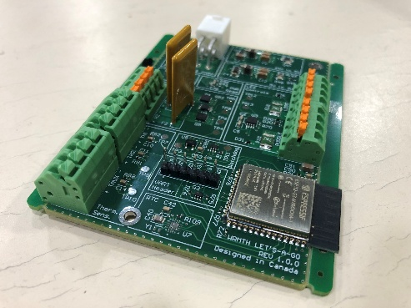
Heated Chair PCB
- Designed schematics and layout for a PCB, designed to run firmware for heated outdoor furniture.
- Developed schematics and CAD in Altium.
- Routed microprocessor signals to components, supporting heaters, temperature sensors, and LED lighting, from an ESP-32.
- Included high current heater controls, a watchdog safety mechanism, and overheating + short circuit protection.
- Implemented power converters, managing three power levels across the board.
- Validated and tested board with oscilloscope and multimeter debugging techniques, ensuring a safe bring-up.

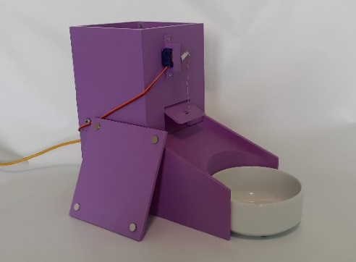
AI-Powered Cat Feeding Robot
- Designed and programmed a 3D printed robot to autonomously feed pets.
- Developed CAD models for 3D printing in SolidWorks.
- Built microcontroller circuits, integrating an Arduino with other simple electronic components, such as LEDs, limit switches, and servos.
- Utilized Computer Vision to detect a cat via an onboard webcam.
- Programmed the robot in C++ and Python to detect a cat’s presence and dispense food, given specific criteria.
- Project details: https://owenmoogk.github.io/projects/cat-feeder

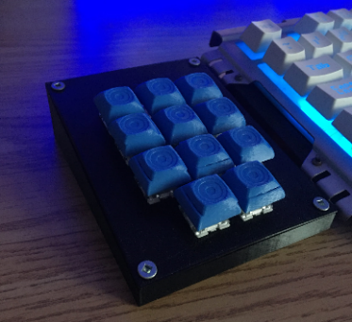
Custom Built MacroPad
- Designed, built, and programmed a complete MacroPad. Capabilities include executing complex keystroke instructions, Spotify API calls, and much more.
- Designed the custom 3D printed housing and keycaps in SolidWorks.
- Designed a custom PCB (printed circuit board) for ease of integration.
- Built a custom mounting system that allowed integration with existing keyboards.
- Integrated hardware switches with an Arduino Nano, which interfaces with a PC.
- Programmed logic with C++ and Python.
- Project details: https://owenmoogk.github.io/projects/macropad

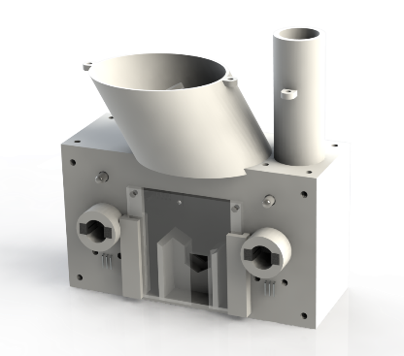
Multi-Function Feeder – Hub for Neuroengineering Solutions
- Designed a rodent cognitive testing device in SolidWorks, with an inbuilt logic and reward feeding system.
- 3D printed components for rapid prototyping, assembly, and use.
- Designed a modular accessory system, allowing for a variety of functionality, dependant on a researcher’s goals and use-case.
- Integrated sensors with actuators through system-level logic in Python.
- Utilized communication protocols including I2C and SPI.
- Tested device with rodent behavior, ensuring proper functionality and usability.
- Project details: https://owenmoogk.github.io/projects/multi-function-feeder

These are some of my favourite and most applicable projects.
For a complete list of projects and more details, please visit my website’s project page, located at:
https://owenmoogk.github.io/projects

