GROUP ASSIGNMENT COVER SHEET
Student ID Number | Surname | Given Names |  | Percentages of Contribution
32353391 | Cheng | Ho Wang |  | 33%
32641451 | Ting | Yuchien |  | 33%
29974151 | chen | kaixiang |  | 34%
Total |  |  |  | 100%
* Please include the names of all other group members.
Unit name | Applied Data Analysis |  | Unit Code | FIT5149
Title of assignment | Job change prediction
Campus | Clayton
Is this an authorised group assignment? √ Yes No
Has any part of this assignment been previously submitted as part of another unit/course? Yes No√
Due Date:21/10/2022 |  | Date submitted |  | 21/10/2022
All work must be submitted by the due date. If an extension of work is granted this must be specified with the signature of the lecturer/tutor.
Extension granted until (date) ................................ Signature of lecturer/tutor ................................................................
Please note that it is your responsibility to retain copies of your assessments.
Intentional plagiarism or collusion amounts to cheating under Part 7 of the Monash University (Council) Regulations

Plagiarism: Plagiarism means taking and using another person’s ideas or manner of expressing them and passing them off as one’s own. For example, by failing to give appropriate acknowledgement. The material used can be from any source (staff, students or the internet, published and unpublished works).

Collusion: Collusion means unauthorised collaboration with another person on assessable written, oral or practical work and includes paying another person to complete all or part of the work.

Where there are reasonable grounds for believing that intentional plagiarism or collusion has occurred, this will be reported to the Associate Dean (Education) or delegate, who may disallow the work concerned by prohibiting assessment or refer the matter to the Faculty Discipline Panel for a hearing.
Student Statement:
- I have read the university’s Student Academic Integrity Policy and Procedures.
- I understand the consequences of engaging in plagiarism and collusion as described in Part 7 of the Monash University (Council) Regulations http://adm.monash.edu/legal/legislation/statutes
- I have taken proper care to safeguard this work and made all reasonable efforts to ensure it could not be copied.
- No part of this assignment has been previously submitted as part of another unit/course.
- I acknowledge and agree that the assessor of this assignment may for the purposes of assessment, reproduce the assignment and:
- provide to another member of faculty and any external marker; and/or
- submit it to a text matching software; and/or
- submit it to a text matching software which may then retain a copy of the assignment on its database for the purpose of future plagiarism checking.
- I certify that I have not plagiarised the work of others or participated in unauthorised collaboration when preparing this assignment.
Signature .............................................................................. Date……………………………………
* delete (iii) if not applicable

Full Name (print): kaixiang chen Signature _________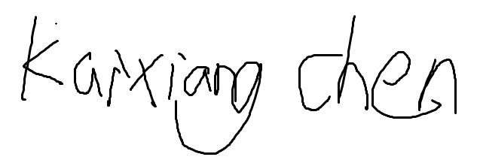_____________________ Date: 21/10/2022 ______

Full Name (print): Cheng Ho Wang Signature ___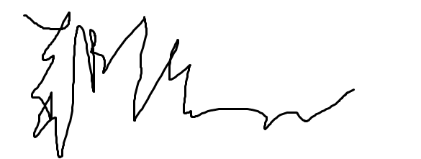__________________________ Date: 21 Oct 2022 ______

Full Name (print): Yuchien Ting Signature _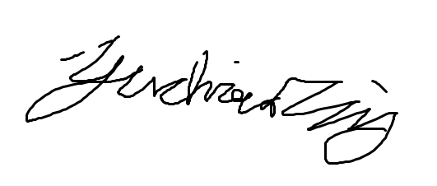__________________ Date:______ 21 Oct 2022 _____

Privacy Statement
The information on this form is collected for the primary purpose of assessing your assignment and ensuring the academic integrity requirements of the University are met. Other purposes of collection include recording your plagiarism and collusion declaration, attending to course and administrative matters and statistical analyses. If you choose not to complete all the questions on this form it may not be possible for Monash University to assess your assignment. You have a right to access personal information that Monash University holds about you, subject to any exceptions in relevant legislation. If you wish to seek access to your personal information or inquire about the handling of your personal information, please contact the University Privacy Officer: privacyofficer@adm.monash.edu.au

