Generative Design System
Independent Learning Contract with Dr. Richard Weiss
By Owen Meyer. 2014

Abstract:
Shape grammars come in a wide variety of forms and applications ranging from architectural design tools to programs used in creating art. Generative Design System (GDS) enters the fray offering users an interactive Graphical User Interface (GUI) to explore the creation of design layouts using generative shape grammars embedded in input designs. The purpose is to facilitate the exploration of designs that bear a stylistic resemblance to the input design, to give the artist a new medium to explore their creativity.

Introduction:
The natural world has served as a limitless resource of material for people creating ornament and design in textiles, jewelry, architecture and art. It provides elements of form and rules for how to combine these elements into aesthetically pleasing patterns and designs. Since natural process can be described with algorithm, it is intuitive for artisans to turn to the algorithms themselves as a source of design material. Generative and algorithmic procedure is not new to the creative process. “In various guises, generative processes have been long evident in art, far predating the current era of the digital computer. From Paleolithic ornamental art and hydraulically activated automata of ancient Alexandria and Islamic art circa the ninth century... all of these are examples of works with generative processes as their basis.”
Today powerful computers are introducing new approaches to creativity in design and art. The computational speed, and the availability, of modern computers puts incredible power in the hands of ordinary people and has opened up new mediums of expression such as computer animation and computational design. The affordability of computers also makes it possible for more people to access this kind of creativity in ways that were once prohibitive. For example, a modest sculpture's wood shop can easily cost $50,000 in equipment, plus the monthly cost of the space and power. By contrast, the programming language Processing is a salient example of how artists have embraced the power of computers to create works that introduce new forms of creativity into the art world without the overhead of an elaborate studio space.

Another powerful tool in computational design is shape grammars. While there is much research in the field of architecture utilizing shape grammars, there does not appear to be as much in the area of generative art. GDS attempts to use some of the ideas behind shape grammars in creating tools to explore creative designs for fine art purposes.

Shape Grammars:
Shape grammars come in a wide variety of forms and can be put to use in numerous applications ranging from generating art, to representing computational systems such as Turing Machines. Early work in shape grammars was presented by George Stiny and James Gips. “Shape grammars were developed originally as the basis for a formalism ("generative specifications") for generating non-representational, geometric paintings.” “It is also possible to use shape grammars for symbol processing by regarding the symbols as shapes.” Before shape grammars, in the 1960s, there were a number of precedents that sought to apply linguistic models to picture processing. “There have been several serious efforts at providing a linguistic model for picture processing. These include the work of Eden (1961, 1962), Narasimhan (1962, 1964, 1966), Clowes (1967a, b), and Anderson (1968).”

The idea of shape is itself inherently ambiguous in nature. Shapes, even fairly simple ones, can be decomposed in multiple ways. “In shape grammars, the shape representing a design is not fixed; rather, it changes dynamically throughout a computation. Any shape, except those composed of distinct isolated points, can be viewed, and hence, decomposed into spatial elements in indeterminately many ways. Each such decomposition provides a specific way of describing a shape.” The ambiguity of shapes gives them a high degree of versatility. The decompositions of a shape are shapes themselves and any shape is a candidate for having a production rule applied to it.

Shape grammars present a production system built out of shape rewriting rules that are analogous to the rewriting rules of linguistic grammars. A shape in the left hand side of the rule is matched to an identical shape in the picture. Then that shape is removed from the picture and replaced by the shape(s) in the right hand side of the rule. Rules can be strictly additive, reductive, or both. Rules can be designed as transformations of the matching shape in the left hand side, where the right hand side presents a rotating, scaling, skewing, or translating of the shape matched in the left hand side of the rule.

Various controls have been conceived of, such as the use of markers and labels, as the means to distinguish between sub shapes and maximal shapes. Haldane Liew presents a method of controlling rule application with a set of seven descriptors. The descriptors control how, when and where rules get applied with such mechanisms as labeling shapes and choice directives predicated on success or failure of rule matching. Liew's controls do not give shape grammars greater computational power. They provide users with means to design and use grammars at a higher level of design abstraction. Due to the large variety of elements that can comprise shape grammars, the possible variants are many.

Project:
The design abstractions illustrated in “Chinese Lattice Designs” by Daniel Dye, provide the source material for this project. Each of these illustrations can be seen as containing embedded shape grammar rules. Generative Design System (GDS) presents a way of using the rules embedded in these designs to generate new designs that bear stylistic resemblance to the input design. Proceeding under the assumption that new designs can be made that resemble the style of the original by decomposing the original design into elements and reassembling them in new and different ways.

Stylistic resemblance is loosely defined, for the purposes of this paper, as being comprised of subsets of the original. These subsets are copied, repeated and composed in various manners across the plane forming new patterns out of aspects of the original design. How large these subsets are, and in what manner are they extracted and then recomposed and still maintain a sense of similarity to the original, varies widely depending on the original design.

GDS provides a means that allows users to experiment with various decompositions of the original design. Each decomposition has a slightly different effect on the generation processes, producing subtle variations of style. The generation process of GDS works similarly to a parallel shape grammar, where each generation of the design serves as the seed to the next generation and all of the possible rule fittings are applied simultaneously.

What is unique about GDS is that the rules themselves are not isolated from the input design that is to be applied from a set of rules. Instead, the input is left intact and the rules are extrapolated on the fly by a system of weighting the intersection of the input design with current generation of the seed design. The user is provided with controls to visually select which aspects of a generation they like the most. This corresponds with the application of some set of rules that have been computed from these choices.

The mechanism that users are given to decompose the input design is an editor that allows them to design a hierarchy of groupings of edges from which the original design is composed. A user inputs a set of nodes, and connections between these nodes corresponding to edges in the original design. When the user has decided that the current composition forms a suitable element, or subset of the original design, they can save it out to become a sub-element of a meta-element. An element can be composed of as many kinds and copies of sub-elements as desired. Additionally, sub-elements can have connections between them. This structure allows the user to make decisions about how the grammar rules are embedded in the input design.

The data structure used to represent the input design is as follows:

Element → ( { Node }, { Connection } )
Node → ( Element, Location )
Connection → ( Node, Node )
Location → < X, Y >

The base design is represented as the set of connections between empty elements where an empty Element is: ( { }, { } ). This set of connections comprises the set of edges that make up the original input design.

The definitions used to compute rules are as follows:

Design → ( { Location }, { Edge } )
Edge → ( Location, Location, Weight )
Weight → ( Rational, Rational )
Source → Element
Intersection → { { Edge } }
Rule → ( Node, { Node } )
Placement → ( Design, Source, Location )

An intersection is computed once per placement. The intersection is between the entire source and a bounded subset of the design. Since there is a smallest unit of measure to the grids these designs are laid out on, there is a finite number of possible placements within any bounded region of the grid. All of the edges that are intersecting between the source and the design are divided into subsets depending on which node they belong to in the source. Each one of these subsets becomes the left hand side of a new rule. The right hand side of the new rule is the set of all nodes that are connected with the left hand side node in the source.

There is a lot of information at this point that can be used to determine weighting scenarios for edges that might become part of the next generation of the design. Per generation, there is the size of the Source. Per placement, there is the size of the bounded subset of the design, and there is the size of the intersection itself. There are several ways that values can be assigned to individual edges in the left hand side of the rules.

In the current version of GDS, these measurements provide the user with the means to select which rules get applied to form the next generation. There are controls for a user to select an upper bound and a lower bound of a threshold value. There are also controls allowing a user to scale the left hand side rule value by percentages of the size of the intersection and the size of the bounded subset of the design.
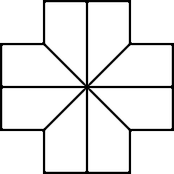
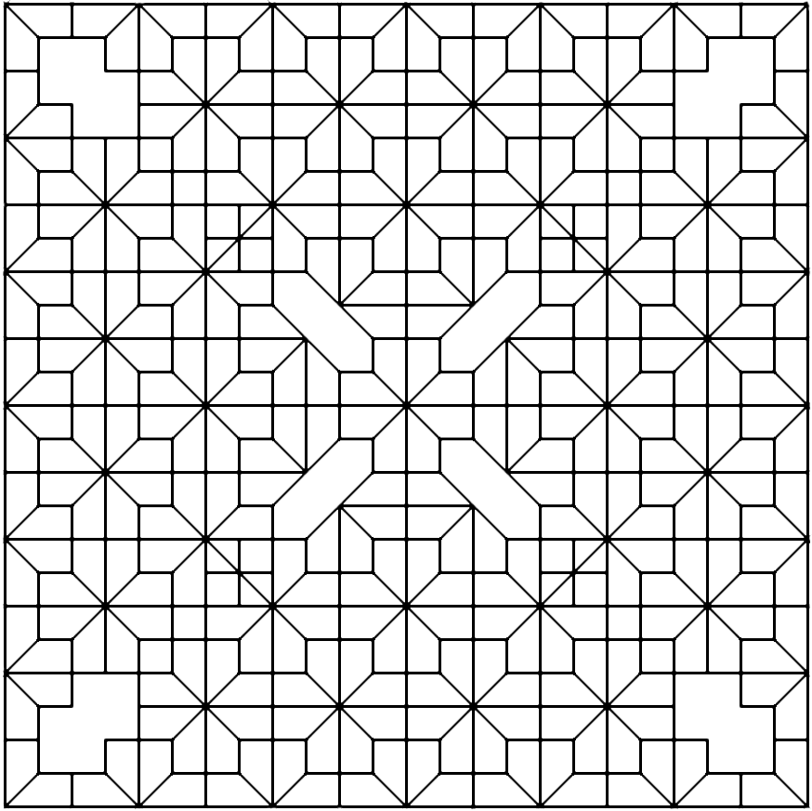
Each new generation is comprised of a subset of the union of all the edges in all the placements of the source in the current generation. This allows for all manner of abutting, overlapping and juxtaposing of elements from the source, exploring new ways to reassemble them. There are virtually endless varieties of how a source design can be decomposed. GDS provides a platform to rapidly explore effective decompositions and ways in which they can be recombined into fresh new forms that are elementally similar to the source pattern.
In the previous image, a source design is on the left and a generated result on the right. The following images are generated from the same source as above, although they have been controlled, during generation, towards a higher level of abstraction from the source design than version above. The source design is an element the reoccurs in many of the designs found in Chinese lattice designs. While the above generated image demonstrates an obvious rearrangement of pieces of the original design, the three results below are perhaps more interesting in that they present new ways of seeing how the original design fits together. Ways of deconstructing and recomposing the original that are not immediately recognizable.
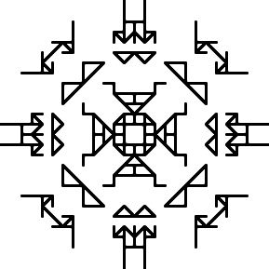
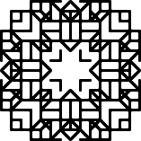
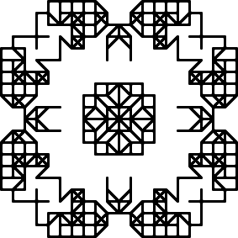

Future:
It is difficult to characterize the set of all results of successful design generations due to the wide ranging styles that can be deemed desirable designs. However, the intersections are a golden opportunity to apply various graph theory analysis methods to provide an even greater range of selection tools to the user in between generations. Because a design can be viewed as a graph with the restriction that edges are vectors, there are many applicable algorithms from graph theory. Future work will involve assembling a tool set to explore this option and testing what kinds of algorithms yield the greatest results. Graph theory is enormous and is not generally designed to indicate aesthetics making it difficult to know where to begin. The hypothesis is that different graph algorithms can be used to isolate certain characteristics of generated designs.

Later Future:
The generated forms produced by GDS are not to be considered as finished designs ready to be printed on textiles or incorporated into architectural ornament. Rather, they are a framework or layout upon which finished elements can be distributed and extruded. Shape grammars can be successfully applied to this end as well. The approach will be much different the idea of embedded grammars in input designs. Instead, rules could be consciously crafted by users where the left hand side of a rule will be composed of nodes and edges produced by GDS designs. The right hand side of the rule will be finished elements that could either be placed at nodes or abstract finished elements that could be extruded along paths, where a path is a serious of connected edges.

Z. W. Hsu and J. Yen outline a system for generating floral decorative ornaments. In one example, four stages of shape grammar rules are used. The first stage is simply a start node. Stages B and C are sets of rules used to generate a design layout in terms of bezier curves. The final stage, D, is where the layout is transformed into a finished design by the application of rules from a final shape grammar set. This final stage, can be similarly imagined to work in conjunction with the layouts produced by GDS to produce fully realized designs.
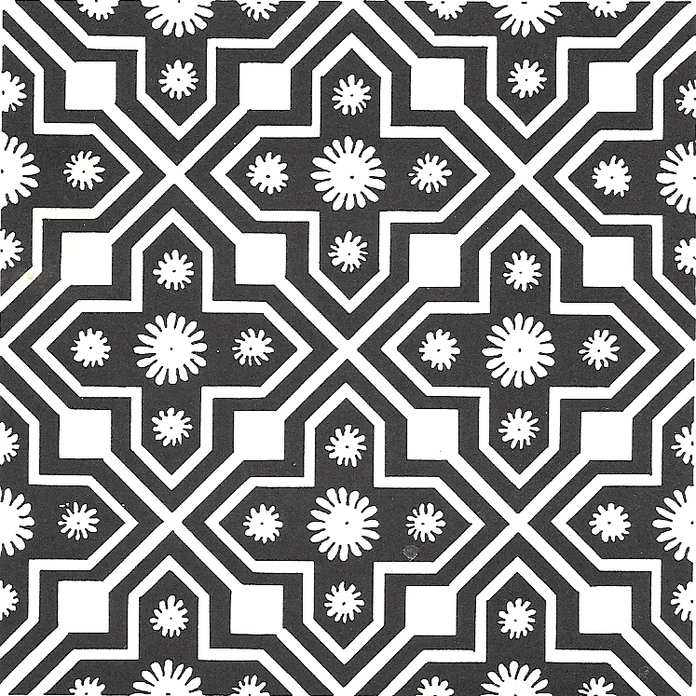
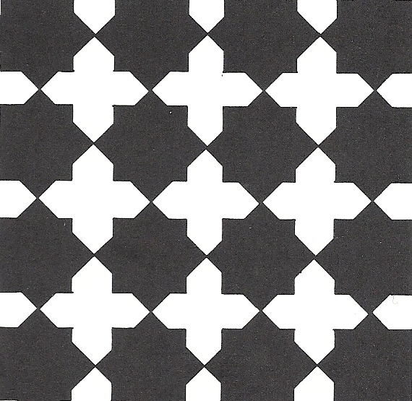
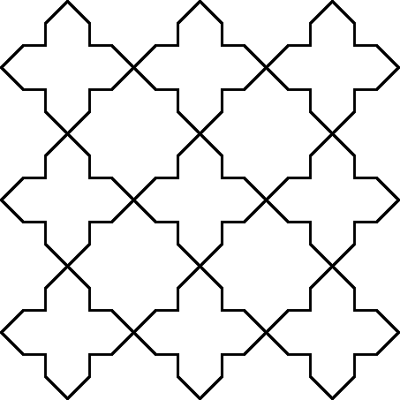
Here is an example of two finished designs that could be made from the same layout. On left is the layout. In the middle is a very simple finished design and on the right is a more complex finished design full of flourish and detail.

Related projects:
These projects provided inspiration, insight and a standard to strive towards with GDS in the future. Consider the following sub categories.

Context Free Art:
Context free art is a domain specific language that allows users to design generative process for two dimensional designs by writing a Context Free Design Grammar file (CFDG). CFDG is a domain specific language with a sophisticated set of tools for creating shape grammars and specifying their application towards generative designs. CFDG files are primarily made up of a set of shape rules and a start shape.

This is a listing of drawing directives that correlate to the right hand side of a shape grammar rule. Elements of this listing can consist of shape parametrized shape primitives such as Circle or Square, or can be other shape declarations. A shape rule can be deterministic or non-deterministic. If a listing is non-deterministic, then it is provided with a weight representing the probability that determines the likelihood that it will be applied at a given moment over the other elements in the listing. Shape Rules also can be recursive, and often are.

The generation of an image begins with the Start Shape and proceeds according the specifications of the Shape Rules. CFDG provides a robust tool-set to define complex rules with expressions, paths, transformations and language control structures. CFGD does not fit rules to a design as is typical in shape grammars. Instead the image generation proceeds strictly through the rule definitions themselves the image itself is output only.

Structure Synth:
Very similar to Context Free Art is Structure Synth. Where Context Free Art produces two dimensional images, Structure Synth produces three dimensional images. Structure Synth images are generated by writing code in EisenScript. Like CFDG, EisenScript does not have any feedback from the generated results. However, unlike CFDG, which is strictly context free in that it maintains no history, EisenScript keeps track of the depth of recursion and can either terminate recursion or change rules upon reaching a specified depth.

More Advanced Work:

GML:
Generative Modeling Language is a stack based domain specific language similar to Adobe Postsctipt. GML is designed to augment and replace aspects of 3D modeling suites. The focus of GML is on the processing sequence. In traditional 3D modeling suites such as the open source Blender, the modeling process is lost to time and the user is left with a data representation of the resulting model. In GML, the modeling process is encoded and the process itself remains intact for modular reuse.

CGA Shape:
City Engine is a high end commercial product that employes the scripting language CGA Shape designed by Pascal Muller. CGA Shape allows user to write shape grammar rules to expedite the modeling of building shapes and building facades for city models. City Engine provides ArcGIS integration.

Conclusion:
There are many more examples of shape grammars and implementations. There yet remain unlimited aspects of creative design, as performed by seeing humans, that have not been codified. Shape grammars still seem to hold great potential to push further into these territories of human endeavor. GDS certainly has presented tools with the potential to allow users to create significant new styles of ornamental design that are derived from abstract algorithmic process rather than by careful study of the natural world. However, it is imaginable that somewhere along the way, generative art will be producing surprising forms of art that viewers will find unexpected and new. On the other hand, man has minded the natural world for images to such an extant that it can feel the gamut of what forms are possible are pretty much played out, but that's how it must feel before every iconic stylistic breakthrough.

Alan Dorin, Jonathan McCabe, Jon McCormack, Gordon Monro and Mitchell Whitelaw, A Framework for Understanding Generative Art, Digital Creati, Vol.23, Nos. 3-4, page 239
James Gips, Shapes Grammars and their Uses, 1975, page 98
Gips, page 94
Alan Shaw, A Formal Picture Description Scheme as a Basis for Picture Processing Systems, Information and Control, Issue 14, 1969, page 10
Kui Yue, Computation-Friendly Shape Grammars With Application to Determining the Interior Layout of Buildings from Image Data, -p 16
Haldane Liew, SGML: A Meta-Language for Shape Grammars, MIT, 2004
Daniel Sheets Dye, A Grammar of Chinese Lattice, Harvard University Press, 1949
Reinhard Diestel, Graph Theory, Graduate Texts in Mathematice Vol. 173, 2010
Z.W. Hsu and J. Yen, Sheni: A Generative System for Decorative Pattern Design,11th Generative Art Conference, 2008

