**IT430: Lab 01 --- Python Basics**

Names: Cooper Walshe, Owen Pitchford

Alphas: 256666, 255076

External source  
I referred to GeeksforGeeks for simple Python syntax help with functions and conditional statements.

I referred to [stack overflow](https://stackoverflow.com/questions/5676646/how-can-i-fill-out-a-python-string-with-spaces) for printing out white space between the end of the second hex column and the plain text.

I referred to [stack overflow](https://stackoverflow.com/questions/40890697/python3-reading-a-binary-file-4-bytes-at-a-time-and-xor-it-with-a-4-byte-long-k) for how to read 16 bytes of a file at a time.

Honor

We wrote the code on our own except the help from the external sources listed above. Moreover, we didn’t copy any part of the code from other midshipmen.

Initials: CW and TOP

Challenges

It was difficult to figure out that a shift would help me set and reset bits.

For part 2, we had difficulties figuring out the best way to read in the file which led us to figure out it was be easiest to take 16 bytes at once and format/print those out then move to the next 16. The comprehension was also a learning curve to get the syntax down.

What we learned and what was interesting to us

(Specify what you learned and what was interesting to you)

We learned that comprehension is a very useful skill in python to save space and make your code look neat. Additionally, there are a ton of formatting tools to print/store lines of data such as join.

How much work each of did (0: nothing, 10: everything)

- Cooper Walshe: 5

- Owen Pitchford: 5

# **Part 1**

(For each part of the lab, give your work -- attach code, screen captures, explanations and answers as necessary)

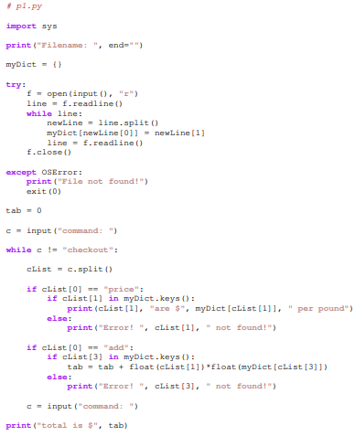

**Part 2**

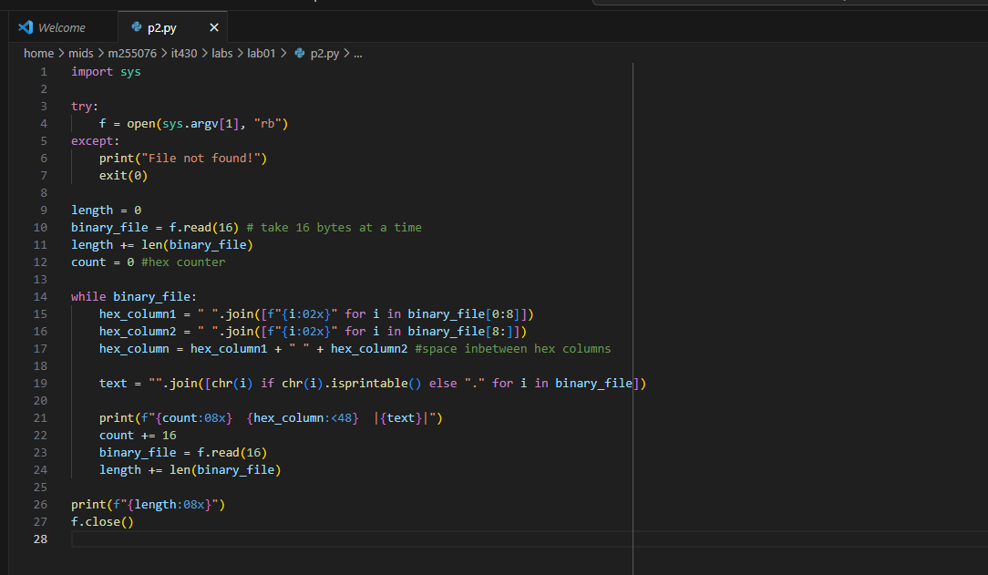

**Part 3**

