

**IT430: Lab 02 — Using Sockets**



Names: Owen Pitchford, Cooper Walshe

Alphas: 255076, 200001

External source   
Class Notes

[Socket Options](https://gist.github.com/webgtx/a24722d5cbb8849351591b6c006b76a5)

[F strings](https://docs.python.org/3/tutorial/inputoutput.html)

[An Overview of HTTPS](https://developer.mozilla.org/en-US/docs/Web/HTTP/Overview)

Honor

We wrote the code on my own except the help from the external source listed above. Moreover, we didn’t copy any part of the code from other midshipmen.

Initials: TOP and CAW

Challenges

(E.g., it was difficult to figure out how to xxx)

It was difficult formatting the HTTP requests and responses in python such as making sure everything was in bytes, the blank lines, and having the correct information.

Also ran into “address already in use” error so I looked up socket options to fix that so I did not have to keep changing the port number.

What we learned and what was interesting to us

(Specify what you learned and what was interesting to you)

We both gained a deeper understanding of how sockets work and specifically, the way HTTP works over TCP connections. We’ve both seen HTTP requests and responses in networks last semester but it was a nice refresher and it was neat to code it ourselves.

How much work each of did (0: nothing, 10: everything)

* Owen Pitchford: 5
* Cooper Walshe: 5

# **Part 1**

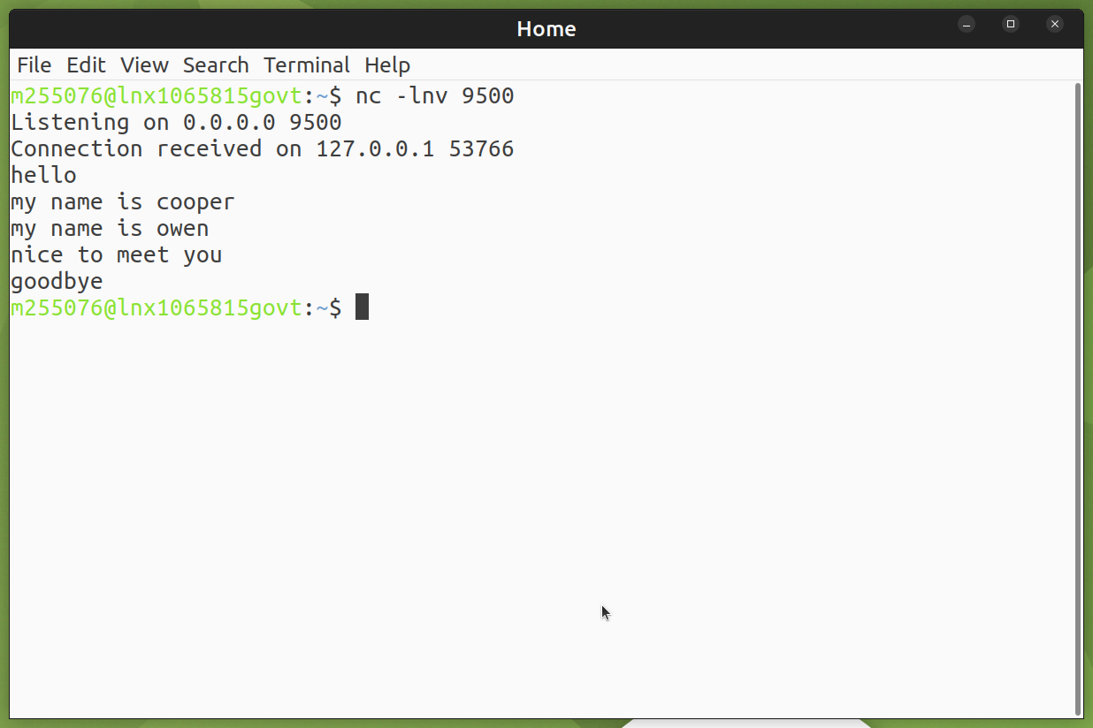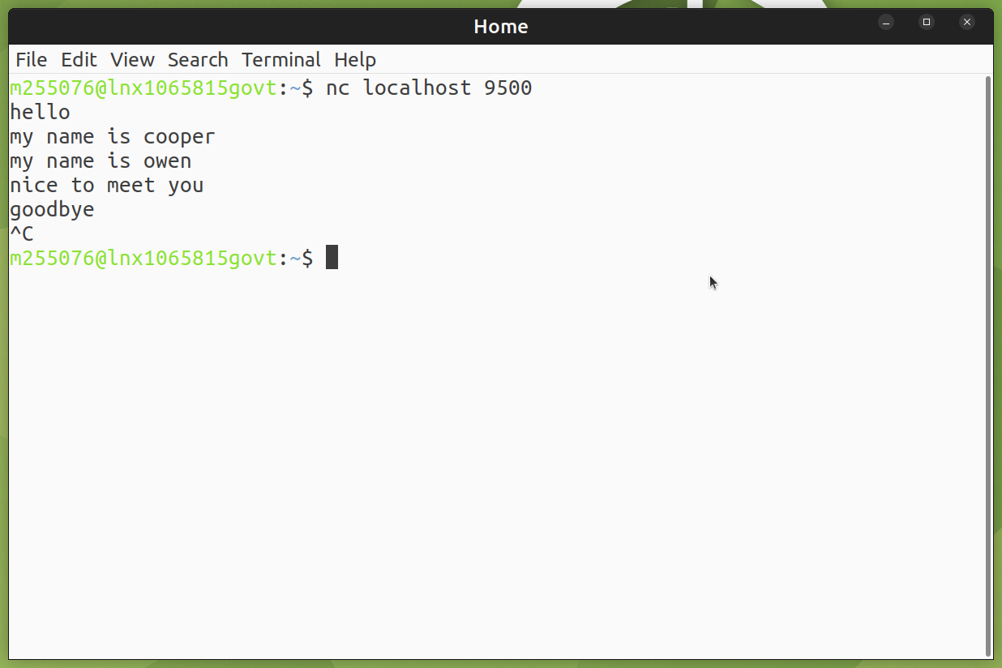

TCP Client Server Communication

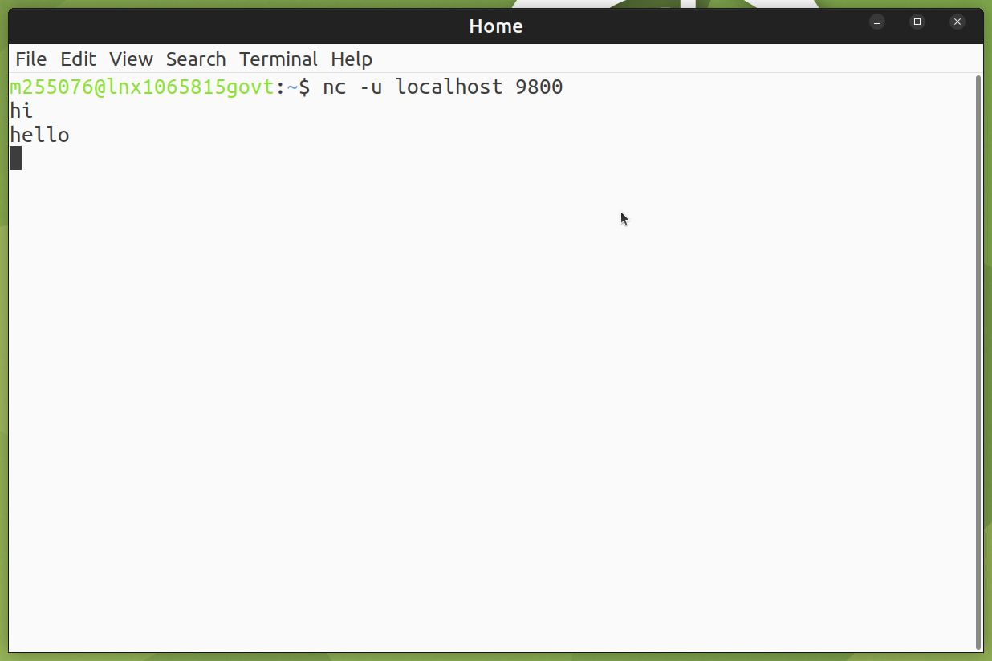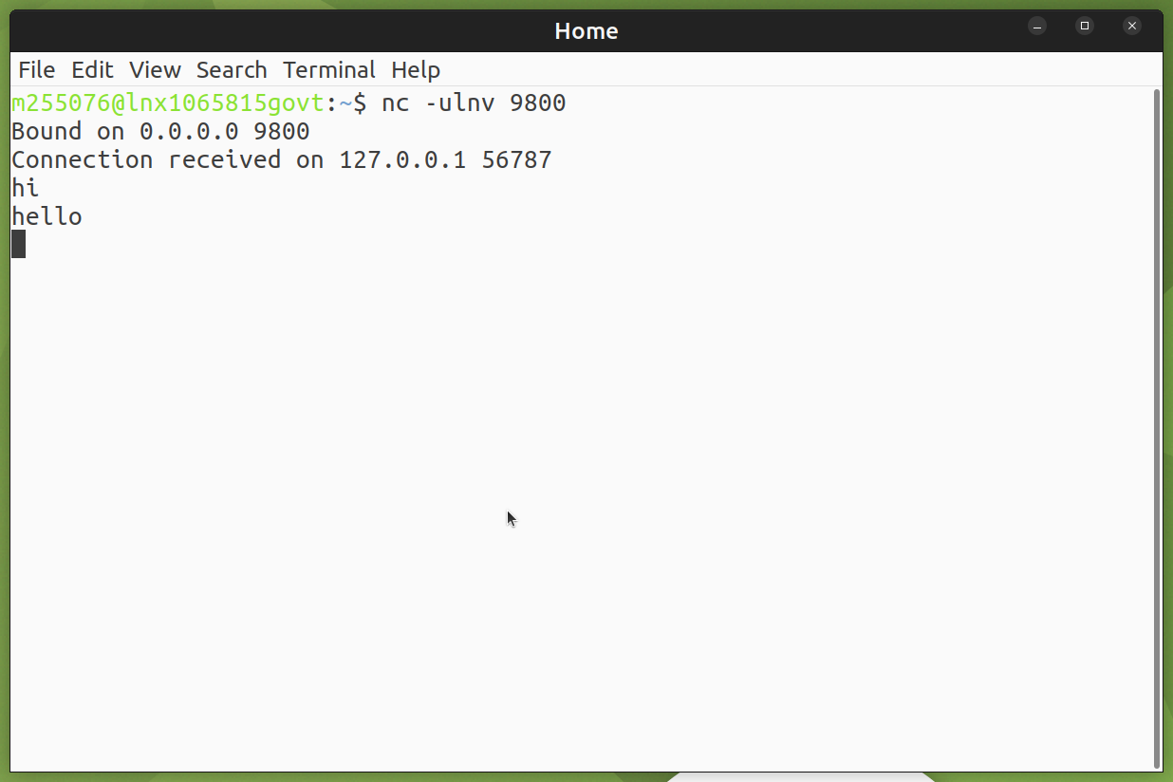

UDP Client Server Communication

# **Part 2**

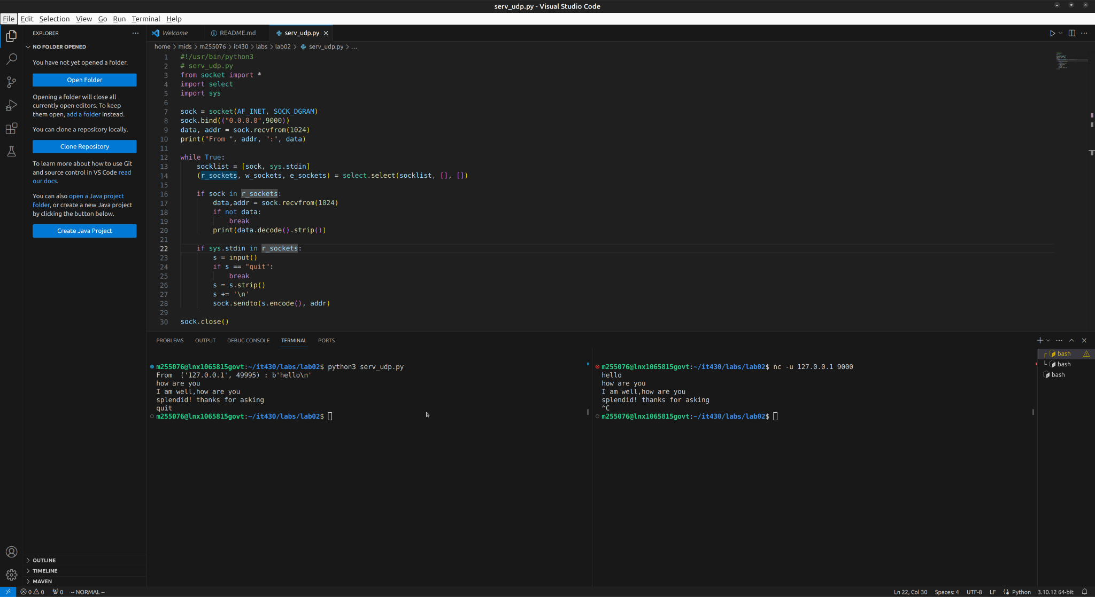

# **Part 3**

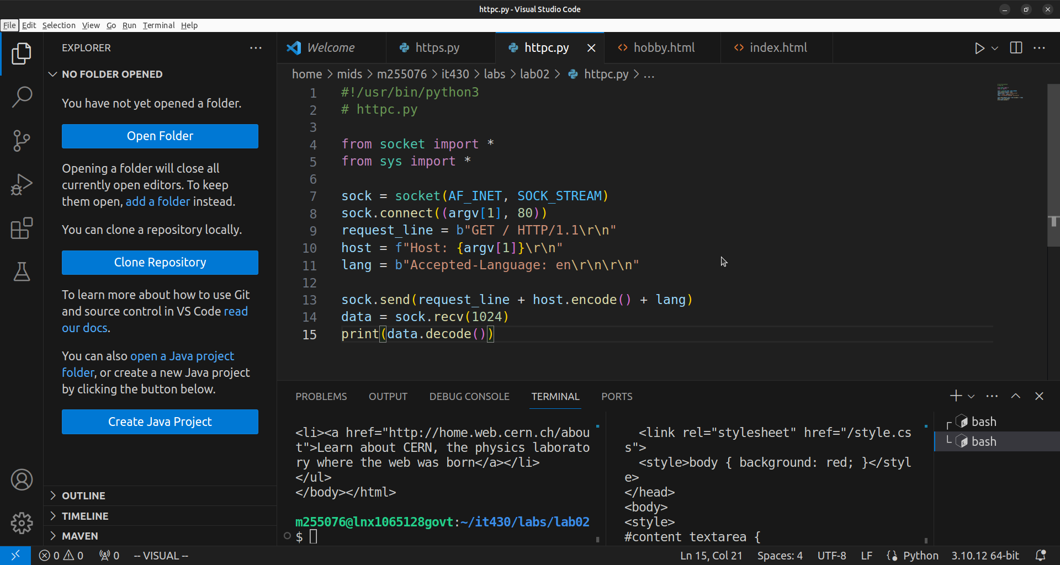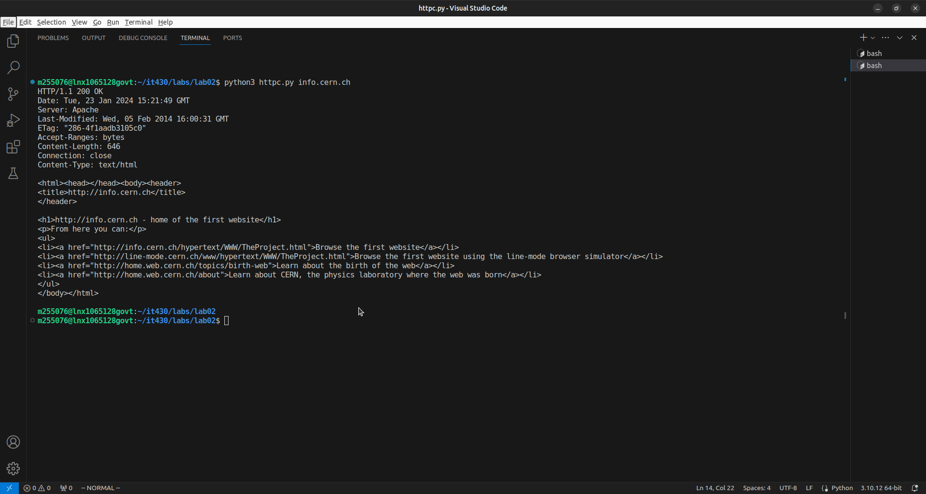

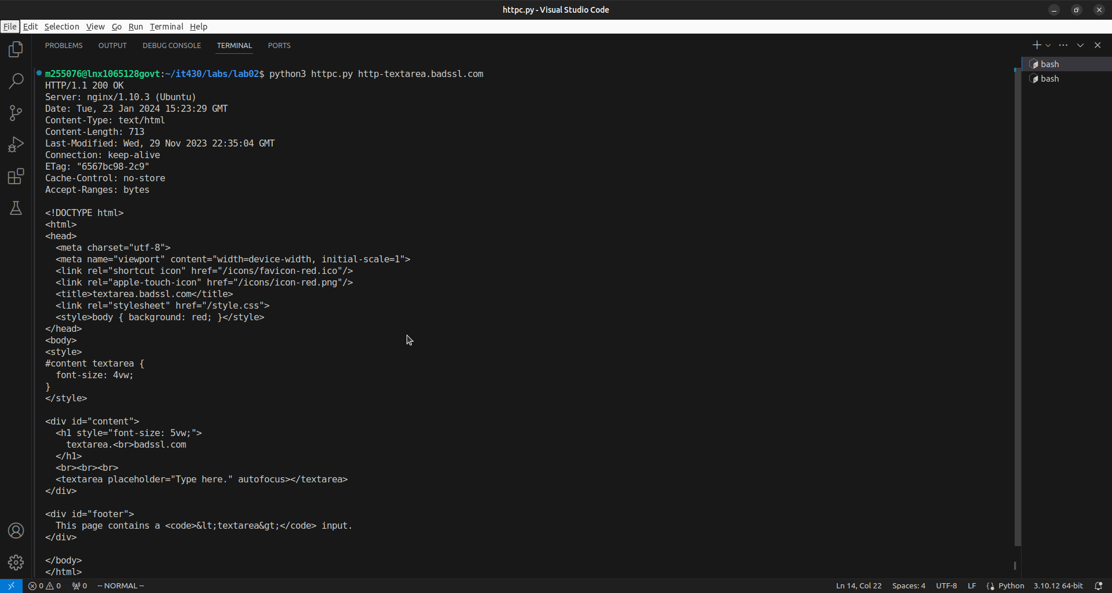

# **Part 4**

