CS 5336 - Web Application Development
Project Title: Luggage Handling App
Application Design Document

Class Diagram
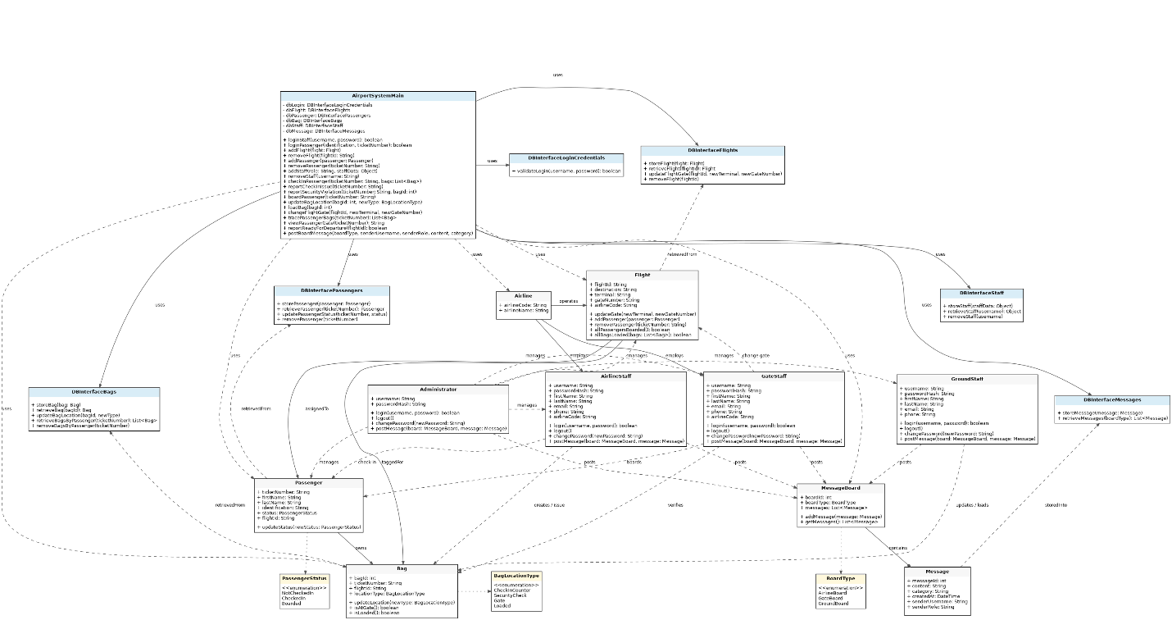
Detailed Description

Common to all classes
All classes have a constructor. All classes will also have getter methods for their attributes. Because all classes contain these functions, they are not included in the method descriptions below.

Classes
Classname: AirportSystemMain
Attributes:
- dbLogin: DBInterfaceLoginCredentials
- dbFlight: DBInterfaceFlights
- dbPassenger: DBInterfacePassengers
- dbBag: DBInterfaceBags
- dbStaff: DBInterfaceStaff
- dbMessage: DBInterfaceMessages
Methods:
- loginStaff(username: String, password: String): boolean
- loginPassenger(identification: String, ticketNumber: String): boolean
- logout(userId: String)
- addFlight(flight: Flight)
- removeFlight(flightId: String)
- addPassenger(passenger: Passenger)
- removePassenger(ticketNumber: String)
- addStaff(role: String, staffData: Object)
- removeStaff(username: String)
- checkInPassenger(ticketNumber: String, bags: List<Bag>)
- reportCheckInIssue(ticketNumber: String)
- reportSecurityViolation(ticketNumber: String, bagId: int)
- boardPassenger(ticketNumber: String)
- updateBagLocation(bagId: int, newType: BagLocationType)
- loadBag(bagId: int)
- changeFlightGate(flightId: String, newTerminal: String, newGateNumber: String)
- tracePassengerBags(ticketNumber: String): List<Bag>
- viewPassengerGate(ticketNumber: String): String
- reportReadyForDeparture(flightId: String): boolean
- postBoardMessage(boardType: BoardType, senderUsername: String, senderRole: String, content: String, category: String)

Classname: Airline
Attributes:
- airlineCode: String
- airlineName: String
Methods:
- None from the design view.

Classname: Administrator
Attributes:
- username: String
- passwordHash: String
Methods:
- login(username: String, password: String): boolean
- logout()
- changePassword(newPassword: String)
- postMessage(board: MessageBoard, message: Message)

Classname: GroundStaff
Attributes:
- username: String
- passwordHash: String
- firstName: String
- lastName: String
- email: String
- phone: String
Methods:
- login(username: String, password: String): boolean
- logout()
- changePassword(newPassword: String)
- postMessage(board: MessageBoard, message: Message)

Classname: GateStaff
Attributes:
- username: String
- passwordHash: String
- firstName: String
- lastName: String
- email: String
- phone: String
- airlineCode: String
Methods:
- login(username: String, password: String): boolean
- logout()
- changePassword(newPassword: String)
- postMessage(board: MessageBoard, message: Message)

Classname: AirlineStaff
Attributes:
- username: String
- passwordHash: String
- firstName: String
- lastName: String
- email: String
- phone: String
- airlineCode: String
Methods:
- login(username: String, password: String): boolean
- logout()
- changePassword(newPassword: String)
- postMessage(board: MessageBoard, message: Message)

Classname: Flight
Attributes:
- flightId: String
- destination: String
- terminal: String
- gateNumber: String
- airlineCode: String
Methods:
- updateGate(newTerminal: String, newGateNumber: String)
- addPassenger(passenger: Passenger)
- removePassenger(ticketNumber: String)
- allPassengersBoarded(): boolean
- allBagsLoaded(bags: List<Bag>): boolean

Classname: Passenger
Attributes:
- ticketNumber: String
- firstName: String
- lastName: String
- identification: String
- status: PassengerStatus
- flightId: String
Methods:
- updateStatus(newStatus: PassengerStatus)

Classname: Bag
Attributes:
- bagId: int
- ticketNumber: String
- flightId: String
- locationType: BagLocationType
Methods:
- updateLocation(newType: BagLocationType)
- isAtGate(): boolean
- isLoaded(): boolean

Classname: MessageBoard
Attributes:
- boardId: int
- boardType: BoardType
- messages: List<Message>
Methods:
- addMessage(message: Message)
- getMessages(): List<Message>

Classname: Message
Attributes:
- messageId: int
- content: String
- category: String
- createdAt: DateTime
- senderUsername: String
- senderRole: String
Methods:
- None from the design view.

Supporting Database Interface Classes
Classname: DBInterfaceLoginCredentials
Attributes:
- None
Methods:
- validateLogin(username: String, password: String): boolean
Classname: DBInterfaceFlights
Attributes:
- None
Methods:
- storeFlight(flight: Flight)
- retrieveFlight(flightId: String): Flight
- updateFlightGate(flightId: String, newTerminal: String, newGateNumber: String)
- removeFlight(flightId: String)
Classname: DBInterfacePassengers
Attributes:
- None
Methods:
- storePassenger(passenger: Passenger)
- retrievePassenger(ticketNumber: String): Passenger
- updatePassengerStatus(ticketNumber: String, status: PassengerStatus)
- removePassenger(ticketNumber: String)
Classname: DBInterfaceBags
Attributes:
- None
Methods:
- storeBag(bag: Bag)
- retrieveBag(bagId: int): Bag
- updateBagLocation(bagId: int, newType: BagLocationType)
- retrieveBagsByPassenger(ticketNumber: String): List<Bag>
- removeBagsByPassenger(ticketNumber: String)
Classname: DBInterfaceStaff
Attributes:
- None
Methods:
- storeStaff(staffData: Object)
- retrieveStaff(username: String): Object
- removeStaff(username: String)
Classname: DBInterfaceMessages
Attributes:
- None
Methods:
- storeMessage(message: Message)
- retrieveMessages(boardType: BoardType): List<Message>
Enumeration Types
Type: PassengerStatus
- NotCheckedIn
- CheckedIn
- Boarded
Type: BagLocationType
- CheckInCounter
- SecurityCheck
- Gate
- Loaded
Type: BoardType
- AirlineBoard
- GateBoard
- GroundBoard

