Crash Lab — Setup Diagram
Week 3 · Thursday · Teacher setup guide · TEACHER ONLY (laminate for prep binder)
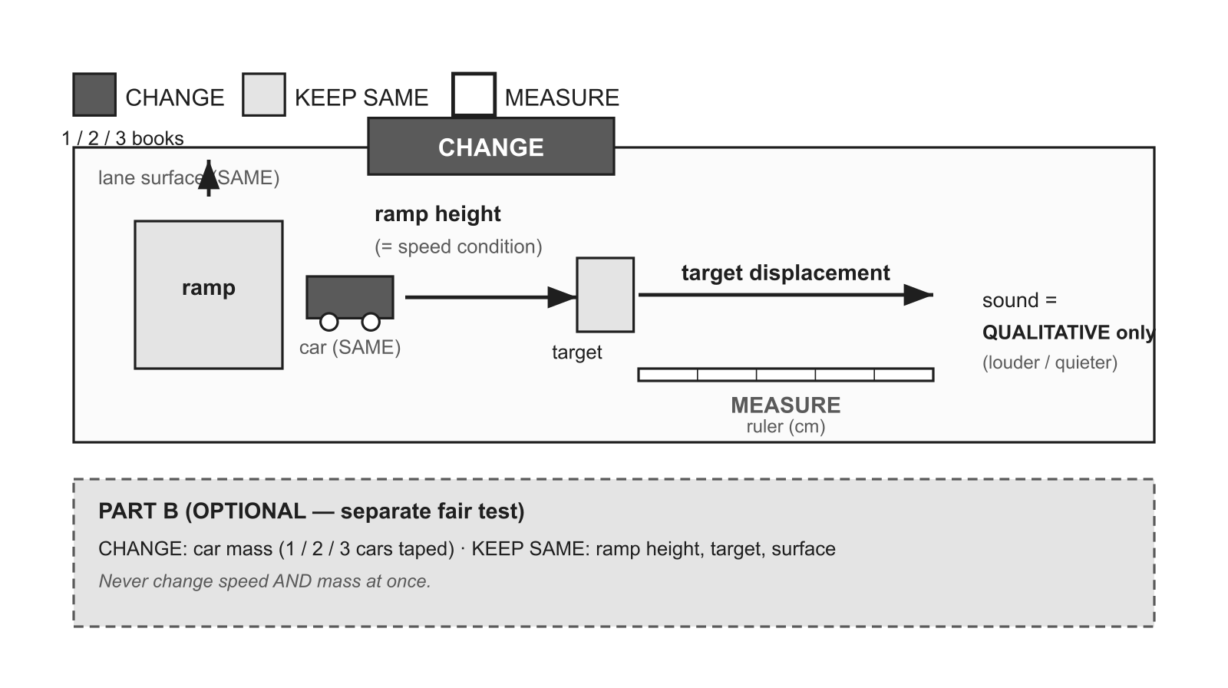

Change | Keep the same | Measure
speed condition / ramp height (1 / 2 / 3 books) | car · target · surface | target displacement (cm)

Materials identical toy car (SAME type) · ramp (cardboard/wood) · books/blocks (3 heights) · target: plastic cup or small block · meter stick / ruler (cm) · tape (start line) · Part B only: 2 extra cars + tape (mass comparison)
Per group 1 car (Part A) · 3 books · 1 target · 1 ruler · tape · (Part B: +2 cars)
Safety Clear the crash lane; cars ROLL (never thrown); Newton's cradle = teacher demo only; no heat measurement.
Reset / cleanup Return cars/ramps/targets; reset lanes; remove tape.
Prep note Use IDENTICAL cars for Part A. Part B (mass) is OPTIONAL and a SEPARATE fair test — never change speed and mass together.

