Grade 4 Science
Unit 1 Assessment — Energy Transfer & Transformation
Name: ________________________________ HR: 4A 4B 4C 4D
Directions: Read each question and choose the ONE BEST ANSWER.
Part 1: Matching (Questions 1–8)
Write the letter of the definition that matches each word.
Vocabulary | Definitions
1. ____ Energy Transfer | A. The things that limit what can be used in a design.
2. ____ Stored Energy | B. The ability to cause change.
3. ____ Speed | C. Energy changing from one form to another form.
4. ____ Collision | D. A form of energy that comes from a vibrating object.
5. ____ Energy of Motion | E. A measurement of the distance an object travels over an amount of time.
6. ____ Criteria | F. Energy moving from one place or object to another.
7. ____ Energy Transformation | G. When two objects come together with impact.
8. ____ Energy | H. The things a good design must do or have.
 | I. Energy that can cause a change at a later time.
 | J. The energy an object has while it is moving.
 | K. The process of an object changing position.

Part 2: Multiple Choice (Questions 9–25)
Choose the ONE BEST ANSWER for each question.
9. What does energy allow an object or a system to do?
A. Stay exactly the same forever
B. Disappear without leaving a trace
C. Cause a change
D. Become invisible
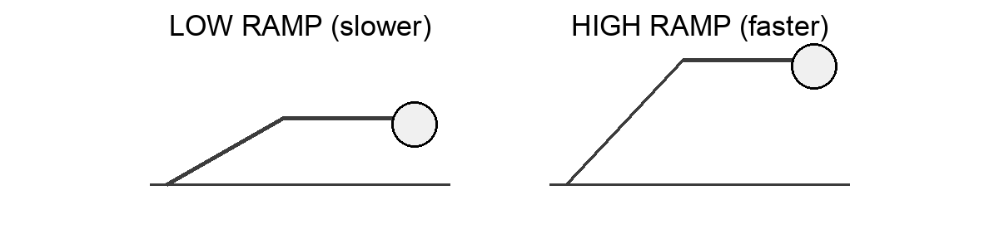
10. The same ball rolls down two ramps. One ramp is low and one ramp is high. On which ramp will the ball most likely have more energy of motion at the bottom?
A. The high ramp, because the ball moves faster at the bottom
B. The low ramp, because it is closer to the ground
C. Both ramps, because it is the same ball
D. Neither ramp, because ramp height does not matter
11. A battery in a flashlight that is turned off is an example of stored energy. What can stored energy do?
A. It disappears as soon as the flashlight is turned off
B. It can only be stored inside a rubber band
C. It always turns into light right away
D. It can cause a change later, when the flashlight is turned on
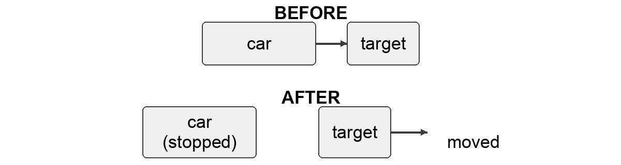
12. After the crash, the rolling car stops and the target moves. What does this change tell us?
A. The energy disappeared when the car stopped
B. Energy of motion transferred from the car to the target
C. The target made its own energy
D. No energy was involved in the crash
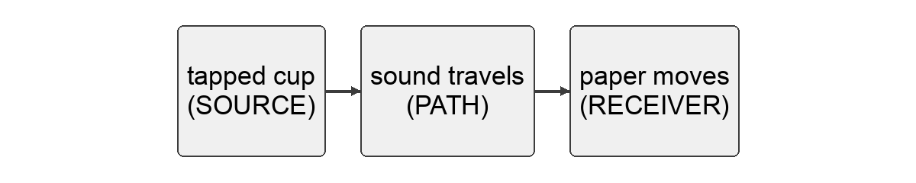
13. In the diagram, energy leaves the tapped cup, travels through the air, and makes the paper move. What is this called?
A. Stored energy
B. A transformation of light
C. Energy transfer
D. Energy of motion only
14. Which of these is an example of an energy TRANSFORMATION?
A. Energy moving from a warm cup to a cooler one
B. A light bulb changing electrical energy into light
C. A moving ball rolling across the floor
D. Sound traveling through the air
15. Students are building a tabletop signal device that must make a sound. They may use only the materials in their box. The rule that they may use only the materials in their box is a ____.
A. Constraint
B. Criterion
C. Transformation
D. Transfer
16. A student sees a light turn on and a fan begin to spin. How do we know energy was involved?
A. We can see energy itself moving
B. Energy is involved only when something makes a sound
C. The objects changed on their own without energy
D. We observe the changes and use them as evidence
17. Which of these shows energy transferring from one place to another?
A. A battery sitting unused in a drawer
B. A flashlight lighting a card across the room
C. A pencil lying still on a desk
D. A ball resting on the floor
18. Which object has stored energy that can cause a change later?
A. A ball that is already rolling across the floor
B. A cup that just stopped moving
C. A stretched rubber band ready to snap
D. A paper that already fell to the ground
19. A car drives slowly through a parking lot and then fast on a highway. When does the car have more energy of motion?
A. When it is moving fast
B. When it is moving slowly
C. The car has the same energy of motion the whole time
D. The car has no energy of motion on the highway
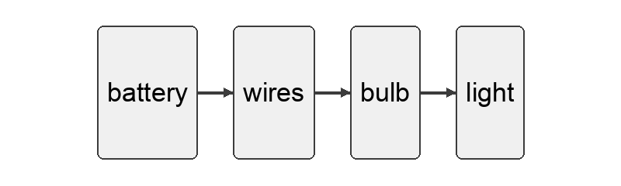
20. A flashlight changes stored energy in the battery into light. At the same time, energy moves through the wires to the bulb. Which is happening?
A. Transfer only
B. Transformation only
C. Neither transfer nor transformation
D. Both transfer and transformation
21. A student rolls the SAME ball down a low ramp and then down a higher ramp. The cup moves farther when the ball comes down the higher ramp. Which conclusion is best supported?
A. The ball became heavier on the higher ramp
B. The ball had more energy of motion when it moved faster from the higher ramp
C. The cup changed on its own
D. Ramp height does not change the ball's energy of motion
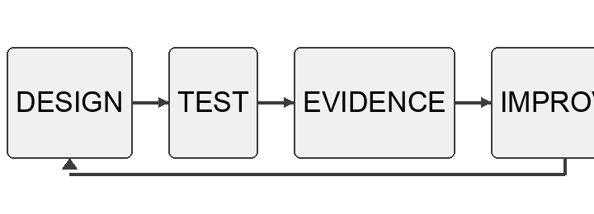
22. An engineer builds a design, tests it, and sees that it does not work well. What should the engineer do next?
A. Use the test result as information to improve the design and test again
B. Give up, because a failed test means the design is useless
C. Ignore the test result and keep the design the same
D. Remove the test result from the notebook
23. A moving marble hits a still marble. The still marble rolls away. Which conclusion is best supported?
A. The still marble created its own energy
B. The moving marble's energy disappeared
C. Energy of motion transferred from the moving marble to the still marble
D. No energy was involved
24. Which sentence about Thomas Edison is true?
A. Edison invented the very first light bulb
B. Edison worked completely alone and never tested his ideas
C. Edison's bulb never needed to be improved by anyone else
D. Edison improved earlier light bulb designs and tested many materials
25. Warm water is placed next to a cooler cup. Soon the cooler cup feels warmer. What happened?
A. Energy transferred from the warm water to the cooler cup
B. Energy transferred from the cooler cup to the warm water
C. The cooler cup made its own heat
D. No energy moved at all

