Ramp It Up — Setup Diagram
Week 2 · Thursday · Teacher setup guide · TEACHER ONLY (laminate for prep binder)
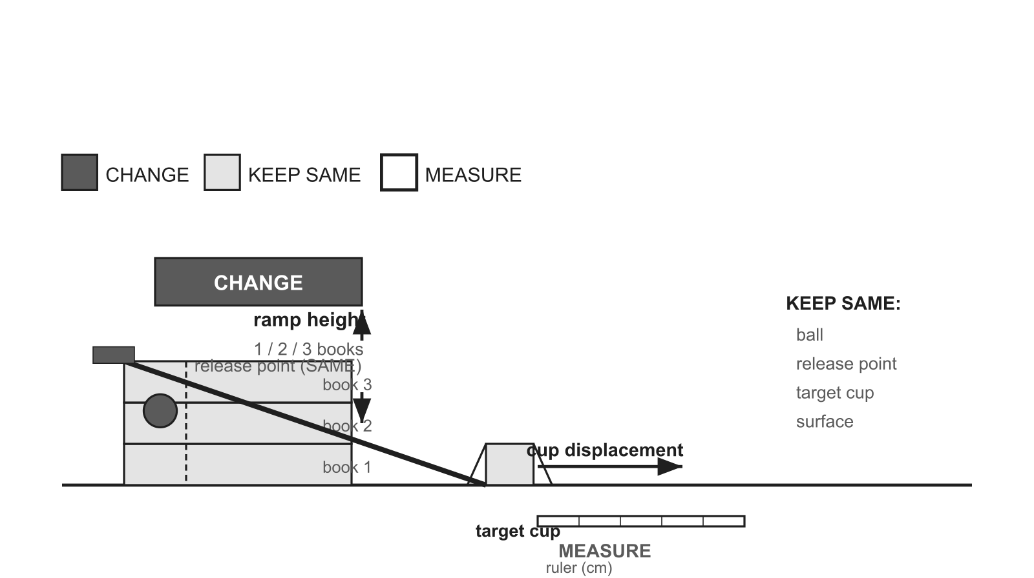

Change | Keep the same | Measure
ramp height (1 / 2 / 3 books) | ball · release point · target cup · surface | cup displacement (cm)

Materials ramp board (or stacked books) · ONE identical ball type · books/blocks (3 heights) · target cup · meter stick / ruler (cm) · tape (release-point marker)
Per group 1 ramp · 1 ball · 3 books · 1 cup · 1 ruler · tape
Safety Clear the roll path; balls ROLL (never thrown); fixed release point.
Reset / cleanup Return balls/books/cups; remove tape marks; straighten rulers.
Prep note Pre-build 5 identical stations; mark the release point and start line the same on every ramp.

