Available-Light Solar Device — Setup Diagram
Week 8 · Thursday · Teacher setup guide · TEACHER ONLY (laminate for prep binder)
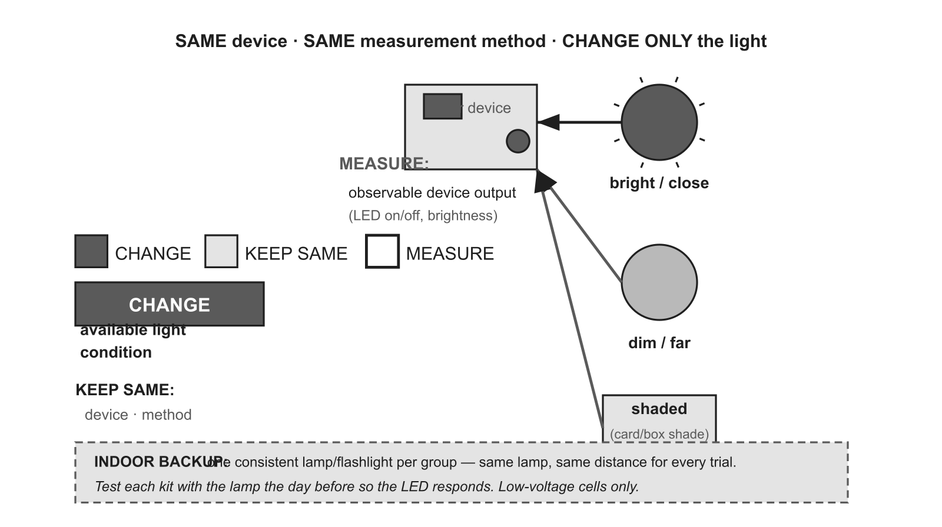

Change | Keep the same | Measure
available light condition (bright/close · dim/far · shaded) | device · measurement method | observable device output (LED on/off, brightness)

Materials small solar cell + LED · flashlight / desk lamp (indoor backup) · card or box (for the shaded condition) · observation sheet · low-voltage cell only
Per group 1 solar device · 1 lamp/flashlight · 1 shade card · 1 observation sheet
Safety Keep the panel at a shallow angle; do NOT look directly at the sun; low-voltage cells only.
Reset / cleanup Store solar kits; return lamps; file observation sheets.
Prep note PRIMARY = window/outdoor light; BACKUP = one consistent lamp per group (same lamp, same distance). Test each kit with the lamp the day before.

