Water Wheel — Setup Diagram
Week 7 · Thursday · Teacher setup guide · TEACHER ONLY (laminate for prep binder)
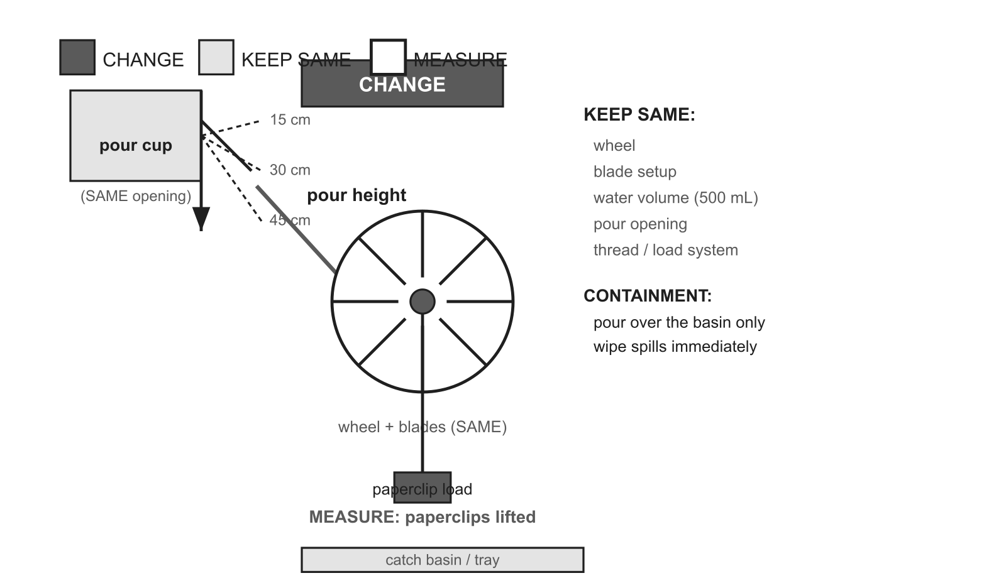

Change | Keep the same | Measure
pour height (15 / 30 / 45 cm) | wheel · blade setup · water volume (500 mL) · pour opening · thread/load system | paperclips lifted (final locked primary response)

Materials paper plate / plastic lid wheel · 8–10 blade cups or popsicle-stick blades · straw / dowel axle · ~50 cm thread · paperclips (load) · pour cup (fixed opening) · 500 mL water source · basin / tray (catch) · ruler (height) · towel
Per group 1 wheel + axle · ~50 cm thread · paperclips · 1 pour cup · 500 mL water · 1 basin · 1 ruler · 1 towel
Safety Pour over the basin only; wipe spills immediately; no horseplay near water.
Reset / cleanup Dry wheels/blades/basins; dispose water in a sink; respool thread; return paperclips.
Prep note Build wheels Wed; fill pitchers Thu. Lock the pour height with a marked ruler; same 500 mL and same opening every trial.

