Chapter 1 — Shurley Packet
Teacher Edition
Page 1 — Cover
Oral Prompts
• What will you learn in Chapter 1?
Expected Responses
Student illustration — no fixed answer.

Page 2 — Lesson 3: Complete Sentences
Timing
12–15 minutes
Oral Prompts
• Chant the Sentence Jingle.
• What part is missing if there is no end mark?
Correction Points
• Capital must be first letter.
• Every sentence needs a subject and verb.
Expected Responses
Five parts: Capital letter, End mark, Complete sense, Subject, Verb.
Common Misconceptions
• Students list parts but don't apply them when writing.

Page 3 — Synonyms and Antonyms
Timing
12–15 minutes
Oral Prompts
• Say a synonym pair aloud.
• Say an antonym pair aloud.
Correction Points
• Synonym = almost same. Antonym = opposite.
Expected Responses
1.Antonym 2.Synonym 3.Synonym 4.Antonym 5.Synonym 6.Synonym 7.Antonym 8.Synonym
Also Accept
Accept valid student-created pairs.
Common Misconceptions
• Students confuse synonyms and antonyms.

Page 4 — Vocabulary Builder
Timing
15–20 minutes
Oral Prompts
• Which word strategy helps you remember new vocabulary?
Correction Points
• Sentence must use the word correctly.
• Drawing should connect to meaning.
Expected Responses
Teacher-assigned word — answers vary.

Chapter 1 — Lesson 4
Understanding Analogies
Learn
An analogy shows how two word pairs are related. It is a special word puzzle.
Spoken: boat is to goat as fan is to ___________.
Written: front : back :: top : ___________
Remember — Analogy Symbols
Colon (:) — separates the two words in each pair.
Double colon (::) — means “is to ___ as”.
“Is to” — connects the first word pair.
“As” — connects the first pair to the second pair.

Worked Example
front : back :: top : bottom
Both pairs are opposites — an antonym analogy.

Four Analogy Relationships
Chapter 1 — Lesson 4
Study each card. Read the example using “is to” and “as.”
Synonym  big : large :: sound : noise  The words in each pair mean almost the same. | Antonym  big : small :: fast : slow  The words in each pair are opposites.
Rhyming  near : deer :: jump : stump  The words in each pair rhyme. | Part-to-Whole  leaf : tree :: paw : dog  The first word is part of the second.

Page 7 — Analogy Practice
Timing
15–20 minutes
Correction Points
• Each answer must match the labeled relationship.
Expected Responses
1. sad (Synonym)
2. awake (Antonym)
3. look/cook/hook (Rhyming)
4. book (Part-to-Whole)
MC: 1. cold 2. tall : short
Also Accept
For #3 accept cook or hook if labeled Rhyming.

Capitalization and Punctuation Reference
Use this reference during Lessons 5 and 6.
Reference 9 — Punctuation Rules (next page)
Reference 7 — Capitalization Rules (following page)
Reference — Capitalization and Punctuation Reference
Procedure
Direct students to use during Lessons 5 and 6.
Expected Responses
Official reference — pages match student edition.

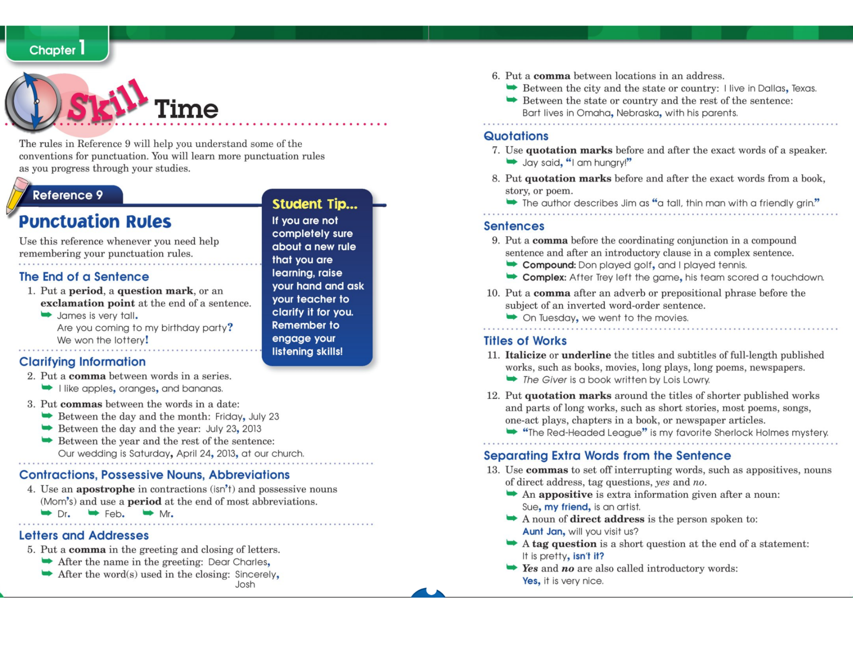

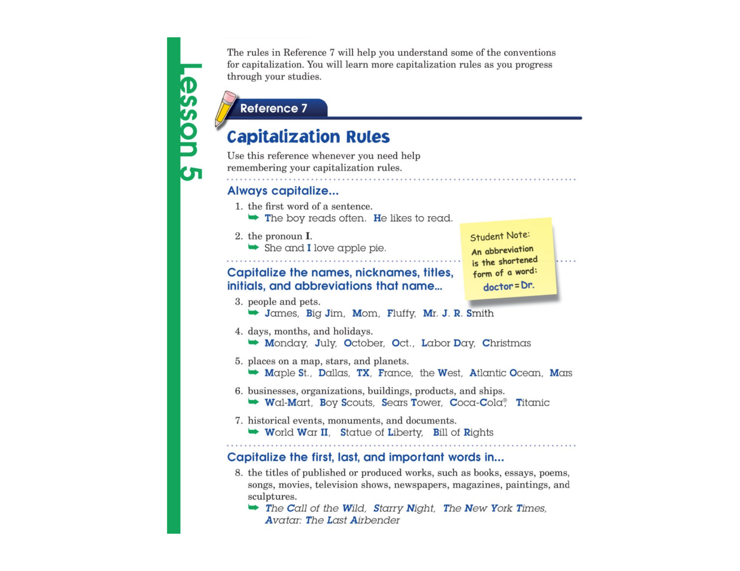

Page 11 — Lesson 5: Capitalization
Correction Points
• Only proper nouns get capitals.
Expected Responses
Passage 1: My, I, Amy, Ford's, Theater, Friday, Nim's, Island
Passage 2: My, Reagan, Beth, Main, Street, July
Common Misconceptions
• Students capitalize common nouns like 'friends' or 'night'.

Page 12 — Capitalization Editing
Timing
15 minutes
Expected Responses
1. We drove to Lake Michigan on Saturday with Mrs. Daniels.
2. Yes, Sam and I work on Saturdays at Quickfill Gas on Jasper Road in Denver.

Page 13 — Lesson 6: Punctuation
Timing
10 minutes
Oral Prompts
• What end mark does a question need?
Expected Responses
Model 1: question mark, commas in list, proper nouns capitalized.
Model 2: comma after direct address, proper noun capitalized.

Page 14 — Editing Practice
Correction Points
• Count capitals, commas, end marks, apostrophe before accepting.
Expected Responses
1. Yes, Mr. Green will move to Denver, Colorado, on June 18, 2024.
2. Did your teacher, Ms. Coleman, read Charlotte's Web to your class today?
Also Accept
Accept ! on Sentence 1 if student treats 'Yes' as strong emotion.

Page 15 — Chapter Review (Part 1)
Procedure
Use as in-class activity — not homework.
Timing
15 minutes (Part 1)
Expected Responses
See review key for full answers.

Page 16 — Chapter Review (Part 2)
Timing
15 minutes (Part 2)
Expected Responses
See review key for full answers.

Page 17 — Application and Enrichment (Optional)
Timing
10–15 minutes optional
Oral Prompts
• Share one analogy with a partner.
Expected Responses
Student analogies and sentences will vary — check labeled relationships and five sentence parts.

