Chapter 1
Shurley Packet
Name: _________________________________
Date: _________________________________
Teacher: _______________________________
Draw a picture about something you are learning in Chapter 1:

Chapter 1 — Lesson 1
Discussion and Goal Setting
Learn
Good discussions help us learn together. When you share in class, follow these expectations:
• Listen respectfully.
• Wait for an appropriate turn.
• Stay on topic.
• Link your comment to what another speaker said.
Remember: Linking a comment means connecting your idea to what someone else shared.
Learn — Linking Comment Starters
• I agree with ___ because...
• I would like to add to what ___ said...
• I have a different idea because...
• When ___ said ___, it made me think...
• Can you explain what you meant by...?
Learn — Goals
A long-term goal takes a longer period of time to achieve.
A short-term goal can be achieved soon and can serve as a step toward a long-term goal.
Academic goals focus on learning and schoolwork.
Personal goals focus on habits, character, relationships, hobbies, and responsibilities.
Practice Together
Sort the goals below. Write S for short-term or L for long-term. Write A for academic or P for personal.
1. _____ / _____ Learn all multiplication facts by December
2. _____ / _____ Read for 20 minutes tonight
3. _____ / _____ Make the school basketball team this year
4. _____ / _____ Clean my room before dinner
5. _____ / _____ Improve my handwriting this semester
6. _____ / _____ Write a letter to my future self

Chapter 1 — Lesson 1
Discussion and Goal Setting (continued)
Practice Independently
Choose one academic long-term goal. Write it below, then write two or three short-term action steps.
My academic long-term goal:
________________________________________________________________________
Short-term action steps:
________________________________________________________________________
Choose one personal long-term goal. Write it below, then write two or three short-term action steps.
My personal long-term goal:
________________________________________________________________________
Short-term action steps:
________________________________________________________________________
Apply
Write one linking comment you could use during a class discussion. Use a sentence starter from this lesson.
________________________________________________________________________
MEMORY CHECK
Without looking back, answer these questions:
1. Name two discussion expectations.
________________________________________________________________________
2. What is the difference between a short-term goal and a long-term goal?
________________________________________________________________________
TEACHER CHECK
Complete: □ Date: __________ Initials: ________

Chapter 1 — Lesson 2
Journaling and Letter to Future Me
Learn
Remember: A journal is a personal written record of thoughts, feelings, experiences, plans, and imagined stories.
You may write about:
• Family
• Friends
• Pets
• Hobbies
• Favorite activities
• Important events
• Future plans
• Worries
• Goals
• Made-up stories
Practice Together
Choose one journal topic from the list. Write a short journal entry below.
________________________________________________________________________
________________________________________________________________________
________________________________________________________________________
Learn — Letter to Future Me
You will write a letter to yourself to read during the last week of school. Include these four parts:
1. Who I Am Right Now
2. My Thoughts About Fourth Grade
3. My Goals and Action Steps
4. A Message to My Future Self

Chapter 1 — Lesson 2
Planning Organizer — Part 1
You may combine sections naturally into paragraphs. You do not need exactly three paragraphs.
Practice Independently — Planning Organizer
Who I Am Right Now
• What are your favorite hobbies?
• What are your favorite foods, games, books, or activities?
• What is important to you right now?
________________________________________________________________________
My Thoughts About Fourth Grade
• What are you excited about?
• What feels new?
• What makes you nervous?
• How will you handle challenges?
________________________________________________________________________

Chapter 1 — Lesson 2
Planning Organizer — Part 2
Practice Independently — Planning Organizer (continued)
My Goals and Action Steps
• What is one academic goal?
• What short-term actions will help you reach it?
• What is one personal goal?
• What short-term actions will help you reach it?
________________________________________________________________________
A Message to My Future Self
• What do you hope you accomplished?
• What do you want your future self to remember?
• What encouragement would you give yourself?
________________________________________________________________________

Chapter 1 — Lesson 2
Model Letter to Future Me
Learn — Model Letter
Read this fourth-grade model letter. Notice how it includes all four parts.
Dear Future Me,

Right now I am a fourth grader who loves drawing, playing soccer, and reading adventure books. My favorite food is mac and cheese, and my best friend is Maya. Something important to me is being a kind friend.

Fourth grade feels exciting and a little new. I am excited about science experiments and the class read-aloud. I feel nervous about harder math, but I plan to ask for help and keep practicing.

One academic goal is to read 20 chapter books this year. A short-term step is to read for 20 minutes four nights each week. One personal goal is to keep my room tidy. A short-term step is to put away my clothes every night.

I hope you remember how hard you worked and how much you grew. Keep being curious, keep being kind, and keep trying even when something feels tough.

Your friend,
Alex

Chapter 1 — Lesson 2
Letter to Future Me — Supported Writing
Apply — Supported Writing Template
Use your planning organizer to write your letter. The lines below give you extra support.
Dear Future Me,
________________________________________________________________________
________________________________________________________________________
________________________________________________________________________
________________________________________________________________________
________________________________________________________________________
Sincerely,
________________________________________________________________________
[Your Name]
________________________________________________________________________

Chapter 1 — Lesson 2
Letter to Future Me — Final Draft
Apply — Write Your Letter
Write your final letter on the lines below. Use your planning organizer and model letter for ideas.
________________________________________________________________________
________________________________________________________________________
________________________________________________________________________
________________________________________________________________________
________________________________________________________________________
Apply — Envelope Directions
When your letter is finished, fold it and place it in an envelope. Write on the envelope:
• Your first and last name
• Teacher or class
• "Do Not Open Until the Last Week of School"
MEMORY CHECK
Without looking back, answer these questions:
1. What is a journal?
________________________________________________________________________
2. What are the four parts of your Letter to Future Me?
________________________________________________________________________
TEACHER CHECK
Complete: □ Date: __________ Initials: ________

Chapter 1 — Lesson 3
Complete Sentences, Synonyms, and Antonyms
Learn
What five things does a sentence need to make it complete? (Hint: Think about the Sentence Jingle.)
________________________________________________________________________
________________________________________________________________________
________________________________________________________________________
________________________________________________________________________
________________________________________________________________________
Remember: The five parts of a complete sentence are: Capital letter, End mark, Complete sense, Subject, and Verb.
Practice Together
Check each part when you write a sentence:
☐ Capital letter
☐ End mark
☐ Complete sense
☐ Subject
☐ Verb
Learn — Synonyms and Antonyms
Synonyms are words that have almost the same meanings.
Examples: noisy and loud, run and dash, yell and shout
Antonyms are words that have opposite meanings.
Examples: night and day, run and walk, yell and whisper

Chapter 1 — Lesson 3
Synonyms and Antonyms Practice
Practice Together
Look at each pair. Circle Synonym or Antonym.
1. remember, forget Synonym or Antonym
2. give, share Synonym or Antonym
3. hurry, rush Synonym or Antonym
4. clumsy, graceful Synonym or Antonym
5. shy, bashful Synonym or Antonym
6. soar, fly Synonym or Antonym
7. cautious, hasty Synonym or Antonym
8. often, frequent Synonym or Antonym
Practice Independently
Write one synonym pair and one antonym pair of your own.
Synonym pair:
________________________________________________________________________
Antonym pair:
________________________________________________________________________

Chapter 1 — Lesson 3
Vocabulary and Memory Check
Apply — Vocabulary
Word: _________________________________
Definition:
________________________________________________________________________
________________________________________________________________________
Kid-friendly meaning (in your own words):
________________________________________________________________________
Synonym:
________________________________________________________________________
Antonym:
________________________________________________________________________
Your sentence:
________________________________________________________________________
________________________________________________________________________
Memory picture — draw something that helps you remember this word:

MEMORY CHECK
Without looking back, answer these questions:
1. Name the five parts of a complete sentence.
________________________________________________________________________
2. What is a synonym?
________________________________________________________________________
TEACHER CHECK
Complete: □ Date: __________ Initials: ________

Chapter 1 — Lesson 4
Understanding Analogies
Learn
An analogy is a way of thinking about how pairs of words are related. It is a special word puzzle.
Spoken example: boat is to goat as fan is to ___________.
Written example: front : back :: top : ___________
Remember — Analogy Symbols
Colon (:) — separates the two words in each pair.
Double colon (::) — means “is to ___ as”.
“Is to” — connects the first word pair.
“As” — connects the first pair to the second pair.

Worked Example
front : back :: top : bottom
The first pair shows opposites. The second pair shows opposites too. That is an antonym analogy.
Quick Check
Try it: boat is to goat as fan is to ___________. Write the word that completes the rhyme.
________________________________________________________________________

Chapter 1 — Lesson 4
Four Common Analogy Relationships
Learn — Four Relationship Types
Study each relationship card below. Notice the large example and the short explanation.
Synonym  big : large :: sound : noise  The words in each pair mean almost the same. | Antonym  big : small :: fast : slow  The words in each pair are opposites.
Rhyming  near : deer :: jump : stump  The words in each pair rhyme. | Part-to-Whole  leaf : tree :: paw : dog  The first word is part of the second.

Tip: Read the relationship name first, then read the example aloud using “is to” and “as.”

Chapter 1 — Lesson 4
Analogy Practice
Practice Together
giggle : chuckle :: unhappy : ___________
Circle relationship: synonym antonym rhyming part-to-whole

fire : ice :: asleep : ___________
Circle relationship: synonym antonym rhyming part-to-whole

hat : cat :: __________ : book
Circle relationship: synonym antonym rhyming part-to-whole

tree : forest :: page : ___________
Circle relationship: synonym antonym rhyming part-to-whole

Practice Independently
Circle the word or pair that best fits each analogy.
1. weak : strong :: hot : ________
weather cold warm
2. mouse : house :: ______________
sold : bold tall : short

Chapter 1 — Lesson 4
Vocabulary and Analogy Example
Apply — Vocabulary
Word: _________________________________
Definition:
________________________________________________________________________
________________________________________________________________________
Kid-friendly meaning (in your own words):
________________________________________________________________________
Synonym:
________________________________________________________________________
Antonym:
________________________________________________________________________
Your sentence:
________________________________________________________________________
________________________________________________________________________
Memory picture — draw something that helps you remember this word:

Example analogy from this lesson: encourage : cheer :: easy : simple
Relationship: Synonym
Your Turn — Create two analogies using your vocabulary word:
1.
________________________________________________________________________
2.
________________________________________________________________________

Chapter 1 — Lesson 4
Create-Your-Own Analogies
Apply — Create Your Own
Write two analogies of your own. Label the relationship for each.
1.
________________________________________________________________________
2.
________________________________________________________________________
MEMORY CHECK
Without looking back, answer these questions:
1. What does :: mean in an analogy?
________________________________________________________________________
2. Name the four analogy relationship types.
________________________________________________________________________
3. Give one example of a synonym analogy.
________________________________________________________________________
TEACHER CHECK
Complete: □ Date: __________ Initials: ________

Capitalization and Punctuation Reference
Use this reference during Lessons 5 and 6. The next pages show the official Shurley punctuation and capitalization rules.
Reference 9 — Punctuation Rules (next page)
Reference 7 — Capitalization Rules (following page)

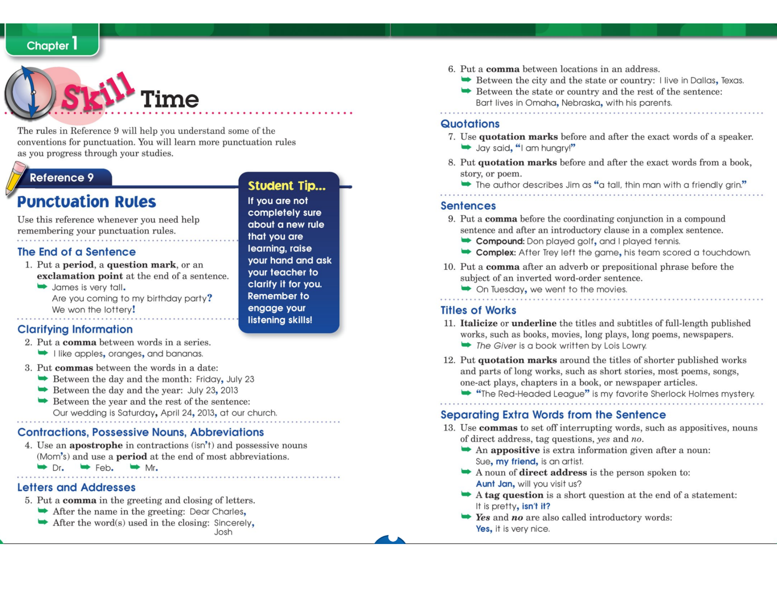

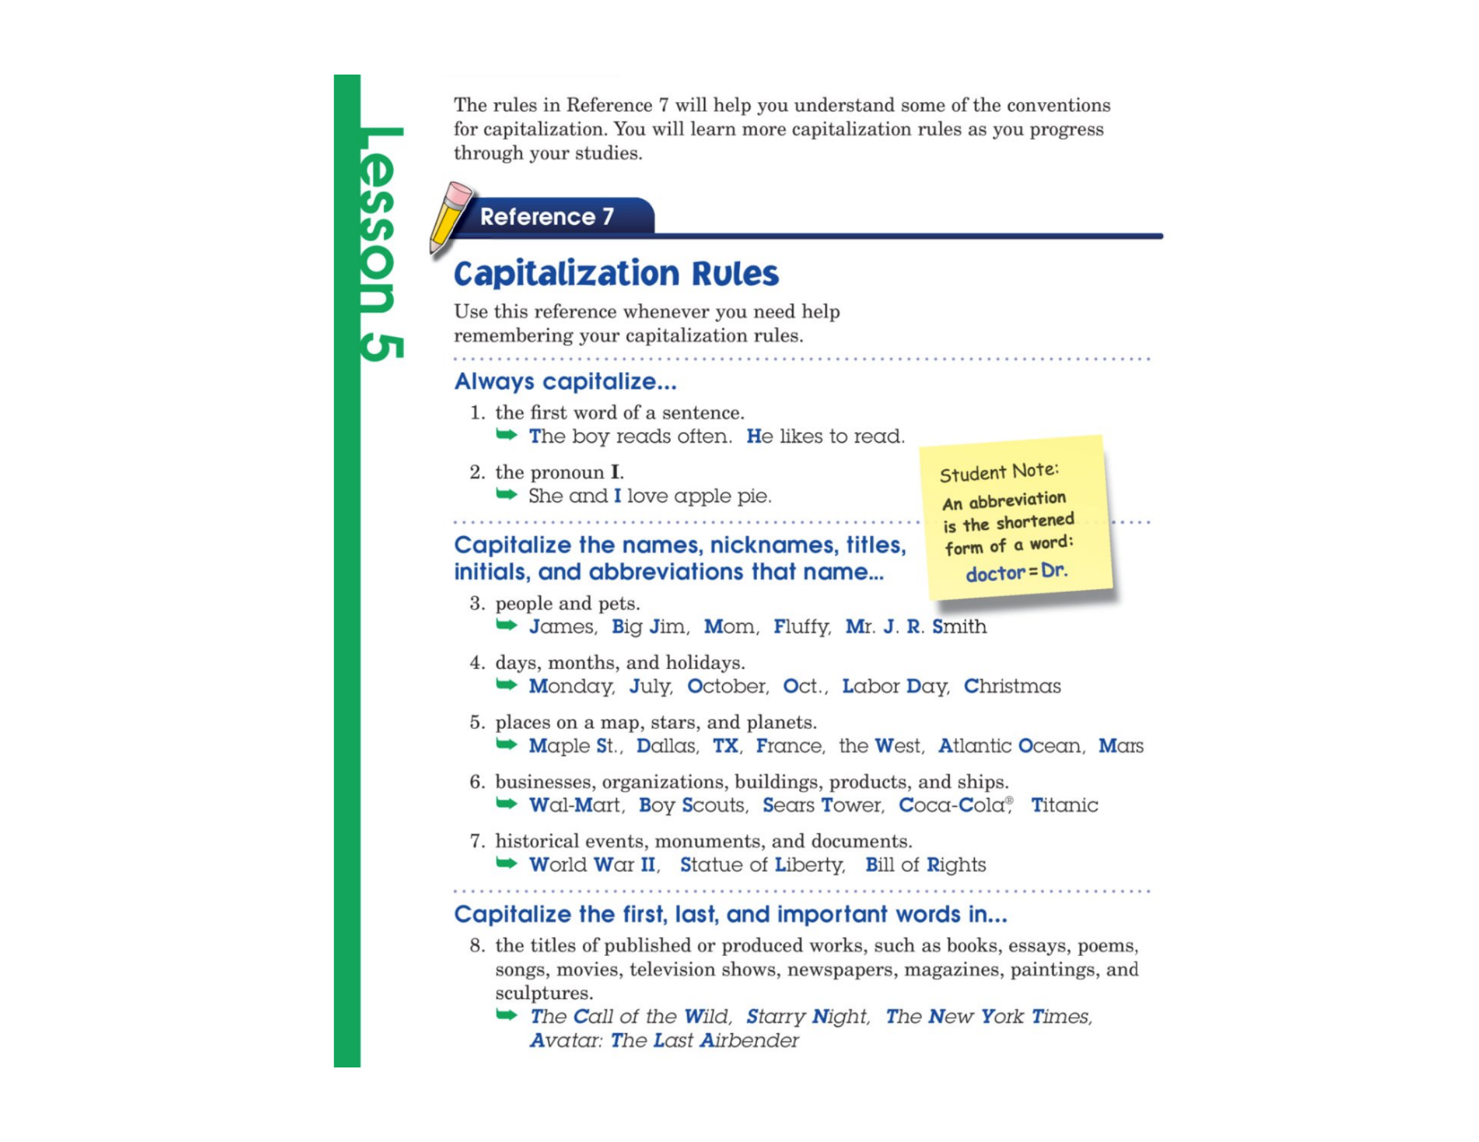

Chapter 1 — Lesson 5
Vocabulary and Analogy Example
Apply — Vocabulary
Word: _________________________________
Definition:
________________________________________________________________________
________________________________________________________________________
Kid-friendly meaning (in your own words):
________________________________________________________________________
Synonym:
________________________________________________________________________
Antonym:
________________________________________________________________________
Your sentence:
________________________________________________________________________
________________________________________________________________________
Memory picture — draw something that helps you remember this word:

Example analogy from this lesson: fraction : whole :: wing : bird
Relationship: Part-to-Whole
Your Turn — Create two analogies using your vocabulary word:
1.
________________________________________________________________________
2.
________________________________________________________________________

Chapter 1 — Lesson 5
Capitalization Practice
Learn
Remember: Proper nouns name specific people, places, or things. Proper nouns begin with a capital letter.
Practice Together — Capitalization
Write the correct capital letter above each word that should be capitalized.
Passage 1:
my friends and i will meet amy at the ford's theater on friday night to see nim's island.
________________________________________________________________________
________________________________________________________________________
Passage 2:
my cousins, reagan and beth, went to the parade on main street in july.
________________________________________________________________________
________________________________________________________________________

Chapter 1 — Lesson 5
Editing Practice — Capitals
Practice Independently — Editing
Each sentence below needs capital letters. Write the correct capital letter above each mistake. Then rewrite the sentence correctly.
Sentence 1:
we drove to lake michigan on saturday with mrs. daniels.
Rewrite:
________________________________________________________________________
________________________________________________________________________
Sentence 2:
yes, sam and i work on saturdays at quickfill gas on jasper road in denver.
Rewrite:
________________________________________________________________________
________________________________________________________________________
MEMORY CHECK
Without looking back, answer these questions:
1. What is a proper noun?
________________________________________________________________________
2. What letter should a proper noun begin with?
________________________________________________________________________
TEACHER CHECK
Complete: □ Date: __________ Initials: ________

Chapter 1 — Lesson 6
Vocabulary and Analogy Example
Apply — Vocabulary
Word: _________________________________
Definition:
________________________________________________________________________
________________________________________________________________________
Kid-friendly meaning (in your own words):
________________________________________________________________________
Synonym:
________________________________________________________________________
Antonym:
________________________________________________________________________
Your sentence:
________________________________________________________________________
________________________________________________________________________
Memory picture — draw something that helps you remember this word:

Example analogy from this lesson: individual : community :: bird : flock
Relationship: Part-to-Whole
Your Turn — Create two analogies using your vocabulary word:
1.
________________________________________________________________________
2.
________________________________________________________________________

Chapter 1 — Lesson 6
Capitalization and Punctuation
Learn
Sentences need correct capital letters, commas, periods, question marks, exclamation marks, and apostrophes.
Practice Together
Read each sentence. Look for correct capitalization and punctuation.
1. May I walk to Central Park with Jeff, Lonny, and Tina?
2. Class, I would like you to meet Ally Mona, our new student.
What did you notice about capitals, commas, and end marks?
________________________________________________________________________

Chapter 1 — Lesson 6
Editing Practice — Mixed Skills
Practice Independently — Editing
Correct each capitalization and punctuation mistake. Rewrite each sentence on the lines below.
Sentence 1:
yes mr green will move to denver colorado on june 18 2024
Rewrite:
________________________________________________________________________
________________________________________________________________________
Sentence 2:
did your teacher ms coleman read charlottes web to your class today
Rewrite:
________________________________________________________________________
________________________________________________________________________
MEMORY CHECK
Without looking back, answer these questions:
1. Name three punctuation marks used in complete sentences.
________________________________________________________________________
2. What is one thing you check when you edit a sentence?
________________________________________________________________________
TEACHER CHECK
Complete: □ Date: __________ Initials: ________

Chapter 1 — In-Class Chapter Review
Complete this review in class with your teacher's directions.
Part A — Complete Sentences
Name the five parts of a complete sentence:
________________________________________________________________________
Part B — Synonyms and Antonyms
1. Synonyms are words that _______________________________.
2. Antonyms are words that _______________________________.
3. Circle: hot/warm = Synonym or Antonym? run/walk = Synonym or Antonym?
Part C — Analogies
1. List the four analogy relationship types:
________________________________________________________________________
2. big : small :: hot : ___________ (relationship: ___________)
3. leaf : tree :: paw : ___________ (relationship: ___________)
Part D — Vocabulary
Write the word and definition for one vocabulary word you studied in this chapter.
________________________________________________________________________
________________________________________________________________________
Part E — Capitalization and Punctuation
Rewrite correctly: kevin asked bobby bill and tonya to his birthday party
________________________________________________________________________
Part F — Application
Write one academic goal and one short-term action step you will take this week.
________________________________________________________________________
TEACHER CHECK
Complete: □ Date: __________ Initials: ________

