Chapter 2
Shurley Packet
Name: _________________________________
Date: _________________________________
Draw a picture about sentence patterns you are learning:

The Sentence Blueprint
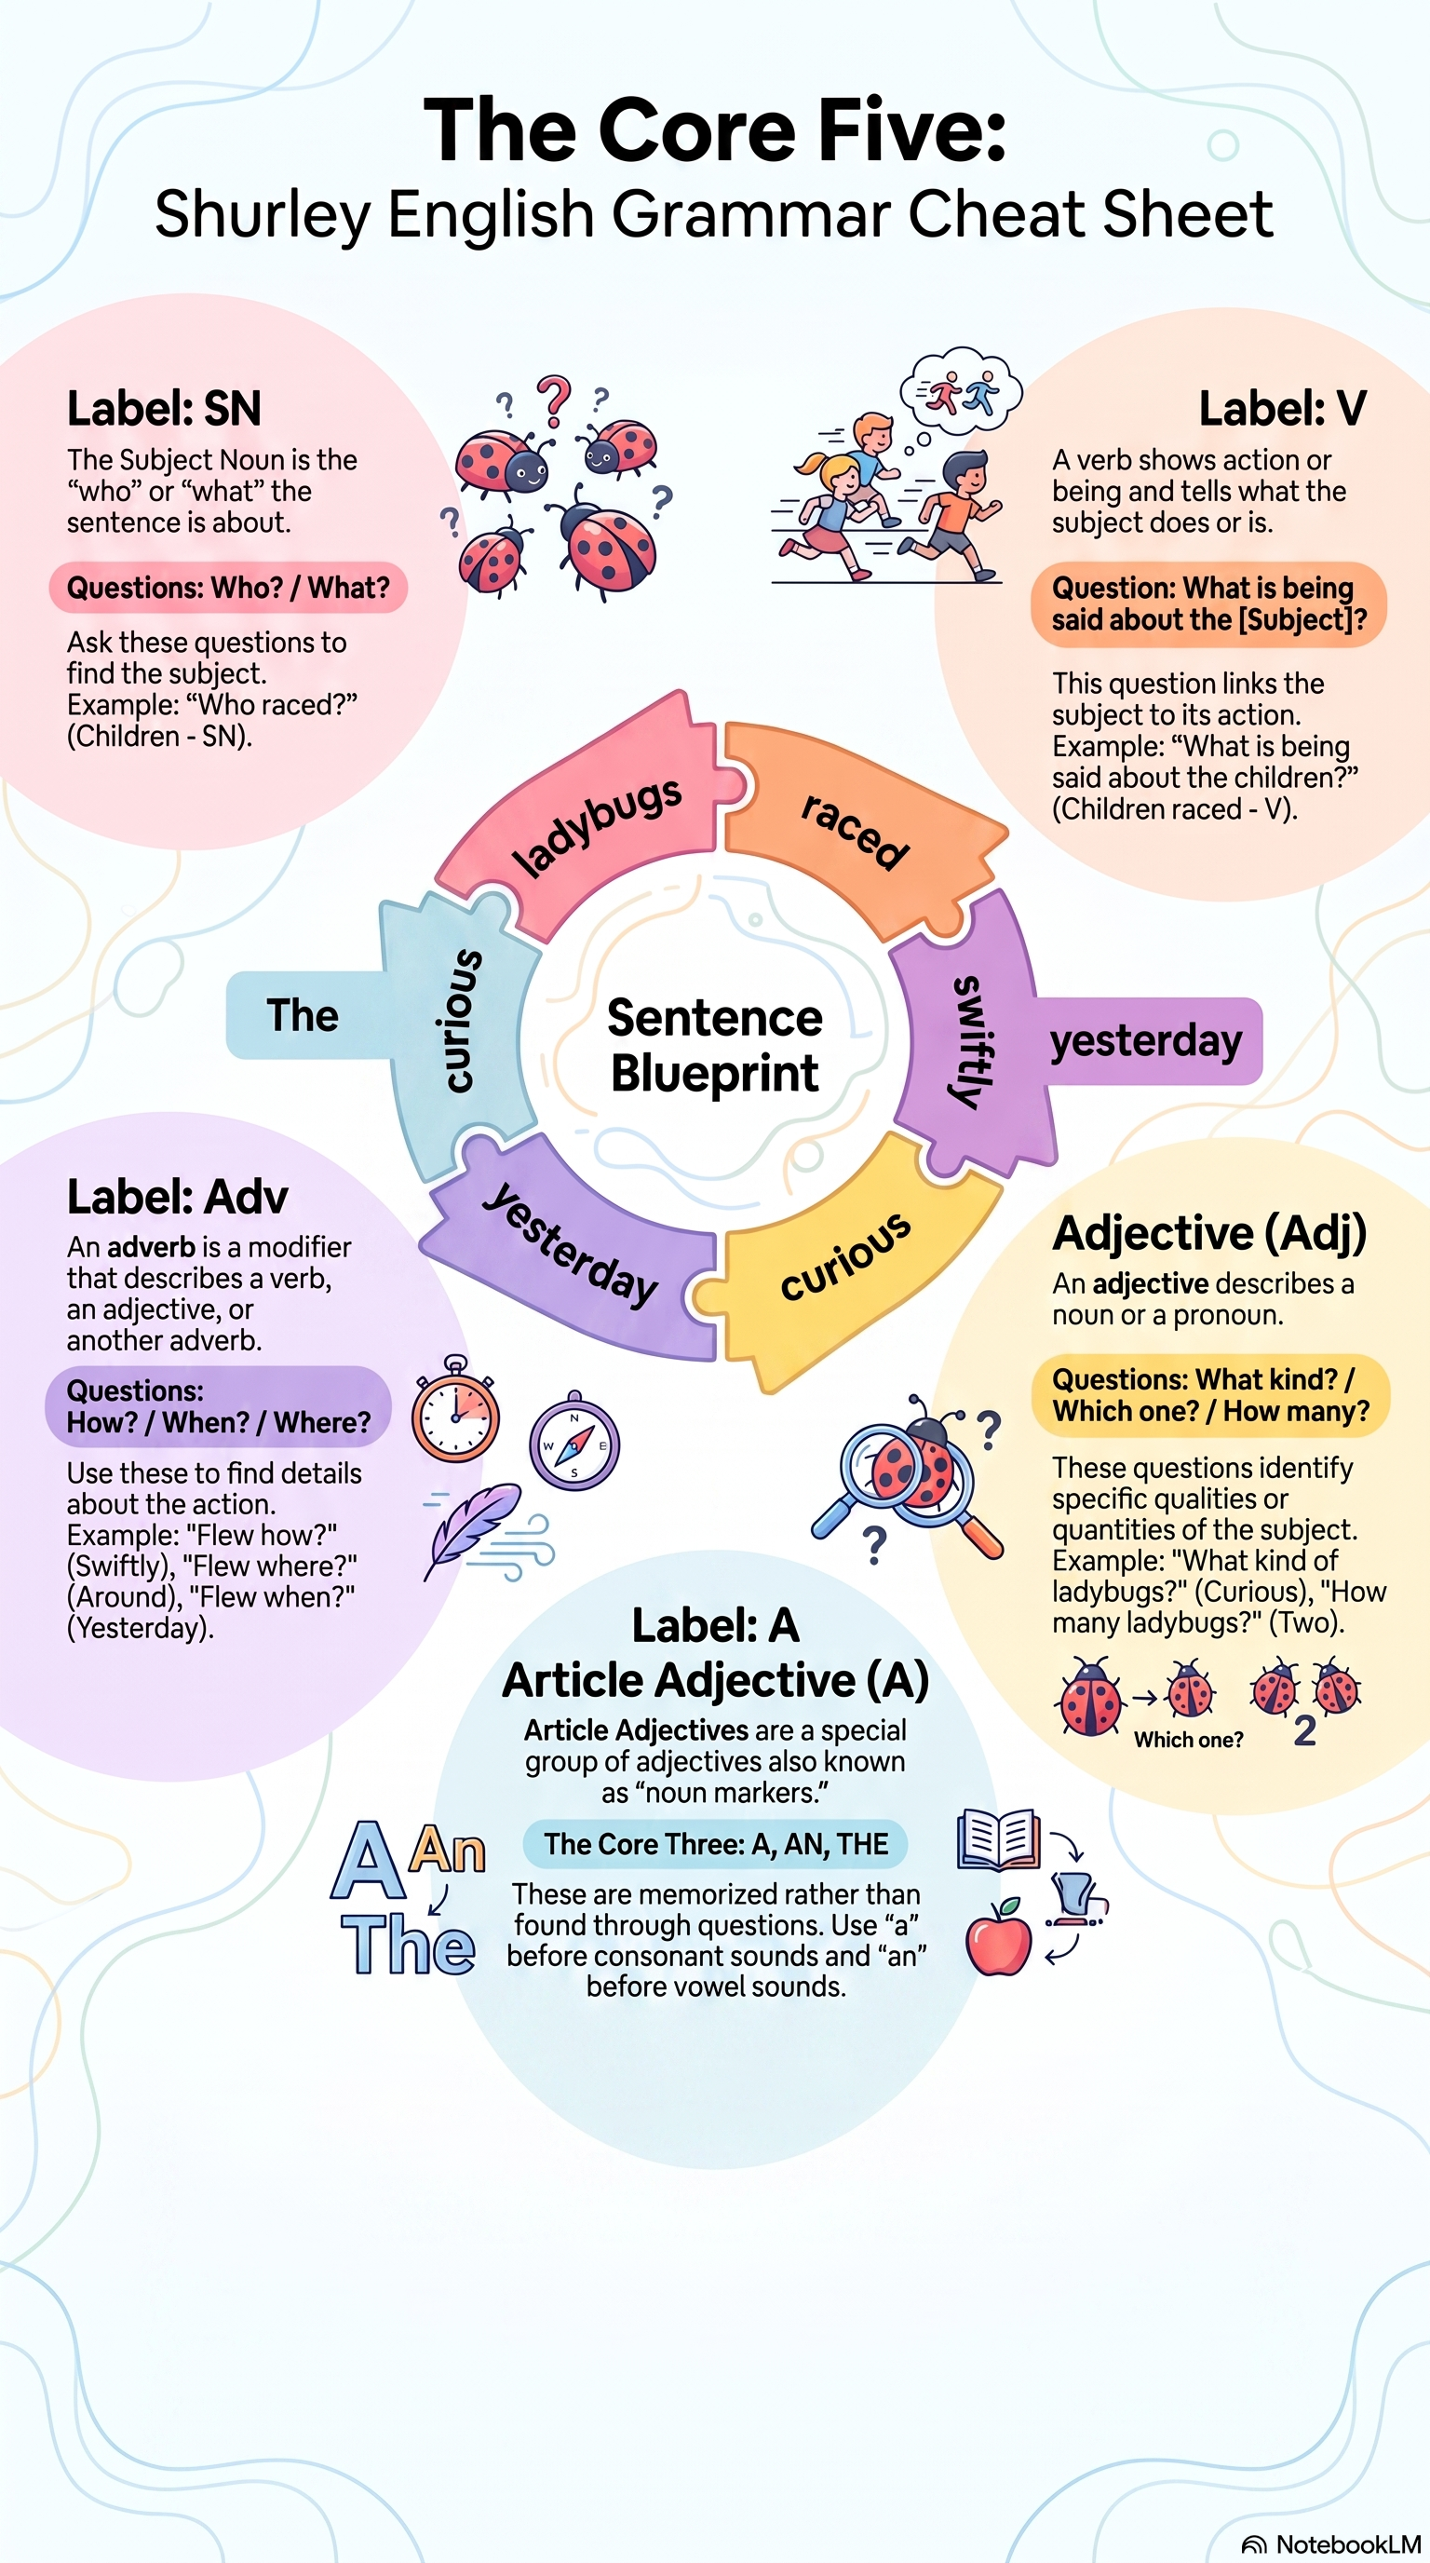
Question and Answer Flow
Four Steps to Classify: Ask → Name → Identify → Label.
• SN: Who? / What?
• V: What is being said about the subject?
• Adv: How? / When? / Where?
• Adj: What kind? / Which one? / How many?
• A: a, an, the (noun markers)
• P1: SN V

The Sentence Blueprint (continued)
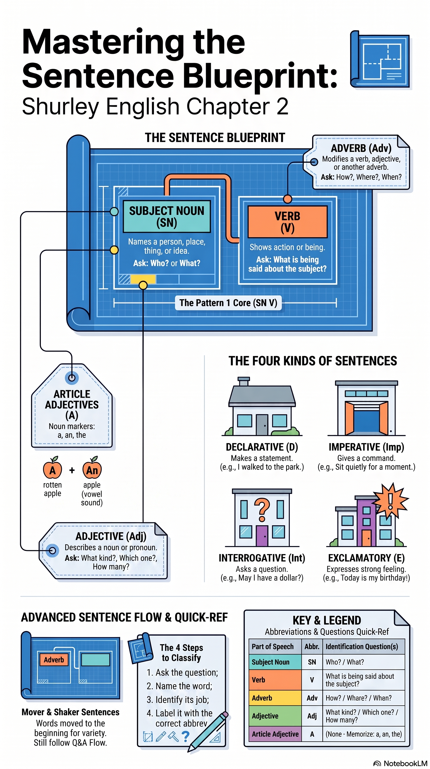
Sentence Types (Lesson 7+)
• Declarative (D)
• Imperative (Imp)
• Interrogative (Int)
• Exclamatory (E)
Remember: The Divide: slash directly before the verb. Mover and Shaker: front-move + comma — not for classification.

Chapter 2 — Lesson 1
Nouns, Verbs, Pattern 1
Learn
What does a noun name?
1. ________________________________________
2. ________________________________________
3. ________________________________________
4. ________________________________________
What are the subject questions?
1. ________________________________________
2. ________________________________________
A verb shows _______________ (called an _______________ verb) or __________________ (called a _________________ verb).
Remember: Subject Noun first, then Verb. Declare: Subject Noun, Verb, Pattern 1.
Practice Together
S. ___________ Ships sailed.
Classify this sentence. Label each word. Write SN V / P1.
________________________________________________________________________
________________________________________________________________________
________________________________________________________________________

Chapter 2 — Lesson 1
Nouns, Verbs, Pattern 1
Practice Together
1. ___________ Plane flew.
Classify this sentence. Label each word. Write SN V / P1.
________________________________________________________________________
________________________________________________________________________
________________________________________________________________________
2. ___________ Ladybugs crawled.
Classify this sentence. Label each word. Write SN V / P1.
________________________________________________________________________
________________________________________________________________________
________________________________________________________________________
3. ___________ Boys raced.
Classify this sentence. Label each word. Write SN V / P1.
________________________________________________________________________
________________________________________________________________________
________________________________________________________________________
MEMORY CHECK
Without looking back, answer briefly:
What are the subject questions?
________________________________________________________________________
What is Pattern 1?
________________________________________________________________________

Chapter 2 — Lesson 1
Nouns, Verbs, Pattern 1
Apply
Write your own sentence using Pattern 1 (SN V):
________________________________________________________________________
________________________________________________________________________
________________________________________________________________________
________________________________________________________________________
TEACHER CHECK
Complete: □ Date: __________ Initials: ________

Chapter 2 — Lesson 2
Adverbs
Learn
What are the adverb questions?
1. ________________________________________
2. ________________________________________
3. ________________________________________
What does an adverb modify?
1. ________________________________________
2. ________________________________________
3. ________________________________________
It is labeled with the abbreviation ________________________________________
Practice Together
S. ___________ Ships sailed slowly away today.
Classify this sentence. Label each word. Write SN V / P1.
________________________________________________________________________
________________________________________________________________________
________________________________________________________________________

Chapter 2 — Lesson 2
Adverbs
Practice Together
1. ___________ Planes flew.
Classify this sentence. Label each word. Write SN V / P1.
________________________________________________________________________
________________________________________________________________________
________________________________________________________________________
2. ___________ Planes flew quickly away today.
Classify this sentence. Label each word. Write SN V / P1.
________________________________________________________________________
________________________________________________________________________
________________________________________________________________________
3. ___________ Spiders crawled around very quickly.
Classify this sentence. Label each word. Write SN V / P1.
________________________________________________________________________
________________________________________________________________________
________________________________________________________________________
MEMORY CHECK
Without looking back, answer briefly:
Name the three adverb questions.
________________________________________________________________________
Name three things adverbs can modify.
________________________________________________________________________

Chapter 2 — Lesson 2
Adverbs
Apply
Write your own sentence using SN V Adv Adv:
________________________________________________________________________
________________________________________________________________________
________________________________________________________________________
________________________________________________________________________
TEACHER CHECK
Complete: □ Date: __________ Initials: ________

Chapter 2 — Lesson 3
Adverb Practice + Sentence Blueprint
Learn
Remember: Mover and Shaker: Move an adverb to the front of the sentence and put a comma after it.
Five parts of a complete sentence: subject, verb, complete sense, capital letter, end mark.
Practice Together
1. ___________ Bees buzzed angrily around today.
Classify this sentence. Label each word. Write SN V / P1.
________________________________________________________________________
________________________________________________________________________
________________________________________________________________________
2. ___________ Rabbits hopped around everywhere.
Classify this sentence. Label each word. Write SN V / P1.
________________________________________________________________________
________________________________________________________________________
________________________________________________________________________
3. ___________ Anthony listened very carefully yesterday.
Classify this sentence. Label each word. Write SN V / P1.
________________________________________________________________________
________________________________________________________________________
________________________________________________________________________

Chapter 2 — Lesson 3
Adverb Practice
Apply
Write your own sentence using SN V Adv Adv:
________________________________________________________________________
________________________________________________________________________
________________________________________________________________________
________________________________________________________________________
MEMORY CHECK
Without looking back, answer briefly:
What punctuation follows a Mover and Shaker adverb at the front?
________________________________________________________________________
TEACHER CHECK
Complete: □ Date: __________ Initials: ________

Chapter 2 — Lesson 4
Adjectives
Learn
An adjective describes a noun or a pronoun.
What kind? _____________________
Which _____________________?
How _______________________?
It is labeled with the abbreviation ________________________________________
Practice Together
S. ___________ Those five cargo ships sailed slowly away today.
Classify this sentence. Label each word. Write SN V / P1.
________________________________________________________________________
________________________________________________________________________
________________________________________________________________________

Chapter 2 — Lesson 4
Adjectives
Practice Together
1. ___________ That owl flew silently.
Classify this sentence. Label each word. Write SN V / P1.
________________________________________________________________________
________________________________________________________________________
________________________________________________________________________
2. ___________ That large white owl flew silently overhead tonight.
Classify this sentence. Label each word. Write SN V / P1.
________________________________________________________________________
________________________________________________________________________
________________________________________________________________________
3. ___________ Several little red ladybugs crawled everywhere yesterday.
Classify this sentence. Label each word. Write SN V / P1.
________________________________________________________________________
________________________________________________________________________
________________________________________________________________________
MEMORY CHECK
Without looking back, answer briefly:
Name the three adjective questions.
________________________________________________________________________

Chapter 2 — Lesson 4
Adjectives
Apply
Write your own sentence using Adj Adj SN V Adv Adv:
________________________________________________________________________
________________________________________________________________________
________________________________________________________________________
________________________________________________________________________
TEACHER CHECK
Complete: □ Date: __________ Initials: ________

Chapter 2 — Lesson 5
Article Adjectives
Learn
Article Adjectives are _______, __________, _________.
They are labeled with the abbreviation ________________________________________
Article adjectives are also known as ___________________.
Remember: Use a before a consonant sound; use an before a vowel sound.
Practice — a or an
____ tall tree.
____ unhappy baby.
____ flying owl. / ____ owl.
Did you find ____ oily cloth in the garage?
Would you like ____ fresh peach?
We saw ____ large animal yesterday.
We saw ____ anteater at the zoo yesterday.
We saw ____ movie yesterday.
We saw ____ exciting movie yesterday.

Chapter 2 — Lesson 5
Article Adjectives
Practice Together
S. ___________ The five cargo ships sailed slowly away.
Classify this sentence. Label each word. Write SN V / P1.
________________________________________________________________________
________________________________________________________________________
________________________________________________________________________
1. ___________ The girls giggled loudly.
Classify this sentence. Label each word. Write SN V / P1.
________________________________________________________________________
________________________________________________________________________
________________________________________________________________________

Chapter 2 — Lesson 5
Article Adjectives
2. ___________ The four happy girls giggled loudly today.
Classify this sentence. Label each word. Write SN V / P1.
________________________________________________________________________
________________________________________________________________________
________________________________________________________________________
3. ___________ A huge whale swam very slowly away.
Classify this sentence. Label each word. Write SN V / P1.
________________________________________________________________________
________________________________________________________________________
________________________________________________________________________
Apply
Write your own sentence using A Adj Adj SN V Adv Adv:
________________________________________________________________________
________________________________________________________________________
________________________________________________________________________
________________________________________________________________________
MEMORY CHECK
Without looking back, answer briefly:
Name the three article adjectives.
________________________________________________________________________
Article adjectives are also known as what?
________________________________________________________________________
TEACHER CHECK
Complete: □ Date: __________ Initials: ________

Chapter 2 — Lesson 6
Full-Pattern Classification
Remember: Full pattern: A Adj Adj SN V Adv Adv — label only the words that are present.
Practice Together
1. ___________ The nice young doctor spoke very kindly today.
Classify this sentence. Label each word. Write SN V / P1.
________________________________________________________________________
________________________________________________________________________
________________________________________________________________________
2. ___________ A little yellow duck waddled slowly away.
Classify this sentence. Label each word. Write SN V / P1.
________________________________________________________________________
________________________________________________________________________
________________________________________________________________________
3. ___________ An enormous black bug flew around today.
Classify this sentence. Label each word. Write SN V / P1.
________________________________________________________________________
________________________________________________________________________
________________________________________________________________________

Chapter 2 — Lesson 6
Full-Pattern Classification
MEMORY CHECK
Without looking back, answer briefly:
What is Pattern 1?
________________________________________________________________________
Where do you place labels for words that are not in the sentence?
________________________________________________________________________
TEACHER CHECK
Complete: □ Date: __________ Initials: ________

Chapter 2 — Lesson 7
Sentence Types + Skill Check
Vocabulary & Analogy Words
Word: ________________________________________
Definition:
________________________________________________________________________
________________________________________________________________________
Synonym: ________________________________________
Antonym: ________________________________________
Sentence:
________________________________________________________________________
________________________________________________________________________
Draw a picture in the box to help you remember the word:

Chapter 2 — Lesson 7
Sentence Types
Analogy: soothing : smoothing :: flying : trying
Relationship: synonym antonym rhyming part-to-whole
________________________________________________________________________
Learn
Declarative sentence makes a statement. It is labeled with a _______.
An imperative sentence gives a command. It is labeled with an ______.
An interrogative sentence asks a question. It is labeled with an ______.
An exclamatory sentence expresses strong feeling. It is labeled with an ______.

Chapter 2 — Lesson 7
Sentence Types
Remember: Skill Check: end mark → purpose → sentence type → label D, Imp, Int, or E.
S. ___________ The two pirate ships appeared quite suddenly!
Classify this sentence. Label each word. Write SN V / P1.
________________________________________________________________________
________________________________________________________________________
________________________________________________________________________
1. ___________ The music played softly.
Classify this sentence. Label each word. Write SN V / P1.
________________________________________________________________________
________________________________________________________________________
________________________________________________________________________

Chapter 2 — Lesson 7
Sentence Types
2. ___________ The very soothing music played softly tonight.
Classify this sentence. Label each word. Write SN V / P1.
________________________________________________________________________
________________________________________________________________________
________________________________________________________________________
3. ___________ Several urgent messages arrived very early today.
Classify this sentence. Label each word. Write SN V / P1.
________________________________________________________________________
________________________________________________________________________
________________________________________________________________________
Parts of Speech
Write the abbreviations for the four parts of speech studied so far:
________________________________________________________________________
MEMORY CHECK
Without looking back, answer briefly:
Name the four sentence types and their labels.
________________________________________________________________________
What is The Divide?
________________________________________________________________________
TEACHER CHECK
Complete: □ Date: __________ Initials: ________

Chapter 2 — Lesson 8
Noun Check + Intensifiers
Vocabulary & Analogy Words
Word: ________________________________________
Definition:
________________________________________________________________________
________________________________________________________________________
Synonym: ________________________________________
Antonym: ________________________________________
Sentence:
________________________________________________________________________
________________________________________________________________________
Draw a picture in the box to help you remember the word:

Analogy: urgent : important :: answer : reply
Relationship: synonym antonym rhyming part-to-whole
________________________________________________________________________
Remember: Noun Check: Subject Noun [word], yes, it is a noun.
Remember: Intensifiers (very, extremely, quite, etc.) strengthen an adjective or adverb.

Chapter 2 — Lesson 8
Noun Check
Practice Together
1. ___________ A young reporter glanced curiously around.
Classify this sentence. Label each word. Write SN V / P1.
________________________________________________________________________
________________________________________________________________________
________________________________________________________________________
2. ___________ The stormy winter sky darkened suddenly!
Classify this sentence. Label each word. Write SN V / P1.
________________________________________________________________________
________________________________________________________________________
________________________________________________________________________
3. ___________ An extremely frightened girl screamed very loudly!
Classify this sentence. Label each word. Write SN V / P1.
________________________________________________________________________
________________________________________________________________________
________________________________________________________________________

Chapter 2 — Lesson 8
Noun Check
MEMORY CHECK
Without looking back, answer briefly:
What does a Noun Check confirm?
________________________________________________________________________
Give one intensifier word.
________________________________________________________________________
TEACHER CHECK
Complete: □ Date: __________ Initials: ________

Chapter 2 — Lesson 9
Practice + Capitalization/Punctuation
Practice Together
1. ___________ Two beautiful butterflies flew slowly away.
Classify this sentence. Label each word. Write SN V / P1.
________________________________________________________________________
________________________________________________________________________
________________________________________________________________________
2. ___________ An old teapot whistled very loudly today.
Classify this sentence. Label each word. Write SN V / P1.
________________________________________________________________________
________________________________________________________________________
________________________________________________________________________
3. ___________ Several angry bees circled around nearby!
Classify this sentence. Label each word. Write SN V / P1.
________________________________________________________________________
________________________________________________________________________
________________________________________________________________________

Chapter 2 — Lesson 9
Capitalization/Punctuation
Using Capitalization and Punctuation Rules
Use your Chapter 1 Capitalization and Punctuation Reference.
Write the rule numbers for each correction in bold in the sentence below:
No, Alex did not go home with John during carpool on Friday.
Corrections to mark: N, comma, A, J, F, period.
________________________________________________________________________
________________________________________________________________________
________________________________________________________________________
________________________________________________________________________
MEMORY CHECK
Without looking back, answer briefly:
Where is the Chapter 1 reference for capitalization and punctuation rules?
________________________________________________________________________
TEACHER CHECK
Complete: □ Date: __________ Initials: ________
Chapter 2 — In-Class Chapter Review
Your teacher will use the separate In-Class Chapter Review during class.
Skills to review: SN/V/P1 classification, full-pattern sentences, sentence types (D/Imp/Int/E), adverb and adjective questions, articles a/an, analogies, capitalization and punctuation (Chapter 1 Reference).

