Chapter 2
Shurley Packet — Teacher Edition
Name: _________________________________
Date: _________________________________
Draw a picture about sentence patterns you are learning:

Student illustration — no fixed answer.

The Sentence Blueprint
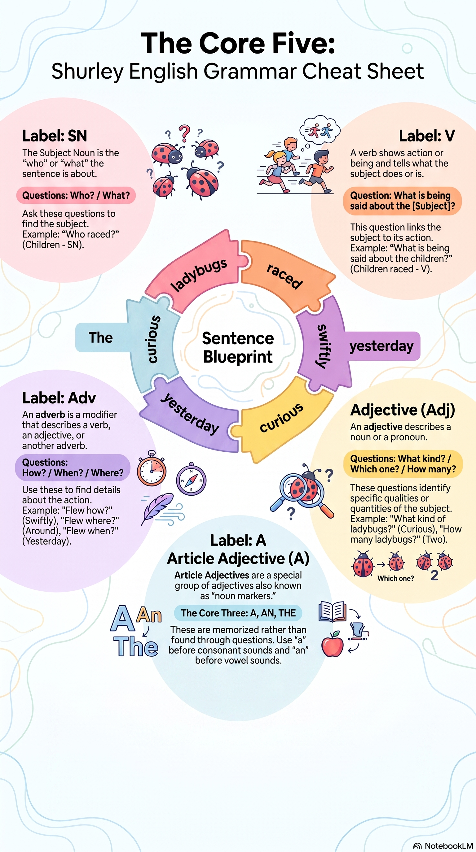
Question and Answer Flow
Four Steps to Classify: Ask → Name → Identify → Label.
• SN: Who? / What?
• V: What is being said about the subject?
• Adv: How? / When? / Where?
• Adj: What kind? / Which one? / How many?
• A: a, an, the (noun markers)
• P1: SN V
Review Q&A Flow before Lesson 1.

The Sentence Blueprint (continued)
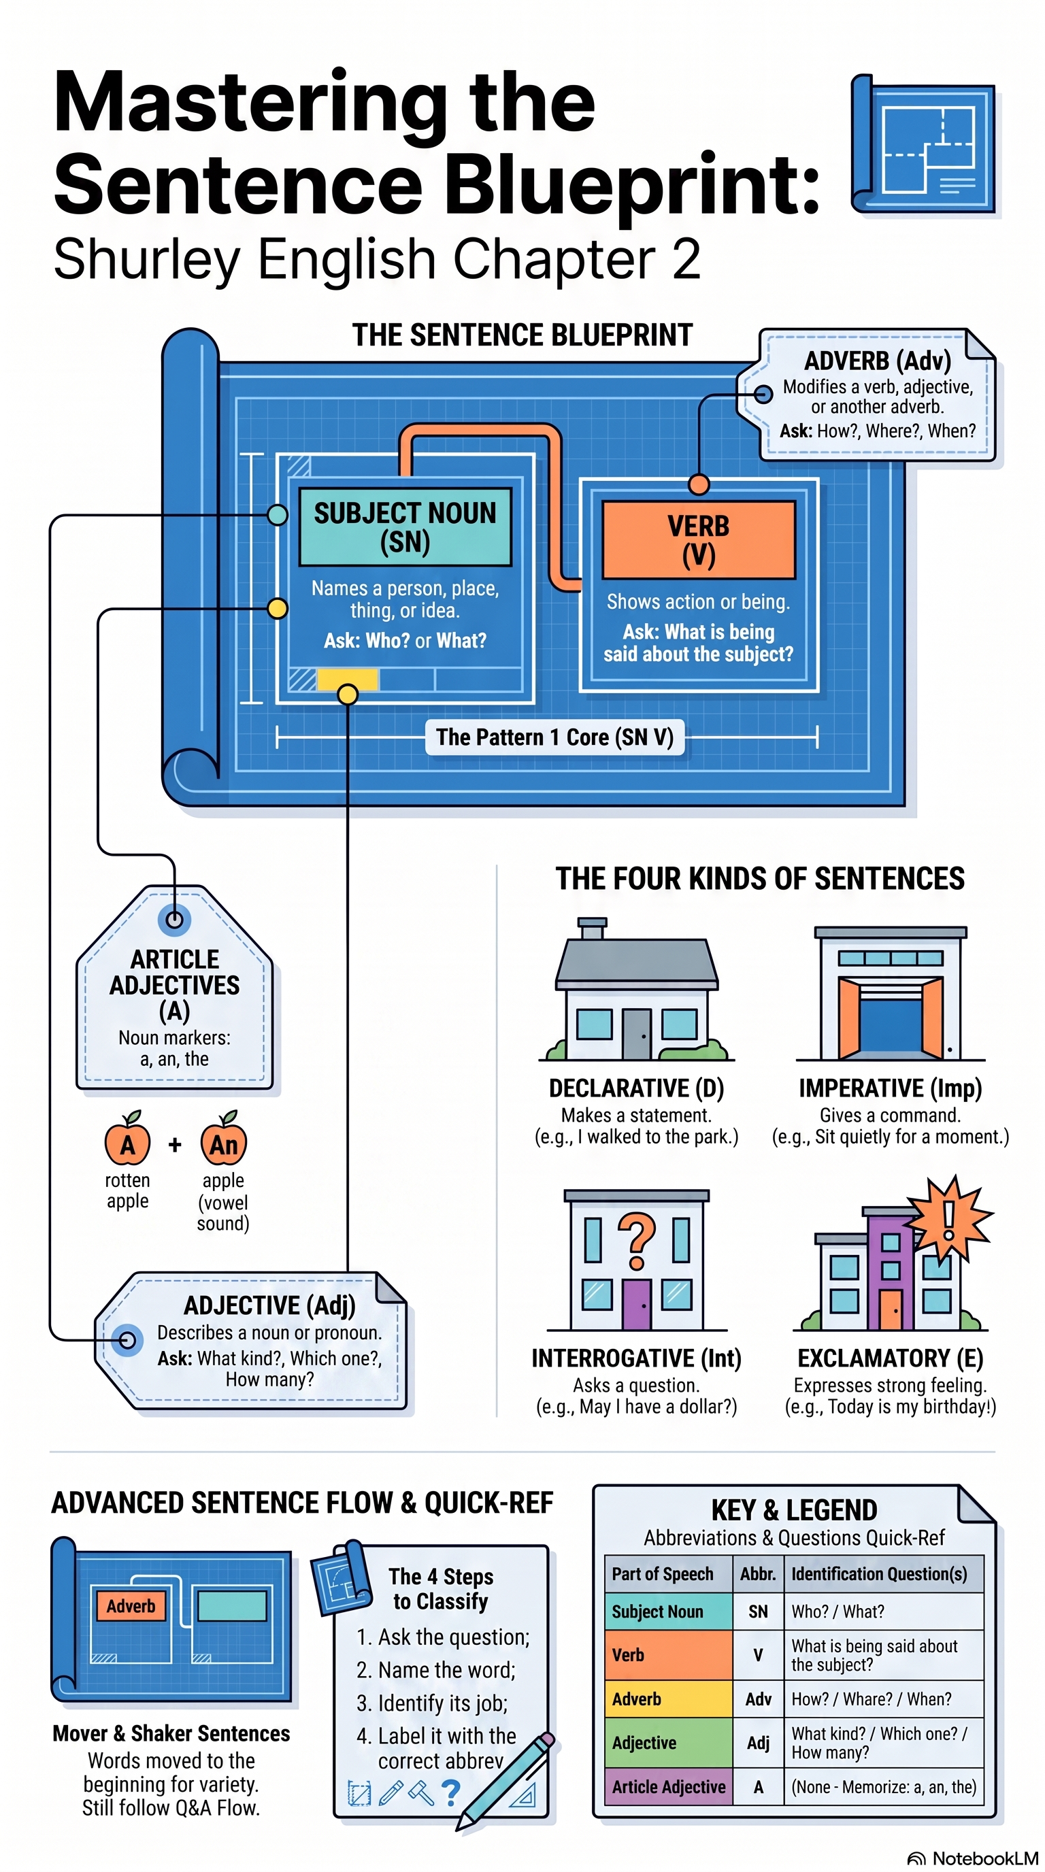
Sentence Types (Lesson 7+)
• Declarative (D)
• Imperative (Imp)
• Interrogative (Int)
• Exclamatory (E)
Remember: The Divide: slash directly before the verb. Mover and Shaker: front-move + comma — not for classification.

Chapter 2 — Lesson 1
Nouns, Verbs, Pattern 1
Learn
What does a noun name?
1. ________________________________________
2. ________________________________________
3. ________________________________________
4. ________________________________________
person, place, thing, idea
What are the subject questions?
1. ________________________________________
2. ________________________________________
Who?, What?
A verb shows _______________ (called an _______________ verb) or __________________ (called a _________________ verb).
action / action verb; being / linking verb
Remember: Subject Noun first, then Verb. Declare: Subject Noun, Verb, Pattern 1.
Practice Together
S. ___________ Ships sailed.
Classify this sentence. Label each word. Write SN V / P1.
________________________________________________________________________
________________________________________________________________________
________________________________________________________________________
SN V / P1 Ships=SN sailed.=V

Read sentence in unison before classifying.

Chapter 2 — Lesson 1
Nouns, Verbs, Pattern 1
Practice Together
1. ___________ Plane flew.
Classify this sentence. Label each word. Write SN V / P1.
________________________________________________________________________
________________________________________________________________________
________________________________________________________________________
SN V / P1 Plane=SN flew.=V

2. ___________ Ladybugs crawled.
Classify this sentence. Label each word. Write SN V / P1.
________________________________________________________________________
________________________________________________________________________
________________________________________________________________________
SN V / P1 Ladybugs=SN crawled.=V

3. ___________ Boys raced.
Classify this sentence. Label each word. Write SN V / P1.
________________________________________________________________________
________________________________________________________________________
________________________________________________________________________
SN V / P1 Boys=SN raced.=V

MEMORY CHECK
Without looking back, answer briefly:
What are the subject questions?
Who?, What?
What is Pattern 1?
Pattern 1 = SN V

Chapter 2 — Lesson 1
Nouns, Verbs, Pattern 1
Apply
Write your own sentence using Pattern 1 (SN V):
________________________________________________________________________
________________________________________________________________________
________________________________________________________________________
________________________________________________________________________
TEACHER CHECK
Complete: □ Date: __________ Initials: ________
Use Who? for Boys (person).

Chapter 2 — Lesson 2
Adverbs
Learn
What are the adverb questions?
1. ________________________________________
2. ________________________________________
3. ________________________________________
How?, When?, Where?
What does an adverb modify?
1. ________________________________________
2. ________________________________________
3. ________________________________________
It is labeled with the abbreviation ________________________________________
verbs, adjectives, adverbs
Adv
Practice Together
S. ___________ Ships sailed slowly away today.
Classify this sentence. Label each word. Write SN V / P1.
________________________________________________________________________
________________________________________________________________________
________________________________________________________________________
SN V / P1 Ships=SN sailed=V slowly=Adv away=Adv today.=Adv

Chapter 2 — Lesson 2
Adverbs
Practice Together
1. ___________ Planes flew.
Classify this sentence. Label each word. Write SN V / P1.
________________________________________________________________________
________________________________________________________________________
________________________________________________________________________
SN V / P1 Planes=SN flew.=V

2. ___________ Planes flew quickly away today.
Classify this sentence. Label each word. Write SN V / P1.
________________________________________________________________________
________________________________________________________________________
________________________________________________________________________
SN V / P1 Planes=SN flew=V quickly=Adv away=Adv today.=Adv

3. ___________ Spiders crawled around very quickly.
Classify this sentence. Label each word. Write SN V / P1.
________________________________________________________________________
________________________________________________________________________
________________________________________________________________________
SN V / P1 Spiders=SN crawled=V around=Adv very=Adv quickly.=Adv

MEMORY CHECK
Without looking back, answer briefly:
Name the three adverb questions.
How?, When?, Where?
Name three things adverbs can modify.
verbs, adjectives, adverbs
Spiders: where? around; how? quickly; How quickly? very

Chapter 2 — Lesson 2
Adverbs
Apply
Write your own sentence using SN V Adv Adv:
________________________________________________________________________
________________________________________________________________________
________________________________________________________________________
________________________________________________________________________
TEACHER CHECK
Complete: □ Date: __________ Initials: ________

Chapter 2 — Lesson 3
Adverb Practice + Sentence Blueprint
Learn
Remember: Mover and Shaker: Move an adverb to the front of the sentence and put a comma after it.
Five parts of a complete sentence: subject, verb, complete sense, capital letter, end mark.
Practice Together
1. ___________ Bees buzzed angrily around today.
Classify this sentence. Label each word. Write SN V / P1.
________________________________________________________________________
________________________________________________________________________
________________________________________________________________________
SN V / P1 Bees=SN buzzed=V angrily=Adv around=Adv today.=Adv

2. ___________ Rabbits hopped around everywhere.
Classify this sentence. Label each word. Write SN V / P1.
________________________________________________________________________
________________________________________________________________________
________________________________________________________________________
SN V / P1 Rabbits=SN hopped=V around=Adv everywhere.=Adv

3. ___________ Anthony listened very carefully yesterday.
Classify this sentence. Label each word. Write SN V / P1.
________________________________________________________________________
________________________________________________________________________
________________________________________________________________________
SN V / P1 Anthony=SN listened=V very=Adv carefully=Adv yesterday.=Adv

Mover and Shaker — revision only.

Chapter 2 — Lesson 3
Adverb Practice
Apply
Write your own sentence using SN V Adv Adv:
________________________________________________________________________
________________________________________________________________________
________________________________________________________________________
________________________________________________________________________
MEMORY CHECK
Without looking back, answer briefly:
What punctuation follows a Mover and Shaker adverb at the front?
comma
TEACHER CHECK
Complete: □ Date: __________ Initials: ________

Chapter 2 — Lesson 4
Adjectives
Learn
An adjective describes a noun or a pronoun.
What kind? _____________________
Which _____________________?
How _______________________?
It is labeled with the abbreviation ________________________________________
What kind?, Which one?, How many?
Adj
Practice Together
S. ___________ Those five cargo ships sailed slowly away today.
Classify this sentence. Label each word. Write SN V / P1.
________________________________________________________________________
________________________________________________________________________
________________________________________________________________________
SN V / P1 Those=Adj five=Adj cargo=Adj ships=SN sailed=V slowly=Adv away=Adv today.=Adv

Chapter 2 — Lesson 4
Adjectives
Practice Together
1. ___________ That owl flew silently.
Classify this sentence. Label each word. Write SN V / P1.
________________________________________________________________________
________________________________________________________________________
________________________________________________________________________
SN V / P1 That=Adj owl=SN flew=V silently.=Adv

2. ___________ That large white owl flew silently overhead tonight.
Classify this sentence. Label each word. Write SN V / P1.
________________________________________________________________________
________________________________________________________________________
________________________________________________________________________
SN V / P1 That=Adj large=Adj white=Adj owl=SN flew=V silently=Adv overhead=Adv tonight.=Adv

3. ___________ Several little red ladybugs crawled everywhere yesterday.
Classify this sentence. Label each word. Write SN V / P1.
________________________________________________________________________
________________________________________________________________________
________________________________________________________________________
SN V / P1 Several=Adj little=Adj red=Adj ladybugs=SN crawled=V everywhere=Adv yesterday.=Adv

MEMORY CHECK
Without looking back, answer briefly:
Name the three adjective questions.
What kind?, Which one?, How many?

Chapter 2 — Lesson 4
Adjectives
Apply
Write your own sentence using Adj Adj SN V Adv Adv:
________________________________________________________________________
________________________________________________________________________
________________________________________________________________________
________________________________________________________________________
TEACHER CHECK
Complete: □ Date: __________ Initials: ________

Chapter 2 — Lesson 5
Article Adjectives
Learn
Article Adjectives are _______, __________, _________.
They are labeled with the abbreviation ________________________________________
Article adjectives are also known as ___________________.
a, an, the
A
noun markers
Remember: Use a before a consonant sound; use an before a vowel sound.
Practice — a or an
____ tall tree.
____ unhappy baby.
____ flying owl. / ____ owl.
Did you find ____ oily cloth in the garage?
Would you like ____ fresh peach?
We saw ____ large animal yesterday.
We saw ____ anteater at the zoo yesterday.
We saw ____ movie yesterday.
We saw ____ exciting movie yesterday.
a/an key: a, an, a, an, a, a, an, a, an
Use noun markers only — no alternate grammar terminology outside TM Ch.2.

Chapter 2 — Lesson 5
Article Adjectives
Practice Together
S. ___________ The five cargo ships sailed slowly away.
Classify this sentence. Label each word. Write SN V / P1.
________________________________________________________________________
________________________________________________________________________
________________________________________________________________________
SN V / P1 The=A five=Adj cargo=Adj ships=SN sailed=V slowly=Adv away.=Adv

1. ___________ The girls giggled loudly.
Classify this sentence. Label each word. Write SN V / P1.
________________________________________________________________________
________________________________________________________________________
________________________________________________________________________
SN V / P1 The=A girls=SN giggled=V loudly.=Adv

Chapter 2 — Lesson 5
Article Adjectives
2. ___________ The four happy girls giggled loudly today.
Classify this sentence. Label each word. Write SN V / P1.
________________________________________________________________________
________________________________________________________________________
________________________________________________________________________
SN V / P1 The=A four=Adj happy=Adj girls=SN giggled=V loudly=Adv today.=Adv

3. ___________ A huge whale swam very slowly away.
Classify this sentence. Label each word. Write SN V / P1.
________________________________________________________________________
________________________________________________________________________
________________________________________________________________________
SN V / P1 A=A huge=Adj whale=SN swam=V very=Adv slowly=Adv away.=Adv

Apply
Write your own sentence using A Adj Adj SN V Adv Adv:
________________________________________________________________________
________________________________________________________________________
________________________________________________________________________
________________________________________________________________________
MEMORY CHECK
Without looking back, answer briefly:
Name the three article adjectives.
a, an, the
Article adjectives are also known as what?
noun markers
TEACHER CHECK
Complete: □ Date: __________ Initials: ________

Chapter 2 — Lesson 6
Full-Pattern Classification
Remember: Full pattern: A Adj Adj SN V Adv Adv — label only the words that are present.
Practice Together
1. ___________ The nice young doctor spoke very kindly today.
Classify this sentence. Label each word. Write SN V / P1.
________________________________________________________________________
________________________________________________________________________
________________________________________________________________________
SN V / P1 The=A nice=Adj young=Adj doctor=SN spoke=V very=Adv kindly=Adv today.=Adv

2. ___________ A little yellow duck waddled slowly away.
Classify this sentence. Label each word. Write SN V / P1.
________________________________________________________________________
________________________________________________________________________
________________________________________________________________________
SN V / P1 A=A little=Adj yellow=Adj duck=SN waddled=V slowly=Adv away.=Adv

3. ___________ An enormous black bug flew around today.
Classify this sentence. Label each word. Write SN V / P1.
________________________________________________________________________
________________________________________________________________________
________________________________________________________________________
SN V / P1 An=A enormous=Adj black=Adj bug=SN flew=V around=Adv today.=Adv

Partial patterns — label only words present.

Chapter 2 — Lesson 6
Full-Pattern Classification
MEMORY CHECK
Without looking back, answer briefly:
What is Pattern 1?
SN V
Where do you place labels for words that are not in the sentence?
Do not add empty labels — partial patterns only
TEACHER CHECK
Complete: □ Date: __________ Initials: ________

Chapter 2 — Lesson 7
Sentence Types + Skill Check
Vocabulary & Analogy Words
Word: ________________________________________
Definition:
________________________________________________________________________
________________________________________________________________________
Synonym: ________________________________________
Antonym: ________________________________________
Sentence:
________________________________________________________________________
________________________________________________________________________
Draw a picture in the box to help you remember the word:

Teacher-assigned word
Vocabulary: Teacher-assigned — do not pre-fill soothing.

Chapter 2 — Lesson 7
Sentence Types
Analogy: soothing : smoothing :: flying : trying
Relationship: synonym antonym rhyming part-to-whole
________________________________________________________________________
Relationship: rhyming
Learn
Declarative sentence makes a statement. It is labeled with a _______.
An imperative sentence gives a command. It is labeled with an ______.
An interrogative sentence asks a question. It is labeled with an ______.
An exclamatory sentence expresses strong feeling. It is labeled with an ______.
D
Imp
Int
E

Chapter 2 — Lesson 7
Sentence Types
Remember: Skill Check: end mark → purpose → sentence type → label D, Imp, Int, or E.
S. ___________ The two pirate ships appeared quite suddenly!
Classify this sentence. Label each word. Write SN V / P1.
________________________________________________________________________
________________________________________________________________________
________________________________________________________________________
SN V / P1 The=A two=Adj pirate=Adj ships=SN appeared=V quite=Adv suddenly!=Adv
type E
1. ___________ The music played softly.
Classify this sentence. Label each word. Write SN V / P1.
________________________________________________________________________
________________________________________________________________________
________________________________________________________________________
SN V / P1 The=A music=SN played=V softly.=Adv
type D
Skill Check per TM Ref 26.

Chapter 2 — Lesson 7
Sentence Types
2. ___________ The very soothing music played softly tonight.
Classify this sentence. Label each word. Write SN V / P1.
________________________________________________________________________
________________________________________________________________________
________________________________________________________________________
SN V / P1 The=A very=Adv soothing=Adj music=SN played=V softly=Adv tonight.=Adv
type D
3. ___________ Several urgent messages arrived very early today.
Classify this sentence. Label each word. Write SN V / P1.
________________________________________________________________________
________________________________________________________________________
________________________________________________________________________
SN V / P1 Several=Adj urgent=Adj messages=SN arrived=V very=Adv early=Adv today.=Adv
type D
Parts of Speech
Write the abbreviations for the four parts of speech studied so far:
________________________________________________________________________
N, V, Adv, Adj
MEMORY CHECK
Without looking back, answer briefly:
Name the four sentence types and their labels.
D, Imp, Int, E
What is The Divide?
Slash before the verb
TEACHER CHECK
Complete: □ Date: __________ Initials: ________

Chapter 2 — Lesson 8
Noun Check + Intensifiers
Vocabulary & Analogy Words
Word: ________________________________________
Definition:
________________________________________________________________________
________________________________________________________________________
Synonym: ________________________________________
Antonym: ________________________________________
Sentence:
________________________________________________________________________
________________________________________________________________________
Draw a picture in the box to help you remember the word:

Teacher-assigned word
Analogy: urgent : important :: answer : reply
Relationship: synonym antonym rhyming part-to-whole
________________________________________________________________________
Relationship: synonym
Remember: Noun Check: Subject Noun [word], yes, it is a noun.
Remember: Intensifiers (very, extremely, quite, etc.) strengthen an adjective or adverb.
Vocabulary: Teacher-assigned — do not pre-fill urgent.

Chapter 2 — Lesson 8
Noun Check
Practice Together
1. ___________ A young reporter glanced curiously around.
Classify this sentence. Label each word. Write SN V / P1.
________________________________________________________________________
________________________________________________________________________
________________________________________________________________________
SN V / P1 A=A young=Adj reporter=SN glanced=V curiously=Adv around.=Adv
type D
2. ___________ The stormy winter sky darkened suddenly!
Classify this sentence. Label each word. Write SN V / P1.
________________________________________________________________________
________________________________________________________________________
________________________________________________________________________
SN V / P1 The=A stormy=Adj winter=Adj sky=SN darkened=V suddenly!=Adv
type E
3. ___________ An extremely frightened girl screamed very loudly!
Classify this sentence. Label each word. Write SN V / P1.
________________________________________________________________________
________________________________________________________________________
________________________________________________________________________
SN V / P1 An=A extremely=Adv frightened=Adj girl=SN screamed=V very=Adv loudly!=Adv
type E
Noun Check after Skill Check.

Chapter 2 — Lesson 8
Noun Check
MEMORY CHECK
Without looking back, answer briefly:
What does a Noun Check confirm?
Subject noun is a noun
Give one intensifier word.
very (also extremely, quite)
TEACHER CHECK
Complete: □ Date: __________ Initials: ________

Chapter 2 — Lesson 9
Practice + Capitalization/Punctuation
Practice Together
1. ___________ Two beautiful butterflies flew slowly away.
Classify this sentence. Label each word. Write SN V / P1.
________________________________________________________________________
________________________________________________________________________
________________________________________________________________________
SN V / P1 Two=Adj beautiful=Adj butterflies=SN flew=V slowly=Adv away.=Adv
type D
2. ___________ An old teapot whistled very loudly today.
Classify this sentence. Label each word. Write SN V / P1.
________________________________________________________________________
________________________________________________________________________
________________________________________________________________________
SN V / P1 An=A old=Adj teapot=SN whistled=V very=Adv loudly=Adv today.=Adv
type D
3. ___________ Several angry bees circled around nearby!
Classify this sentence. Label each word. Write SN V / P1.
________________________________________________________________________
________________________________________________________________________
________________________________________________________________________
SN V / P1 Several=Adj angry=Adj bees=SN circled=V around=Adv nearby!=Adv
type E

Chapter 2 — Lesson 9
Capitalization/Punctuation
Using Capitalization and Punctuation Rules
Use your Chapter 1 Capitalization and Punctuation Reference.
Write the rule numbers for each correction in bold in the sentence below:
No, Alex did not go home with John during carpool on Friday.
Corrections to mark: N, comma, A, J, F, period.
________________________________________________________________________
________________________________________________________________________
________________________________________________________________________
________________________________________________________________________
Rule numbers: Verify against protected reference.
Bold corrections: N, comma, A, J, F, period.
MEMORY CHECK
Without looking back, answer briefly:
Where is the Chapter 1 reference for capitalization and punctuation rules?
Chapter 1 Capitalization and Punctuation Reference
TEACHER CHECK
Complete: □ Date: __________ Initials: ________
Chapter 2 — In-Class Chapter Review
Your teacher will use the separate In-Class Chapter Review during class.
Skills to review: SN/V/P1 classification, full-pattern sentences, sentence types (D/Imp/Int/E), adverb and adjective questions, articles a/an, analogies, capitalization and punctuation (Chapter 1 Reference).
Rule numbers: Verify against protected reference.

