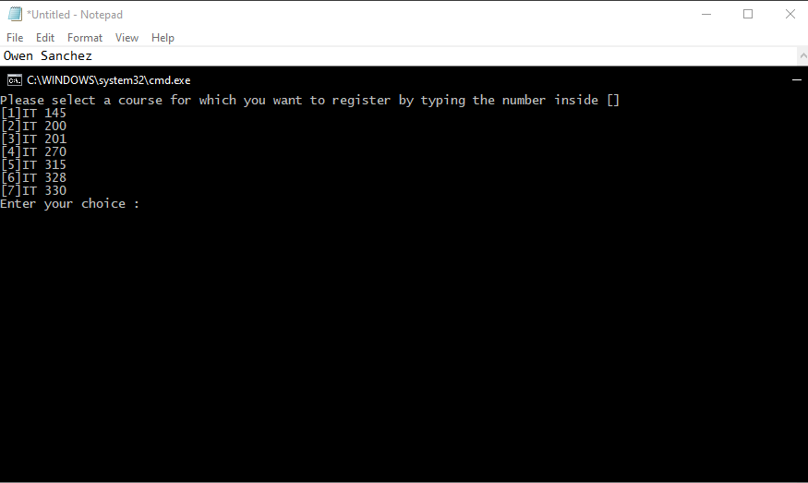
The main menu of the application, listing the courses that the student can register for.
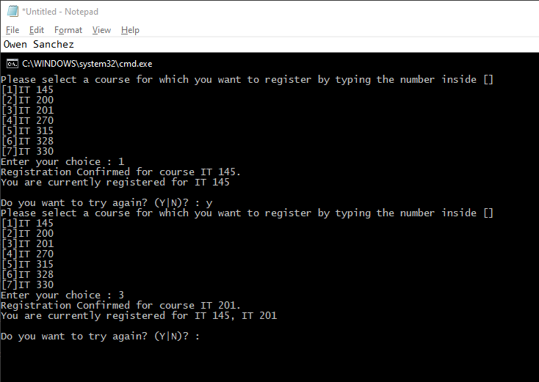
Registering for two different courses, opting to continue after each registration. The course selections are confirmed and printed in a list.

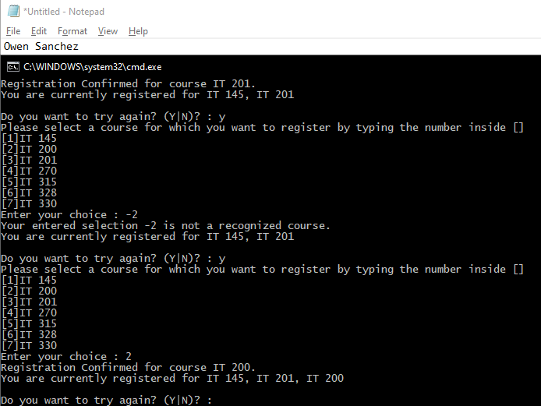
Registering for an invalid choice and a third, valid choice. The invalid choice is rejected with an error message.

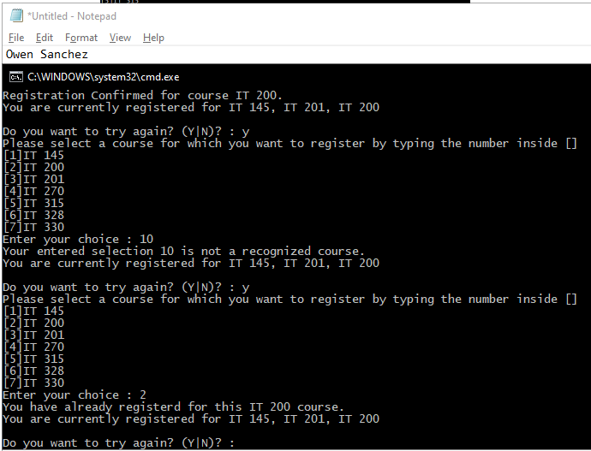
Registering for another invalid course and a duplicate course. The invalid choice is again rejected, and the duplicate registration is rejected as well with a different error message.

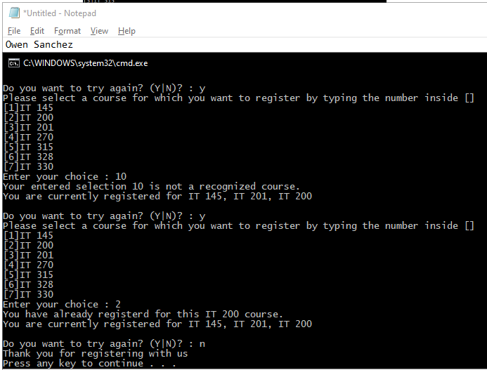
Exiting the program after the student is done registering for courses. A message is printed, and the program is done executing.

using System;
using System.Collections.Generic;
using System.Linq;
using System.Text;
using System.Threading.Tasks;

namespace ConsoleRegisterStudent
{
class Program
{
static void Main(string[] args)
{
(new Program()).run();
}

void run()
{
int choice;
int firstChoice = 0, secondChoice = 0, thirdChoice = 0;
int totalCredit = 0;
string yesOrNo = "";

do
{
WritePrompt();
choice = Convert.ToInt32(Console.ReadLine());

switch (ValidateChoice(choice, firstChoice, secondChoice, thirdChoice, totalCredit))
{
case -1:
Console.WriteLine("Your entered selection {0} is not a recognized course.", choice);
break;
case -2:
Console.WriteLine("You have already registerd for this {0} course.", ChoiceToCourse(choice));
break;
case -3:
Console.WriteLine("You can not register for more than 9 credit hours.");
break;
case 0:
Console.WriteLine("Registration Confirmed for course {0}.", ChoiceToCourse(choice));
totalCredit += 3;
if (firstChoice == 0)
firstChoice = choice;
else if (secondChoice == 0)
secondChoice = choice;
else if (thirdChoice == 0)
thirdChoice = choice;
break;
}

WriteCurrentRegistration(firstChoice, secondChoice, thirdChoice);
Console.Write("\nDo you want to try again? (Y|N)? : ");
yesOrNo = (Console.ReadLine()).ToUpper();
} while (yesOrNo == "Y");

Console.WriteLine("Thank you for registering with us");
}

void WritePrompt()
{
Console.WriteLine("Please select a course for which you want to register by typing the number inside []");
Console.WriteLine("[1]IT 145\n[2]IT 200\n[3]IT 201\n[4]IT 270\n[5]IT 315\n[6]IT 328\n[7]IT 330");
Console.Write("Enter your choice : ");
}

int ValidateChoice(int choice, int firstChoice, int secondChoice, int thirdChoice, int totalCredit)
{
if (choice < 1 || choice > 7)
return -1;
else if (choice == firstChoice || choice == secondChoice || choice == thirdChoice)
return -2;
else if (totalCredit >= 9)
return -3;
return 0;
}

void WriteCurrentRegistration(int firstChoice, int secondChoice, int thirdChoice)
{
if (secondChoice == 0)
Console.WriteLine("You are currently registered for {0}", ChoiceToCourse(firstChoice));
else if (thirdChoice == 0)
Console.WriteLine("You are currently registered for {0}, {1}", ChoiceToCourse(firstChoice), ChoiceToCourse(secondChoice));
else
Console.WriteLine("You are currently registered for {0}, {1}, {2}", ChoiceToCourse(firstChoice), ChoiceToCourse(secondChoice), ChoiceToCourse(thirdChoice));
}

string ChoiceToCourse(int choice)
{
string course = "";
switch (choice)
{
case 1:
course = "IT 145";
break;
case 2:
course = "IT 200";
break;
case 3:
course = "IT 201";
break;
case 4:
course = "IT 270";
break;
case 5:
course = "IT 315";
break;
case 6:
course = "IT 328";
break;
case 7:
course = "IT 330";
break;
default:
break;
}
return course;
}
}
}

