1. Click UI.

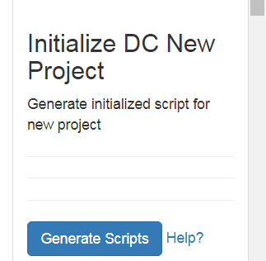

1. Choose param

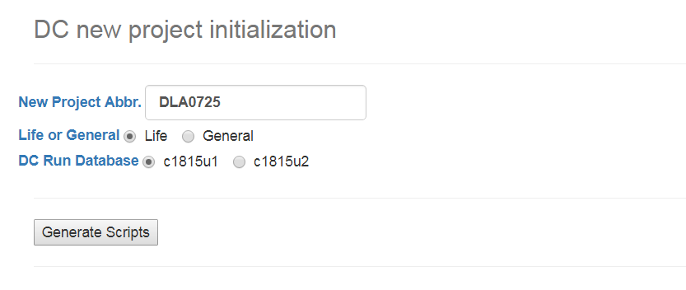

Get

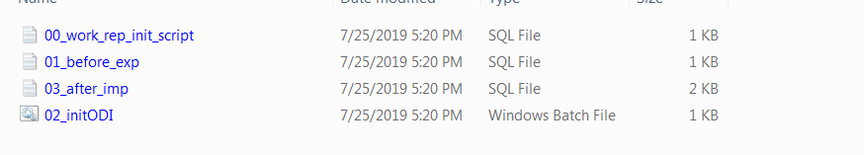

1. Manual Run 00_work_rep_init_script under dc/dc@o46g4

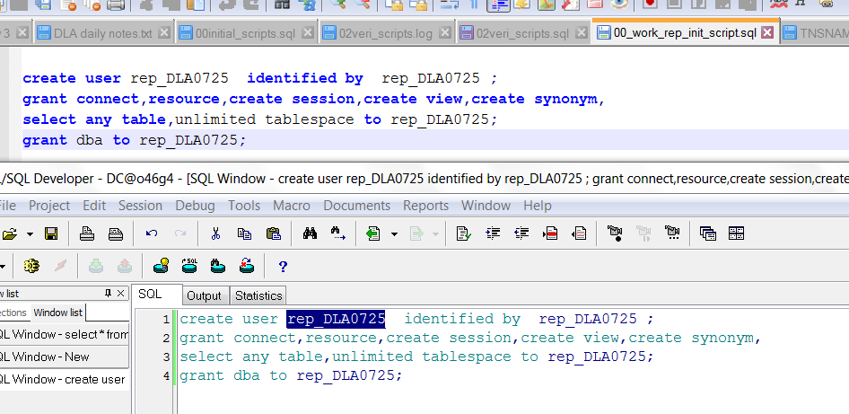

1. New work rep at ODI master

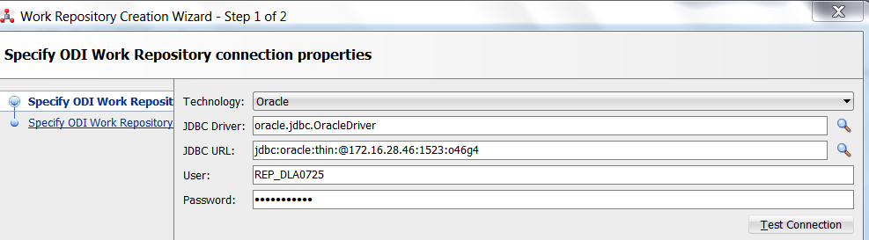

1. Click 02_initODI.bat

Check log file , all successful.

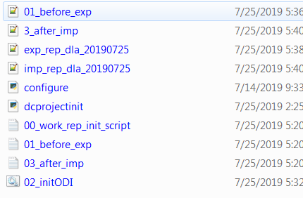

Log into new project .

