Café Operations System
A proposal for running the balcony café with less admin

Prepared 30 September 2026
Status: design approved; build not yet started
You make the coffee, and the system takes the orders, checks payments, tracks beans and money, and prepares your Instagram posts.

1 What changes for you
Your time goes into coffee and customers, rather than admin. You stay in control. The system handles the repetitive work and asks you only when a person is needed.

What you do
- Make coffee and serve customers.
- Tap the drinks on the counter tablet for walk-in customers.
- Hand over pre-orders at the pickup time.
- Order beans online when the system tells you which ones and how much.
- Glance at the Sunday summary to see sales, costs and profit.
- Review your Instagram posts by chatting with Claude, then post them.

What the system does for you
- Takes pre-orders through a simple online form linked from Instagram.
- Checks each payment screenshot automatically and only alerts you if something looks wrong.
- Keeps a record of every sale, pre-order and cost in one place.
- Works out when beans are running low, including the resting time fresh beans need.
- Calculates profit per drink and sends you a weekly summary.
- Plans 3–4 Instagram posts a week and designs them in Canva using your real photos.

2 How the system works
Read the diagram from left to right: who uses the system, what they use, the café system in the middle that remembers everything, and what comes out.
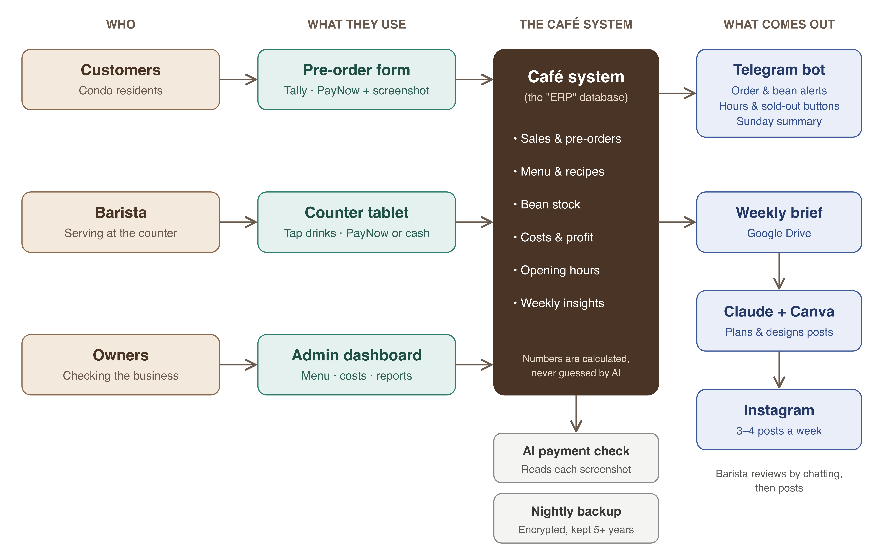
Figure 1. The complete system at a glance.

The four parts in plain words
- Who: customers order ahead; you serve at the counter; the owners check how the business is doing.
- What they use: a pre-order form (no app to install), a counter tablet, and an admin dashboard for menu, costs and reports.
- The café system: one private database (a digital record) that remembers every sale, recipe, bean bag and expense, and does all the maths.
- What comes out: Telegram messages to your phone, a weekly brief that Claude uses to plan posts, and ready-to-post Instagram designs.

3 What customers experience

Pre-order up to 7 days ahead
- Tap the order link in the café Instagram bio or the condo chat.
- Choose drinks. The total is added up automatically.
- Pick a day and a pickup time within opening hours.
- Enter name and mobile number.
- Scan the PayNow QR, pay the exact total, and use their mobile number as the reference.
- Upload the payment screenshot. They immediately see “Order confirmed”.
- Collect the drink at the chosen time. It is already paid.
Behind the scenes, AI reads the screenshot and checks the amount, recipient, time and reference. If everything matches, you need do nothing. If it does not, you get a Telegram alert with a link to message the customer on WhatsApp.

Walk-in
- The customer orders at the balcony counter.
- You tap the drinks on the tablet. It shows a PayNow QR with the exact amount, or you choose Cash.
- The sale is saved instantly and the screen clears for the next customer.

4 Your week with the system
When | What happens | Your effort
Each morning | Telegram asks “Opening today 8:00–14:00?” The order form updates itself. | One tap
During service | Walk-ins on the tablet; pre-orders listed by pickup time. | Normal service
Any time | Pause pre-orders, close early, or mark an item sold out from Telegram. | One tap
When flagged | A payment screenshot did not match. Message the customer. | Only when needed
When beans run low | List of beans and quantities to reorder. Order online, tap “Ordered”. | A few minutes
When beans arrive | Tap “Arrived” so stock stays accurate. | One tap
Sunday evening | Summary of sales, costs and profit, plus one suggestion. Compare the PayNow total with your bank app. | A few minutes
Sunday night onward | Claude has planned the week’s posts. Send any requested photos, chat to adjust, then post. | Short chat per post

5 The building blocks
Part | What it does | Service used
Pre-order form | Menu, pickup day and time, payment screenshot. Updates itself when hours or menu change. | Tally (free)
Counter tablet | Fast drink buttons, exact-amount PayNow QR, cash, today’s pre-orders. | Our web app on Cloudflare Pages (free)
Admin dashboard | Menu and prices, recipes, beans, expenses, reports. | Our web app on Cloudflare Pages (free)
Café system (ERP) | The single record of sales, stock, costs and hours. Runs all scheduled jobs. | Supabase, Singapore (free)
Telegram bot | Your inbox: alerts, buttons, weekly summary. Talks only to the owners. | Telegram (free)
Payment check | Reads screenshots and compares them with the order. | Claude AI (pay per use)
Content assistant | Plans and designs 3–4 posts a week from your photos and ideas. | Claude + Canva, on your Claude account
Backups | Encrypted copy of all records every night, kept at least 5 years. | GitHub + Cloudflare R2 (free)

6 Keeping it accurate and safe
- AI never makes up numbers. Stock, costs, profit and reorder amounts are calculated from real records. AI only reads screenshots, explains the numbers, and helps with posts.
- Prices are checked twice. Every pre-order total is recalculated from your menu, so an out-of-date form cannot undercharge without being noticed.
- Payment screenshots are checked, not blindly trusted. Duplicates and mismatches are flagged. Comparing the weekly PayNow total with your bank app catches what a screenshot cannot prove.
- Nothing stops service. If the tablet or internet fails, a printed PayNow QR and a paper tally keep you going; entries are added later.
- Records are kept safe. Nightly encrypted backups, tested monthly, cover the five-year record-keeping rule for Singapore businesses.
- Customer privacy. Only name and mobile are collected, only for pre-orders, and only to contact the customer about their order.

7 What we need from you
Item | Why it is needed
Menu with prices and recipes | Recipes (grams of beans, millilitres of milk, cups) let the system work out cost and stock.
Bean suppliers, bag sizes, prices, delivery time | Needed for bean alerts and costing.
Default opening hours | Used for the pre-order form and the morning check-in.
Your PayNow name and QR code | Shown on the order form and checked against screenshots.
Brand kit (logo, colours, fonts, tone) | Keeps Instagram posts on-brand.
Instagram Business account | Lets the system learn which posts perform best (can come later).
A paid Claude plan on your account | Runs the weekly content assistant and connects to your Canva.

8 Running costs
Most services run on free plans that allow business use. Prices were checked in September 2026 and can change.
Item | Monthly cost
Supabase, Cloudflare Pages, Cloudflare R2, Tally, Telegram, Google Drive, GitHub | Free
Claude AI for payment checks and weekly summary | A few Singapore dollars (pay per use; confirmed at build time)
Claude subscription on your account (content assistant) | Standard paid plan (check current price)
Canva Pro or Teams | Already held
Custom web address (optional) | About S$15 a year

9 How it will be built
The system is built in six stages, each working on its own, so the café benefits early.
# | Stage | What you get
1 | Foundation | The café system, secure logins, menu editor, and the Telegram bot connected to your phone.
2 | Counter tablet | Fast walk-in sales with PayNow QR or cash. Sales records start here.
3 | Pre-orders | The Tally order form that updates itself, automatic payment checks, and hours and sold-out buttons in Telegram.
4 | Beans and money | Bean alerts, profit per drink, the Sunday summary and reports.
5 | Backups and weekly brief | Nightly encrypted backups and the weekly brief for the content assistant.
6 | Content assistant | Claude and Canva planning and designing your posts, set up on your account.

After stage 6, a one-week pilot with residents irons out anything awkward in real use. Until stage 3 is ready, pre-orders can run on a manually edited Tally form.

10 Next steps
- Read this proposal and note anything that does not match how you want to work.
- Gather the items in section 7, starting with the menu, recipes and bean details.
- Stage 1 begins. You will be asked to create the Telegram bot and staff logins yourself, so no passwords are shared.

