SWIM SIGHT 3D
Codex UI / UX Prompt Pack
Public Landing Page + Private Logged-In Coach Dashboard
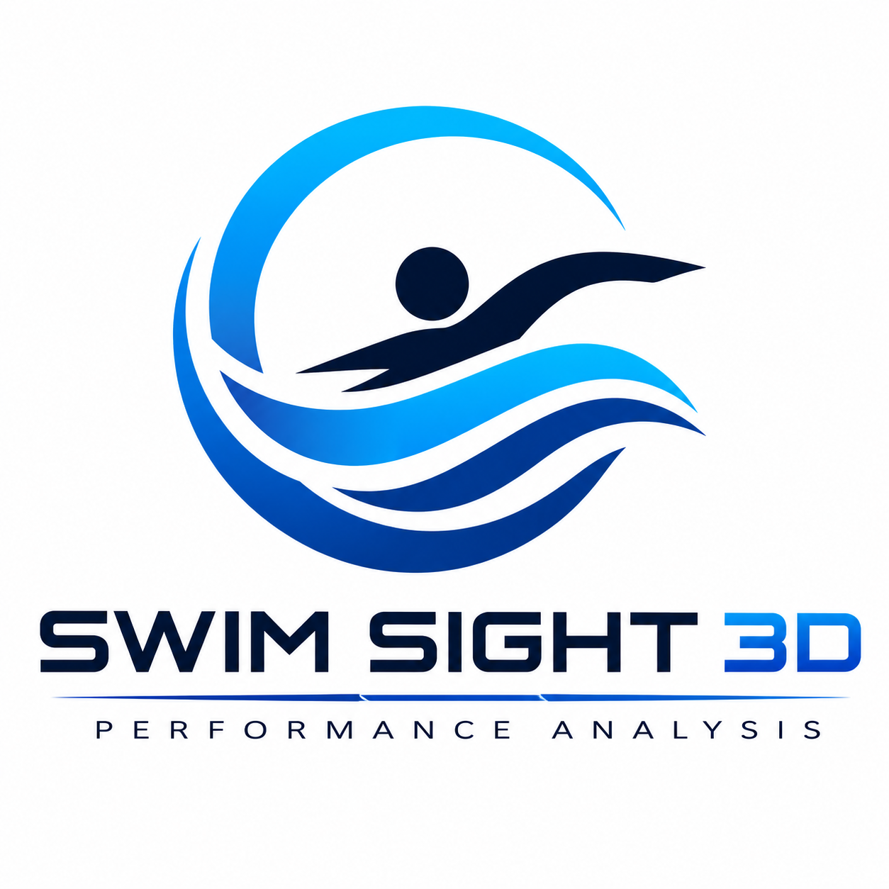
Use this first: Copy one prompt at a time into Codex/agent. Start with the Master Protection Prompt, then provide the image assets, then paste the page-specific prompt. Do not ask the agent to rebuild the whole app.

1. Assets to include

Public UI Page.jpeg - public landing reference
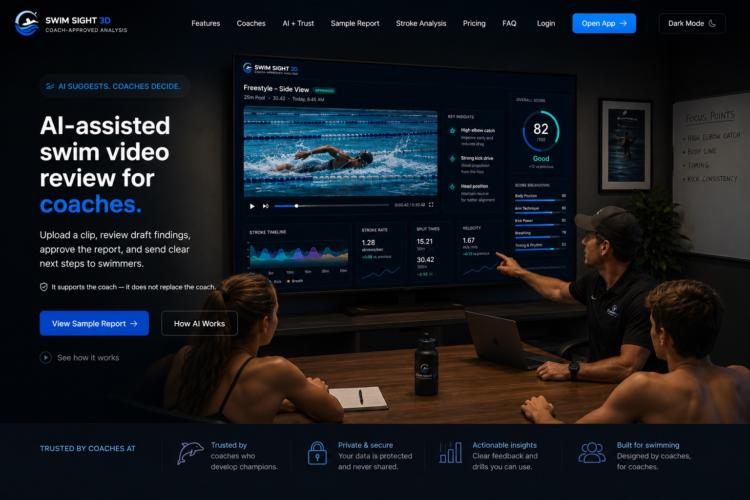

Logged Page.jpeg - private dashboard reference
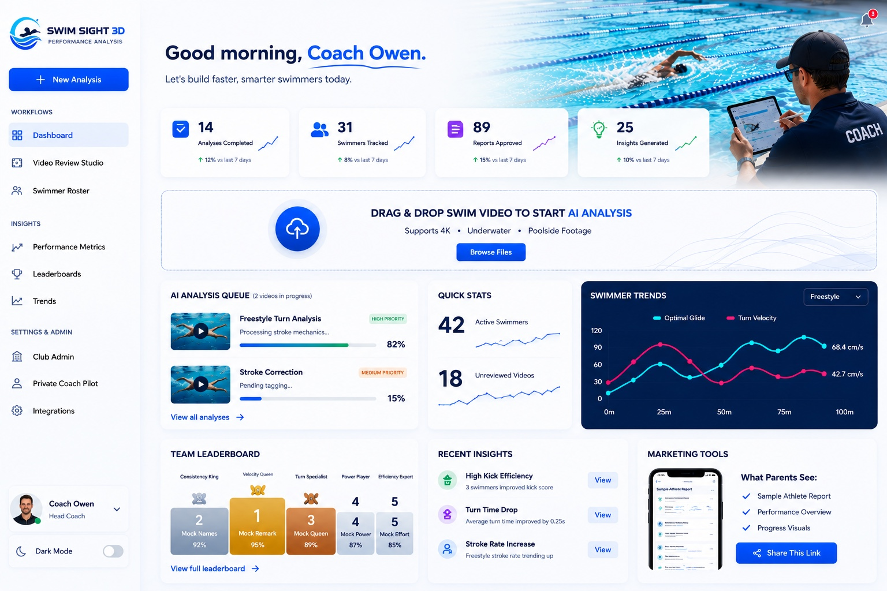

image.png - real Swim Sight 3D logo


2. Master Protection Prompt
Before editing, inspect the current route/component structure. This project already has working auth, AI callbacks, upload/storage, report approval, PDF/export, and share-link logic.

This task is UI-focused only unless explicitly stated otherwise.

Do not change auth, protected routing, AI callback handlers, upload/storage APIs, report approval, share links, database schemas, env vars, worker integration, deployment settings, or Vercel function structure.

If a backend/protected logic file appears to need editing, stop and explain why before touching it.

Work in small commits. Keep existing tests passing. Do not deploy unless explicitly asked.

3. Asset Instruction Prompt
Use these visual references and assets:

1. Public UI Page.jpeg
Purpose: final public landing page visual target.
Use it to match the dark cinematic landing page direction.

2. Logged Page.jpeg
Purpose: final logged-in coach dashboard visual target.
Use it to match the light white/blue SaaS dashboard direction.

3. image.png
Purpose: real Swim Sight 3D logo.
Use this logo in the top-left public nav and logged-in sidebar.

4. Do not hardcode real club names yet.
5. Do not use fake club logos yet.
6. Keep all public trust sections generic until real clubs approve their use.

4. Phase 1 Prompt - Public Landing Page UI
You are working on the Swim Sight 3D app. Implement the new PUBLIC LANDING PAGE UI only.

Critical rule:
Do not rebuild the whole app. Do not touch private dashboard functionality, authentication logic, AI analysis logic, storage logic, callback APIs, report approval logic, report sharing logic, or protected routes unless absolutely required for navigation links. This task is visual/public-page only.

Goal:
Create a polished public landing page that matches the approved dark cinematic reference image. The page should feel like a professional SaaS product for swim coaches, while keeping the message simple: AI assists, coaches approve.

Reference design:
Use “Public UI Page.jpeg” as the primary visual direction:
- Dark navy/black cinematic website.
- Swim Sight 3D logo top-left.
- Full-width hero section.
- Left-side hero copy.
- Right/background image showing a coach reviewing swim analysis on a large TV with one male swimmer and one female swimmer in a professional review room.
- Large analysis screen in the background showing Swim Sight 3D video analysis, score, stroke timeline, and extra analytics.
- Dark overlay/gradient so text remains readable.
- Bottom trust strip with four value cards.
- Minimal, premium, realistic, not cartoonish, not overly AI-looking.

Top Navigation:
- Fixed or sticky top navigation.
- Dark translucent background with slight blur.
- Top-left: Swim Sight 3D logo + text.
- Use the real Swim Sight 3D logo asset.
- Nav links: Features, Coaches, AI + Trust, Sample Report, Stroke Analysis, Pricing, FAQ, Login.
- Primary CTA: Open App.
- Optional right-side toggle: Dark Mode.
- Do not show logged-in coach controls on the public page.

Hero Section:
- Full viewport-height or near-full viewport-height hero.
- Dark cinematic background image fills the section.
- Background image should sit mostly on the right side.
- Left side should have a dark gradient overlay so the text is clear.
- Use a subtle grid or soft radial glow only if it matches the reference.
- Do not use 3D model graphics here.

Hero badge:
“AI SUGGESTS. COACHES DECIDE.”

Hero headline:
“AI-assisted swim video review for coaches.”

Style:
- Large bold white text.
- Highlight the word “coaches.” in bright Swim Sight blue.
- Keep typography clean and strong.

Supporting text:
“Upload a clip, review draft findings, approve the report, and send clear next steps to swimmers.”

Safety/support line:
“It supports the coach — it does not replace the coach.”

Buttons:
- Primary: View Sample Report
- Secondary: How AI Works
- Small demo link: See how it works

Button behavior:
- View Sample Report should link to existing sample report route if one exists.
- How AI Works should scroll to the AI/trust section if available, or to a placeholder section.
- See how it works can scroll to a workflow section or open a placeholder modal for now.
- Do not build a complex video system yet.

Hero Background Image Treatment:
- Coach presenting Swim Sight 3D analysis on a wall-mounted TV.
- One male swimmer and one female swimmer visible from behind or side, seated at a table.
- Coaches/parents can be subtly present, but do not overcrowd the scene.
- TV screen should display Swim Sight 3D logo, swim video, stroke timeline, AI score, key insights, score breakdown, stroke rate, split times, and velocity.
- No real club names.
- Avoid fake club branding.
- Keep all people realistic, professional, and non-distracting.
- Blend the image into the page, not as a hard rectangle.
- Use CSS gradients: left-to-right dark overlay, bottom fade into trust strip, top subtle nav fade.

Trust Strip:
At the bottom of the hero, add a dark semi-transparent trust strip.

Cards:
1. Trusted by coaches — “Built for coaches who develop champions.”
2. Private & secure — “Your data is protected and never shared.”
3. Actionable insights — “Clear feedback and drills you can use.”
4. Built for swimming — “Designed by coaches, for coaches.”

Do not list real club names yet. Do not use fake club logos yet.

Animations:
- Hero text fades up on load.
- Badge fades/slides in slightly before headline.
- Buttons fade in after text.
- Background image slowly scales from 1.03 to 1.0 or has a subtle parallax effect.
- Trust cards fade up with staggered delay.
- CTA buttons have small hover lift and glow.
- Nav links have subtle hover underline or opacity change.
- Analysis screen can have a very subtle glow/pulse.
- Respect prefers-reduced-motion.
- Use CSS animations unless Framer Motion is already installed.
- Avoid adding large animation dependencies.

Responsive Layout:
Desktop: text left, cinematic image right/center, nav horizontal.
Tablet: reduce headline size, stronger image overlay.
Mobile: logo, Login, Open App; text full-width; image dimmed; buttons stack; trust cards stack.

Accessibility:
- Use semantic HTML: header, nav, main, section.
- Buttons and links must be keyboard accessible.
- Maintain contrast.
- Decorative overlays should be aria-hidden.
- Use alt text for informative images.

Integration Rules:
- Preserve route structure.
- Reuse existing Button, Card, Logo, Layout components where safe.
- Do not change auth redirects.
- Do not change logged-in dashboard route.
- Do not change API routes.
- Do not change database/entity schemas.
- Do not change AI worker integration.
- Do not change storage/upload logic.
- Do not change report approval logic.

Content Rules:
Use: “AI-assisted”, “draft findings”, “coach-approved”, “AI suggests. Coaches decide.”
Avoid: “fully automated coaching”, “guaranteed performance improvement”, “replaces coaches”, “medical-grade biomechanics”, “Olympic-level accuracy”.

Visual Style:
- Background: #020617, #030712, #07111f.
- Accent blue: #0B84FF.
- Cyan: #67E8F9 sparingly.
- Text: white and soft grey.
- Cards: translucent navy/black with subtle border.
- Borders: low-opacity blue/white.
- Use existing font if present.
- Premium spacing.

Suggested components:
- PublicLandingPage
- PublicNavbar
- HeroSection
- HeroActions
- TrustStrip
- ValueCard

QA:
- Landing page loads without login.
- Login/Open App work.
- Protected dashboard still works.
- Upload/report/AI pages untouched.
- No console/import/TypeScript/lint errors.
- Mobile usable.
- Reduced motion respected.
- No real club names hardcoded.

Commit:
“Implement cinematic public landing page UI”

Do not deploy unless explicitly asked.

5. Phase 2 Prompt - Private Logged-In Dashboard UI
You are working on the Swim Sight 3D app. Implement the new PRIVATE LOGGED-IN COACH DASHBOARD UI only.

Critical rule:
Do not rebuild the app. Do not touch backend logic, auth logic, protected route logic, AI worker/callback logic, upload/storage logic, report approval logic, share-link logic, database schemas, or API routes unless a tiny visual integration requires it. This is a front-end dashboard UI task only.

Primary goal:
Update the logged-in coach dashboard to match the approved light SaaS dashboard reference image. The page should look premium, clean, modern, coach-focused, and easy to use. It should feel like the professional working dashboard after a coach logs in from the public landing page.

Use “Logged Page.jpeg” as the main visual direction.

Product language:
- AI-assisted
- Coach-approved
- AI suggests. Coaches decide.
- Draft findings
- Reports approved
- Private club workspace

Do not imply that AI makes final coaching decisions.

Scope:
Only implement/refactor the private dashboard UI and reusable visual components needed for this dashboard. Do not modify the public landing page unless shared components require a safe import update.

Overall visual style:
- Light white/blue SaaS interface.
- Soft rounded cards.
- Subtle shadows.
- Large breathing space.
- Pool-water blue accents.
- Professional sports-tech feeling.
- No clutter.
- No harsh borders.
- No cartoon styling.
- No overly AI-generated look.

App Shell:
Use a two-column layout:
- Left fixed sidebar.
- Main dashboard content area.

Sidebar:
- White/light background.
- Swim Sight 3D logo at top.
- Small subtitle: “Performance Analysis” or “Analysis Platform”.
- Primary CTA: “+ New Analysis”.

WORKFLOWS:
- Dashboard
- Video Review Studio
- Swimmer Roster

INSIGHTS:
- Performance Metrics
- Leaderboards
- Trends

SETTINGS & ADMIN:
- Club Admin
- Private Coach Pilot
- Integrations

Bottom sidebar:
- Coach profile card: Coach Owen, Head Coach, avatar, small chevron.
- Dark Mode toggle.

Important:
The coach profile should appear only at the bottom-left sidebar. Do not duplicate the coach profile in the top-right.

Top-right area:
- Only a small notification bell icon.
- No full user profile in top-right.
- No club selector in this version unless already required by existing functionality.

Main hero/header:
Text:
“Good morning, Coach Owen.”
Subtext:
“Let’s build faster, smarter swimmers today.”

Design:
- Large clean heading.
- “Coach Owen” can use blue accent and subtle underline stroke.
- Top-right hero background image should show the poolside coach with tablet scene from the approved reference.
- Image must sit top-right and fade seamlessly into white background.
- Do not place the image as a hard rectangle.
- Use gradient masks/fades: fade left into white, fade bottom into white, fade top softly.
- Coach image should sit far enough right that the coach is close to the right edge.
- Image should not cover dashboard text or KPI cards.
- Keep notification icon visible.
- No club logo placeholder section.
- No “insert logo” box.

KPI cards:
1. 14 — Analyses Completed — ↑ 12% vs last 7 days
2. 31 — Swimmers Tracked — ↑ 8% vs last 7 days
3. 89 — Reports Approved — ↑ 15% vs last 7 days
4. 25 — Insights Generated — ↑ 10% vs last 7 days

Card style:
- White glassy cards.
- Rounded corners.
- Very soft shadows.
- Blue/purple/green icon accents.
- Tiny sparkline if easy.
- Use mock/demo data if no real source exists.
- Add comment: TODO replace mock dashboard data with real approved report/video analysis data.

Upload Panel:
Text:
“DRAG & DROP SWIM VIDEO TO START AI ANALYSIS”
Subtext:
“Supports 4K • Underwater • Poolside Footage”
Button:
“Browse Files”

Visual:
- Large circular upload icon.
- Thin dotted/outlined border.
- Soft blue wave-line decoration on the right.
- White/light background.
- If real upload functionality exists, preserve it. Do not replace working upload logic with fake UI.

Main content grid:
Row 1:
A. AI Analysis Queue
B. Quick Stats
C. Swimmer Trends

AI Analysis Queue:
Title: “AI ANALYSIS QUEUE”
Note: “2 videos in progress”
Item 1: Freestyle Turn Analysis, Processing stroke mechanics..., 82%, High Priority.
Item 2: Stroke Correction, Pending tagging..., 15%, Medium Priority.
Each item: thumbnail, play icon, title, status, progress bar, percentage, priority chip.
Footer: “View all analyses →”

Quick Stats:
42 Active Swimmers
18 Unreviewed Videos
Add small blue sparklines.

Swimmer Trends:
- Dark navy chart card.
- Dropdown: Freestyle.
- Lines: Optimal Glide and Turn Velocity.
- Cyan and pink lines.
- x-axis: 0m, 25m, 50m, 75m, 100m.
- Labels: 68.4 cm/s and 42.7 cm/s.
- Use existing chart library if installed; otherwise use lightweight SVG/CSS.

Row 2:
A. Team Leaderboard
B. Recent Insights
C. Marketing Tools

Team Leaderboard:
Columns/cards:
- Consistency King
- Velocity Queen
- Turn Specialist
- Power Player
- Efficiency Expert
Placeholder names/scores:
- Mock Names 92%
- Mock Remark 95%
- Mock Queen 89%
- Mock Power 87%
- Mock Effort 85%
Footer: “View full leaderboard →”

Recent Insights:
1. High Kick Efficiency — 3 swimmers improved kick score — View
2. Turn Time Drop — Average turn time improved by 0.25s — View
3. Stroke Rate Increase — Freestyle stroke rate trending up — View

Marketing Tools:
Title: “MARKETING TOOLS”
“What Parents See:”
- Sample Athlete Report
- Performance Overview
- Progress Visuals
Button: “Share This Link”
Do not expose private signed URLs publicly.

Responsive:
Desktop: fixed sidebar, KPI row, aligned card grid.
Tablet: KPI cards 2x2.
Mobile: sidebar collapses if existing pattern supports it, cards stack, chart does not overflow.

Animations:
- Content fades up on load.
- KPI cards stagger in.
- Progress bars animate from 0 to target.
- Upload icon hover glow.
- Cards lift 2-4px on hover.
- Sidebar active state transitions.
- Respect prefers-reduced-motion.
- No bouncing, no cartoon motion.

Dark mode compatibility:
- If existing app supports dark mode, style dashboard to respond properly.
- If not wired yet, keep toggle visually present but do not force a global theme refactor.
- Default dashboard remains light mode.

Preserve all existing behavior:
- Auth/login/logout
- Protected dashboard access
- User/role checks
- Club workspace context
- Video upload/private storage
- AI trigger
- AI callback handling
- Coach approval workflow
- Shared report links
- PDF/export
- Existing tests/routes

Do not:
- Remove role protection.
- Hardcode insecure URLs.
- Hardcode private signed video URLs.
- Change API contracts.
- Add serverless functions unnecessarily.
- Modify worker repo.
- Modify database schema.
- Modify env variable names.
- Modify callback secret handling.

Suggested components:
- CoachDashboardPage
- DashboardSidebar
- DashboardHero
- MetricCard
- UploadAnalysisPanel
- AnalysisQueueCard
- QuickStatsCard
- SwimmerTrendsCard
- TeamLeaderboardCard
- RecentInsightsCard
- MarketingToolsCard

Styling:
- Background: #F7FBFF or similar.
- Cards: white with slight blue tint.
- Text: deep navy.
- Accent: Swim Sight blue.
- Chart card: deep navy.
- Border: low-opacity blue/grey.
- Shadows: subtle and premium.

Acceptance:
- Dashboard loads only after login.
- Public page still works.
- Sidebar navigation works.
- New Analysis routes correctly.
- Upload flow works or routes to existing upload page.
- No duplicate top-right coach profile.
- Notification only top-right.
- Top-right hero image fades seamlessly.
- No club logo placeholder.
- Mobile usable.
- No console/import/TypeScript/lint errors.
- Build passes if stable.
- No API/backend files changed.

Commit:
“Implement polished private coach dashboard UI”

Do not deploy unless explicitly asked.

6. Animation Polish Prompt
Add a subtle professional animation layer to the public landing page and logged-in dashboard.

Constraints:
- Do not add heavy dependencies.
- Use CSS animations unless Framer Motion is already installed and used.
- Respect prefers-reduced-motion.
- Do not animate layout in ways that cause jank.
- Do not overdo it.

Public page animations:
- Navigation fades down on load.
- Hero badge fades up first.
- Hero headline fades up second.
- Hero paragraph/support line fades up third.
- CTA buttons fade up fourth.
- Background image has a subtle slow zoom/settle effect.
- Trust cards fade up with slight stagger.
- Buttons have hover lift and glow.
- Nav links have subtle hover underline.

Private dashboard animations:
- Dashboard content fades up on load.
- KPI cards appear with slight stagger.
- Progress bars animate from 0 to target percentage.
- Upload panel icon has subtle hover glow.
- Cards lift 2-4px on hover.
- Sidebar active item transitions smoothly.
- Do not animate the large top-right image beyond static fade/gradient.

Reduced motion CSS:
@media (prefers-reduced-motion: reduce) {
*, *::before, *::after {
animation-duration: 0.01ms !important;
animation-iteration-count: 1 !important;
scroll-behavior: auto !important;
transition-duration: 0.01ms !important;
}
}

Acceptance:
- Animations feel premium and restrained.
- No layout shifting after load.
- No performance issues.
- No console errors.

7. QA / Safety Test Prompt
Run a focused QA pass after implementing the UI.

Routing:
- Public landing page loads unauthenticated.
- Login link works.
- Open App link works.
- Protected dashboard still requires authentication.
- Dashboard route still resolves.
- New Analysis button routes correctly.
- Video Review Studio route still works.
- Sample report link works or fails gracefully.

Security preservation:
- No auth code changed unless explicitly necessary.
- No AI callback code changed.
- No upload/private storage code changed.
- No report approval code changed.
- No public share security changed.
- No API contracts changed.
- No env names changed.
- No serverless function count increased.

Visual:
- Public page matches dark cinematic reference.
- Logged dashboard matches light SaaS reference.
- Logo is correct in public nav and dashboard sidebar.
- No duplicate top-right coach profile.
- Notification icon remains top-right.
- Dashboard hero image fades cleanly.
- No club names hardcoded.
- No club logos used yet.
- Text readable on all backgrounds.
- Cards consistent.

Responsive:
- Public hero remains readable.
- Nav does not overflow.
- Buttons usable.
- Dashboard cards stack cleanly.
- Sidebar does not break mobile layout.
- Chart card does not overflow.

Accessibility:
- Buttons/links keyboard accessible.
- Focus states visible.
- Contrast acceptable.
- Decorative images aria-hidden or alt text suitable.
- Reduced motion respected.

Build checks:
Run whatever exists:
- npm run lint
- npm run build
- npm test
- existing safety/readiness tests

If a check fails:
- Fix only the UI-related issue.
- If failure is pre-existing and unrelated, document it clearly.

Commit after passing:
Public UI: “Implement cinematic public landing page UI”
Private dashboard: “Implement polished private coach dashboard UI”
Do not deploy unless explicitly asked.

8. Visual Correction Prompt
Perform a visual correction pass against the supplied reference image.

Rules:
- Do not redesign.
- Do not change architecture.
- Do not touch backend/API/auth/AI logic.
- Only adjust spacing, colour, typography, image position, card sizing, gradients, and visual polish.

Public page checklist:
- Dark cinematic mood.
- Left text readable and not cramped.
- Hero image realistic and blended, not boxed.
- Real Swim Sight 3D logo top-left.
- “coaches.” highlighted in blue.
- Trust strip at bottom.
- No fake club names.
- No crowded scene.

Logged dashboard checklist:
- Light white/blue dashboard.
- Sidebar clean and fixed.
- Top-right image pushed right with seamless fade.
- Notification only top-right.
- Coach profile only bottom-left.
- KPI cards balanced.
- Upload panel full width and clean.
- Main card grid aligned.
- No “insert logo” placeholder.

Make the smallest possible changes to match the references. Re-run lint/build checks after changes.

9. Next Safe Build Phase Prompt
After the public landing page and private dashboard UI are implemented, prepare the next safe build phase.

Goal:
Do not add new major backend features yet. First polish the user journey around the new UI.

Next phase tasks:
1. Add a “How AI Works” section below the public hero.
2. Add a “View Sample Report” public sample report preview.
3. Add a simple workflow section:
Upload clip → AI-assisted draft → Coach review → Approved report → Share with swimmer/parent.
4. Make the public page explain clearly that AI supports the coach and does not replace the coach.
5. Keep content static/demo for now unless an existing safe data source already exists.
6. Do not change AI callback or private report logic.
7. Do not add real club logos or claims yet.

Visual style:
- Continue the dark public-page style.
- Use glass cards, subtle blue/cyan accents, and realistic product screenshots.
- Keep page speed high.
- Add internal anchor links from nav sections to page sections.

Acceptance:
- Public page feels complete enough for a coach/parent to understand the product.
- Logged-in app remains unchanged except links to existing areas.
- No backend/security changes.

10. Fast Copy Sequence
Recommended sequence:

1. Upload assets: Public UI Page.jpeg, Logged Page.jpeg, image.png.
2. Paste Master Protection Prompt.
3. Paste Asset Instruction Prompt.
4. Paste Phase 1 Public Landing Page UI prompt.
5. Review the diff manually.
6. Ask Codex to run available checks.
7. Commit: Implement cinematic public landing page UI.
8. Paste Master Protection Prompt again.
9. Paste Phase 2 Private Logged-In Dashboard UI prompt.
10. Review the diff manually.
11. Ask Codex to run available checks.
12. Commit: Implement polished private coach dashboard UI.
13. Use Animation Polish Prompt only after static layouts are correct.
14. Use Visual Correction Prompt for final spacing/colour/image-position cleanup.
15. Do not deploy until you approve the UI locally.

