Overview:

This network takes a Laplacian map and a sampled sparse image as input, and outputs a recovered image.

(Another setting is: (a Laplacian map+ a super-resolved low-resolution image) -> (recovered image). In this case, you can simply replace the sampled image as a super-resolved low-resolution image.)

Input:

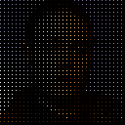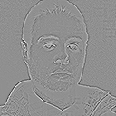

Output:

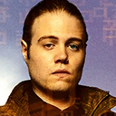

To run the code:

1. Change the training dataset directory at line 38~39 in the “train.py” file
2. The models will be saved in the “models” folder
3. To run the model on the testing image, refer to “inference.py” file