Items sold by weight
Some things are sold by the kilo: meat, fish, fruit and vegetables, loose sugar or sweets, nyama choma. ZapTill sells them with the weight as the quantity (0.452 kg) and works out the amount from the price per kg. This manual covers:
- marking an item as sold by weight;
- weighing at the till with the weight keypad (every kind of business);
- weighing on a label scale and scanning its label at the till;
- choosing your scale and testing a label;
- what the receipt and the kitchen ticket show.
The amount is always price per kg × weight, rounded to the cent — 0.452 kg at KES 650/kg is KES 293.80. When a scale prints the price on its label, the label's price is what the customer pays.

1. Mark an item as sold by weight
- On the web, open Menu › Products and Edit the item (or add a new one).
- Set Price to the price per kg.
- Switch on ⚖️ Sold by weight (price per kg).
- Show the weight in: Kilograms (0.452 kg) or Grams (452 g). The price stays per kg either way.
- Scale code (PLU): the number the item has on your weighing scale (for example 1234). Leave it empty if you do not use a label scale.
- Click Save. The tills pick it up at their next sync.
Each scale code can belong to one item only. 01234 and 1234 are the same code.

2. Weighing at the till (any business)
Tap an item sold by weight on the till (or on the web POS). ZapTill asks for the weight:
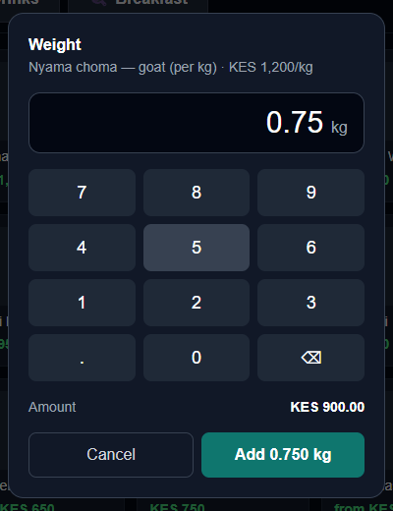
The weight keypad
- Read the weight on your scale and type it in kg: 0.75 for 750 g, 1.2 for 1.2 kg. Up to three decimals (the gram).
- The amount is shown as you type.
- Click Add. The item goes on the order as its own line with its weight.
A weighed line has no + / − buttons: to change it, remove it (✕) and weigh it again. Two bags of the same item are two lines.
This works in every kind of business:
- Shops, minimarts, butcheries — loose goods on the grid.
- Restaurants and cafés — nyama choma or fish by the kilo. The kitchen ticket shows the weight: 0.750 kg GOAT MEAT.
- Petrol stations — items from the shop. Fuel is still sold from the pumps in litres, exactly as before.
- Parking and other businesses — the same as a shop, for any goods you sell.

3. Label scales: scan the label
A label scale weighs the item and prints a sticker with a barcode. The barcode carries the item's scale code and either the price or the weight. At the till, just scan the sticker: the item is added with its weight and the right amount — no typing.
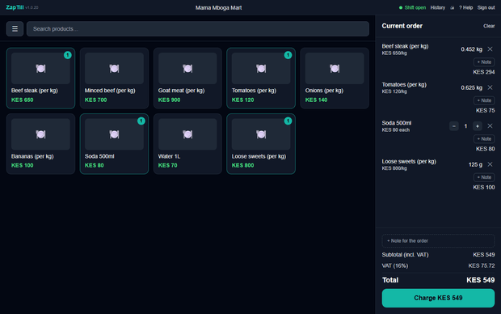
A shop's till after scanning two labels
Scanning works on the till in shops, minimarts, parking and "other" businesses, and on a petrol station's shop screen (not on the pump screen). A restaurant till taps items instead of scanning.
Scale barcodes start with 21 to 29. Barcodes that start with 20 are ZapTill's own codes for your products (from Generate barcodes) and are never read as scale labels.
If the till says "No item has the scale code …", the scale code on the label is not set on any item: open the item on the web and type the code in Scale code (PLU).

4. Choose your scale and test a label
On the web, open Settings › Business › Scale labels.
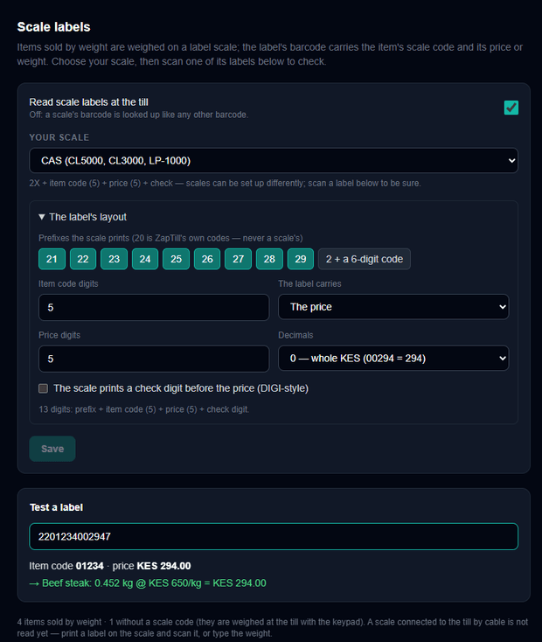
Settings › Business › Scale labels
- Your scale — pick the one you have:
Choice | What the label carries
Standard — price on the label | 2X + item code (5) + price (5) + check digit
Standard — weight on the label | 2X + item code (5) + weight in grams (5) + check digit
CAS (CL5000, CL3000, LP-1000) | 2X + item code (5) + price (5) + check digit
DIGI (SM-100, SM-120, SM-5300) | 2X + item code (5) + price check digit + price (4) + check digit
Ishida (Uni-3, Uni-5, BC-4000) | 2X + item code (5) + weight in grams (5) + check digit
Six-digit item code — price | 2 + item code (6) + price (5) + check digit

- Scales can be set up differently in their own menus. Open The label's layout to set the prefixes your scale prints (21–29), the item code length, price or weight, the number of digits and decimals (a price in whole shillings or in cents; a weight in grams or tens of grams), and whether the scale prints a price check digit.
- Print one label on your scale and scan it into Test a label. ZapTill shows the item code, the price or weight, the item it found and the amount. When that is right, click Save.
Who can change it: anyone with Business settings. The tills read the new layout at their next sync and keep it for when they are offline.

5. Receipts and kitchen tickets
A weighed item prints as one item with its weight and price per kg under it, so Total Qty counts it once:
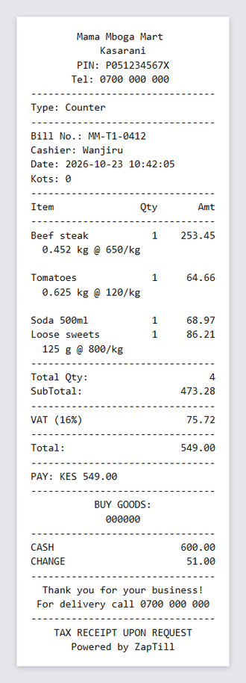
Receipt and kitchen ticket
The kitchen ticket puts the weight before the dish:
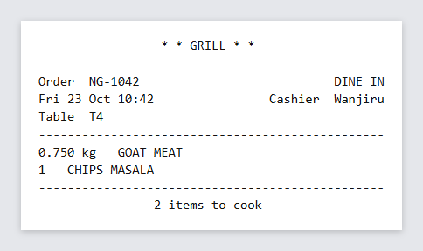
Kitchen ticket
Stock is taken off to the gram (10 kg − 0.452 kg = 9.548 kg), and a refund puts the same weight back.

6. Good to know
- A scale connected to the till by a cable is not read yet. Print a label on the scale and scan it, or type the weight on the keypad.
- Offers such as "buy 2 get 1" count whole items, so they do not apply to weighed lines.
- The till's own Menu screen does not change "Sold by weight" or the scale code yet — set them on the web.
- After this update, ask your technician to run migration 167 (weights kept to the gram) and install the new till (it needs the new till version to show the weight keypad).

