1.

#include <cstring>

#include <iostream>

using namespace std;

int main() {

int n;

cout << "Introduceti lungimea sirului:";

cin >> n;

int V[n];

//1//

for (int i = 0; i < n; i++) cin >> V[i];

for (int i = 0; i < n-1; i++)

{

if (V[i] > V[i + 1]) swap(V[i], V[i + 1]);

}

for (int i = 0; i < n; i++) cout << V[i] << " ";

return 0;

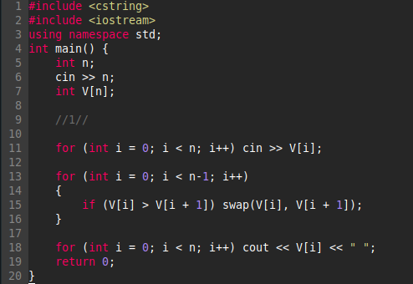}

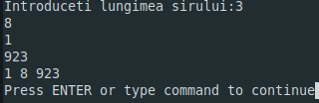

2.

#include <iostream>

using namespace std;

int main() {

int masiv[5] = {13, 1, 20, 4, 9};

for (int i = 0; i < 4; i++)

for (int j = 0; j < 4; j++)

if (-1 \* masiv[j] > -1 \* masiv[j + 1]) swap(masiv[j], masiv[j + 1]);

for (int i = 0; i < 5; i++) cout << -1 \* masiv[i] << " ";

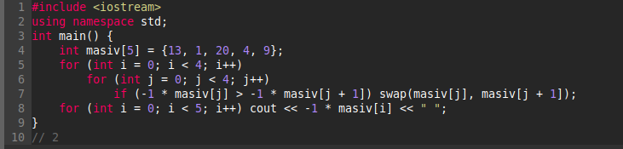}

3.

#include <iostream>

using namespace std;

int main() {

int n, j;

cout << "Introduceti lungimea sirului:";

cin >> n;

int V[n];

for (int i = 0; i < n; i++) {

cin >> V[i];

}

for (int i = 0; i < n; i++) {

if (V[i] == 0) {

for (int c = i; c < n - 1; c++) V[c] = V[c + 1];

i--;

n--;

}

}

for (int i = 1; i < n; i++) {

j = i;

while ((j > 0) && (V[j - 1] > V[j])) {

swap(V[j], V[j - 1]);

j--;

}

}

for (int i = 0; i < n; i++) cout << V[i] << " ";

return 0;

}

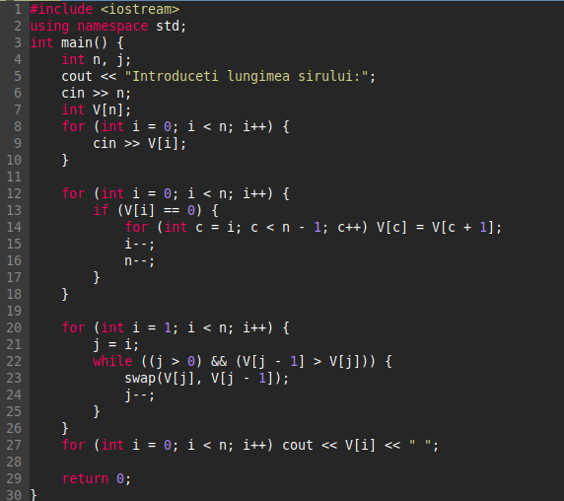}

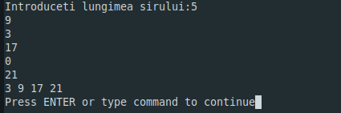

4.

#include <iostream>

using namespace std;

int main() {

int n = 5, k = 2;

int V[n] = {7, 3, 19, 1, 3};

for (int i = 0; i < k; i++) {

if (V[i] > V[i + 1]) swap(V[i], V[i + 1]);

}

for (int i = n - k; i < n - 1; i++) {

if (V[i] < V[i + 1]) swap(V[i], V[i + 1]);

}

for (int i = 0; i < n; i++) cout << V[i] << " ";

return 0;

}

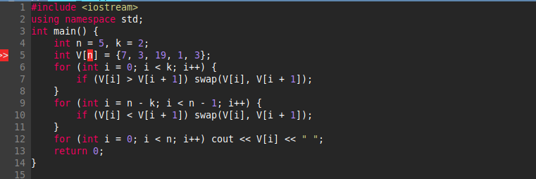

5.

#include <iostream>

using namespace std;

int main() {

int x,y,n = 3, m = 4, j;

int V[n][m] = {{3, 9, 1, 2}, {5, 1, 10, 9}, {7, 2, 9, 5}};

for (int i = 1; i < m; i++) {

j = i;

while (j > 0 && V[0][j] < V[0][j - 1]) {

swap(V[0][j], V[0][j - 1]);

j--;

}

}

for (int i = 0; i < n; i++) {

for (int j = 0; j < m; j++) {

cout << V[i][j] << " ";

}

cout << endl;

}

return 0;

}

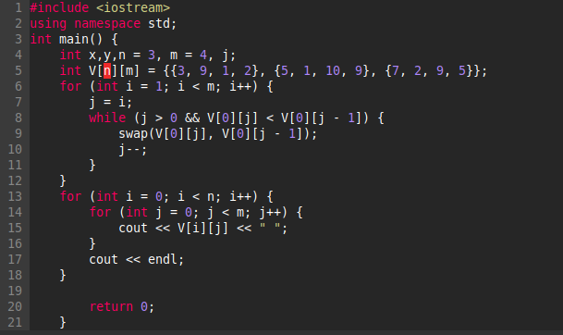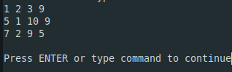

6.

#include <iostream>

#include <string>

#include <vector>

using namespace std;

int main() {

string v[3] = {"zaab", "cnn", "xqac"};

for (int i = 0; i < 2; i++)

if (v[i] > v[i + 1]) swap(v[i], v[i + 1]);

for (int i = 0; i < 3; i++) cout << v[i] << " ";

