Programming for Computational Biologists (PCB)
BIO551A – R Programming
Name: Ansh Tandon Roll No: MT26222

Part A: Species Prevalence and abundance
A1:
The five most prevalent bacterial species across all the 60 samples are:
'Escherichia coli'
'Faecalibacterium prausnitzii'
'Collinsella aerofaciens'
'Prevotella copri'
'Roseburia inulinivorans'

A2:
The relative abundance, mean and median of each of the selected 5 species are:
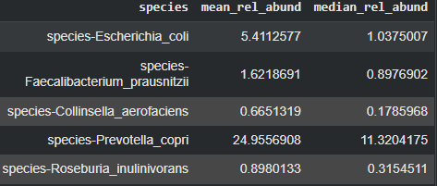
A3:
No, the most prevalent species 'Escherichia coli' does not have the highest median relative abundance, instead the 4th most prevalent species 'Prevotella copri', has the highest median relative abundance.

Part B: Descriptive statistics and group comparison
B1:
Mean, Median, IQR of relative abundance for each species in CRC samples:
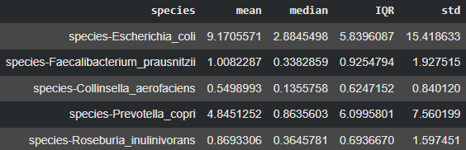
Mean, Median, IQR of relative abundance for each species in Healthy samples:
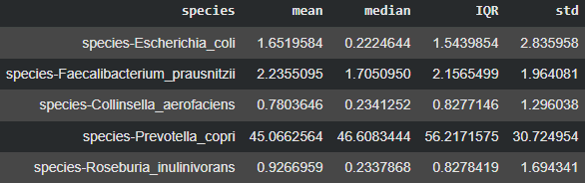
B2:
'Prevotella copri' in the ‘healthy’ group shows the largest absolute difference in median relative abundance between CRC and Healthy samples:
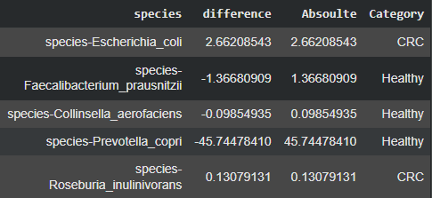

B3:
Again for standard deviation as well, ‘Prevotella copri' in the ‘healthy’ group shows the largest absolute difference in standard deviation of relative abundance between CRC and Healthy samples:

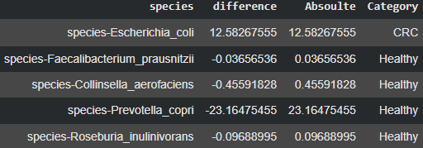
This indicates that the abundance of ‘Prevotella copri' in the ‘healthy’ group is more as compared to CRC samples. Therefore, on the basis of this observation we can infer that ‘Prevotella copri' is more abundant in the healthy samples as compared to CRC groups. We can also infer that due to CRC the abundance of ‘Prevotella copri' greatly decreases.

Part C: Probability and Independence
C1:
Probability of randomly selecting an individual who belongs to CRC: 0.5
Probability of randomly selecting an individual who is female: 0.5
Probability of randomly selecting an individual who belongs to CRC and is female: 0.2
C2:
The joint probability of CRC and Female is: 0.2
The marginal probability of CRC and Female is: 0.25
Since, the difference is 0.05, which is very low, we can infer that disease is not dependent on gender.
To emphasise on this a chi2 test of independence was conducted, wherein the value of p-value was very high than 0.05. It was 0.1967. Hence, we failed to reject the hypothesis. And we say that disease and gender are independent of each other.
C3:
The theoretical and simulated probabilities are given below:
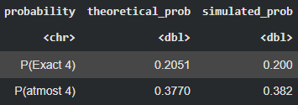
Based on the above table, we observe that the difference between the simulated probability and the theoretical probability is very minimal. With this we can say that simulation agrees with the theoretical binomial model and supports the theoretical probabilities.
Part D: Normal distribution and simulation
D1:
The mean of given age: 50.65
The standard deviation of given age: 50.65
The mean of simulated age: 51.47
The standard deviation of simulated age: 50.23
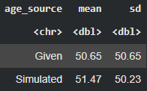
Based on the above table and information, as the difference is very minimal we can say that our descriptive statistical metrics are right.
D2:
Density at age 50: 0.01
Probability of being age 50 years or younger: 0.49
The density tells us that how deep a curve is. Having a 0.1 density means that the curve is not very deep at 50, i.e., the age is spread across different age groups. It is important to know that density only tells us the depth of the curve and not the probability.
The probability actually tells us about the probability of the condition/question. The probability of .49 tells us that about half of the fitted distribution of people are exactly at or under the age of 50.
D3:
The theoretical probability of being between 40 and 60 years old: 0.16
Probability of being between 40 and 60 years in the given data: 0.16
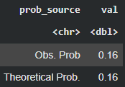
As we can see that they are identical, we can infer that there is a hint of normal distribution within this range of 40-60 years.
D4:
Shapiro-Wilk T-stat val: 0.8629
Shapiro-Wilk P-val: 7.501 * 10⁻⁶
Therefore, based on this information we can infer that the observed age data does not follow a normal distribution as, based on the Shapiro-Wilk normality test, the p-value is below the significance level of 0.05, thereby, indicating a non-normal distribution.

