Project #1 – 10/6/21

Due - 10/18/21, Professor will collect at the start of class that day. Late submissions will not be accepted.

Project Worth 50 Points Total, 25 points per problem.

Instructions:

1. Work must be submitted in a Python file. File name should be your last name. You must include your full name in a comment section at the top of your program file.
2. You must use the POS.csv file for this project.
3. All code must utilize for loop(s) and if statement(s).
4. The only acceptable data structure to use in the program is LISTs. Do not use Pandas, Dataframes, or Dictionaries.
5. Do not use special libraries, e.g. numpy. Only the default libraries are acceptable.
6. Each problem can be addressed independently. See problems below.

PROBLEM 1:

1. You must dynamically process all transactions in the POS file, identifying the distinct brand names, and any distinct class names that apply for each brand, and aggregate the sales amount.
2. You cannot hardcode for brand names or class names.
3. Create an output csv file named BrandAnalysis.csv contains the columns of information shown below.

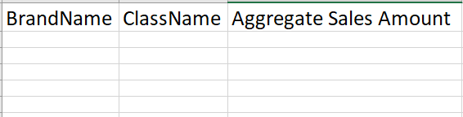

PROBLEM 2:

1. Capture the average sales amount per quarter, per North American holiday, per Month.
2. You cannot hardcode for quarters, holidays, or months.
3. Create a csv file called AverageSales.csv as formatted in the screen shot below.

