User Guide & Demo Script
Intelligence-Driven Pipeline for Detecting Emerging Financial Fraud Patterns
Pickaxe Analytics • DSBA 6390 • April 2026

1. Overview
Pickaxe Analytics is a fraud intelligence platform that continuously monitors publicly available sources to surface emerging financial fraud patterns. It is designed for fraud analysts, risk officers, and institutional stakeholders who need proactive situational awareness without manual research overhead.

The application consists of five pages accessible from the left-hand navigation panel:

- Executive Overview: High-level dashboard of articles monitored, active clusters, emerging themes, and risk trends
- Intelligence Search: Natural language query interface that retrieves and synthesizes fraud intelligence with cited sources
- Fraud Pattern Clusters: Embedding-based cluster explorer showing how fraud themes group, grow, and shift over time
- Network Relationships: Visual graph revealing how fraud clusters connect through shared article evidence
- Alerts & Watchlists: Severity-tiered alert feed for monitored themes with recommended institutional actions

2. Getting Started
2.1 Prerequisites
- Python 3.9+: Required to run the pipeline scripts and Streamlit application
- Supabase account: Free-tier sufficient; project must have pgvector extension enabled
- Google API key: Used for Gemini synthesis in the RAG intelligence layer
- Dependencies: Install via: pip install -r requirements.txt from the project root

2.2 Configuration
Create a .env file in the project root by copying .env.example, then populate the following three values:

- SUPABASE_URL: Your Supabase project URL (found in Project Settings → API)
- SUPABASE_KEY: Your Supabase anon/service key
- GOOGLE_API_KEY: Your Google AI Studio API key for Gemini access

2.3 Running the Application
- Run the data pipeline: Execute python pipeline/ingest.py to populate the article corpus, then python pipeline/embed.py to generate embeddings, and python pipeline/cluster.py to build clusters. This step is only required on a fresh database or when refreshing the data.
- Launch the app: From the project root, run: streamlit run app.py
- Open in browser: Navigate to http://localhost:8501. The application loads directly to the Executive Overview page.

ℹ️ Note: The data pipeline only needs to be run once per data refresh cycle. Once the Supabase database is populated, you can launch the Streamlit app directly without re-running the pipeline.

3. Demo Walkthrough
The following steps guide a first-time user through a complete end-to-end demo of the application. The recommended flow starts with the Executive Overview to establish situational context, then moves to Intelligence Search to conduct a focused query, and finally navigates through the cluster, network, and alert modules to explore the results in depth.

Executive Overview | Intelligence Search | Fraud Pattern Clusters | Network Relationships | Alerts & Watchlists

Step 1 Review the Executive Overview
When the application loads, you land on the Executive Overview page. This page gives a bird’s-eye view of everything the platform is currently monitoring. Start here to orient yourself before running any searches.

Review the four KPI tiles at the top of the page:
- Articles Monitored: Total articles ingested and actively tracked. A percentage change vs the prior 7 days indicates ingestion velocity.
- Active Theme Clusters: Number of distinct fraud theme clusters currently formed. The ‘+N emerging’ label flags newly forming clusters.
- Emerging Themes: Count of clusters in the Emerging lifecycle stage — the earliest and highest-attention signal tier.
- Avg Cluster Risk: The mean risk score across all active clusters. A rising score signals increasing threat density.

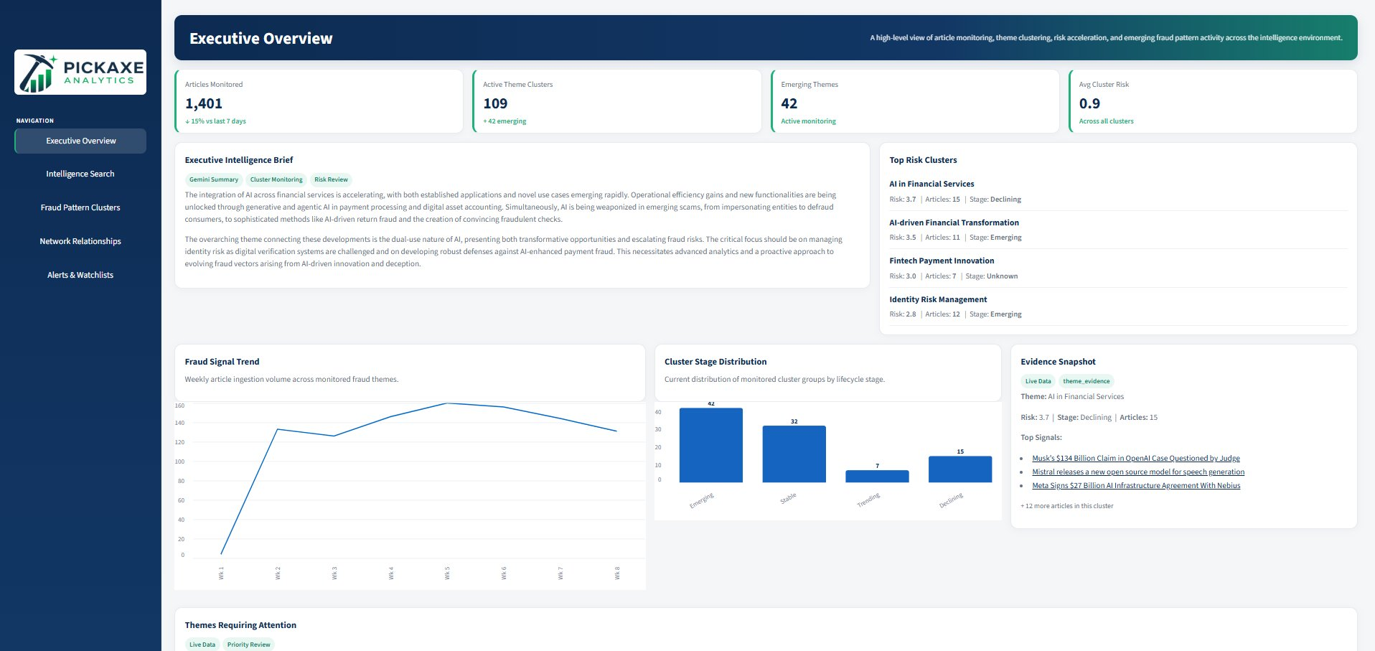
Figure 1a — Executive Overview: KPI tiles, intelligence brief, and top risk clusters

Below the KPI tiles, read the Executive Intelligence Brief. This is a Gemini-synthesized narrative that synthesizes the dominant themes across the corpus into a single plain-language summary. Pay particular attention to the Top Risk Clusters panel on the right — these are the highest-ranked threats by risk score and are the recommended starting point for any further investigation.

Scroll down to view the Fraud Signal Trend chart (weekly article volume over time), the Cluster Stage Distribution bar chart (how many clusters sit at each lifecycle stage), and the Themes Requiring Attention panel, which expands individual cluster cards with descriptions and target audience tags.

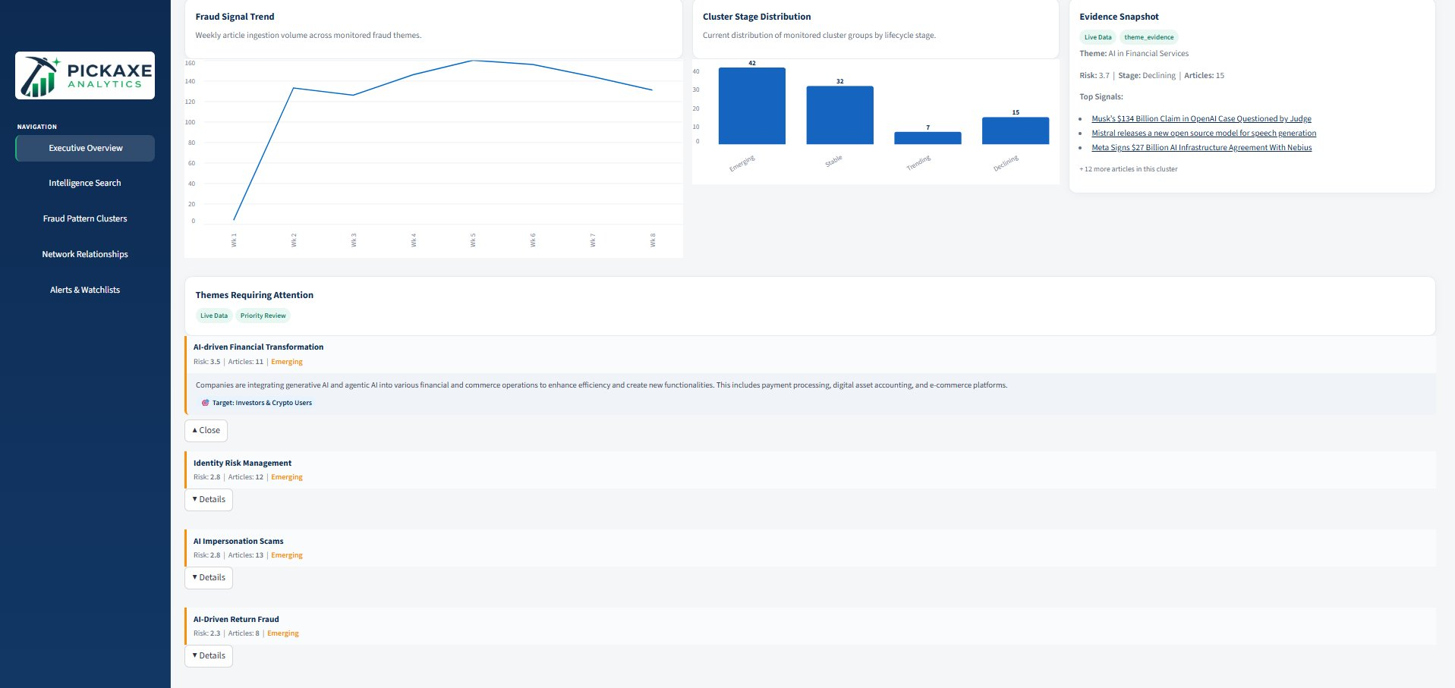
Figure 1b — Executive Overview: Fraud Signal Trend, Cluster Stage Distribution, and Themes Requiring Attention

Executive Overview | Intelligence Search | Fraud Pattern Clusters | Network Relationships | Alerts & Watchlists

Step 2 Navigate to Intelligence Search
Click Intelligence Search in the left-hand navigation panel. This is the core analytical module — it accepts a natural language query, retrieves the most semantically relevant articles from the corpus, and uses Gemini to synthesize a structured intelligence brief grounded in that evidence.

At the top of the page you will see a row of Suggested Searches. These are pre-built query prompts derived from the most active themes in the current corpus. For the purposes of this demo, click:

🔍 Suggested Search: AI-enhanced payment fraud schemes

This populates the Search Query field automatically. Before clicking Analyze Intelligence, review the three configurable search parameters:
- Documents to Retrieve: Controls how many top-k articles are pulled from the vector index. The default of 5 is appropriate for most queries; increase to 10–15 for broader coverage.
- Time Horizon: Filters articles by publication date. ‘Last 90 Days’ is recommended for emerging threat detection; extend to ‘All Time’ for historical pattern analysis.
- Min Risk Threshold: Sets a floor on the risk score of retrieved articles. Leave at 0.00 for the demo to maximize coverage.

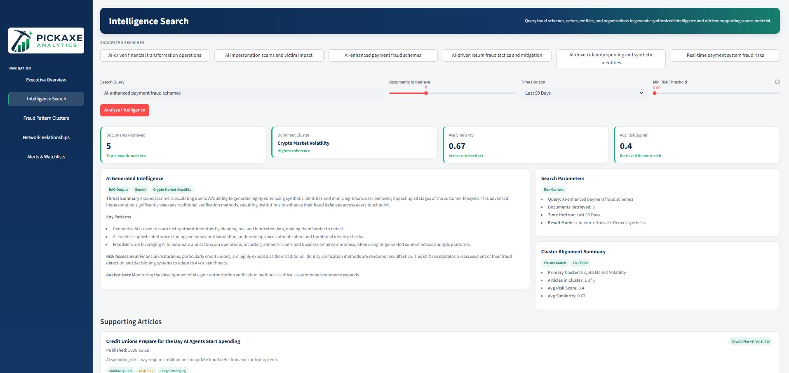
Figure 2a — Intelligence Search: Suggested searches, query configuration, and AI-generated intelligence brief

Click Analyze Intelligence. The system performs semantic retrieval against the vector index and passes the retrieved documents to Gemini for synthesis. Results typically return within a few seconds.

The AI Generated Intelligence panel returns a structured brief with four labelled sections:
- Threat Summary: A concise overview of the fraud landscape for the query topic
- Key Patterns: Specific fraud behaviors and tactics identified across retrieved articles
- Risk Assessment: Institutional exposure analysis, often with sector-specific commentary
- Analyst Note: A forward-looking observation or monitoring recommendation

To the right of the brief, the Cluster Alignment Summary shows which existing fraud cluster most closely aligns with the retrieved documents, along with the average risk score and similarity across the result set.

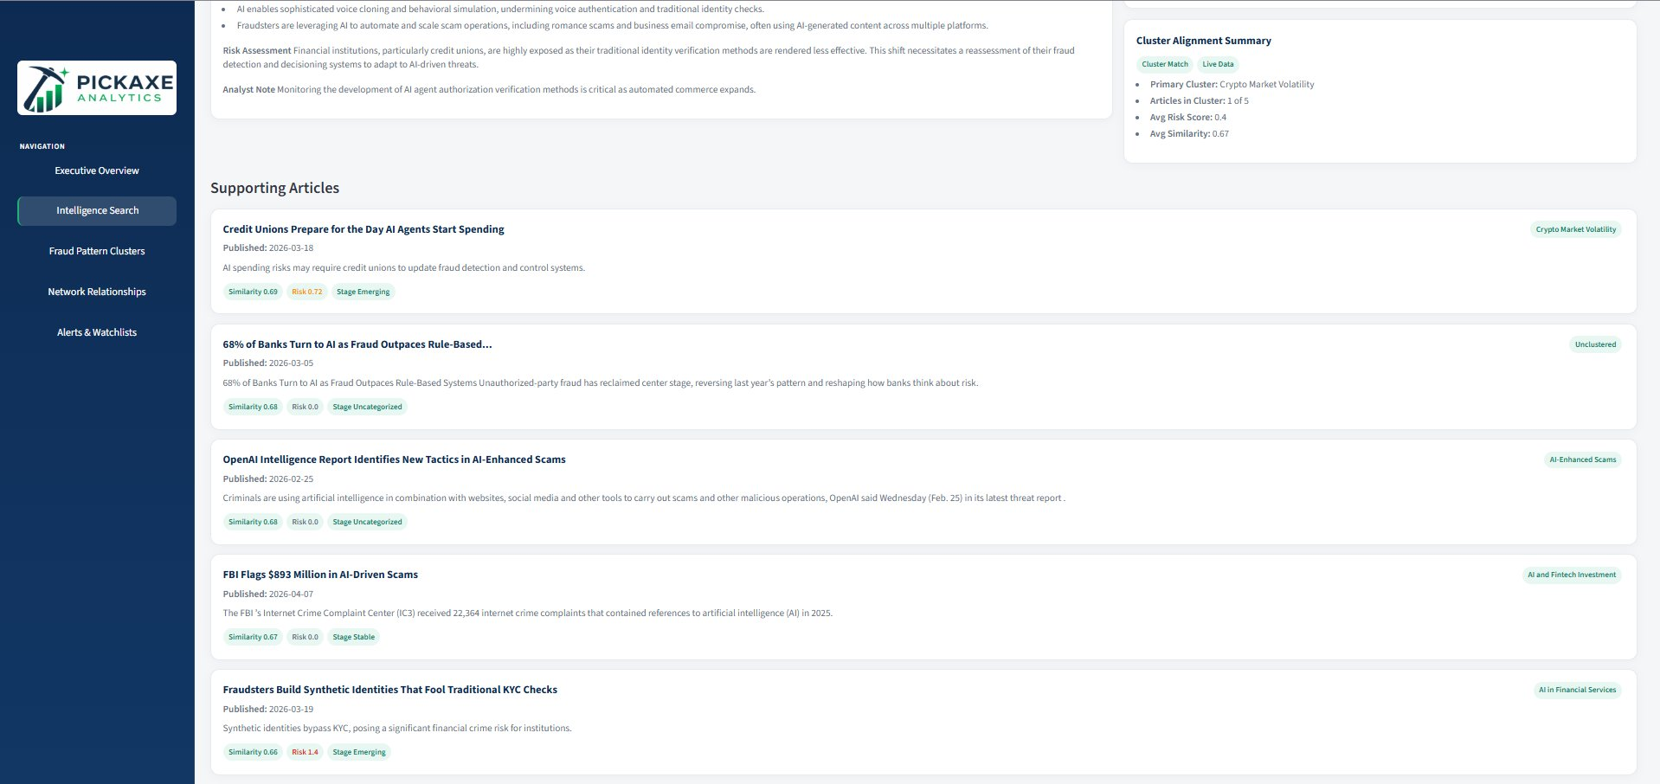
Figure 2b — Intelligence Search: Supporting articles with similarity, risk, and cluster attribution

Scroll down to the Supporting Articles section. Each article card shows the title, publication date, similarity score to your query, risk score, and the cluster it belongs to. These are the primary evidence sources grounding the intelligence brief above.

💡 Tip: The cluster tag on each supporting article (e.g., ‘Crypto Market Volatility’ or ‘AI-Enhanced Scams’) links the article to the broader cluster ecosystem. Use these tags to navigate to Fraud Pattern Clusters for deeper exploration of any theme that appears relevant.

Executive Overview | Intelligence Search | Fraud Pattern Clusters | Network Relationships | Alerts & Watchlists

Step 3 Explore Fraud Pattern Clusters
Click Fraud Pattern Clusters in the left navigation. This module shows how fraud narratives in the corpus group into semantically coherent themes, and tracks each cluster’s lifecycle stage and risk trajectory over time.

The page loads with the same query context carried forward from your Intelligence Search. At the top, three summary tiles show the number of Retrieved Clusters, the Average Cluster Risk across those clusters, and the count of Emerging Clusters — the early-stage threats most deserving of attention.

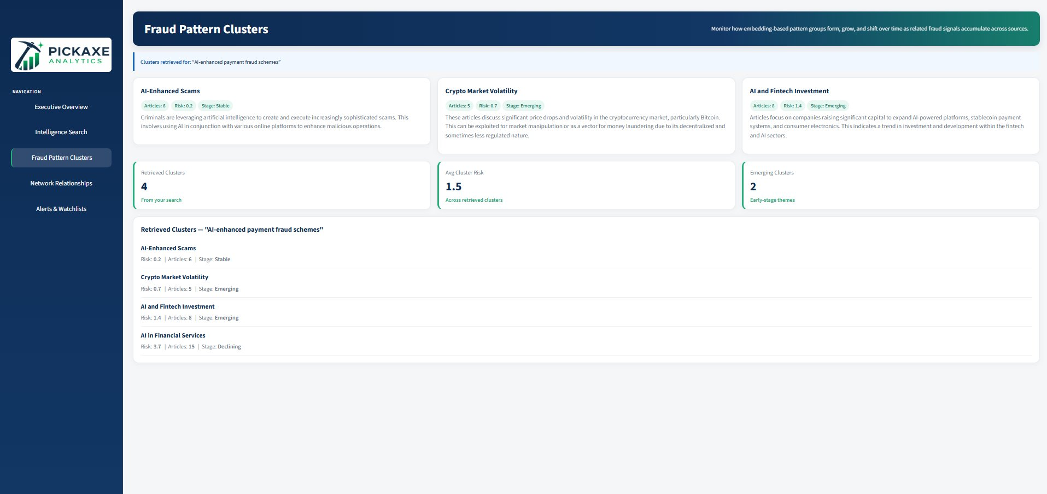
Figure 3 — Fraud Pattern Clusters: Retrieved cluster cards with stage, risk, and article count

Each cluster card displays:
- Cluster name and description: A label and plain-language summary of the fraud theme
- Risk score: A multi-factor signal score based on volume, velocity, and source authority
- Article count: The number of articles grouped into this cluster
- Lifecycle stage: Emerging (early signal), Stable (established), Trending (accelerating), or Declining (fading)

Below the cluster cards, the Retrieved Clusters list presents the same data in a structured table for easy comparison. Note which clusters are tagged Emerging — these are the highest-priority themes for proactive monitoring.

💡 Tip: A cluster showing a high risk score with an Emerging stage tag is the most actionable signal in the platform — it indicates a threat that is growing in prominence but may not yet be on institutional radar.

Executive Overview | Intelligence Search | Fraud Pattern Clusters | Network Relationships | Alerts & Watchlists

Step 4 Explore Network Relationships
Click Network Relationships in the left navigation. This module visualizes how fraud clusters relate to one another through shared article evidence and proximity in embedding space. It is most useful for identifying convergent threats — cases where two seemingly distinct fraud themes are drawing from the same underlying signals.

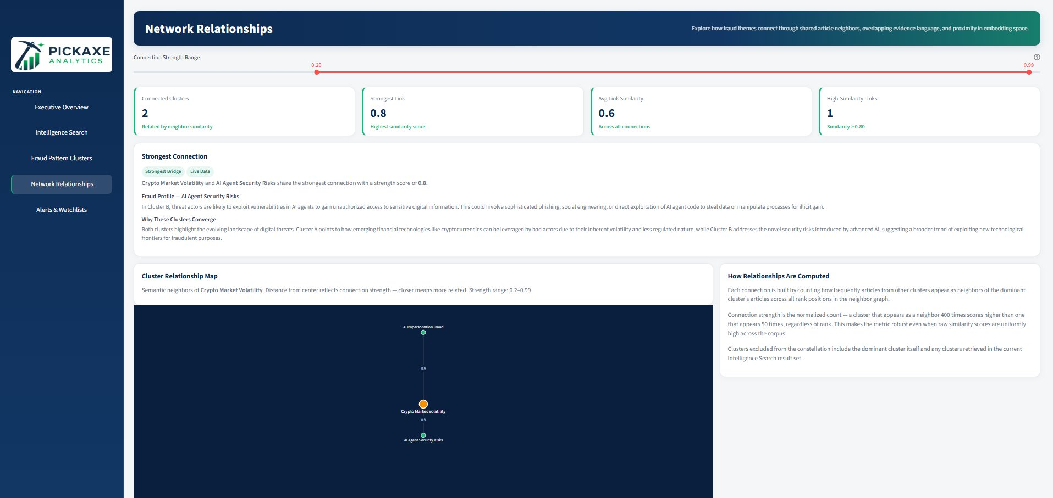
Figure 4a — Network Relationships: Connection metrics, strongest link, and cluster relationship map

The page loads centered on the dominant cluster from your prior search. Review the four summary tiles: Connected Clusters (how many clusters are linked), Strongest Link score, Average Link Similarity, and High-Similarity Links (connections at or above 0.80).

The Strongest Connection panel identifies the two clusters with the highest co-occurrence of shared article neighbors. It includes:
- Fraud Profile: A description of the threat posture of the secondary cluster
- Why These Clusters Converge: An explanation of the common underlying signal driving their proximity

The Cluster Relationship Map is a visual graph where the dominant cluster appears at center and related clusters orbit at distances proportional to connection strength — closer nodes are more strongly connected. Use the Connection Strength Range slider at the top of the page to filter which connections are displayed.

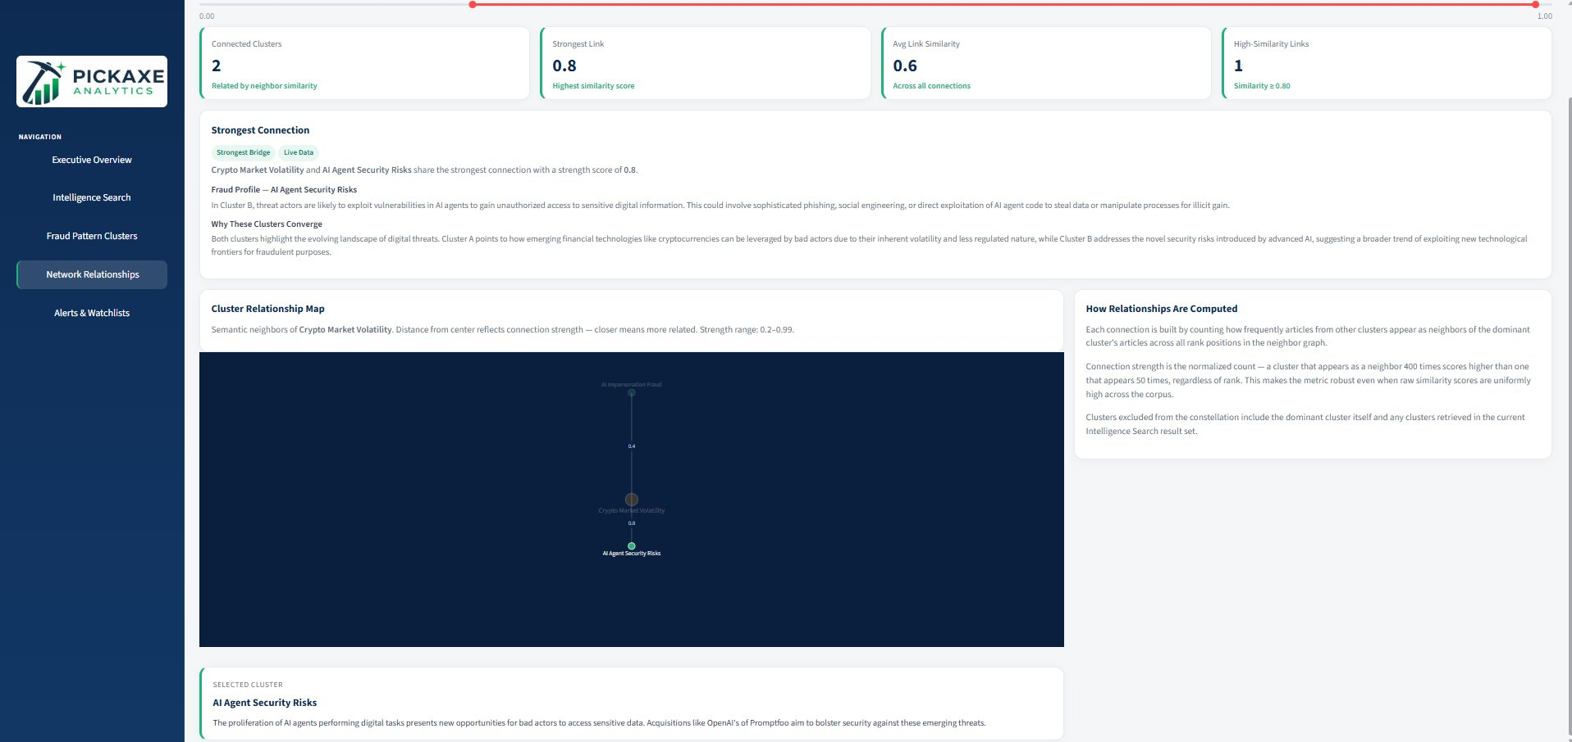
Figure 4b — Network Relationships: Selected cluster detail panel showing description and convergence context

Click any node in the graph to open its Selected Cluster detail panel at the bottom of the page, which provides the cluster description and convergence context for that specific theme.

💡 Tip: If two high-risk clusters show a strong connection, that convergence is a meaningful signal — it suggests a broader fraud ecosystem rather than isolated incidents, and may warrant cross-functional monitoring or escalation.

Executive Overview | Intelligence Search | Fraud Pattern Clusters | Network Relationships | Alerts & Watchlists

Step 5 Review Alerts & Watchlists
Click Alerts & Watchlists in the left navigation. This module surfaces triggered alerts for themes on the monitored watchlist, ranked by risk severity. It is the action-oriented layer of the platform — where situational awareness converts into recommended institutional response.

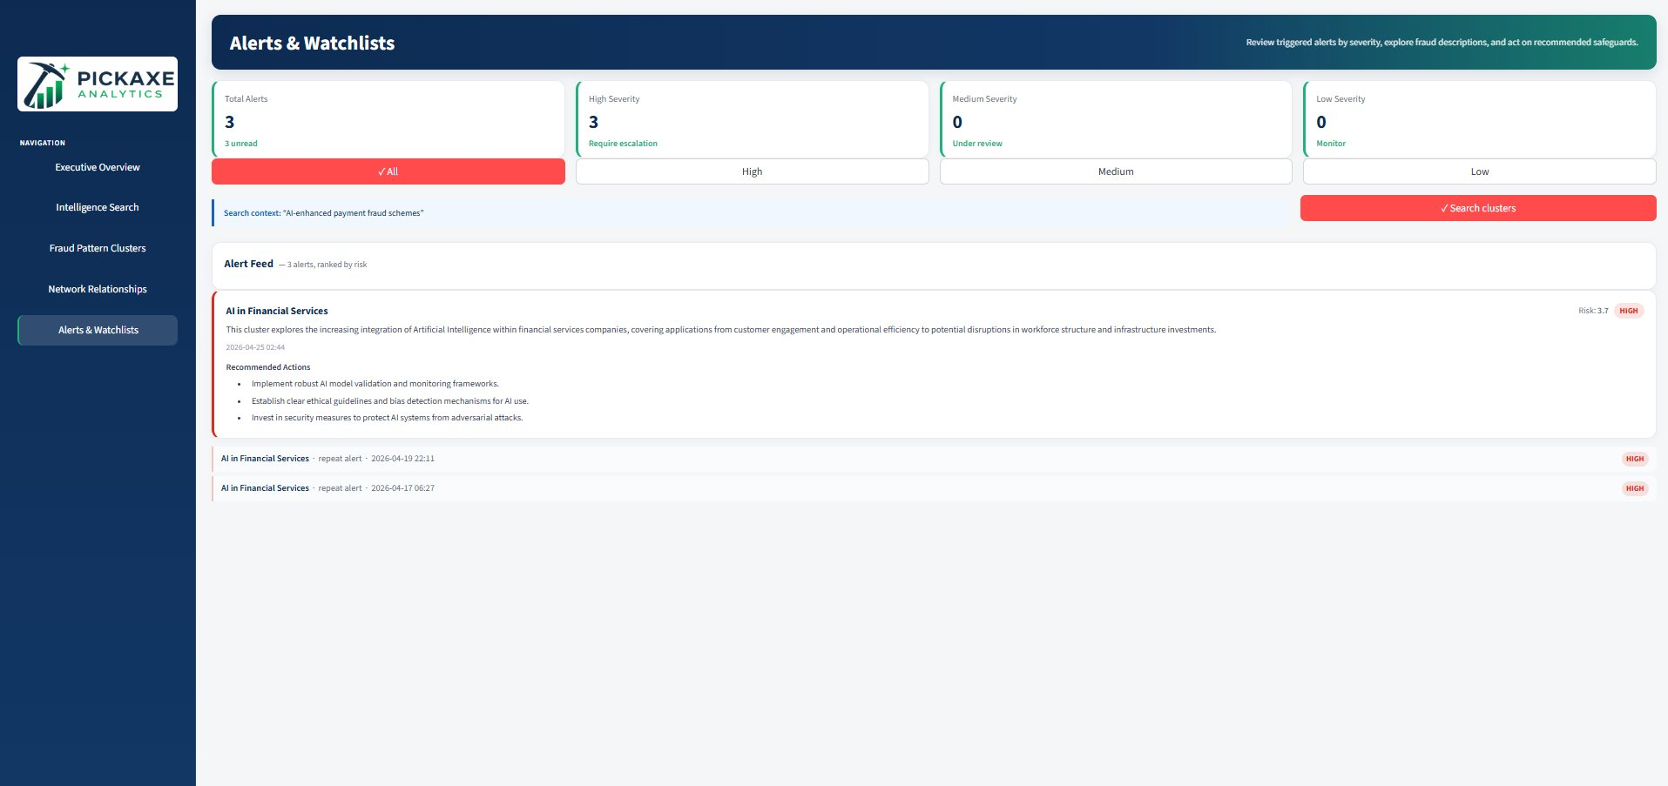
Figure 5 — Alerts & Watchlists: Severity counts, alert feed, and recommended actions

At the top of the page, the four severity tiles show counts of Total Alerts, High Severity (require escalation), Medium Severity (under review), and Low Severity (monitor). Use the filter tabs — All, High, Medium, Low — to segment the feed by urgency tier.

Each alert card in the feed displays:
- Cluster name and risk score: The watchlist theme that triggered the alert, with its current risk score and severity badge
- Cluster description: A plain-language summary of the fraud theme associated with this alert
- Recommended Actions: Concrete institutional steps generated for this specific threat cluster
- Repeat alert history: Prior instances of the same alert listed with timestamps, indicating recurring or escalating signals

The Search clusters button in the top-right corner of the page launches a cluster search scoped to the current alert context, linking directly back to the Fraud Pattern Clusters module for deeper investigation.

💡 Tip: Repeat alerts on the same cluster over multiple dates are a strong indicator of a persistent or escalating threat. If the same theme reappears week over week, treat it as a priority escalation candidate regardless of its current risk score tier.

4. Quick Reference

Page | Primary Purpose | Best Used When…
Executive Overview | Situational awareness across the full corpus | Starting a session or briefing a stakeholder on current threat landscape
Intelligence Search | Deep-dive analysis on a specific fraud topic | Investigating a particular scheme type or answering a specific threat question
Fraud Pattern Clusters | Exploring how fraud themes group and evolve over time | Assessing which themes are emerging vs. stable and comparing cluster risk profiles
Network Relationships | Understanding threat convergence across clusters | Identifying if two fraud themes share common signals or represent a broader ecosystem
Alerts & Watchlists | Monitoring priority themes and acting on escalations | Conducting a daily review or preparing an escalation recommendation

Pickaxe Analytics — DSBA 6390 Capstone, UNC Charlotte. Repository: github.com/owilli38/DSBA6390-Fraud-Detection-Emerging-Fraud-Signals-Dashbaord-

