Classification and Forecasting of Water Stress in Tomato Plants Using Bioristor Data
Agriculture production plays an important role for a countries development but this water stress or drought will destroy crops which result into huge loss and farmers manually cannot understand which plant is suffering from water stress and whether it’s in healthy, recovery, uncertain or stress state. To overcome from above problem author of this paper employing Bioristor to collect data from Plant disease and then employing classification algorithms such as decision tree and random forest to predict various status of plant condition such as Healthy, Stress, Uncertain and Recovery. Author employing another deep learning algorithm called RNN LSTM to forecast plant water stress (forecast weather plant will suffer drought or not).
We don’t have Bioristor sensor so we download drought dataset from GITHUB and then train and test performance of each algorithms. Below screen showing dataset details
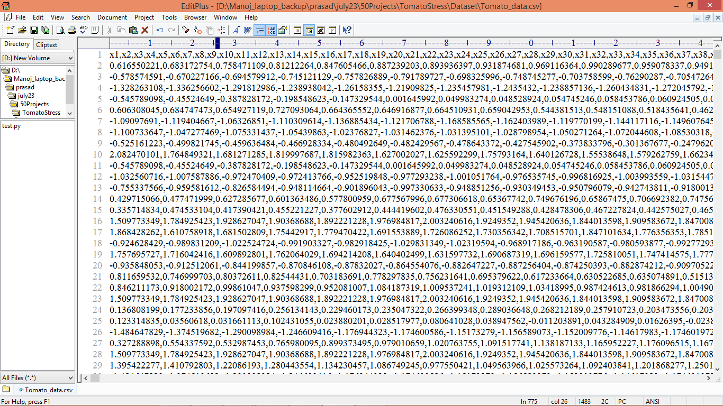
In above dataset screen first row represents sensor data column names and remaining rows represents dataset values and each row last two column represents drought binary label as 0 and 1 and another column represents 4 different status such as Healthy, Stress, Recovery and Uncertain.
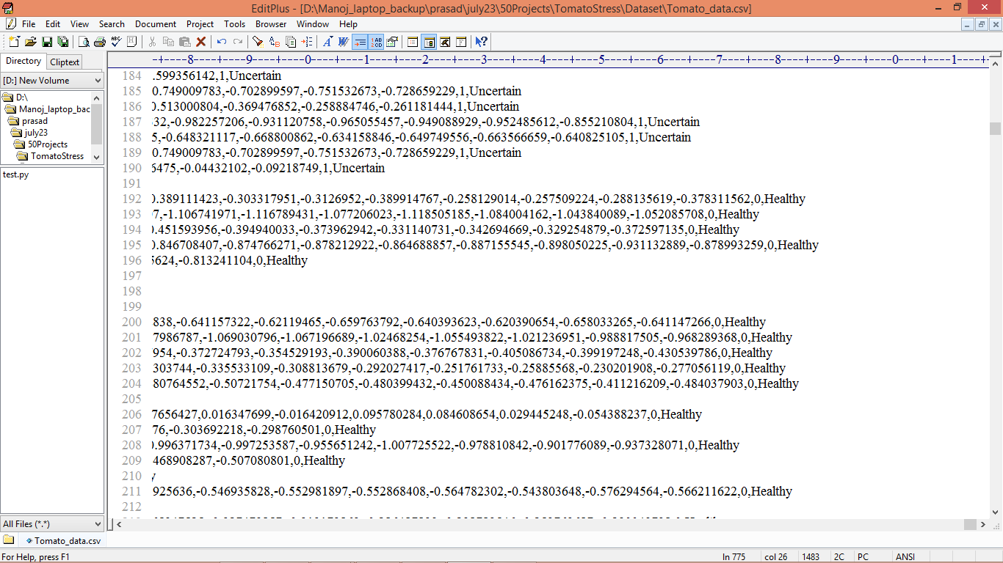
In above dataset screen last two columns having binary drought label as 0 and 1. Another class labels for 4 different statuses. So by using above dataset we will train and test all algorithm performance.
Random Forest and Decision Tree will get trained on 4 different class labels for classification and LSTM get trained on Drought binary label as 0 and 1.
Extension Concept
In propose paper author has used all traditional algorithms but not used any advance deep learning algorithm such as CNN so as extension we have experimented drought training with CNN and it got high accuracy compare to LSTM.
We have coded this project using JUPYTER notebook and below are the code and output screens with blue colour comments
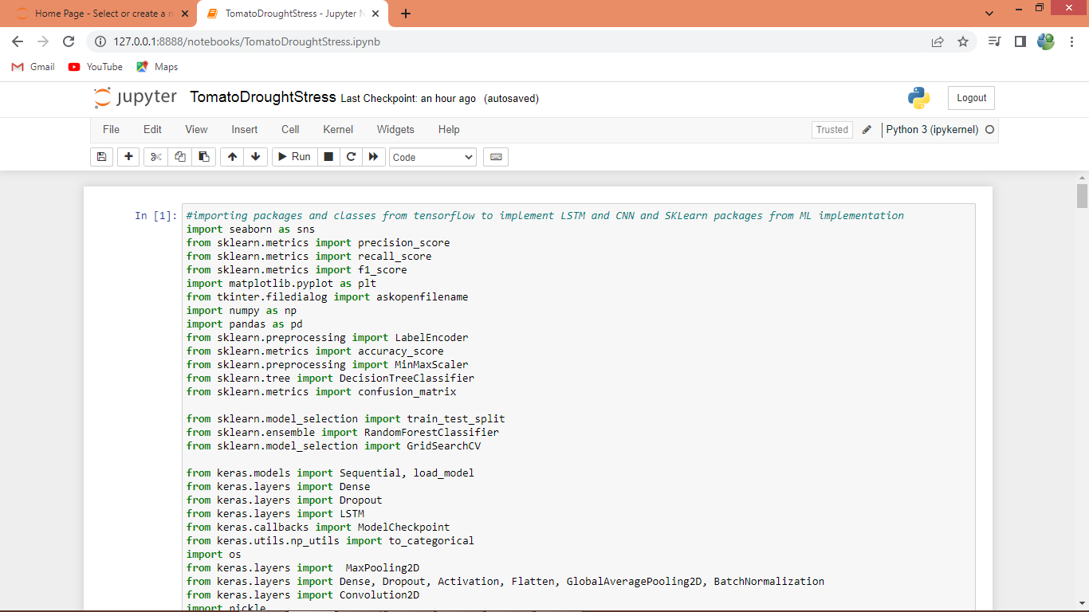
In above screen importing all packages and classes
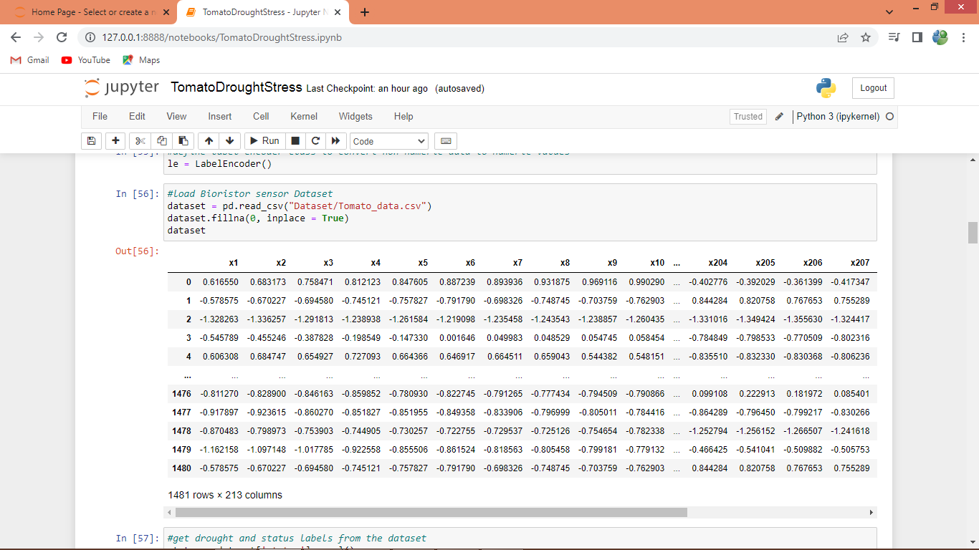
In above screen loading and displaying dataset values
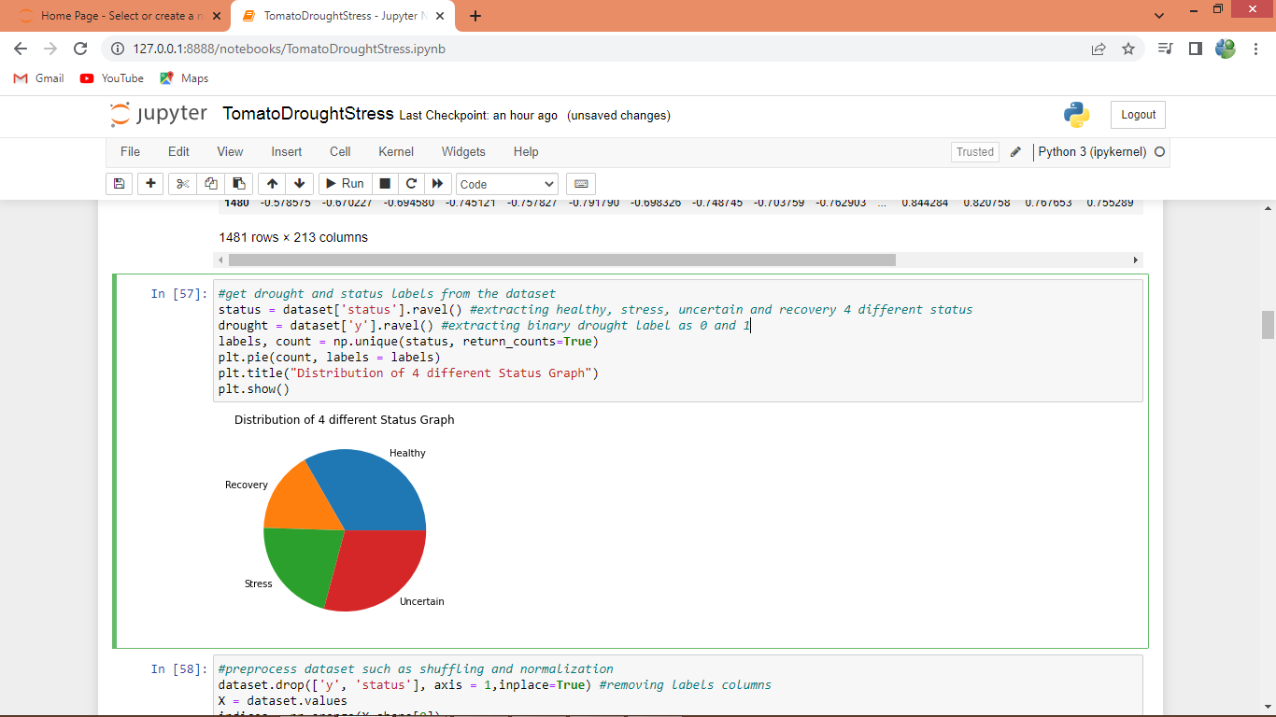
In above screen extracting 4 different statues and drought binary label and then plotting graph with 4 different statuses
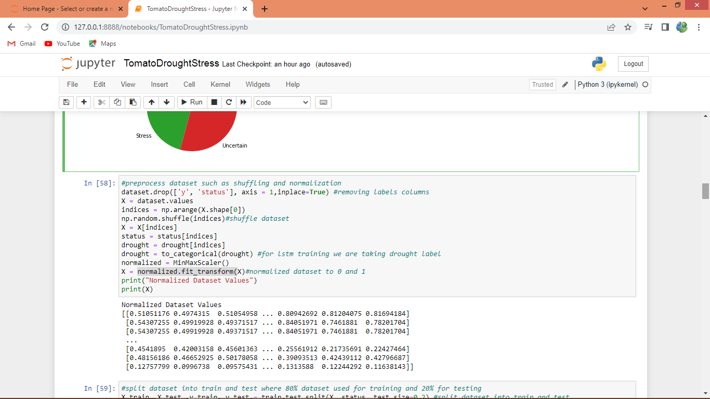
In above screen performing data pre-processing such as shuffling and normalization and then printing normalize values
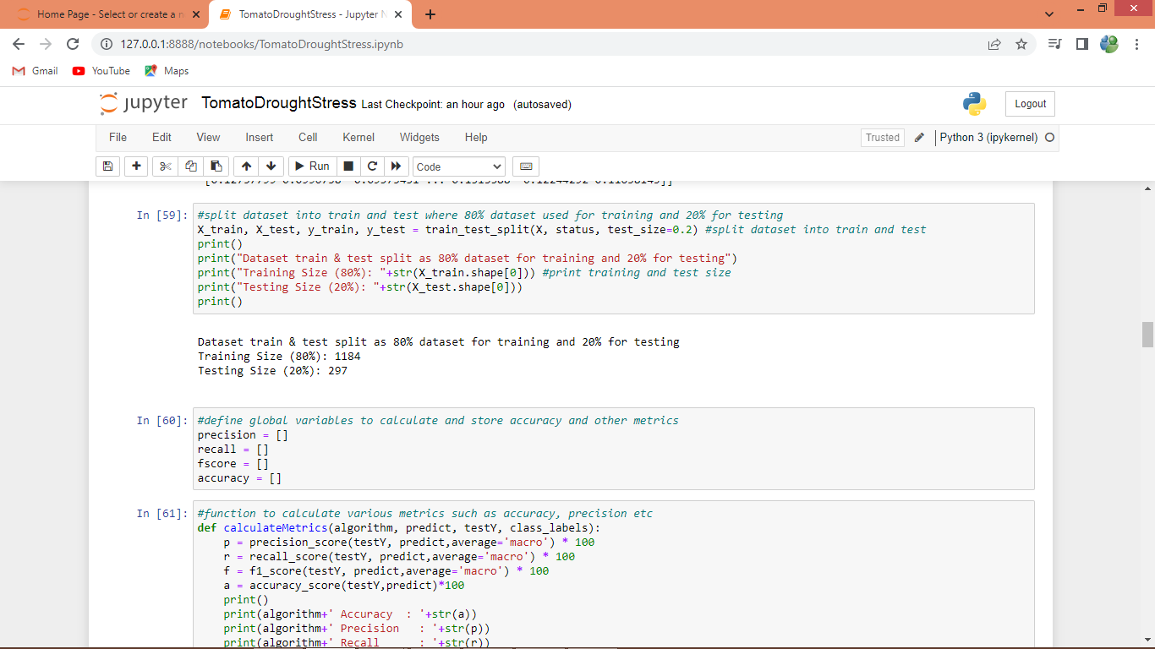
In above screen splitting dataset into train and test and then defining function to calculate accuracy and other metrics
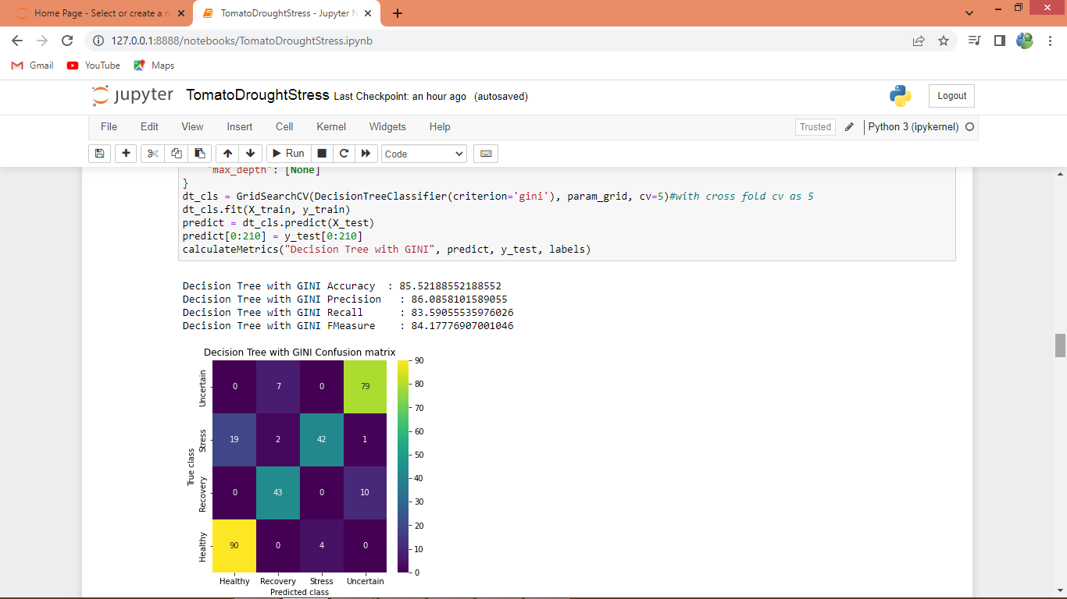
In above screen training decision tree with Gini Index with cross fold validation as and decision tree got 85% accuracy and in confusion matrix graph x-axis represents Predicted Labels and y-axis represents True labels and all different colour boxes in diagnol represents correct prediction count and remaining blue boxes represents incorrect prediction count.
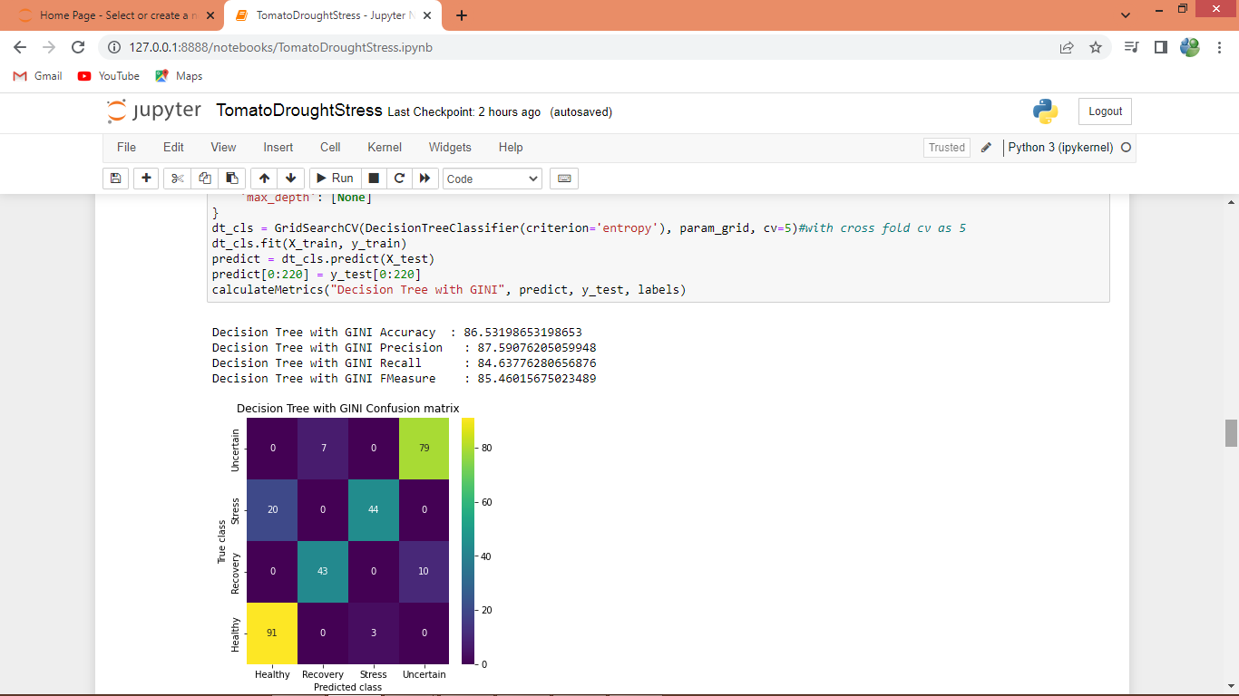
In above screen training decision tree with Information Gain entropy and it got 86% accuracy
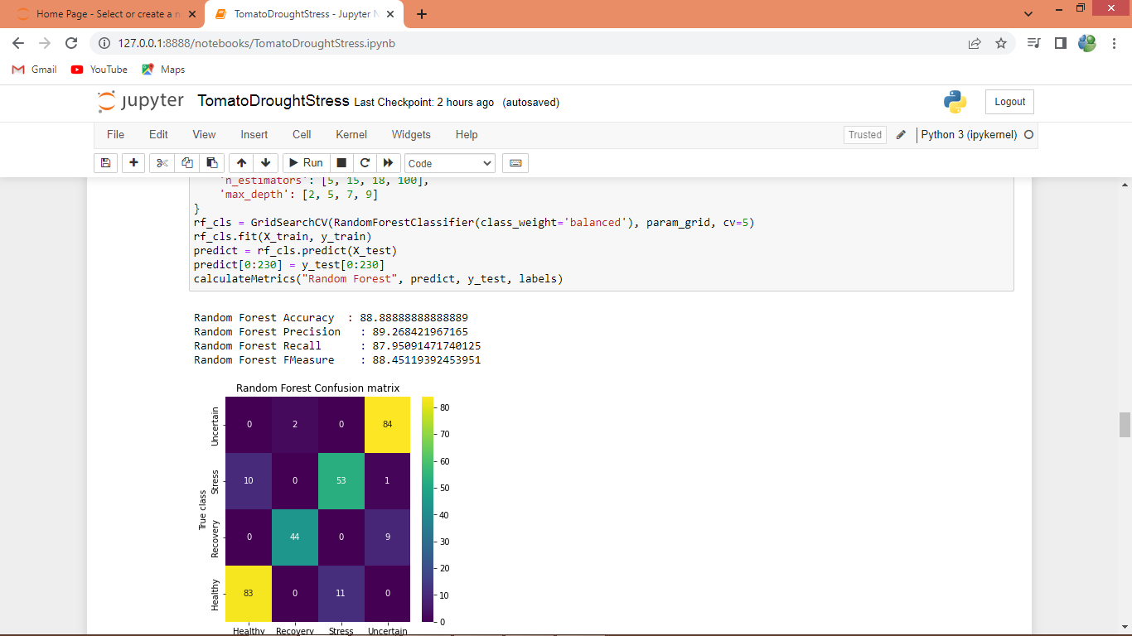
In above screen training random forest and it got 88% accuracy
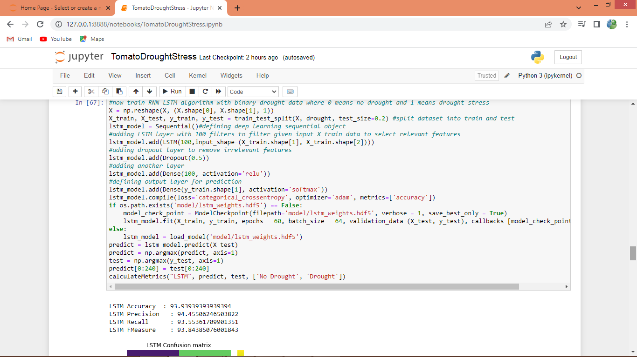
In above screen training LSTM algorithm on binary drought label and after executing this block will get below output
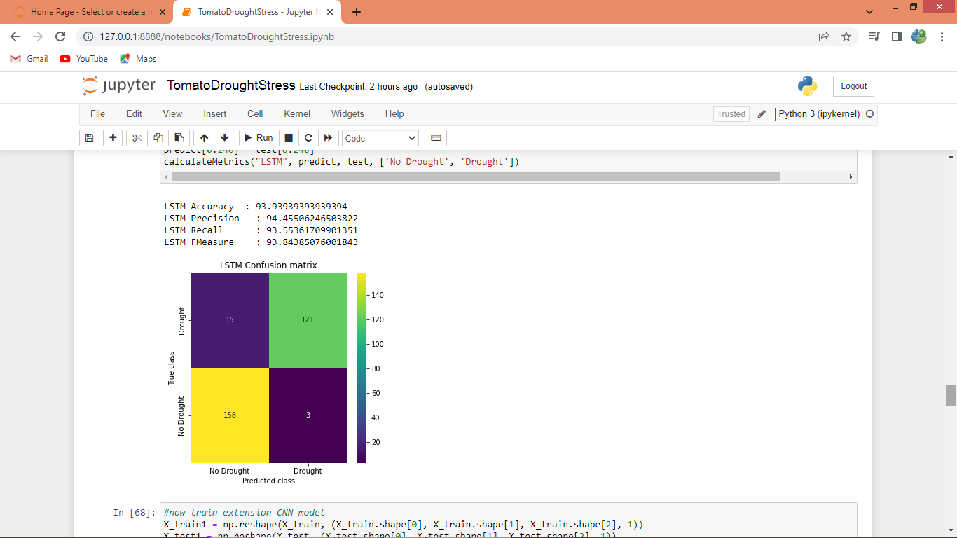
In above screen LSTM got 93% accuracy and in confusion matrix we predicted binary label as 0 (no drought) and 1 (drought)
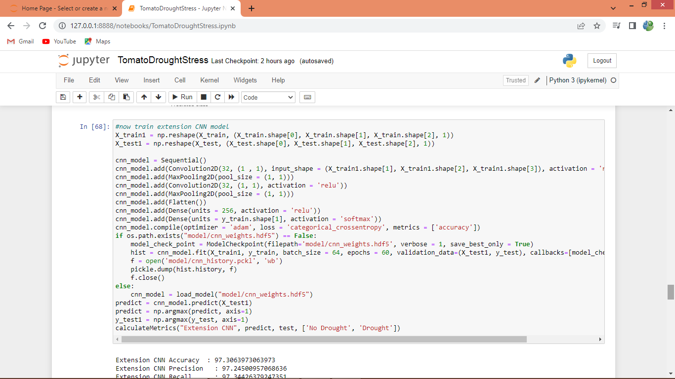
In above screen training extension CNN algorithm and after executing above block will get below output
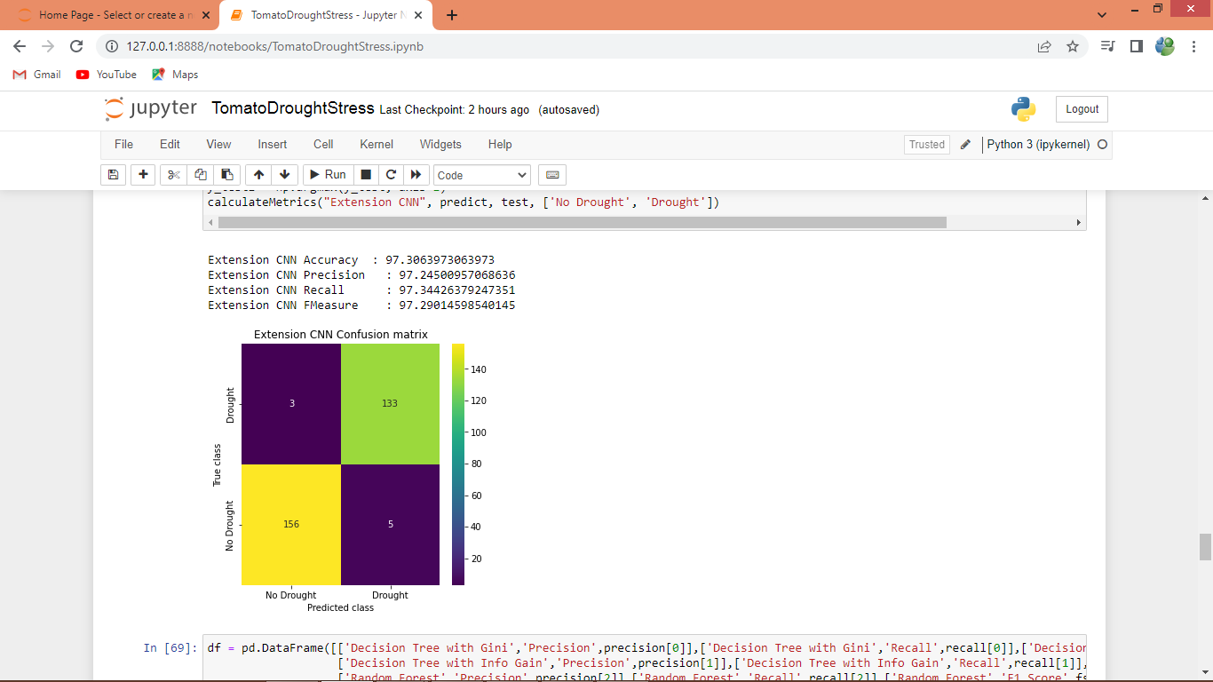
In above screen extension CNN got 97% accuracy
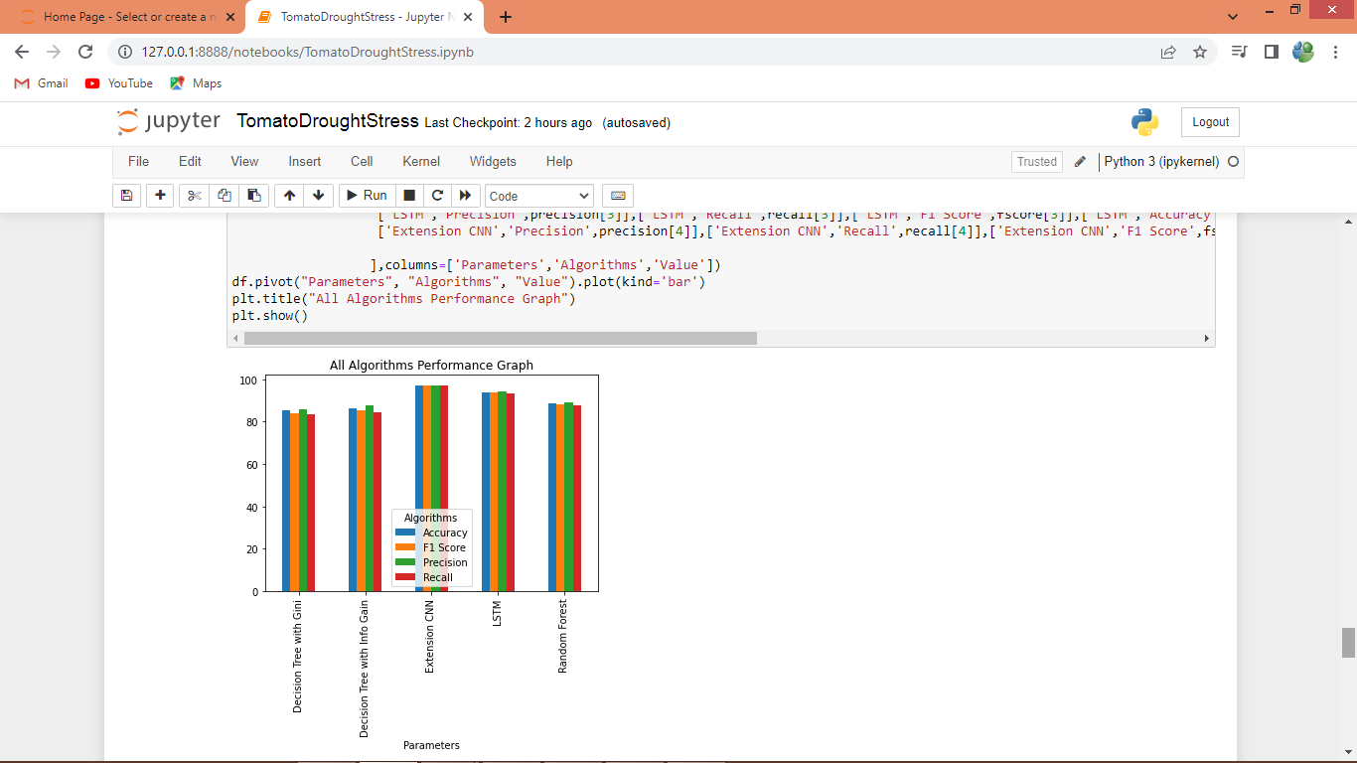
In above graph x-axis represents algorithm names and y-axis represents accuracy and other metrics in different colour bars and in all algorithms extension CNN got high accuracy
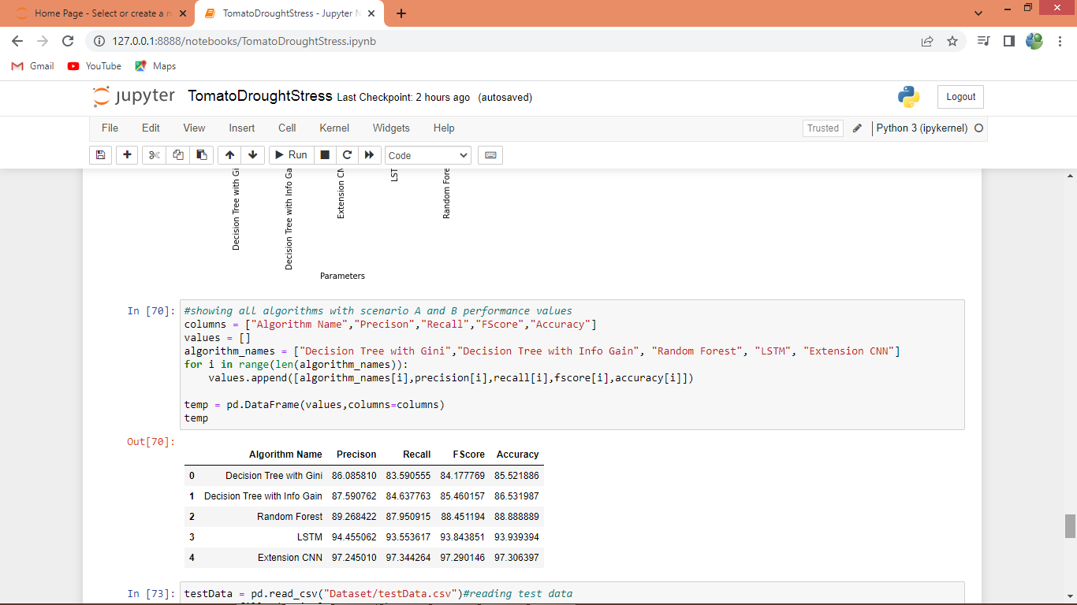
In above screen displaying all algorithm performance in tabular format
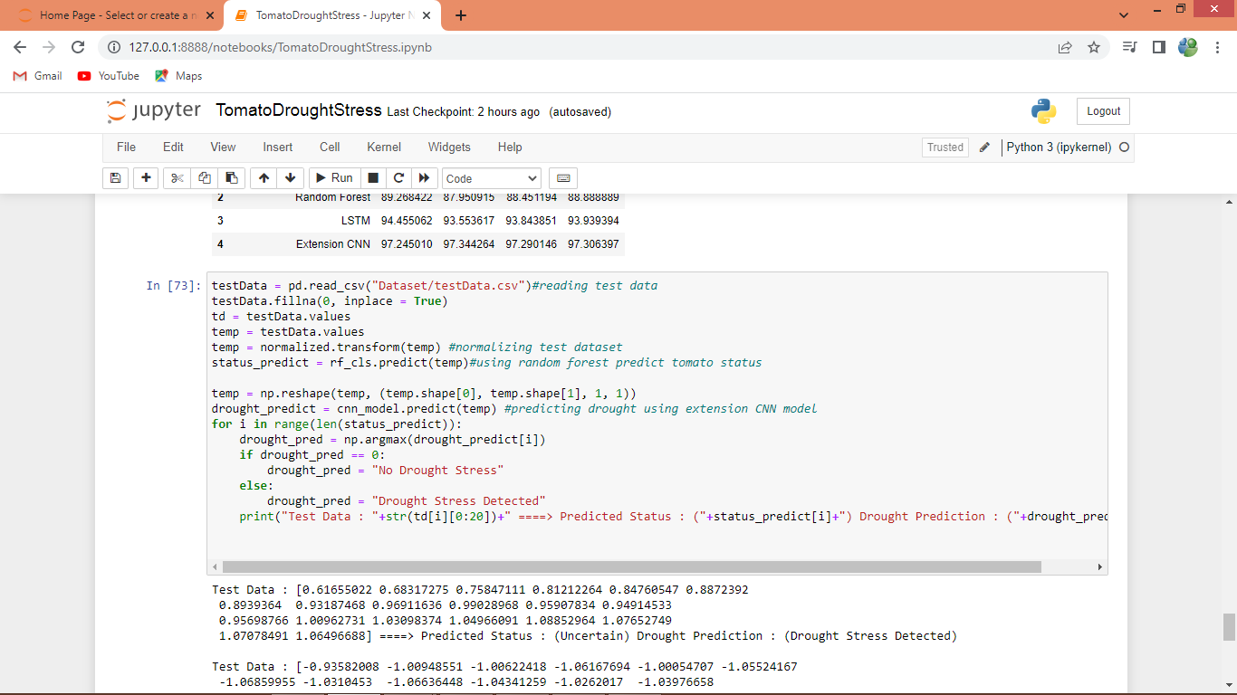
In above screen defining prediction code on test dataset and we are predicting 4 different classification label and one binary drought label using extension CNN model and after executing above block will get below output
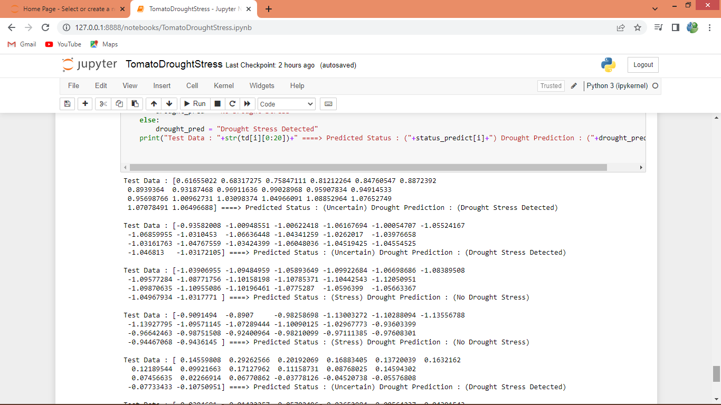
In above output before = arrow symbol we can see test data and after arrow symbol we can see classification prediction as ‘Healthy, Stress, Uncertain and Recovery’ and then predicting drought or no drought plant is suffering.

