Advanced Java Programming

Project03

Due: 2016/10/12

Gregory Westbrook

Here is the version of the compiler I was using:

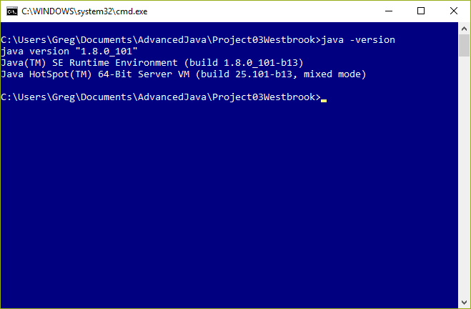

I was also using IntelliJ Community Edition 15.0.3 for the development environment.

Here is a screenshot of the program running:

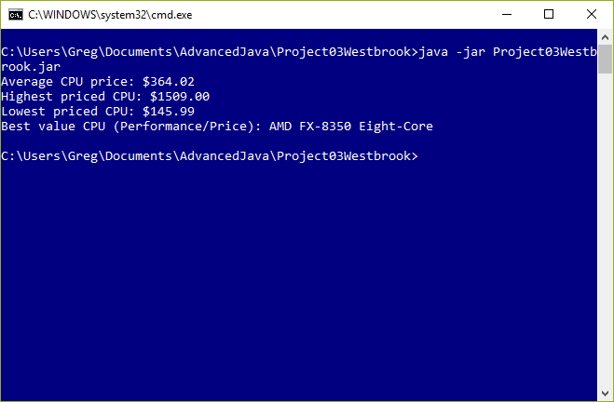

The main method defines a predicate that is used in a subsequent filter to detect if a line ends with “NA” in which case, that line is ignored. The lambda expression gets each line (skipping the first one since it’s a title line), filters the NA lines out, and builds a list of the Cpu objects that are left. The Cpu constructor actually does the pattern matching to deconstruct each line into the Cpu name, Cpu price, and Cpu performance (also calculating the value). The main method then outputs the max, min, average, and best value using the stream max, min, and average methods.

This fulfills the requirements set out in the Project03 assignment: “Use Java 8's Stream and Lambda Expressions to process a CSV ﬁle”. The attached jar file contains classes and source files (in the ‘company’ folder).