Own Protocol — How the Money Works
A plain-language guide to the protocol's financial mechanics. For founders, investors, market makers, and LPs — no code required. Numbers reflect live market rates as of June 2026. Illustrative — actual returns vary with market conditions.

1. The whole thing in one picture
Own is a marketplace with three kinds of customers, and each one pays into a pool the others earn from:
LPs TRADERS MARKET MAKER
(deposit USDC, (mint stock tokens, (quotes prices,
wstETH, BTC) borrow, loop) hedges exposure)
| | |
| collateral | pay borrow interest | earns spread
v v + trading spread v
+----------------------------------------------------------+
| OWN PROTOCOL |
| collateral backs the tokens . lending book earns |
| interest . spread on every trade |
+----------------------------------------------------------+
| |
v v
LPs earn 30-50% more than Aave/Lido Protocol takes a small cut
The core idea: traders want leveraged stock exposure on-chain and will pay for it. LPs provide the collateral that makes it safe and earn the interest. The market maker keeps prices fair and earns the spread. Own sits in the middle and takes a thin cut.

2. Where the demand comes from — the funding arbitrage
This is the engine. Here's the trade a crypto fund wants to run, in plain terms.
The opportunity: On crypto exchanges, people who bet long on stocks like NVDA via “perpetual futures” (perps) pay a fee called funding to the other side. For hot names this runs +13%/year (NVDA), averaging around +5%/year across names. That's income for whoever takes the short side — if they hold an offsetting long so they don't care which way the stock moves.
Own supplies the offsetting long — cheaply and with leverage:
Trader has $100k
|
v
(1) Mint $100k eNVDA on Own
(2) Borrow $70k, mint more, repeat (the "loop")
|
--> ends with $300k eNVDA (3x), $200k borrowed at ~7%
|
(3) Short $300k NVDA perp on Hyperliquid
|
--> collects +13% funding on $300k = +$39,000/yr
--> pays 7% interest on $200k = -$14,000/yr
--------------------------------------------------
NET: ~$25,000/yr on $100k = ~25% gross
(~12-18% after fees - and the trade doesn't care if NVDA goes up or down)
Why this matters: the trader is delta-neutral (direction doesn't affect them), so they keep the position open as long as funding stays above the borrow rate. That makes them a stable, repeat borrower — exactly what fills the lending book.
Why they use Own instead of a US broker: crypto-native capital often can't open a TradFi brokerage account. Own gives them the long leg synthetically, in USDC, with on-chain leverage, 24/7, no broker, no KYC.

3. How Own captures it — the borrow rate is the bridge
The trader keeps the funding. So how do LPs and the protocol get paid? Through the interest the trader pays to borrow.
Funding the trader collects (13%)
|
| they happily pay borrow interest out of it...
v
Borrow rate they pay (7%) = Aave cost (4.16%) + Own premium (~2.9%)
|
v
This premium flows to LPs + MM + protocol
The beautiful part: when funding is high (hot market), traders pay more to borrow, so the premium — and LP yield — automatically rises exactly when demand is hottest. No one has to adjust anything.
Rule of thumb: keep Own's borrow rate comfortably below perp funding (~7% vs ~13%). That keeps the trade profitable for borrowers, which keeps the book full, which keeps LPs earning.

4. The lending kink — one dial that sets both yield and supply
The borrow rate isn't flat. It follows a two-slope curve with a bend — the “kink” — at 80% lending utilization (how full the loan book is). This one shape balances the whole system. The picture shows the kink together with the caps it sits inside.
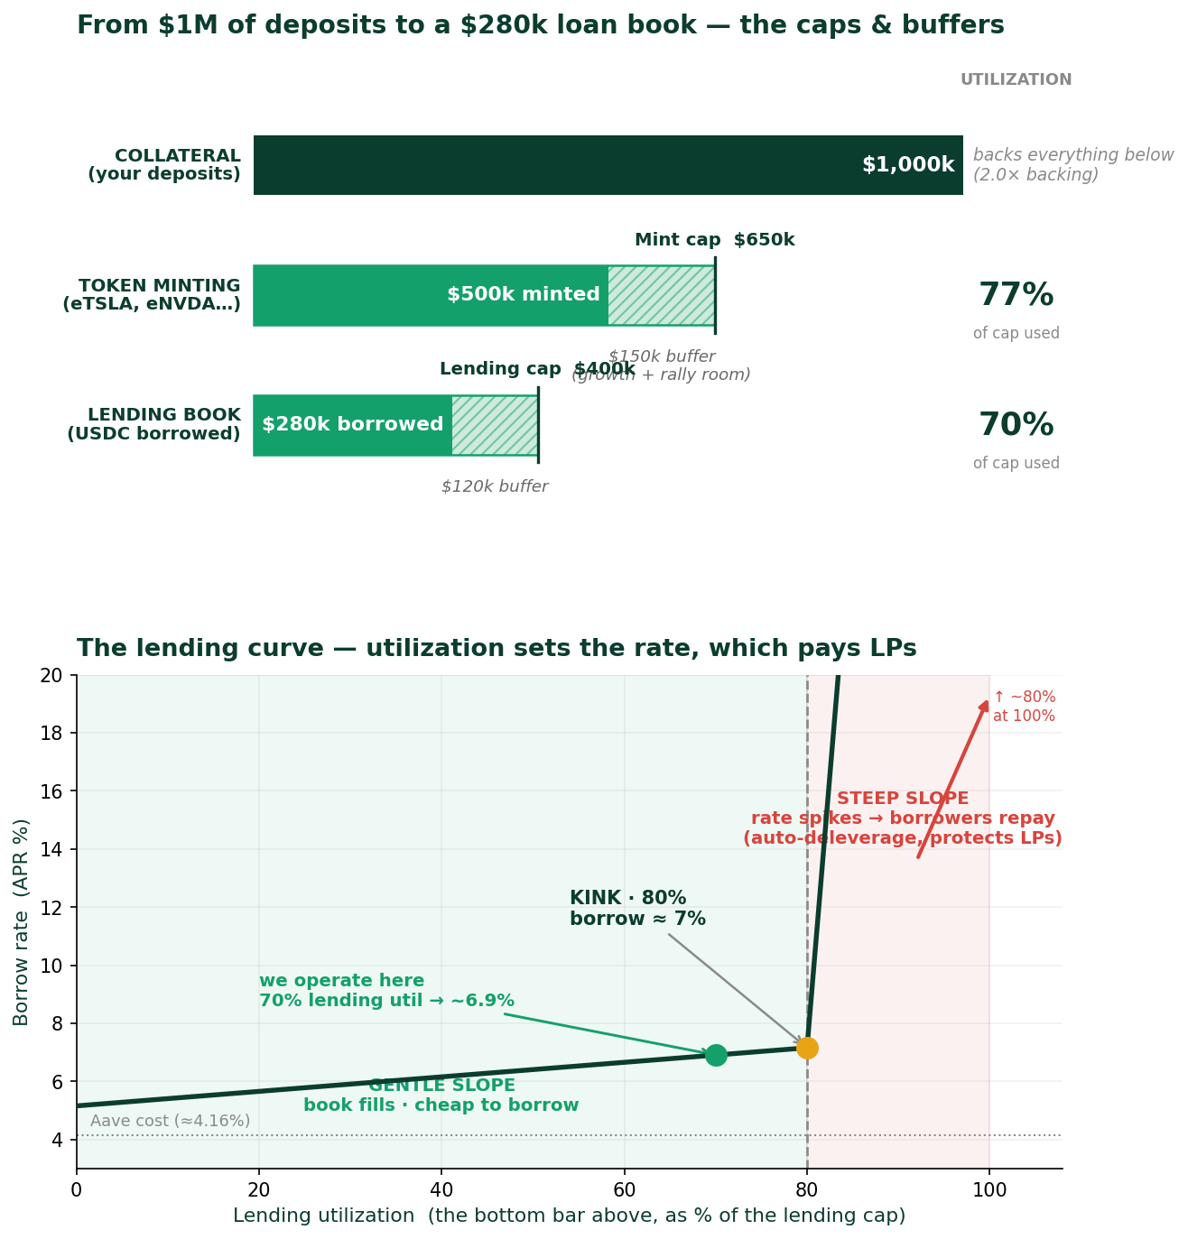
Top half — the caps (sizes). $1M of collateral can mint at most $650k of tokens (the mint cap); we run it at ~$500k — 77% of that cap — leaving a buffer to grow and to absorb price rallies. Of the tokens minted, up to $400k can be borrowed against (the lending cap); ~$280k is borrowed today — 70% of that cap.
Bottom half — the rate (price). That 70% lending utilization is exactly what sets the borrow rate: read it straight off the curve.
How to read the curve:
- Below the kink (gentle slope): borrowing is cheap (~5–7%), so the book fills. Each extra dollar borrowed nudges the rate — and LP income — up slightly.
- At the kink (~80%, the target): utilization is high (LP capital working hard) yet borrowing is still cheap enough (~7%) to keep traders in. Maximum LP yield without scaring borrowers off.
- Above the kink (steep slope): the rate spikes toward ~80%. Borrowing becomes uneconomic, so borrowers repay and deleverage, pulling utilization back down. An automatic brake that protects LPs and keeps their capital withdrawable.
Why this one dial drives yield AND supply at the same time:
- Yield rises as the book fills toward the kink — more borrowed means more interest paid to LPs.
- Supply self-corrects: if utilization pushes past the kink, the rate spike both pushes borrowers to repay (freeing room) and lifts the vault's yield, which pulls in fresh LP deposits. Either response restores headroom.
In one line: put the kink where borrowing is still cheaper than perp funding (~7% vs ~13%), run the book up toward it, and the curve does the rest — paying LPs the most it safely can while keeping their exits open.

5. What LPs actually earn — 30–50% above Aave / Lido
LP income stacks three layers. Here's the per-vault picture at a healthy operating point:
Income layer | aUSDC vault | wstETH vault | cbBTC vault
Base yield (earned elsewhere) | 3.12% (Aave) | 2.55% (Lido staking) | ~0.2% (idle BTC ≈ 0%)
+ Lending premium (borrower interest) | +0.8% | +0.6% | +0.7%
+ Trading spread share | +0.6% | +0.6% | +0.6%
= Organic LP yield | ~4.5% | ~3.8% | ~1.5%
vs. the benchmark | +44% over Aave | +49% over stETH | vs ~0% idle BTC
With launch incentives | ~6.5–7% | ~5.5–6% | ~3.5%
Read each vault against its own benchmark, not against each other:
- aUSDC competes with Aave/Morpho (3–5%) → it wins on yield.
- wstETH competes with nothing (Aave pays wstETH ~0% on Base) → the only place to earn extra on staked ETH.
- cbBTC competes with idle BTC (0%) → even 1.5% is “something from nothing.” Its real job is diversifying the collateral mix, not topping the yield chart.

6. The negative-funding case — hedging that pays LPs directly
Funding isn't always positive. Some names (e.g. TSLA recently, −2.6%) have negative funding — shorts pay longs. The trader's loop doesn't work there, but a different opportunity opens:
Negative funding = shorts pay longs
|
v
The Market Maker hedges the tokens it issued by going LONG the perp
|
| on a negative-funding name, the MM is PAID to hold that long
v
MM collects the funding --> shares it with LPs via the vault
|
v
Adds up to ~+2% to LP yield on those names
- Positive-funding names (most of the time): funding goes to traders; LPs earn via the borrow premium (Section 3).
- Negative-funding names: funding goes to the Market Maker → LPs directly.
Either way, LPs benefit from the funding cycle. We treat the negative-funding bonus as upside, never a promise — it's regime-dependent.

7. The control knobs — and the optimal setting for each vault
Own has a few dials. Each collateral type gets its own settings because each has a different risk profile (USD can't crash; ETH and BTC can).
Dial | What it controls | aUSDC | cbBTC | wstETH
Backing cap | Max tokens vs. collateral (safety ceiling) | 65% (1.5×) | 55% (1.8×) | 50% (2.0×)
Operating level | Where we run it (room to grow + rallies) | ~50% | ~42% | ~38%
Borrow limit | How big the lending book can get | 40% | 35% | 32%
Borrow rate | Price borrowers pay | ~7% | ~7% | ~7%
Result: borrowed | Lending book at operating level | ~$280k | ~$235k | ~$213k
Why the ladder? The riskier the collateral, the more conservative the settings: aUSDC (cash, can't drop) → highest caps; cbBTC (Bitcoin, volatile but less than ETH) → middle; wstETH (staked ETH, most volatile) → tightest, most backing.
One golden rule: never raise the backing cap to make room for more demand. The cap is the safety limit. When you hit it, the fix is attract more collateral (which raises the ceiling automatically) — not loosen the safety. Figures per $1M of collateral; everything scales up as TVL grows.

8. The flywheel — why this compounds
More LP collateral deposited
|
v
Bigger lending capacity --------> More traders can loop/borrow
^ |
| v
Higher LP yield <------------ More borrow interest + spread earned
^ |
| v
LPs attracted by the yield <---- Utilization rises -> yield rises
|
+--------------> (back to top - it compounds)
The self-balancing trick: tie LP rewards to how full the book is. When borrowing demand is high, LP yield rises → pulls in more collateral → reopens capacity for more borrowing. The system pulls in exactly the collateral it needs, exactly when it needs it.

9. How the trading spread is split — two options
Every mint and redeem carries a small spread (~0.25%). On expected volume this is real revenue. Who gets what is a business decision — two models, costed at ~$3M TVL (~$15.6M annual volume → ~$39k/yr spread):

Option A — Maker-friendly (50% LPs / 40% Market Maker / 10% Protocol)
Recipient | Share | $/year | Effect
LPs | 50% | ~$19,500 | +0.65% to LP yield
Market Maker | 40% | ~$15,600 | Strong incentive to keep quoting & hedging
Protocol | 10% | ~$3,900 | Treasury
Best for launch — a generous maker share is how you recruit and keep your first market maker.

Option B — LP-friendly (80% LPs / 10% Market Maker / 10% Protocol)
Recipient | Share | $/year | Effect
LPs | 80% | ~$31,200 | +1.04% to LP yield
Market Maker | 10% | ~$3,900 | Thin — only works once volume is high
Protocol | 10% | ~$3,900 | Treasury
Best once you have scale — high volume makes even 10% worthwhile for the maker, and extra LP yield supercharges TVL growth.
Option A (launch) Option B (scale)
LP ######## 50% LP ################ 80%
MM ####### 40% MM ## 10%
Prot ## 10% Prot ## 10%
--> recruit the maker --> reward the LPs
The trade-off in one line: more to the Maker = easier to launch and keep liquidity; more to LPs = faster TVL growth. Start with Option A, migrate toward Option B as volume scales.

10. Summary — the numbers that matter
Question | Answer
Where's the demand? | Crypto funds harvesting perp funding (~+5–13%/yr) via leveraged stock positions
How do we capture it? | Borrowers pay ~7% — the premium above Aave (~3%) flows to LPs, MM, protocol
What do LPs earn? | ~4.5% (USDC), ~3.8% (wstETH), ~1.5% (BTC) organic — 30–50% above benchmark; ~6–7% with incentives
What do borrowers pay? | ~7% — cheaper than perp funding, so the trade stays profitable
How much gets borrowed? | ~21–28% of each vault, at ~70% of the lending book's capacity
What keeps it safe? | Per-collateral backing caps (1.5×–2.0×), never loosened for growth
How does it grow? | Flywheel: yield → collateral → capacity → borrowing → yield
How is spread split? | 50/40/10 at launch (recruit the maker) → 80/10/10 at scale (reward LPs)
This document describes target mechanics and illustrative economics. It is not an offer, investment advice, or a guarantee of returns. Synthetic stock exposure carries market, smart-contract, and counterparty risk. Not available to US persons or other restricted jurisdictions.

