Lab 4 - Distance Vector Routing

(i) Distance vector routing is a algorithm that calculate the lowest cost to all nodes in the network. Based on a nodes neighbours cost table the node can update its own table so that the node can route through the route with the lowest cost. If a nodes cost-table is changed, the node sends its changed cost table to its neighbours and then they change their cost-table and sends it to its neighbours and so on. This is done until all nodes have found its route at the lowest cost. The Distance vector routing is a iterative, asynchronous and distributed algorithm.

(ii) We tested the algorithm by writing down the correct pattern(route cost) from the assigned values in RoutingSimulator.java file. Then we compared with our result in the GUI-windows for each node. We also checked the time events in Router Simulator window and compared them with the node events. We checked the routes taken, the cost and direct distance to each node. The changed link-cost was also checked closely, both when the link-cost was raised and lowered.

(iii)
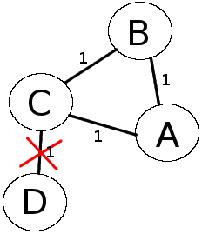

Imagine the link between C and D breaks.

- When the link breaks, C marks D as unreachable and reports that to A and B
- Suppose A learns it first, before B learns
- A now thinks best path to D is through B
- A reports D unreachable to B and a route of cost=3 to C
- C thinks D is reachable through A at cost 4 and reports that to B
- B reports a cost 5 to A who reports new cost to C and so on..

(iv)
To solve this problem, a timer could be implemented. Instead of (A and B) sending the new table right away, the nodes wait a certain amount of time so that all nodes have time to receive the update (from C in the example above) before they send their new tables to each other.

